**ALIAS**

A custom shortcut that represents long commands or series of commands

Syntax: alias “custom” = “command”

For example, alias L = ls-lrt

Alias -p is used to list down all the created alias

TYPES:

1. **Customizing commands**: example 🡪 alias L = “ls-ltr”
2. **Shortening lengthy commands**: example 🡪 alias backup = “tar-cvzf”
3. **Navigating directories:** example 🡪 alias myscript = “cd /home/temp/f1/myscript”

**# Alisa commands that are made are temporary and are removed when the system is powered off.**

**# To make these commands permanent we can perform some steps 🡪** 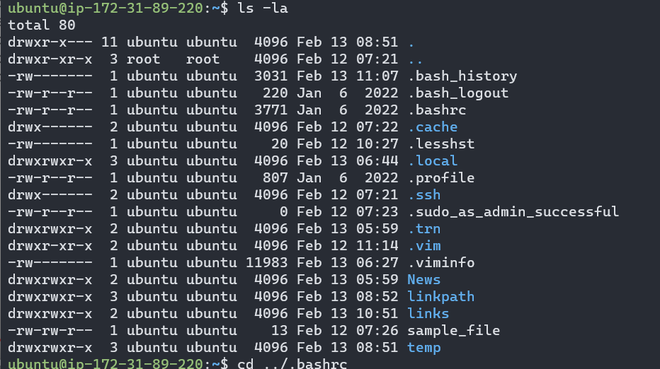

Edit .bashrc file

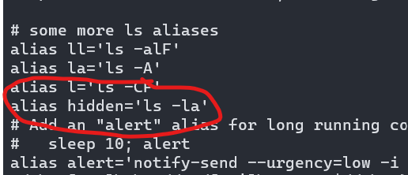

Add custom alias

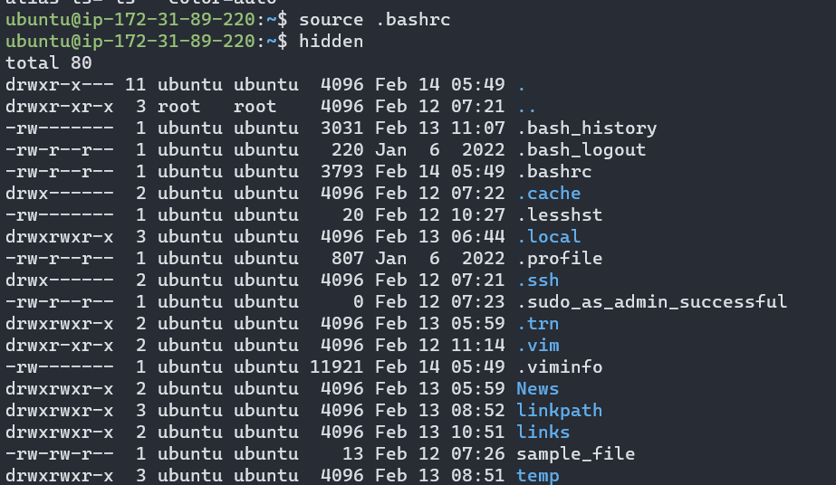

We have used source .bashrc command to implement changes.