**LINKS**

The connection between a file name and actual data. Mainly it creates a shortcut.

**TYPES**

1. **SOFT LINKS**: - links will be removed if the original file is removed or deleted.

**Command**: ln -s “path” “name-of-softlink ”

This is our path where we have a file (myfile)



we made some entry in the (myfile)



Now we made dir name links in ./

Now making softlink and try to access the file using softlink



Now removing file and checking if link works or not

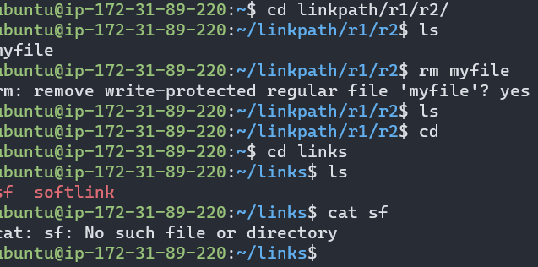link failed

1. **HARD LINKS**: - links will remain present even if the file is removed/ deleted/ renamed. It can also act as a backup.

**Command:** ln “path” “name-of-hard-link”

