- Problem Statement-
Myntra needs a way to progressively understand and retain user preferences so that future agentic experiences can become more personalized, relevant, and useful over time—creating long-term value rather than optimizing only for individual shopping sessions.
- Goals and What are my non-goals -
- Goals-
  - Make shopping feel like a conversation
  - Reduce the time users spend discovering and narrowing down relevant products.
- Non- Goals-
  - No separate application or standalone experience will be introduced.
  - No dependency on separate screens or applications to complete the shopping transaction.
3. Success Metric Prompt
- North Star - Increase incremental products sold through the agentic shopping experience.
- L1 -1. Number of adoptions, 2.# tasks per users
- Counter - Task drop rate, D30 retention/inactivity rate
4. Use Journey- Empathy Map
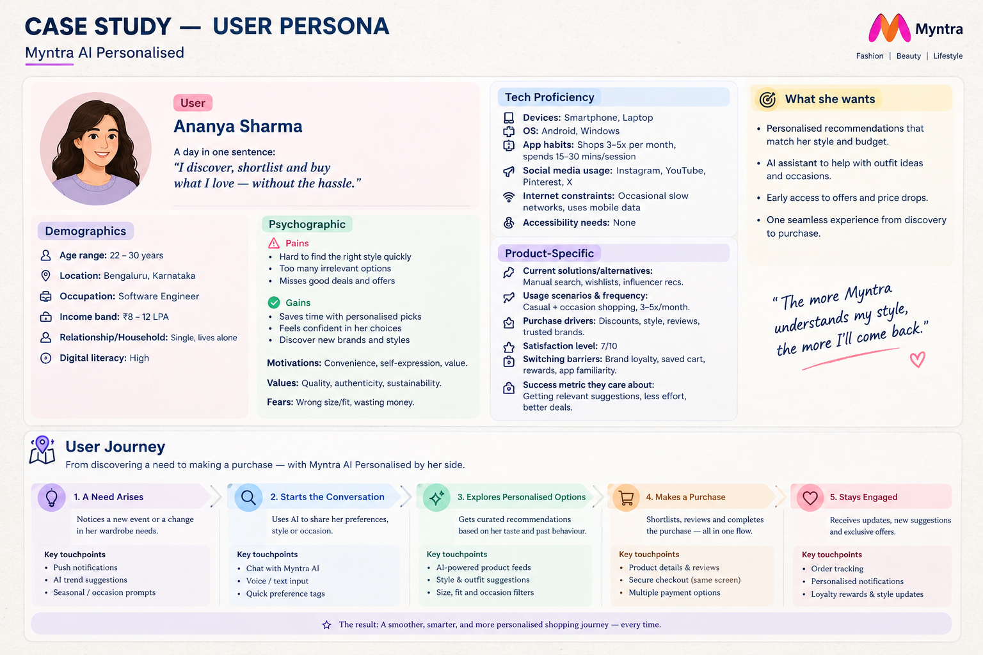
5. What are competitors offering?
- Persistent Personalization — AI remembers user preferences and uses previous interactions to personalize future experiences.
- Context-Aware Recommendations — AI considers factors such as occasion, budget, style, previous preferences, and current intent together.
- End-to-End Shopping Tasks — AI can take a user's shopping goal from discovery through actions such as product selection and checkout.

Solution / Opportunity | Reach | Impact | Confidence | Effort | RICE Score | Priority
Persistent Personalization | MED | HIGH | HIGH | MED |  | p0
Context-Aware Recommendations | HIGH | HIGH | MED | MED |  | p1
End-to-End Shopping Tasks | MED | HIGH | HIGH | HIGH |  | p1

6.FUNCTIONAL AND ACCEPTANCE CRITERIA / NON-FUCTIONAL REQUIREMENTS
- Functionals - Users can submit a task through image, text or voice, and myntra ai should autonomously plan and execute the required steps with minimal user intervention.
- Non-functional requirement -
  - P - performance - Simple tasks should complete within 45 seconds; long-running tasks should provide progress updates and an estimated completion time.
  - Q - Quality - Completed tasks should satisfy the user's requested outcome with minimal corrections, retries, or rework.
  - R - Reliability - the user should be able to recover, restore and re-trigger the chats without losing context
  - S - ˘Secure - User data must be encrypted in transit and at rest, with access limited to authorized services and users.
  - T - Transparency - Every task execution should provide a clear, user-visible and recoverable activity log showing the actions taken, current status, and final outcome
  - U - Useability - Users should be able to complete common shopping tasks with minimal conversational interactions and without unnecessary navigation or manual steps.

7. MOCK-UP - https://stitch.google.com/projects/16054567078214139540?pli=1
8. PROTOTYPES (TENTATIVE)
9. GITHUB PUSH AS A PORTOLIO:

