Audacity:
Music Portal

Submitted By  Bikram Lal Shrestha  MCA  Registration# : 551019373 | Submitted To  Sikkim Manipal University  Via  Infomax College , LC Code: 02536  Pokhara

June 2012

Cover Page

Emblem
Infomax College, Pokhara , 02536
Audacity: Music Portal

By
(Bikram Lal Shrestha)

A project report submitted in partial fulfillment of the requirements for the degree of Master of Computer Application of Sikkim Manipal University, India.

Sikkim-Mnipal University of Health, Medical and Technological Sciences
Distance Education Wing
Manipal

Certification

The project report of
(Bikram Lal Shrestha)

Audacity: Music Portal

Is approved and is acceptable in quality and form.

Internal Examiner External Examiners

Student Declaration

I, hereby, declare that the project report entitled “Audacity: Music Portal” is the result of the project carried out by me under the guidance and supervision of Dr. B. S. Daya Sagar Information Technology Department, Infomax College. This project work is submitted in partial fulfillment of the requirement of the course leading to the award of the ‘Master in Computer Application’ in Sikkim Manipal University.

I further declare that this project report has not been previously submitted to any other institution/university for any other degree/ diploma or any other person by me or any other person.

Date:
Pokhara, Nepal (Bikram Lal Shrestha)

Acknowledgement
I am greatly indebted to my Supervisor Er. …… Thanks are due to Sikkim Manipal University for giving consent to carry on this project work. This project has been benefitted by suggestions from friends and well-wishers. I would like to thank all of them. I am grateful to my friends Bikesh Babu Rajbanshi, Subash Aryal for their friendship and moral support. I owe a special debt to my dear friend Anita for her continuous support throughout the period. It would be unfair not to mention the love and support my family has always shown me; in particular, I wish to acknowledge my brother’s encouragement.

Abstract
This report outlines the design and development of a computer software system to launch a music portal for upcoming artists as a platform for sharing their work. Such a portal will allow novice artists to get their music heard/watched. The application is written in J2EE platform recommended to run under the Linux operating system which can be ran on other OS which have a JDK port. The design and ensuing program are highly modular in nature and make maximum use of MVC design pattern and software reuse. This report pays particular attention to system requirement and design.

Contents

Introduction

Objectives

Problem Statement

Requirement Analysis

Users/Actors of the system
The following user types are expected of the system:
Administrator
This is the super user of the application who has overall application configuration, reports and management sections. Generally this user is the owner of the site too.

Band Manager
This is a registered user in the application who maintains the profile of the band. Generally a band manager is supposed to have a login in the application, who is responsible for maintaining band profile, album profile and uploading the songs in the system.

Viewer
This is non registered, end user of the application who can access the pages made available to the public. Registered users can also act as a viewer.

Use case index

ID | Use Case | Actor
1 | Login with username/password | Band Manager
2 | Register Band | Band Manager
3 | Create Albums | Band Manager
4 | Add Songs to Album | Band Manager
5 | Edit Album | Band Manager
6 | Delete Album | Band Manager
7 | List Albums | Band Manager
8 | Login with username/password | Admin
9 | Set dashboard privacy setting | Admin
10 | Mark feature songs | Admin
11 | Mark feature bands | Admin
12 | Censorship | Admin
13 | Browse all available songs | Viewer
14 | Play a song | Viewer
15 | See top 10 songs | Viewer
16 | See top 10 albums | Viewer
17 | See most recent songs | Viewer
18 | Play random song | Viewer
19 | Shuffle through random playlist | Viewer

Use case diagram

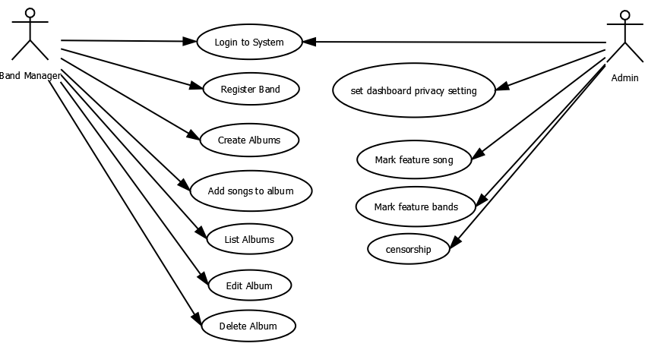
Diagram 1: Use cases for Band Manager and Administrator

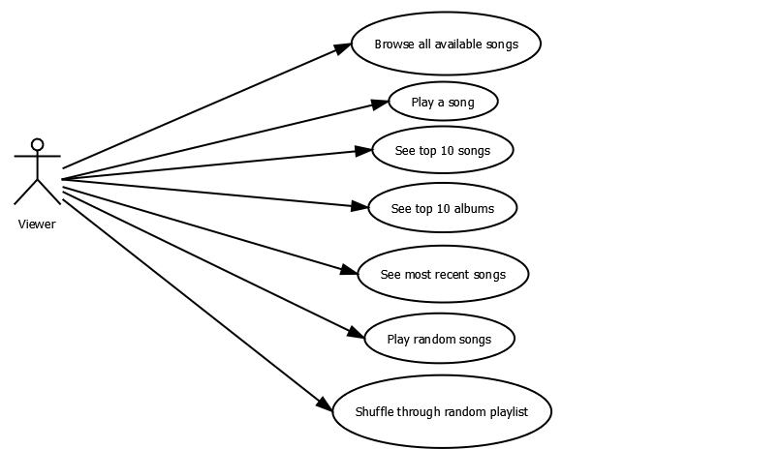
Diagram 2: Use cases for Viewer

Use case description

1 Login with username/password

Participating Actor
Band Manager/Admin

Precondition
Login page is loaded in browser

Flow
- Provider username
- Provider password
- Click Submit Button
- Check the combination of username/ password in the authentication database
- If credentials are correct redirect to dashboard
- If credentials are not correct redirect to login page

Exit Condition
- Correct username/password lead to band manager dashboard.
- Incorrect combination of username/password redirects to the login page again.

2 Register Band
Participating Actor
Band Manager

Precondition
Band manager is authenticated and authorized for registration.

Flow
- Click on register band link:
- Registration form is displayed
- Band manager provides band information
- Clicks submit button
- Save data and redirect to dashboard

Exit Condition
Saved in database and redirected to the dashboard.

3 Create Album
Participating Actor
Band Manager

Precondition
Band manager is successfully logged in and band is registered.

Flow
- Band manager clicks on add album link
- Display album form
- Add album details
- Click on submit button
- Save the data and redirect to album listing page

Exit Condition
Album detail is saved

4 Add Songs to Album
Participating Actor
Band Manager

Precondition
- Band manager is successfully logged in
- Atleast one album is created.

Flow
- Add song form is displayed after creating album or clicking add songs link in album list.
- Add song detail
- Select album
- Upload song
- Click save button
- Save song and redirect to songs listing

Exit Condition
Provided song is saved in database.

5 Edit Album

Participating Actor
Band Manager

Precondition
- Album is created
- User is logged in as a Band Manager

Flow
- In album list click edit link/icon
- In album detail form, provide updated info
- Click save button.
- Save the record and redirect to album listing

Exit Condition
Album information is updated in database

6 Delete Album

Participating Actor
Band manager

Precondition
- Album is listed in album list
- User is logged in as a Band Manager

Flow
- Click on delete icon on the album list
- Delete all songs in the album
- Delete album information
- Refresh album listing page

Exit Condition
Songs in album and album is wiped out.

7 List Albums

Participating Actor
Band Manager

Precondition
Band manager is successfully logged in and albums are created

Flow
- Click on albums link
- list of albums created by the user are displayed with options to modify the albums.

Alternative Flow
- Add a new album
- List of the albums created by the user are displayed with options to modify the ablums

Exit Condition
Display album listing page

8 Login with Username/Password

Participating Actor
Band Manager, Administrator

Precondition
- Login page is loaded in browser
- User has registered account in the system

Flow
- User provides username
- User provides password
- User clicks the Login button
- System checks the credentials (username and password) with the credentials stored while registration
- If credentials are correct check the user type
  - If user is administrator redirect to admin dashboard
  - If user is band manager, redirect to band dashboard
- If credentials are not correct, redirect to the login page

Exit Condition
- Show user dashboard based on user type when credential match
- Show login form if the credenitals don't match

9 Set Dashboard Privacy Settings
Participating Actor
Administrator

Precondition
User is logged in with administrative privelage

Flow
Privacy settings are set and settings and pages corresponds to specific user session.

Exit Condition
Privacy setting is available in session.

Use Case ID | 10
Use Case Name | Mark feature songs
Participating Actor | Admin
Pre condition | Logged in as admin
Flow | - Get the list of songs  - Mark featured checkbox  - Click save button.
Exit Condition | Featured information is saved and published to public user

Use Case ID | 11
Use Case Name | Make feature band
Participating Actor | Admin
Pre condition | Logged in as admin and band available
Flow | - Go to band listing  - Check the feature checkbox  - Click save button  - Publish the featured bands
Exit Condition | Featured band is published

Use Case ID | 12
Use Case Name | Censorship
Participating Actor | Admin
Pre condition | Logged in as admin
Flow | List song/album/comments  Delete them if found abusive
Exit Condition | Abusive songs/album/comments are removed

Use Case ID | 13
Use Case Name | Browse all available songs
Participating Actor | Viewer
Pre condition | -
Flow | User visits the site or click on song list link
Exit Condition | Song listing page is displayed

Use Case ID | 14
Use Case Name | Play a song
Participating Actor | Viewer
Pre condition | User is in song list page
Flow | Click on song play icon
Exit Condition | Song is played

Use Case ID | 15
Use Case Name | See top 10 songs
Participating Actor | Viewer
Pre condition | -
Flow | Click on top 10 songs link
Exit Condition | Top 10 songs listed

Use Case ID | 16
Use Case Name | See top 10 albums
Participating Actor | Viewer
Pre condition | -
Flow | Click on top 10 album link
Exit Condition | Top 10 album listed

Use Case ID | 17
Use Case Name | See most recent songs
Participating Actor | Viewer
Pre condition | -
Flow | When user lands to homepage recent songs are listed.
Exit Condition | Recent songs are listed.

Use Case ID | 18
Use Case Name | Play random songs
Participating Actor | Viewer
Pre condition | -
Flow | Click on random play link
Exit Condition | Random songs played.

Use Case ID | 19
Use Case Name | Shuffle through random playlist
Participating Actor | Viewer
Pre condition | Playlists are available
Flow | Visit to the play list and click play button
Exit Condition | Songs are played from random playlist.

Supplementary Specification
The requirements not captured in the use cases are listed below:
- Buffering requirement
The application should not stall till whole audio file gets downloaded. As soon as some parts of the file are downloaded it should start playing. This should be accomplished with buffering techinques available.
- Client side requirement
The application should be usable in any modern web browser without need of extra application or plugins so that it is reachable to all kind of devices and operating systems, mainly Windows, Mac, Linux OS on Desktop and Android, iPhone on tablet and mobile devices
- Server side requirement
The application should be hosted in easily available web servers with J2EE containers and MySQL database
- Scalability/Performance requirement
The application is supposed to viewed by thousands of users round the world hence should be scalable and have high performance
- Legal issues
Any library/tools used in developing the application should be properly licensed, use of open source tools and libraires are highly encouraged.

Flow diagrams
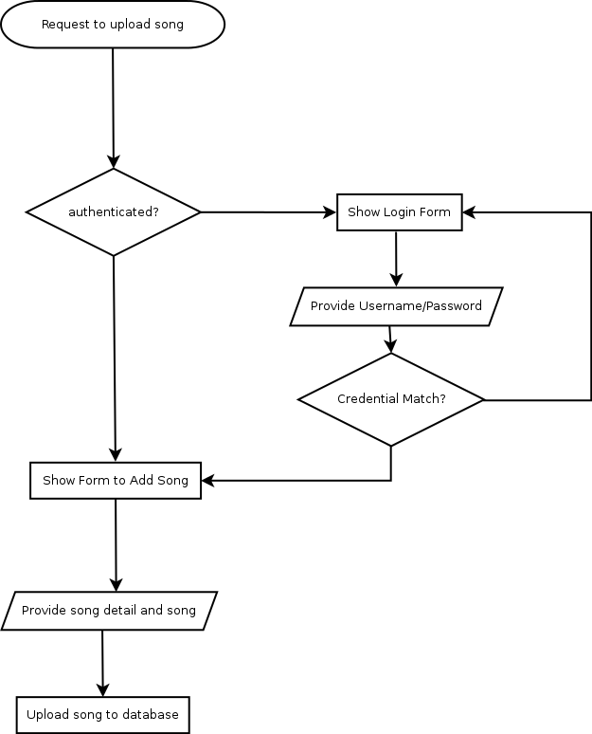

Use case : 4. Add songs to album

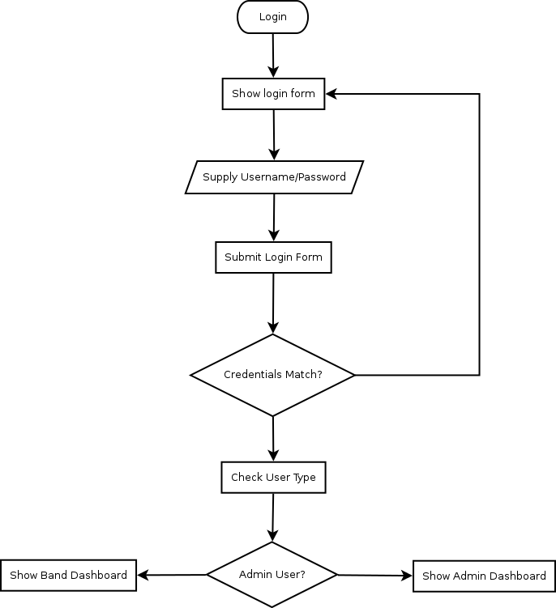

Use case : 8. Login User with Username/Password

Analysis and Design

Software Architecture

The application is divided into multi-layer architecture to make presentation, application processing, security, data management, data-access management logically separate processes. Following are the layers identified in the system :

Presentation Layer
This is the topmost level of the application. The presnetation tier is responsible for rendering the output, providing forms to get input from the users and does not involve in any other roles.

Controller Layer
The system, being a web application, involves a lot of logic to redirect from one page of the application to other and back. During this redirection to different pages the application has to maintain data required by the presentation layer to the views. The controller layer is responsible for managing these tasks. A controller will maintain all the data model requesting from Service layer and redirecting to the appropriate presentation.
This layer is interconnected with most of the layers of the application and is responsible for communicating among these layers. This layer helps application collect all the required data with the help of application layer and sends to the view implementation

Application Layer or Service Layer
The application layer contains all the application/business logic and provides functions to access results based requirement. Most of the business logic is applied on the data objects of the system and
Domain Layer

Data Access Layer
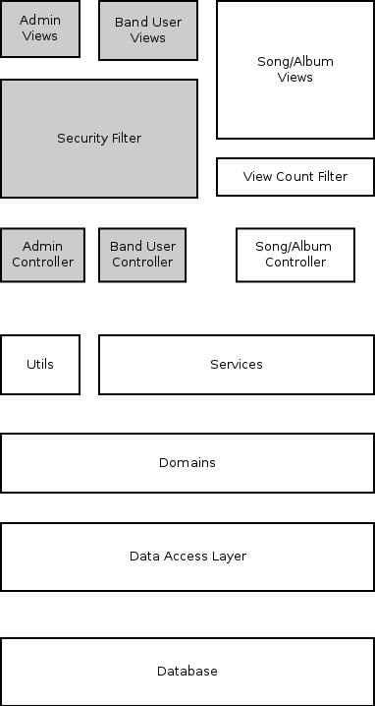

Fig : Overall Architecture of the Application

Layer interaction
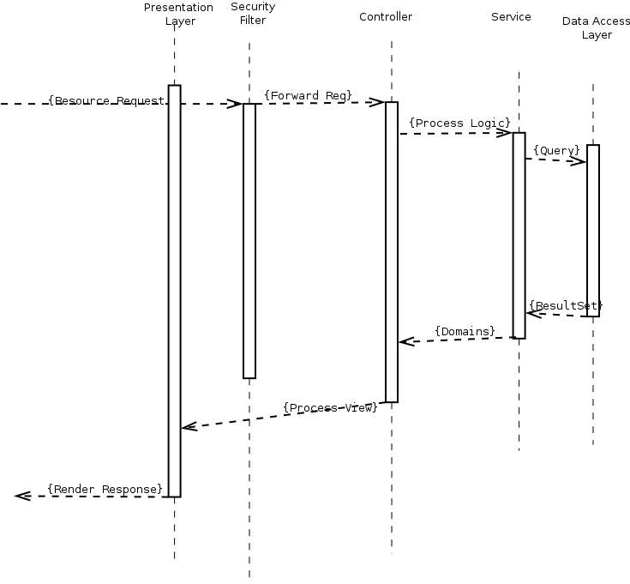

Class Diagram

Data Model

Coding

Testing Procedures

Testing Reports

Future Application

Conclusion

Bibliography

