**Final Project Report File**

**Topic Golf Pro**

**About Project**

**Welcome to our Golf Academy**

Best of Everything: 55 things you probably didn’t know you needed.

**A set of head-turning headcovers**

Seamus Golf’s head-cover collection features endless options to choose from. It’s one of the greatest things about the brand. There are unique and attractive prints, custom major championship detailing and even designs celebrating your favorite college sports team. The variety is endless, which also is one of the toughest things about buying a Seamus headcover. It’s nearly impossible to pick just one.

**A pair of tech-forward earbuds that fit just right**

The new Bose Quiet-Comfort earbuds will transport you into your own zone during practice sessions. They’re designed with internal and external microphones to cancel out unwanted noise, and they have supersoft nozzles that contour to your ear to create a seal from the world outside.

This is simple Golf Game site that Shows that services provided by the Golf Academy on the service page and Moreover can also add employee and register new employees with watching messages of people who have contacted them



How to Use admin Login?

Click on Golf Pro Logo on the Top and admin login Page will be open like that

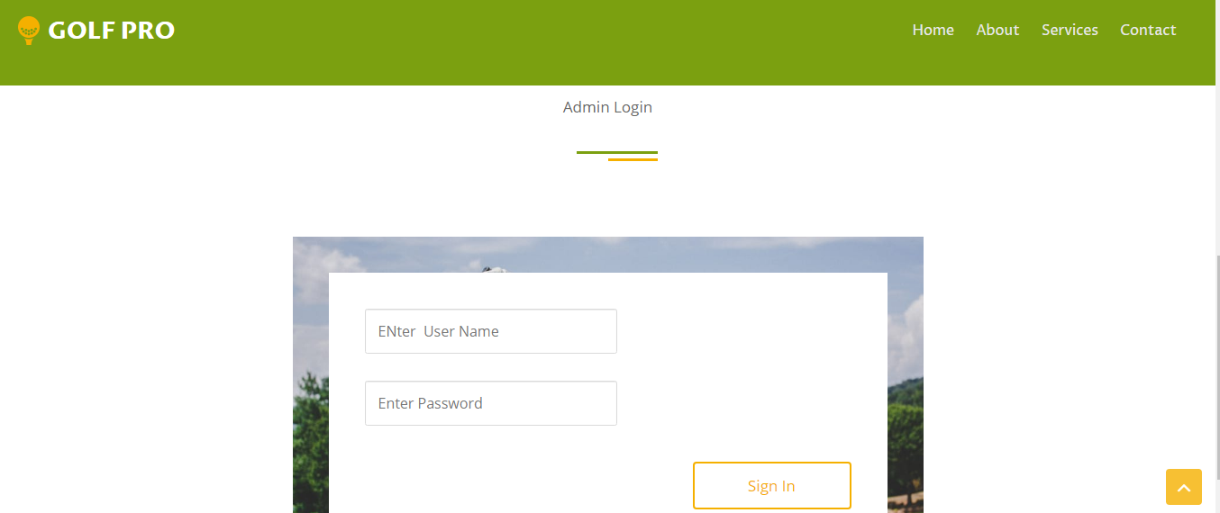

Just Fill Right Details Below

**User Name :** [**admin@gmail.com**](mailto:admin@gmail.com)

**Password : admin**

**User DashBoard:**

After a Successful login the Below given Dashboard will be opened

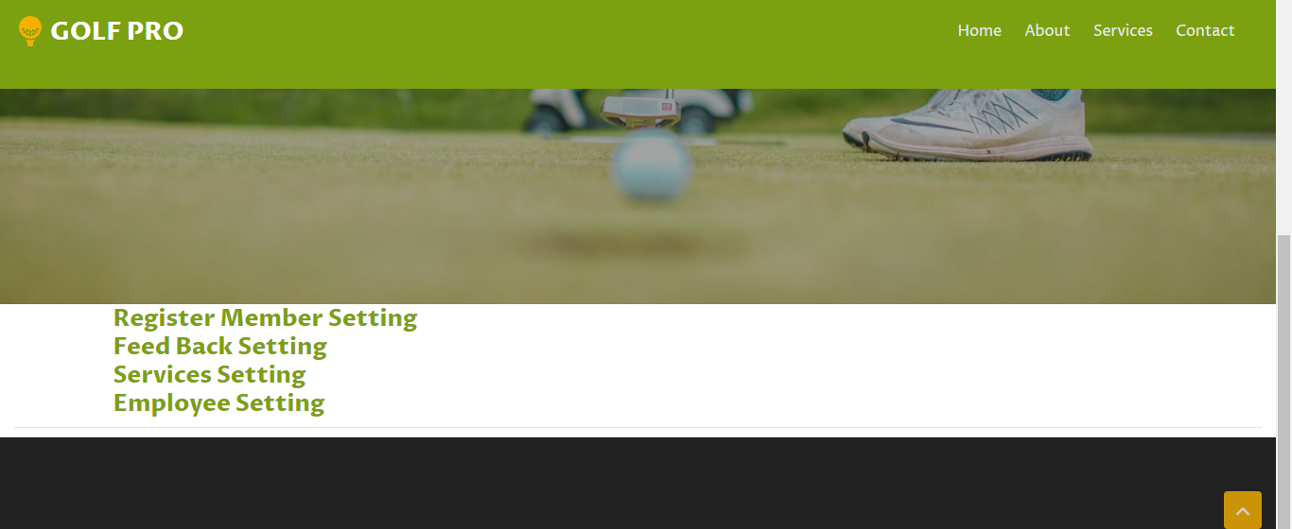

These dashboard allows Admin to Register New Member

View all the Received Messages

Add New Services to Website

Add New Employees

All these Above things can be Edited, Updated and Deleted

Register New Member Page

If we want to register new Member these type of page will be opened

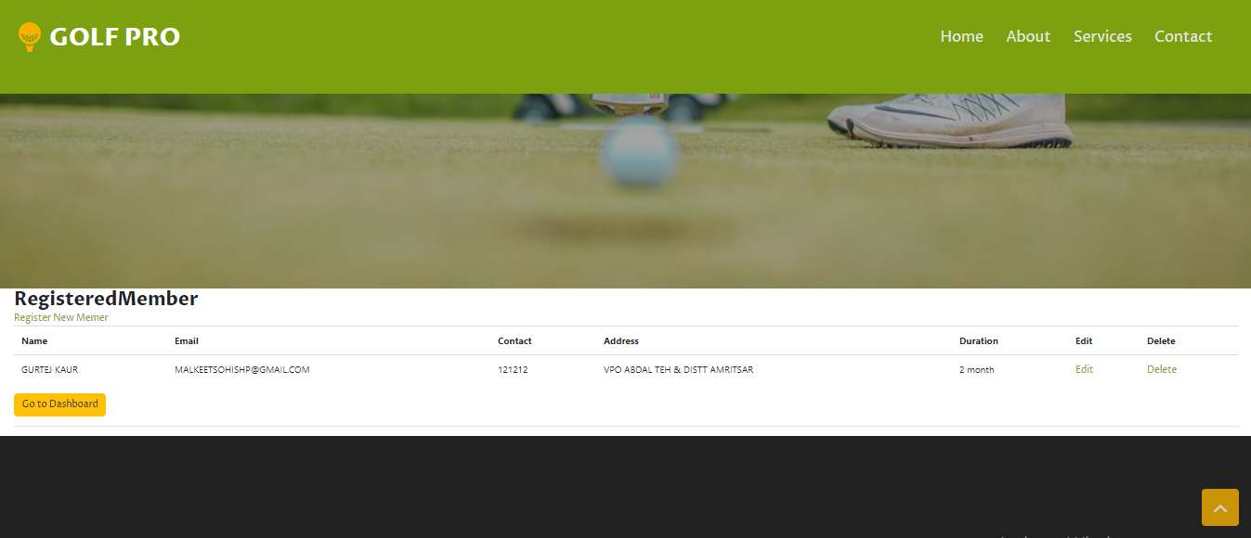

Service Add Update Delete Page

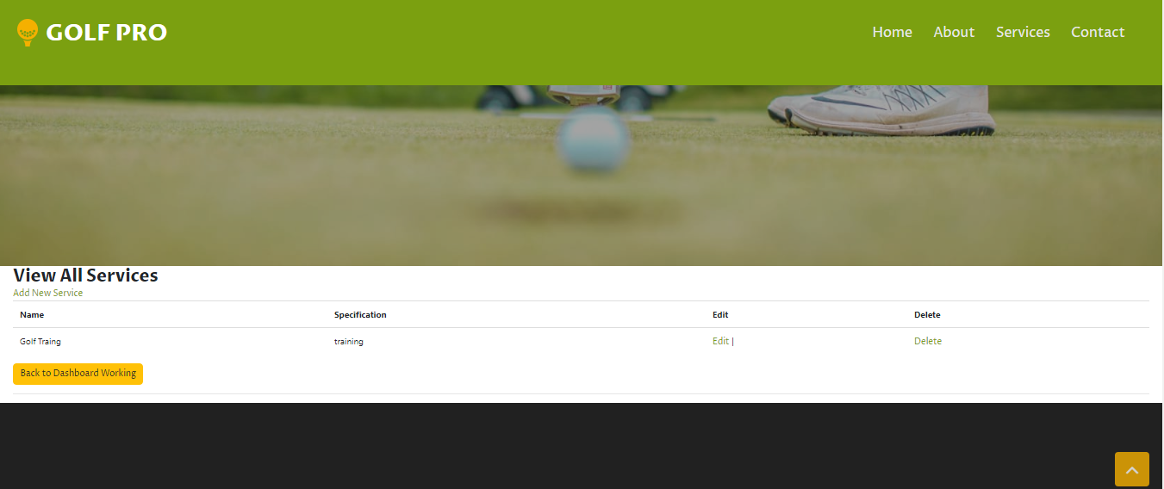

**Index Page [Homepage]**

**  **

About Us

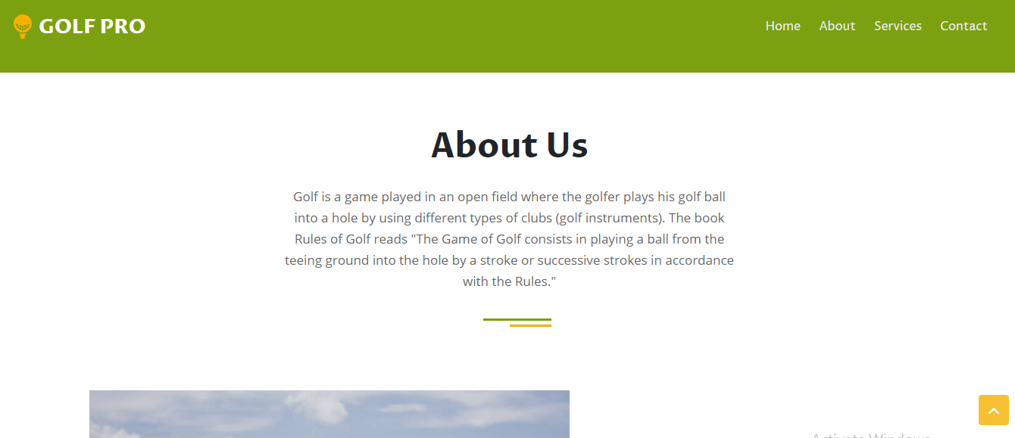 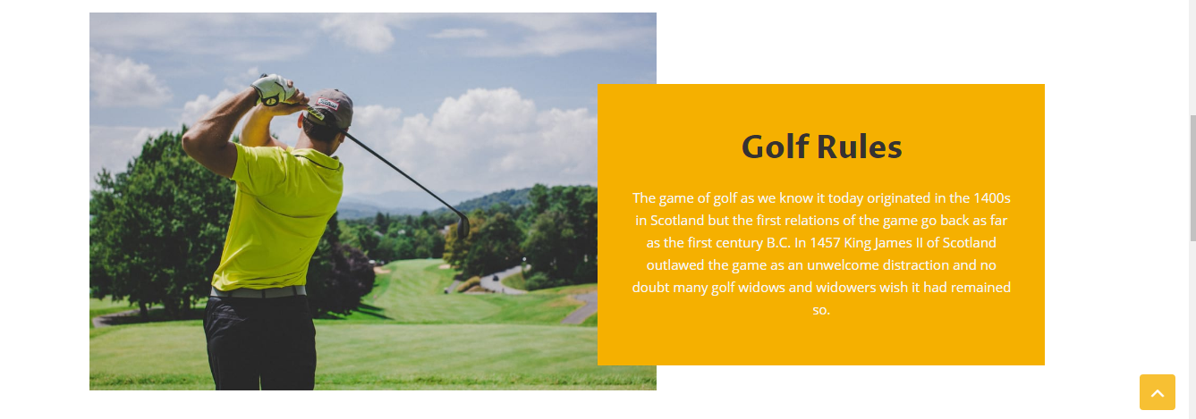 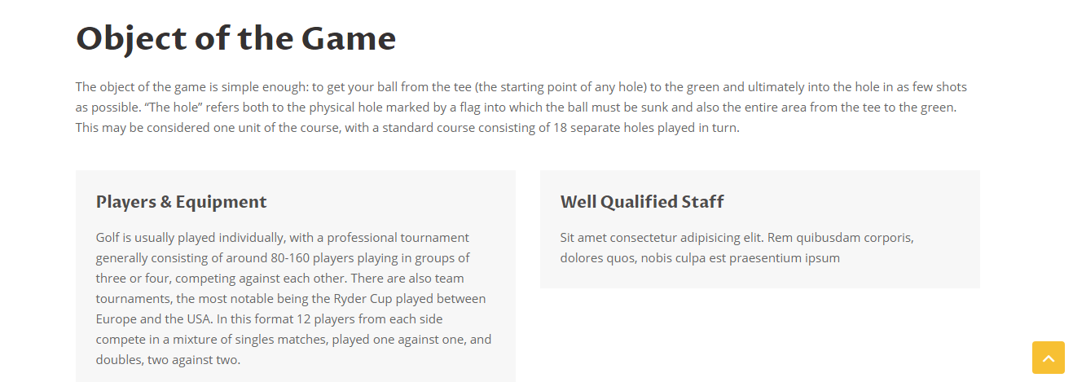

**Services Pages**

These services are showing from the database

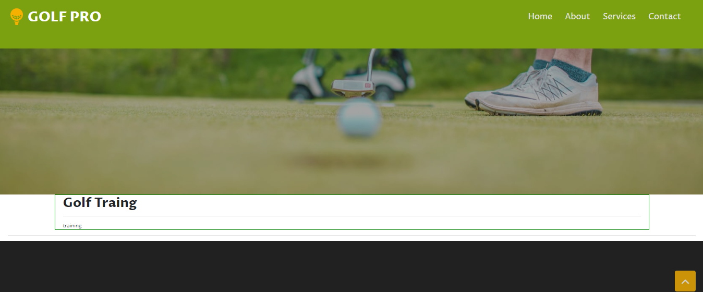

**Contact**

