**Successful response from the API Endpoint**

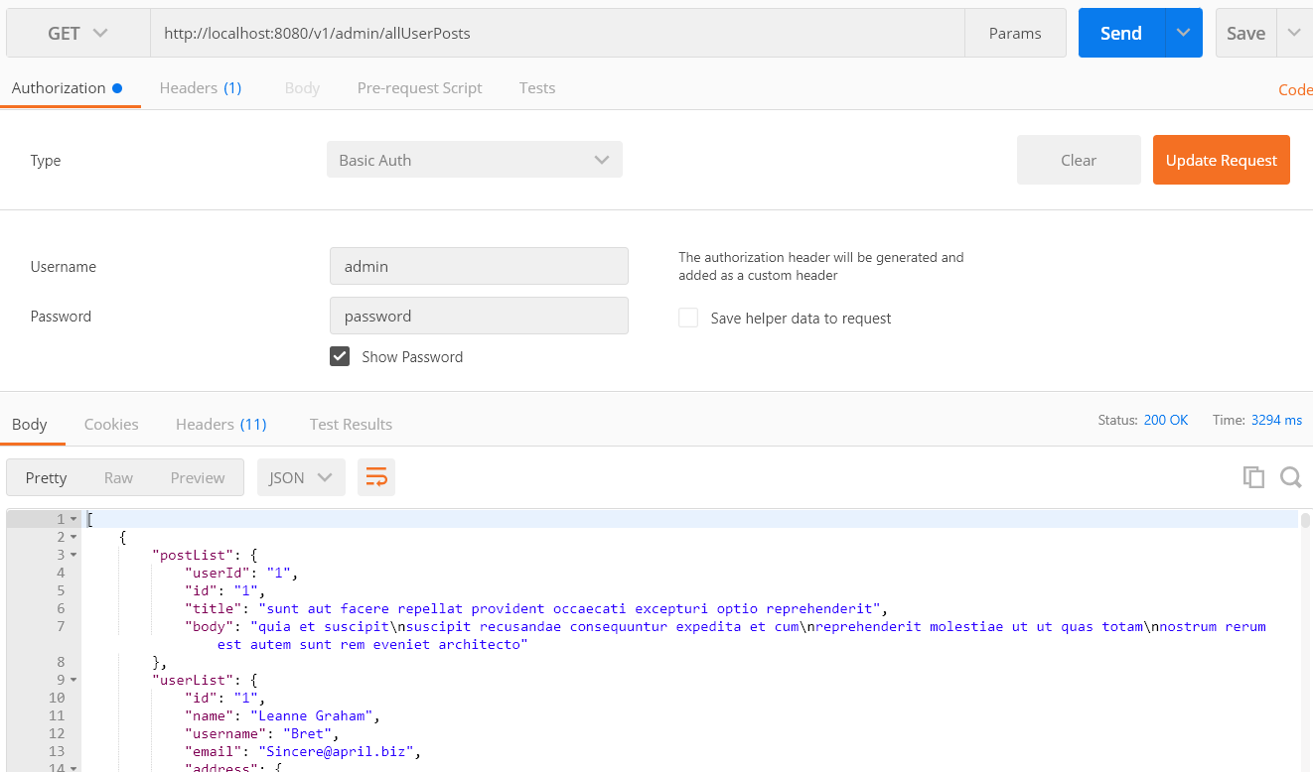

**Response Object contains both “PostList” and “UserList”**

|  |
| --- |
| [  {  "postList": {  "userId": "1",  "id": "1",  "title": "sunt aut facere repellat provident occaecati excepturi optio reprehenderit",  "body": "quia et suscipit\nsuscipit recusandae consequuntur expedita et cum\nreprehenderit molestiae ut ut quas totam\nnostrum rerum est autem sunt rem eveniet architecto"  },  "userList": {  "id": "1",  "name": "Leanne Graham",  "username": "Bret",  "email": "Sincere@april.biz",  "address": {  "street": "Kulas Light",  "suite": "Apt. 556",  "city": "Gwenborough",  "zipcode": "92998-3874",  "geo": {  "lat": "-37.3159",  "lng": "81.1496"  }  },  "phone": "1-770-736-8031 x56442",  "website": "hildegard.org",  "company": {  "name": "Romaguera-Crona",  "catchPhrase": "Multi-layered client-server neural-net",  "bs": "harness real-time e-markets"  }  }  } |

**If upstream api(External api endpoint ) is down**

