Week-2
Develop an application that receives user‟s name, contact and city and displays the same using Layout Managers and Event Listeners.
Android app in Java using Android Studio that receives the user’s name, contact, and city via EditText fields and displays them in a TextView when a button is clicked.
Using LinearLayout as the layout manager and implement an OnClickListener for the button. activity_main.xml
layout with 3 EditTexts, a Button, and a TextView to display the result.
<?xml version="1.0" encoding="utf-8"?>
<LinearLayout xmlns:android="http://schemas.android.com/apk/res/android" android:layout_width="match_parent"
android:layout_height="match_parent"
android:padding="16dp"
android:orientation="vertical">
<EditText
android:id="@+id/editTextName"
android:layout_width="match_parent"
android:layout_height="wrap_content"
android:hint="Enter Name"
android:inputType="textPersonName" />
<EditText
android:id="@+id/editTextContact"
android:layout_width="match_parent" android:layout_height="wrap_content" android:hint="Enter Contact"
android:inputType="phone" />
<EditText
android:id="@+id/editTextCity"
android:layout_width="match_parent" android:layout_height="wrap_content" android:hint="Enter City"
android:inputType="text" />
<Button
android:id="@+id/buttonSubmit"
android:layout_width="wrap_content" android:layout_height="wrap_content" android:text="Submit"
android:layout_marginTop="16dp" />
<TextView
android:id="@+id/textViewDisplay" android:layout_width="match_parent" android:layout_height="wrap_content" android:text=""
android:textSize="18sp"
android:layout_marginTop="24dp" />
</LinearLayout>
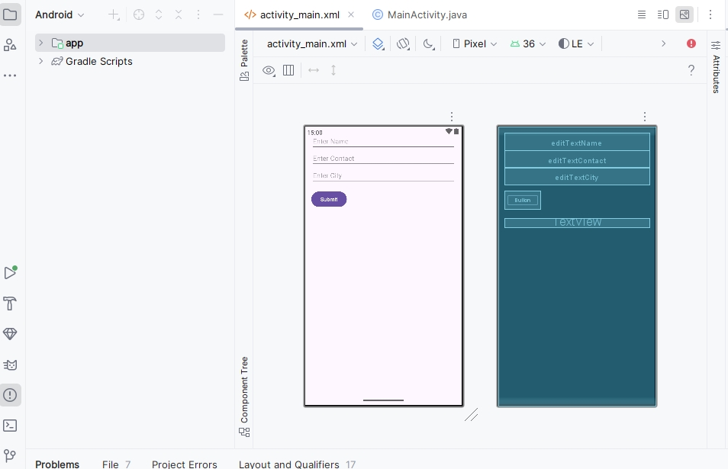
MainActivity.java
package com.example.userinputapp;
import androidx.appcompat.app.AppCompatActivity;
import android.os.Bundle; import android.view.View; import android.widget.Button; import android.widget.EditText; import android.widget.TextView;
public class MainActivity extends AppCompatActivity {
EditText editTextName, editTextContact, editTextCity; Button buttonSubmit;
TextView textViewDisplay;
@Override
protected void onCreate(Bundle savedInstanceState) { super.onCreate(savedInstanceState);
setContentView(R.layout.activity_main);
// Initialize views
editTextName = findViewById(R.id.editTextName); editTextContact = findViewById(R.id.editTextContact); editTextCity = findViewById(R.id.editTextCity); buttonSubmit = findViewById(R.id.buttonSubmit); textViewDisplay = findViewById(R.id.textViewDisplay);
// Set listener for button
buttonSubmit.setOnClickListener(new View.OnClickListener() { @Override
public void onClick(View view) {
// Get input values
String name = editTextName.getText().toString().trim();
String contact = editTextContact.getText().toString().trim(); String city = editTextCity.getText().toString().trim();
// Display the values
String displayText = "Name: " + name + "\nContact: " + contact + "\nCity: " + city; textViewDisplay.setText(displayText);
}
});
}
}
Output:
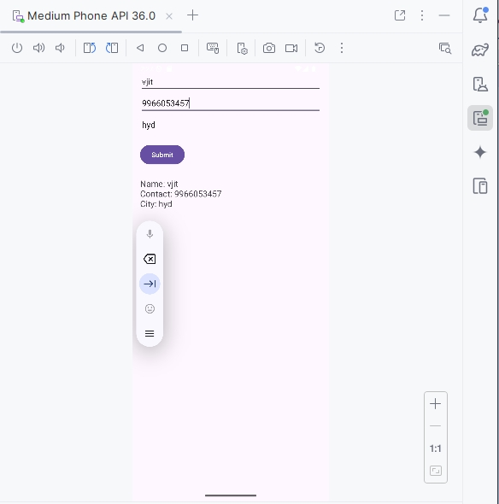
Explanation:
- Layout Manager: LinearLayout arranges the views vertically.
- Event Listener: buttonSubmit.setOnClickListener listens for the button click.
- When the button is clicked, it fetches the input values and shows them in the TextView.

Develop an application that shows names as a list and on selecting a name it should show the details of the candidate on the next screen with a “Back” button.

create a simple two-screen Android app in Java using Android Studio.

activity_main.xml
<?xml version="1.0" encoding="utf-8"?>
<LinearLayout xmlns:android="http://schemas.android.com/apk/res/android"
android:orientation="vertical"
android:padding="16dp"
android:layout_width="match_parent"
android:layout_height="match_parent">

<ListView
android:id="@+id/listViewNames"
android:layout_width="match_parent"
android:layout_height="match_parent" />

</LinearLayout>

activity_detail.xml

<?xml version="1.0" encoding="utf-8"?>
<LinearLayout xmlns:android="http://schemas.android.com/apk/res/android"
android:orientation="vertical"
android:padding="16dp"
android:gravity="center_horizontal"
android:layout_width="match_parent"
android:layout_height="match_parent">

<TextView
android:id="@+id/textViewDetails"
android:layout_width="wrap_content"
android:layout_height="wrap_content"
android:textSize="20sp"
android:text="Details will appear here" />

<Button
android:id="@+id/buttonBack"
android:layout_width="wrap_content"
android:layout_height="wrap_content"
android:text="Back"
android:layout_marginTop="24dp" />

</LinearLayout>
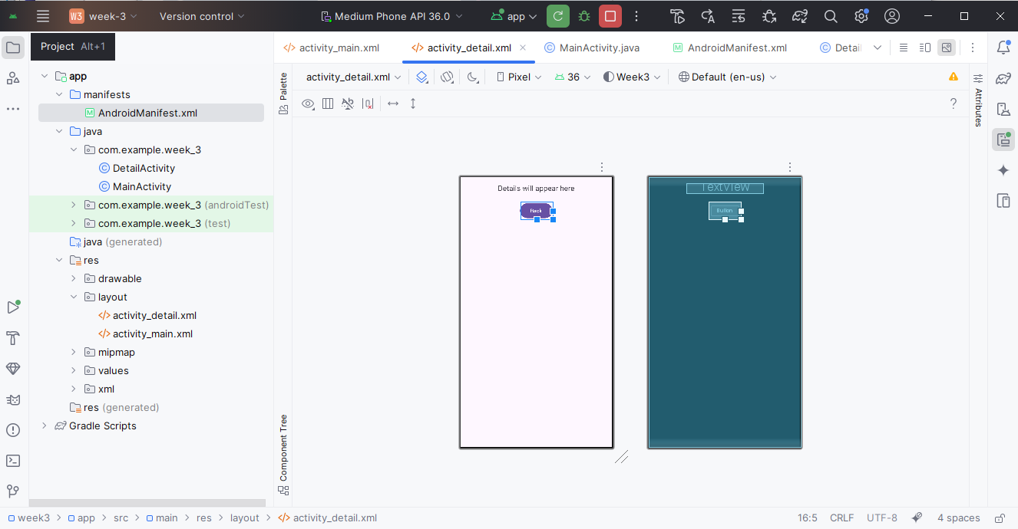
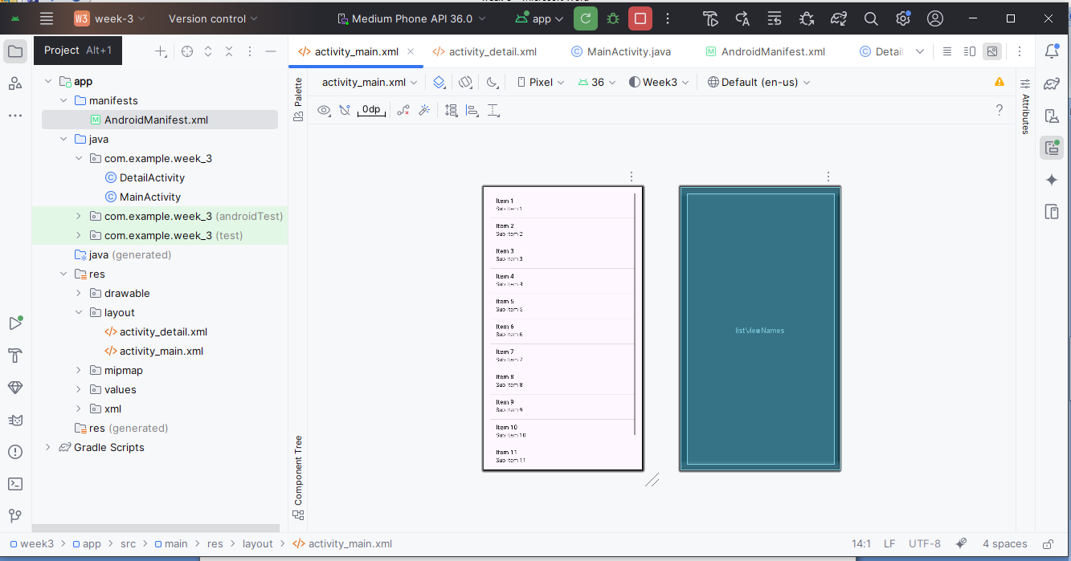

MainActivity.java
java
CopyEdit
package com.example.nameapp;

import androidx.appcompat.app.AppCompatActivity;
import android.content.Intent;
import android.os.Bundle;
import android.widget.AdapterView;
import android.widget.ArrayAdapter;
import android.widget.ListView;

public class MainActivity extends AppCompatActivity {

ListView listViewNames;
String[] names = {"Alice", "Bob", "Charlie", "David"};
String[] details = {
"Alice - Android Developer from NYC",
"Bob - Data Scientist from LA",
"Charlie - UX Designer from Chicago",
"David - QA Engineer from Seattle"
};

@Override
protected void onCreate(Bundle savedInstanceState) {
super.onCreate(savedInstanceState);
setContentView(R.layout.activity_main);

listViewNames = findViewById(R.id.listViewNames);
ArrayAdapter<String> adapter = new ArrayAdapter<>(this, android.R.layout.simple_list_item_1, names);
listViewNames.setAdapter(adapter);

listViewNames.setOnItemClickListener((parent, view, position, id) -> {
Intent intent = new Intent(MainActivity.this, DetailActivity.class);
intent.putExtra("details", details[position]);
startActivity(intent);
});
}
}

DetailActivity.java
java
CopyEdit
package com.example.nameapp;

import androidx.appcompat.app.AppCompatActivity;
import android.os.Bundle;
import android.widget.Button;
import android.widget.TextView;

public class DetailActivity extends AppCompatActivity {

TextView textViewDetails;
Button buttonBack;

@Override
protected void onCreate(Bundle savedInstanceState) {
super.onCreate(savedInstanceState);
setContentView(R.layout.activity_detail);

textViewDetails = findViewById(R.id.textViewDetails);
buttonBack = findViewById(R.id.buttonBack);

// Get passed details from Intent
String detail = getIntent().getStringExtra("details");
textViewDetails.setText(detail);

buttonBack.setOnClickListener(v -> finish()); // Go back to previous screen
}
}

AndroidManifest.xml
xml
CopyEdit
<application
... >

<activity android:name=".DetailActivity" />
<activity android:name=".MainActivity">
<intent-filter>
<action android:name="android.intent.action.MAIN" />
<category android:name="android.intent.category.LAUNCHER" />
</intent-filter>
</activity>

</application>

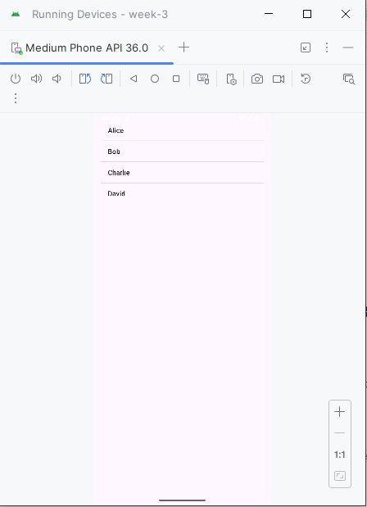
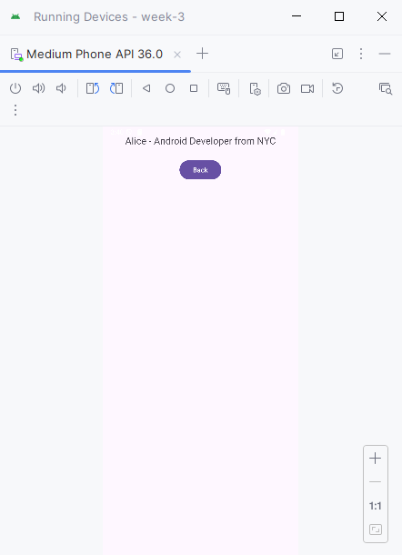
Week-4
Create a native calculator application.
activity_main.xml
<?xml version="1.0" encoding="utf-8"?>
<LinearLayout xmlns:android="http://schemas.android.com/apk/res/android" android:layout_width="match_parent"
android:layout_height="match_parent"
android:orientation="vertical"
android:padding="16dp"
android:gravity="center">
<EditText
android:id="@+id/editTextNumber1"
android:layout_width="match_parent" android:layout_height="wrap_content" android:hint="Enter first number"
android:inputType="numberDecimal" />
<EditText
android:id="@+id/editTextNumber2"
android:layout_width="match_parent" android:layout_height="wrap_content" android:hint="Enter second number"
android:inputType="numberDecimal"
android:layout_marginTop="8dp" />
<LinearLayout
android:layout_width="match_parent" android:layout_height="wrap_content" android:orientation="horizontal"
android:layout_marginTop="16dp" android:gravity="center">
<Button
android:id="@+id/btnAdd"
android:layout_width="wrap_content" android:layout_height="wrap_content" android:text="+" />
<Button
android:id="@+id/btnSubtract"
android:layout_width="wrap_content" android:layout_height="wrap_content" android:text="-"
android:layout_marginStart="8dp" />
<Button
android:id="@+id/btnMultiply"
android:layout_width="wrap_content" android:layout_height="wrap_content" android:text="×"
android:layout_marginStart="8dp" />
<Button
android:id="@+id/btnDivide"
android:layout_width="wrap_content" android:layout_height="wrap_content" android:text="÷"
android:layout_marginStart="8dp" />
</LinearLayout>
<TextView
android:id="@+id/textViewResult"
android:layout_width="match_parent" android:layout_height="wrap_content" android:text="Result: "
android:textSize="18sp"
android:layout_marginTop="24dp" />
</LinearLayout>
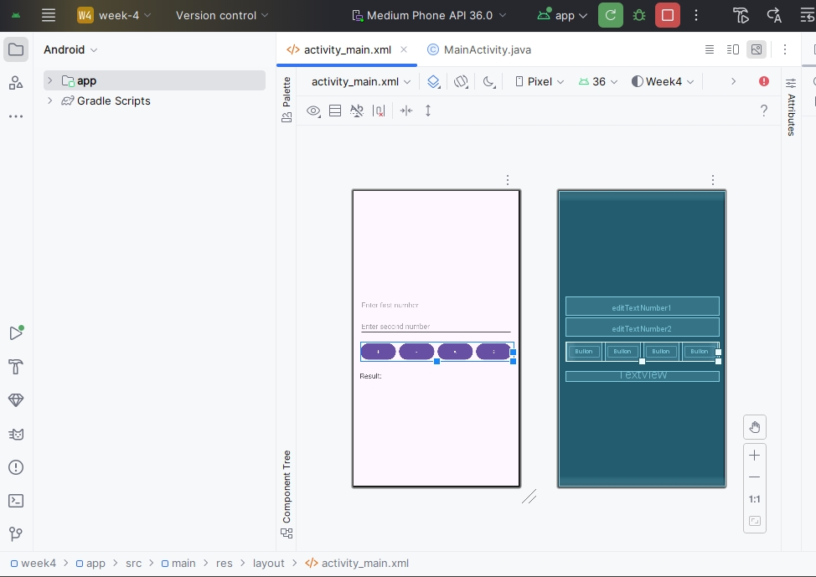
MainActivity.java
package com.example.calculatorapp;
import androidx.appcompat.app.AppCompatActivity; import android.os.Bundle;
import android.view.View; import android.widget.*;
public class MainActivity extends AppCompatActivity {
EditText editTextNumber1, editTextNumber2; Button btnAdd, btnSubtract, btnMultiply, btnDivide; TextView textViewResult;
@Override
protected void onCreate(Bundle savedInstanceState) { super.onCreate(savedInstanceState);
setContentView(R.layout.activity_main);
editTextNumber1 = findViewById(R.id.editTextNumber1); editTextNumber2 = findViewById(R.id.editTextNumber2); btnAdd = findViewById(R.id.btnAdd);
btnSubtract = findViewById(R.id.btnSubtract); btnMultiply = findViewById(R.id.btnMultiply);
btnDivide = findViewById(R.id.btnDivide);
textViewResult = findViewById(R.id.textViewResult);
btnAdd.setOnClickListener(v -> calculate('+'));
btnSubtract.setOnClickListener(v -> calculate('-')); btnMultiply.setOnClickListener(v -> calculate('*')); btnDivide.setOnClickListener(v -> calculate('/'));
}
private void calculate(char operator) {
String num1Str = editTextNumber1.getText().toString(); String num2Str = editTextNumber2.getText().toString();
if (num1Str.isEmpty() || num2Str.isEmpty()) {
textViewResult.setText("Please enter both numbers"); return;
}
double num1 = Double.parseDouble(num1Str); double num2 = Double.parseDouble(num2Str); double result = 0;
switch (operator) {
case '+':
result = num1 + num2;
break;
case '-':
result = num1 - num2;
break;
case '*':
result = num1 * num2;
break;
case '/':
if (num2 == 0) {
textViewResult.setText("Cannot divide by zero"); return;
}
result = num1 / num2;
break;
}
textViewResult.setText("Result: " + result); }
}
Output:
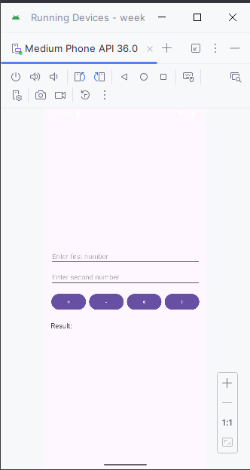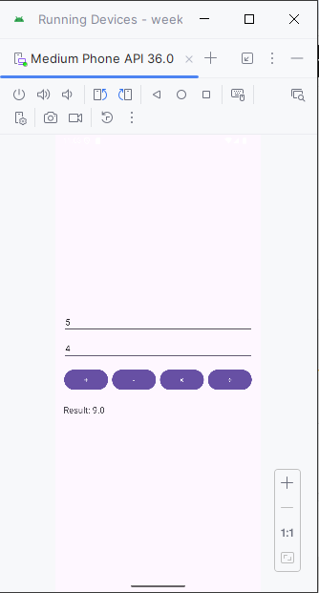

Week-5
Create an application that saves user information like name, age, gender etc. in shared preference and retrieves them when the program restarts.
Functionality
- User enters name, age, and gender.
- Info is saved using SharedPreferences.
- When the app restarts, data is automatically loaded from preferences.
activity_main.xml (UI Layout)
<?xml version="1.0" encoding="utf-8"?>
<LinearLayout
xmlns:android="http://schemas.android.com/apk/res/android" android:layout_width="match_parent"
android:layout_height="match_parent"
android:orientation="vertical"
android:padding="20dp">
<EditText
android:id="@+id/editName"
android:layout_width="match_parent" android:layout_height="wrap_content" android:hint="Name" />
<EditText
android:id="@+id/editAge"
android:layout_width="match_parent" android:layout_height="wrap_content" android:inputType="number"
android:hint="Age" />
<EditText
android:id="@+id/editGender"
android:layout_width="match_parent"
android:layout_height="wrap_content" android:hint="Gender" />
<Button
android:id="@+id/btnSave"
android:layout_width="match_parent" android:layout_height="wrap_content" android:text="Save Info" />
<TextView
android:id="@+id/textDisplay"
android:layout_width="match_parent"
android:layout_height="wrap_content"
android:paddingTop="20dp"
android:text="User Info Will Be Displayed Here" /> </LinearLayout>
MainActivity.java
import android.content.SharedPreferences;
import android.os.Bundle;
import android.widget.*;
import androidx.appcompat.app.AppCompatActivity;
public class MainActivity extends AppCompatActivity {
EditText editName, editAge, editGender; Button btnSave;
TextView textDisplay;
SharedPreferences sharedPreferences;
public static final String PREF_NAME = "UserInfo";
@Override
protected void onCreate(Bundle savedInstanceState) { super.onCreate(savedInstanceState);
setContentView(R.layout.activity_main);
editName = findViewById(R.id.editName);
editAge = findViewById(R.id.editAge);
editGender = findViewById(R.id.editGender); btnSave = findViewById(R.id.btnSave);
textDisplay = findViewById(R.id.textDisplay);
sharedPreferences = getSharedPreferences(PREF_NAME, MODE_PRIVATE); loadUserData();
btnSave.setOnClickListener(v -> { saveUserData();
});
}
private void saveUserData() {
String name = editName.getText().toString();
String age = editAge.getText().toString();
String gender = editGender.getText().toString();
SharedPreferences.Editor editor = sharedPreferences.edit(); editor.putString("Name", name);
editor.putString("Age", age);
editor.putString("Gender", gender);
editor.apply();
textDisplay.setText("Saved: " + name + ", " + age + ", " + gender); }
private void loadUserData() {
String name = sharedPreferences.getString("Name", "Not set");
String age = sharedPreferences.getString("Age", "Not set");
String gender = sharedPreferences.getString("Gender", "Not set");
textDisplay.setText("Loaded: " + name + ", " + age + ", " + gender); }
}
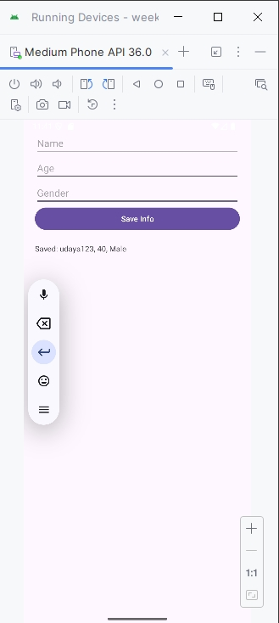

Week-6
Develop a Registration and Login application that makes use of database.
The SQlite database as its name suggests, is a lightweight database which is used to store the data locally in your Android mobile devices. One can create a simple login and register app using SQlite which can also work as test bench or platform for launching the app for web servers.
Let us first create a Database helper class which extends the properties of SQliteOpenHelperClass.
The code snippet for DB Helper class "DBHelper.class" is as follows:
package com.learnandroid.loginsqlite;
import android.content.ContentValues;
import android.content.Context;
import android.database.Cursor;
import android.database.sqlite.SQLiteDatabase; import android.database.sqlite.SQLiteOpenHelper; import androidx.annotation.Nullable;
public class DBHelper extends SQLiteOpenHelper { public static final String DBNAME = "Login.db"; public DBHelper(Context context) {
super(context, "Login.db", null, 1); }
@Override
public void onCreate(SQLiteDatabase MyDB) {
MyDB.execSQL("create Table users(username TEXT primary key, password TEXT)");
}
@Override
public void onUpgrade(SQLiteDatabase MyDB, int i, int i1) { MyDB.execSQL("drop Table if exists users");
}
public Boolean insertData(String username, String password){ SQLiteDatabase MyDB = this.getWritableDatabase();
ContentValues contentValues= new ContentValues();
contentValues.put("username", username);
contentValues.put("password", password); long result = MyDB.insert("users", null, contentValues); if(result==-1) return false;
else
return true;
}
public Boolean checkusername(String username) {
SQLiteDatabase MyDB = this.getWritableDatabase();
Cursor cursor = MyDB.rawQuery("Select * from users where username = ?", new String[]{username});
if (cursor.getCount() > 0)
return true;
else
return false;
}
public Boolean checkusernamepassword(String username, String password){
SQLiteDatabase MyDB = this.getWritableDatabase();
Cursor cursor = MyDB.rawQuery("Select * from users where username = ? and password = ?", new String[] {username,password});
if(cursor.getCount()>0)
return true;
else
return false;
}
}
Let us first create main_activity.xml which serves as the register page. This page will have three edit text boxes, username, password and retype password. The code snippet for main_activity.xml is as follows.
<?xml version="1.0" encoding="utf-8"?>
<RelativeLayout xmlns:android="http://schemas.android.com/apk/res/android" xmlns:app="http://schemas.android.com/apk/res-auto"
xmlns:tools="http://schemas.android.com/tools"
android:layout_width="match_parent"
android:layout_height="match_parent"
android:padding="10dp"
tools:context=".MainActivity">
<EditText
android:id="@+id/username"
android:layout_width="match_parent" android:layout_height="wrap_content" android:hint="User Name"
android:layout_marginTop="50dp"/>
<EditText
android:id="@+id/password"
android:layout_width="match_parent"
android:layout_height="wrap_content"
android:hint="Password"
android:layout_marginTop="50dp"
android:layout_below="@+id/username"/>
<EditText
android:id="@+id/repassword"
android:layout_width="match_parent"
android:layout_height="wrap_content"
android:hint="Retype Password"
android:layout_marginTop="50dp"
android:layout_below="@+id/password"/>
<Button
android:id="@+id/btnsignup"
android:layout_width="match_parent"
android:layout_height="wrap_content"
android:text="Register"
android:layout_marginTop="50dp"
android:layout_below="@+id/repassword"/>
<Button
android:id="@+id/btnsignin"
android:layout_width="match_parent"
android:layout_height="wrap_content"
android:text="Existing user! Go to Sign in page" android:layout_marginTop="50dp"
android:layout_below="@+id/btnsignup"/>
</RelativeLayout>
The code snippet for MainActivity.java is as follows.
package com.learnandroid.loginsqlite;
import androidx.appcompat.app.AppCompatActivity; import android.content.Intent;
import android.os.Bundle;
import android.view.View;
import android.widget.Button; import android.widget.EditText; import android.widget.Toast;
public class MainActivity extends AppCompatActivity {
EditText username, password, repassword;
Button signup, signin;
DBHelper DB;
@Override
protected void onCreate(Bundle savedInstanceState) { super.onCreate(savedInstanceState);
setContentView(R.layout.activity_main);
username = (EditText) findViewById(R.id.username);
password = (EditText) findViewById(R.id.password);
repassword = (EditText) findViewById(R.id.repassword); signup = (Button) findViewById(R.id.btnsignup);
signin = (Button) findViewById(R.id.btnsignin);
DB = new DBHelper(this);
signup.setOnClickListener(new View.OnClickListener() { @Override
public void onClick(View view) {
String user = username.getText().toString();
String pass = password.getText().toString();
String repass = repassword.getText().toString();
if(user.equals("")||pass.equals("")||repass.equals("")) Toast.makeText(MainActivity.this, "Please enter all the fields", Toast.LENGTH_SHORT).show();
else{
if(pass.equals(repass)){
Boolean checkuser = DB.checkusername(user);
if(checkuser==false){
Boolean insert = DB.insertData(user, pass);
if(insert==true){
Toast.makeText(MainActivity.this, "Registered successfully", Toast.LENGTH_SHORT).show();
Intent intent = new Intent(getApplicationContext(),HomeActivity.class);
startActivity(intent);
}else{
Toast.makeText(MainActivity.this, "Registration failed", Toast.LENGTH_SHORT).show();
}
}
else{
Toast.makeText(MainActivity.this, "User already exists! please sign in", Toast.LENGTH_SHORT).show();
}
}else{
Toast.makeText(MainActivity.this, "Passwords not matching", Toast.LENGTH_SHORT).show();
}
} }
});
signin.setOnClickListener(new View.OnClickListener() {
@Override
public void onClick(View view) {
Intent intent = new Intent(getApplicationContext(), LoginActivity.class);
startActivity(intent);
}
});
}
}
Now create another activity for Login. The code snippet for activity_login.xml is as follows. <?xml version="1.0" encoding="utf-8"?>
<RelativeLayout xmlns:android="http://schemas.android.com/apk/res/android"
xmlns:app="http://schemas.android.com/apk/res-auto"
xmlns:tools="http://schemas.android.com/tools"
android:layout_width="match_parent"
android:layout_height="match_parent"
android:padding="10dp"
tools:context=".LoginActivity">
<EditText
android:id="@+id/username1"
android:layout_width="match_parent" android:layout_height="wrap_content" android:hint="User Name"
android:layout_marginTop="50dp"/>
<EditText
android:id="@+id/password1"
android:layout_width="match_parent" android:layout_height="wrap_content" android:hint="Password"
android:layout_marginTop="50dp"
android:layout_below="@+id/username1"/>
<Button
android:id="@+id/btnsignin1"
android:layout_width="match_parent"
android:layout_height="wrap_content"
android:text="Sign in"
android:layout_marginTop="50dp"
android:layout_below="@+id/password1"/> </RelativeLayout>
The code snippet for LoginActivity.java is as follows:
package com.learnandroid.loginsqlite;
import androidx.appcompat.app.AppCompatActivity;
import android.content.Intent; import android.os.Bundle; import android.view.View; import android.widget.Button; import android.widget.EditText; import android.widget.Toast;
public class LoginActivity extends AppCompatActivity {
EditText username, password;
Button btnlogin;
DBHelper DB;
@Override
protected void onCreate(Bundle savedInstanceState) { super.onCreate(savedInstanceState);
setContentView(R.layout.activity_login);
username = (EditText) findViewById(R.id.username1); password = (EditText) findViewById(R.id.password1); btnlogin = (Button) findViewById(R.id.btnsignin1); DB = new DBHelper(this);
btnlogin.setOnClickListener(new View.OnClickListener() { @Override
public void onClick(View view) {
String user = username.getText().toString(); String pass = password.getText().toString();
if(user.equals("")||pass.equals(""))
Toast.makeText(LoginActivity.this, "Please enter all the fields", Toast.LENGTH_SHORT).show();
else{
Boolean checkuserpass = DB.checkusernamepassword(user, pass);
if(checkuserpass==true){
Toast.makeText(LoginActivity.this, "Sign in successfull", Toast.LENGTH_SHORT).show();
Intent intent = new Intent(getApplicationContext(), HomeActivity.class);
startActivity(intent);
}else{
Toast.makeText(LoginActivity.this, "Invalid Credentials", Toast.LENGTH_SHORT).show();
}
}
}
});
}
}
Output:
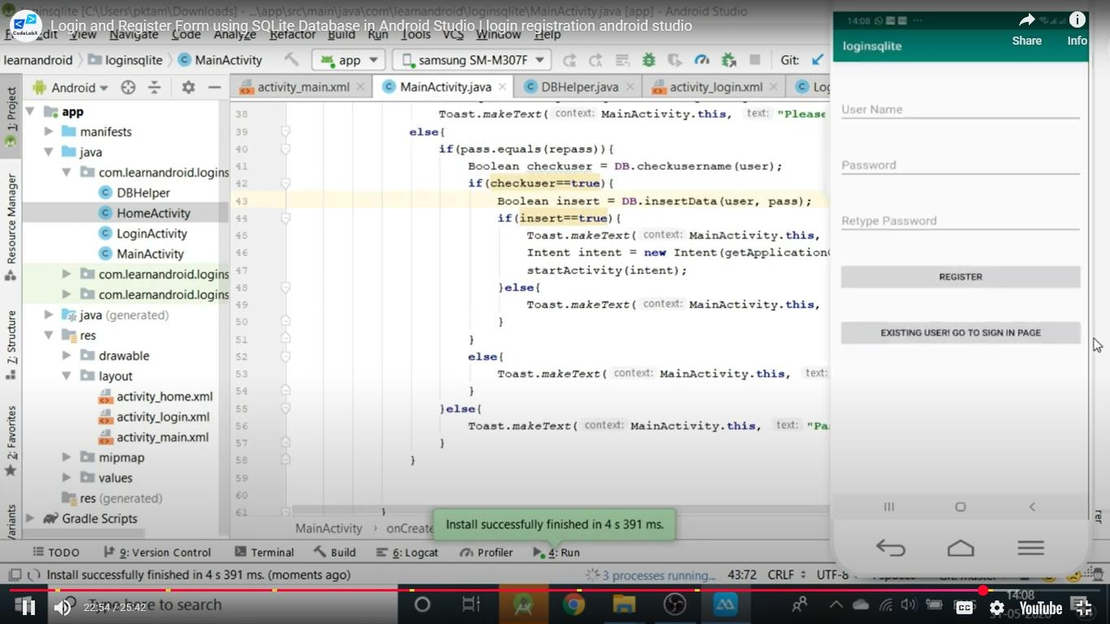
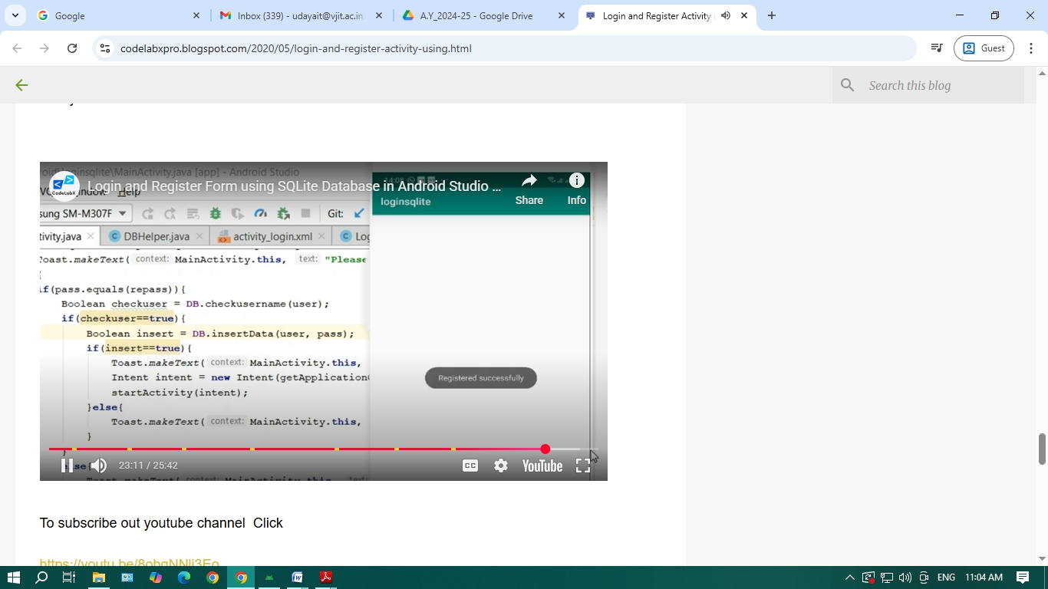
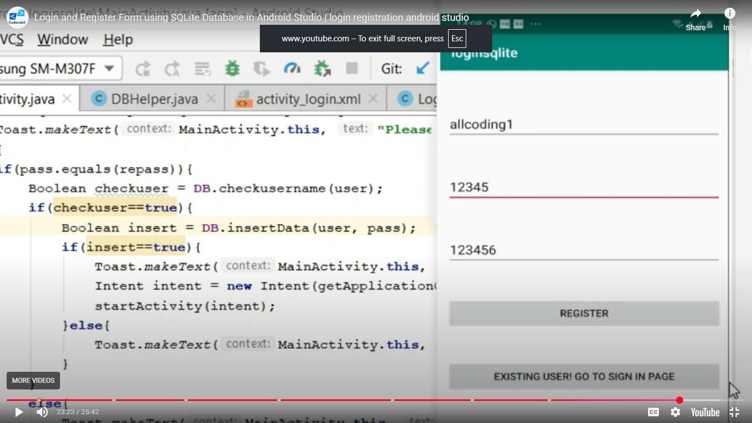
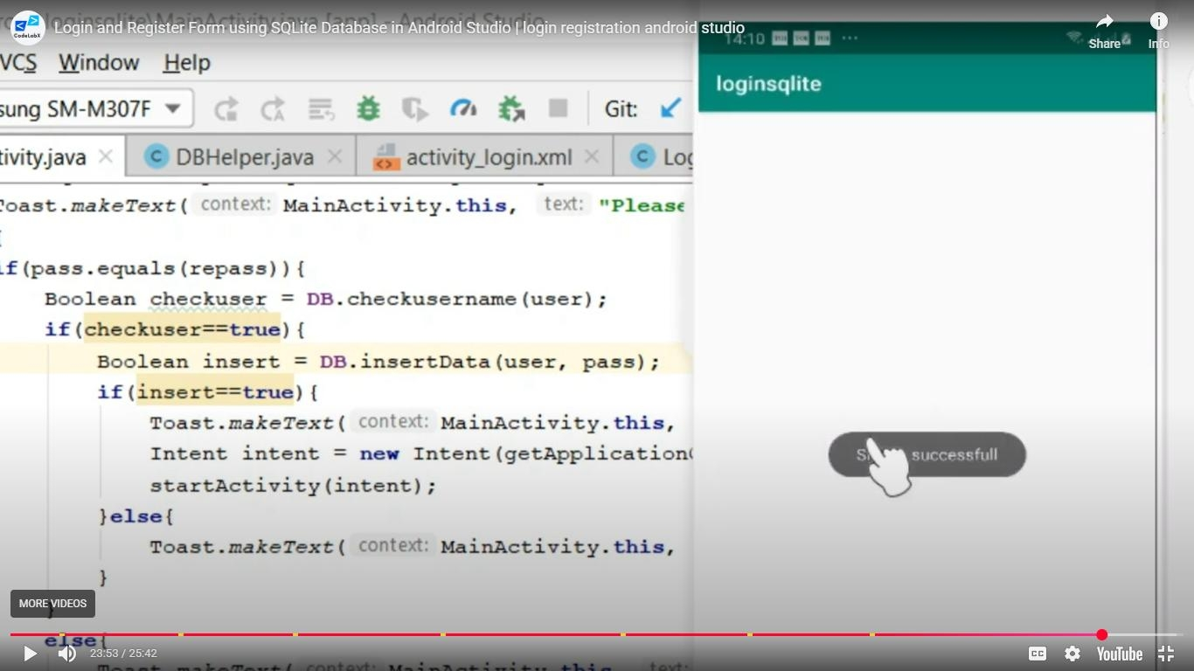
Supporting link is “https://codelabxpro.blogspot.com/2020/05/login-and-register-activity-using.html”

Week 7:
Develop an application that inserts some notifications into Notification area and whenever a notification is inserted, it should show a toast with details of the notification.
Activtity_main.xml
<?xml version="1.0" encoding="utf-8"?> <androidx.constraintlayout.widget.ConstraintLayout xmlns:android="http://schemas.android.com/apk/res/android" xmlns:app="http://schemas.android.com/apk/res-auto"
xmlns:tools="http://schemas.android.com/tools"
android:layout_width="match_parent"
android:layout_height="match_parent"
tools:context=".MainActivity">
<Button
android:id="@+id/btnCreateNotification" android:layout_width="wrap_content"
android:layout_height="wrap_content"
android:text="Create Notification"
tools:layout_editor_absoluteX="170dp"
tools:layout_editor_absoluteY="322dp" /> </androidx.constraintlayout.widget.ConstraintLayout>
Mainactivity.java
package com.example.notify;
import androidx.appcompat.app.AppCompatActivity; import androidx.core.app.NotificationCompat;
import android.annotation.SuppressLint; import android.os.Bundle;
/*public class MainActivity extends AppCompatActivity {
@Override
protected void onCreate(Bundle savedInstanceState) { super.onCreate(savedInstanceState);
setContentView(R.layout.activity_main);
}
}*/
import android.app.NotificationChannel ;
import android.app.NotificationManager ;
import android.content.ContentResolver ;
import android.content.Context ;
import android.graphics.Color ;
import android.media.AudioAttributes ;
import android.net.Uri ;
//import android.support.v4.app.NotificationCompat ; //import android.support.v7.app.AppCompatActivity ; //import android.os.Bundle ;
import android.view.View ;
import android.widget.Button ; import java.util.Objects;
public class MainActivity extends AppCompatActivity {
public static final String NOTIFICATION_CHANNEL_ID = "10001" ; private final static String default_notification_channel_id;
static {
default_notification_channel_id = "default"; }
@Override
protected void onCreate (Bundle savedInstanceState) {
super .onCreate(savedInstanceState) ;
setContentView(R.layout. activity_main ) ;
@SuppressLint({"MissingInflatedId", "LocalSuppress"}) Button btnCreateNotification = findViewById(R.id.btnCreateNotification ) ;
btnCreateNotification.setOnClickListener( new View.OnClickListener() {
@SuppressLint("NotificationPermission")
@Override
public void onClick (View v) {
Uri sound = Uri. parse (ContentResolver. SCHEME_ANDROID_RESOURCE + "://" + getPackageName() + "/raw/quite_impressed.mp3" ) ;
NotificationCompat.Builder mBuilder = new NotificationCompat.Builder(MainActivity. this,
default_notification_channel_id )
.setSmallIcon(R.drawable. ic_launcher_foreground )
.setContentTitle( "Test" )
.setSound(sound)
.setContentText( "Hello! This is my first push notification" );
NotificationManager mNotificationManager = (NotificationManager) getSystemService(Context. NOTIFICATION_SERVICE ) ;
if (android.os.Build.VERSION. SDK_INT >= android.os.Build.VERSION_CODES. O ) {
AudioAttributes audioAttributes = new AudioAttributes.Builder()
.setContentType(AudioAttributes. CONTENT_TYPE_SONIFICATION )
.setUsage(AudioAttributes. USAGE_ALARM )
.build() ;
int importance = NotificationManager. IMPORTANCE_HIGH ; NotificationChannel notificationChannel = new
NotificationChannel( NOTIFICATION_CHANNEL_ID , "NOTIFICATION_CHANNEL_NAME" , importance) ;
notificationChannel.enableLights( true ) ;
notificationChannel.setLightColor(Color. RED ) ;
notificationChannel.enableVibration( true ) ;
notificationChannel.setVibrationPattern( new long []{ 100 , 200 , 300 , 400 , 500 , 400 , 300 , 200 , 400 }) ;
notificationChannel.setSound(sound , audioAttributes) ; mBuilder.setChannelId( NOTIFICATION_CHANNEL_ID ) ;
assert mNotificationManager != null;
mNotificationManager.createNotificationChannel(notificationChannel) ;
}
Objects.requireNonNull(mNotificationManager).notify(( int ) System. currentTimeMillis (), mBuilder.build()) ;
}
}) ;
}
}
output:
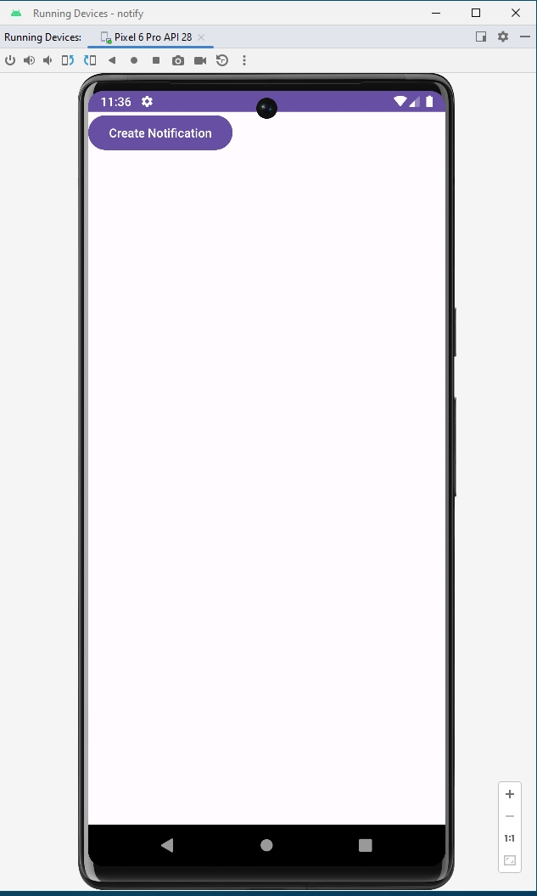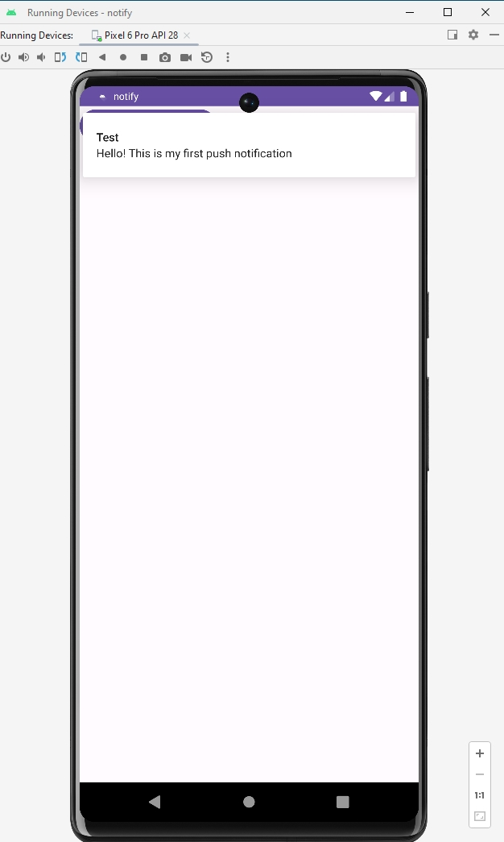

Week-8
Develop an application that uses a menu with 3 options for dialing a number, opening a website and to send an SMS. On selecting an option, the appropriate action should be invoked using intents.
Step-by-Step Implementation
1. Create a New Android Project
- Open Android Studio
- Select Empty View Activity
- Name it (e.g., IntentMenuApp)
- Choose Language: Java
- Minimum SDK: API 21 or above.
activity_main.xml
This layout includes three buttons for the three actions.
<?xml version="1.0" encoding="utf-8"?>
<LinearLayout xmlns:android="http://schemas.android.com/apk/res/android" android:layout_width="match_parent"
android:layout_height="match_parent"
android:orientation="vertical"
android:gravity="center"
android:padding="24dp">
<Button
android:id="@+id/btnDial"
android:layout_width="match_parent" android:layout_height="wrap_content" android:text="Dial a Number" />
<Button
android:id="@+id/btnWebsite"
android:layout_width="match_parent" android:layout_height="wrap_content" android:text="Open a Website"
android:layout_marginTop="16dp"/>
<Button
android:id="@+id/btnSMS"
android:layout_width="match_parent" android:layout_height="wrap_content" android:text="Send an SMS"
android:layout_marginTop="16dp"/>
</LinearLayout>
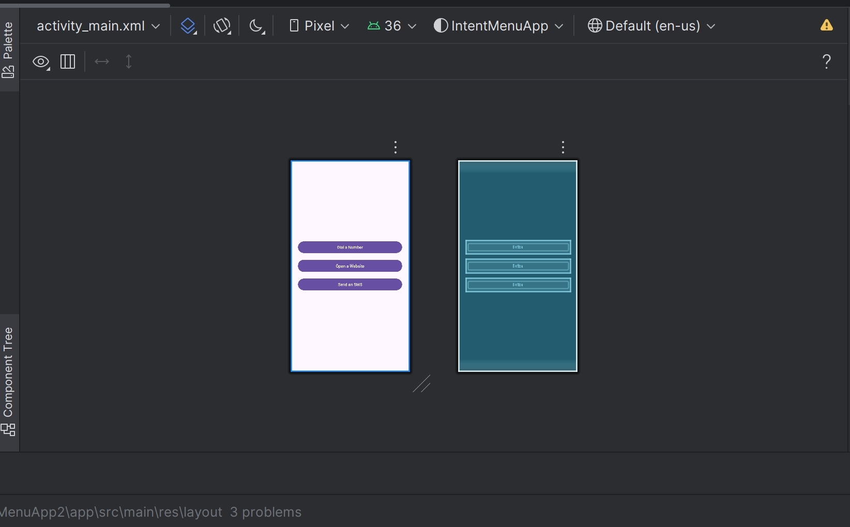
MainActivity.java
This Java file contains the logic to handle button clicks and launch the corresponding Intent.
package com.example.intentmenuapp;
import androidx.appcompat.app.AppCompatActivity; import android.content.Intent;
import android.net.Uri;
import android.os.Bundle;
import android.view.View;
import android.widget.Button;
import android.widget.Toast;
public class MainActivity extends AppCompatActivity { Button btnDial, btnWebsite, btnSMS;
@Override
protected void onCreate(Bundle savedInstanceState) { super.onCreate(savedInstanceState);
setContentView(R.layout.activity_main);
btnDial = findViewById(R.id.btnDial); btnWebsite = findViewById(R.id.btnWebsite); btnSMS = findViewById(R.id.btnSMS);
// Option 1: Dial a Number
btnDial.setOnClickListener(new View.OnClickListener() {
@Override
public void onClick(View v) {
Intent intent = new Intent(Intent.ACTION_DIAL);
intent.setData(Uri.parse("tel:1234567890")); // sample number startActivity(intent);
}
});
// Option 2: Open a Website
btnWebsite.setOnClickListener(new View.OnClickListener() { @Override
public void onClick(View v) {
Intent intent = new Intent(Intent.ACTION_VIEW);
intent.setData(Uri.parse("https://www.google.com"));
startActivity(intent);
}
});
// Option 3: Send an SMS
btnSMS.setOnClickListener(new View.OnClickListener() {
@Override
public void onClick(View v) {
Intent intent = new Intent(Intent.ACTION_VIEW);
intent.setData(Uri.parse("sms:1234567890"));
intent.putExtra("sms_body", "Hello! This is a test message."); try {
startActivity(intent);
} catch (Exception e) {
Toast.makeText(MainActivity.this, "No SMS app found!", Toast.LENGTH_SHORT).show();
} }
});
}
}
AndroidManifest.xml
You don’t need special permissions for ACTION_DIAL or ACTION_VIEW with sms: or https: — but if you use ACTION_CALL or send SMS directly, you would.
For this app, you can just leave the default manifest like this:
<manifest xmlns:android="http://schemas.android.com/apk/res/android" package="com.example.intentmenuapp">
<application
android:allowBackup="true"
android:label="Intent Menu App"
android:icon="@mipmap/ic_launcher"
android:roundIcon="@mipmap/ic_launcher_round"
android:supportsRtl="true"
android:theme="@style/Theme.IntentMenuApp">
<activity android:name=".MainActivity">
<intent-filter>
<action android:name="android.intent.action.MAIN"/>
<category android:name="android.intent.category.LAUNCHER"/> </intent -filter>
</activity>
</application>
</manifest>
Ouput:
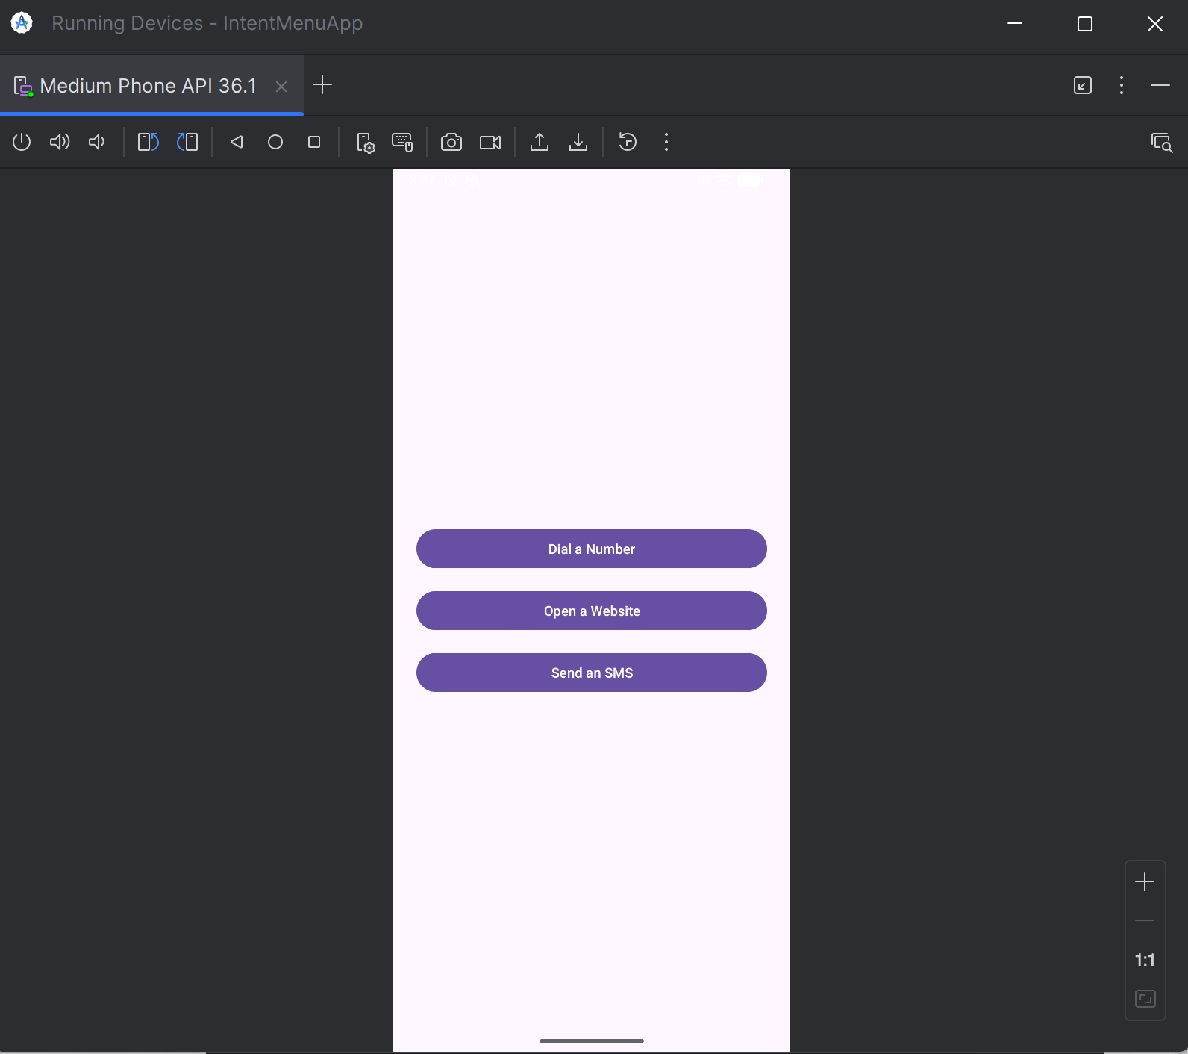
Dial Number:
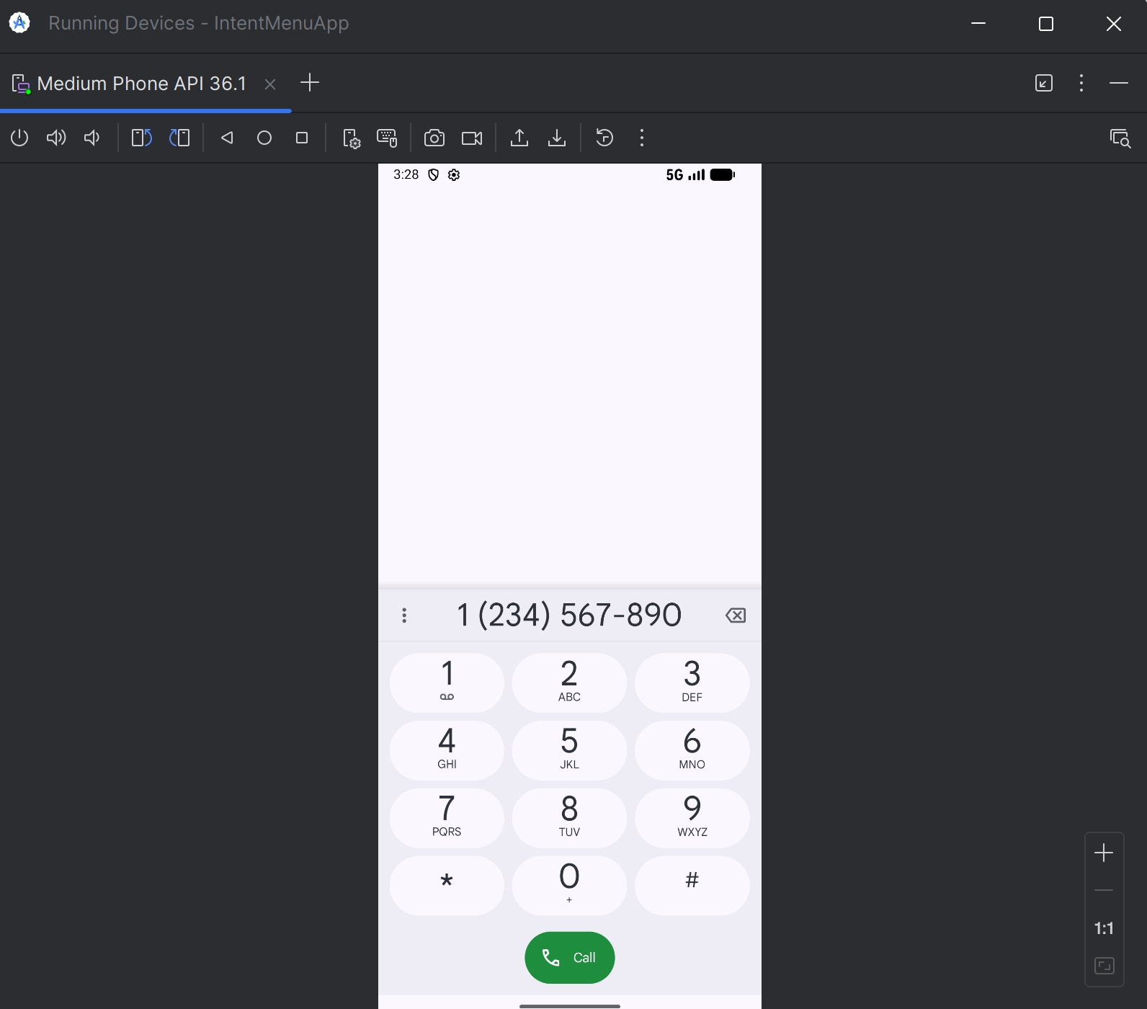
Open Website:
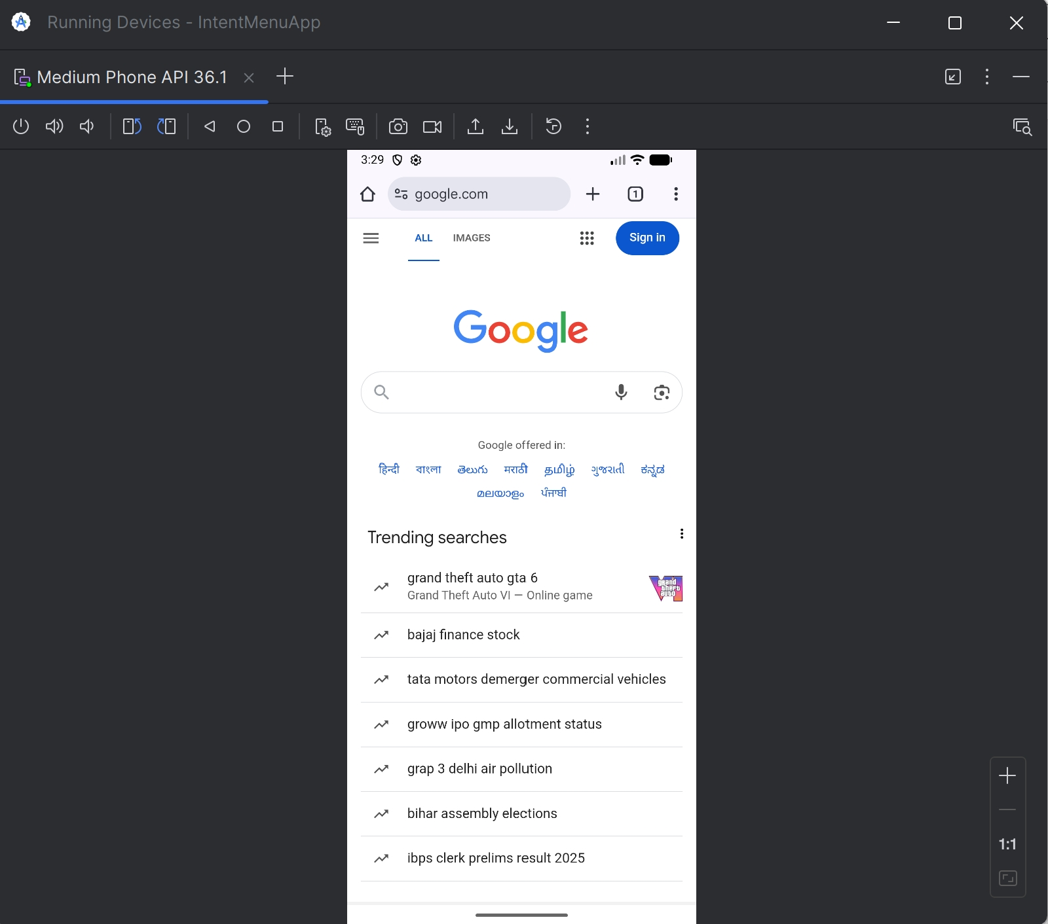
SMS:
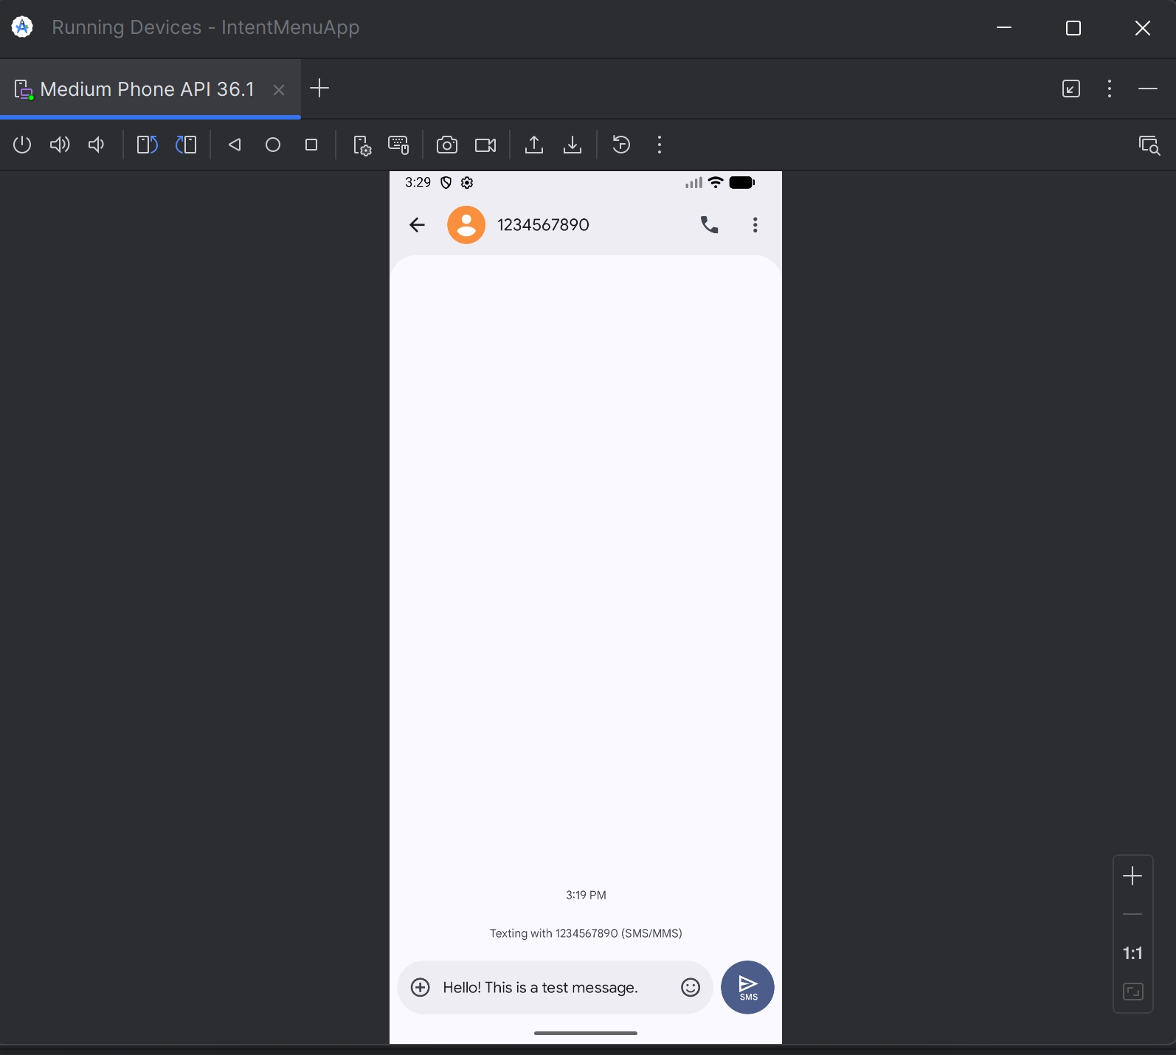

Week-9
Create an alarm application using time picker to set alarm time.
Create the Layout (activity_main.xml)
<LinearLayout
xmlns:android="http://schemas.android.com/apk/res/android" android:layout_width="match_parent"
android:layout_height="match_parent"
android:orientation="vertical"
android:padding="16dp">
<Button
android:id="@+id/btnSetTime"
android:layout_width="match_parent" android:layout_height="wrap_content" android:text="Set Alarm Time" />
<TextView
android:id="@+id/tvAlarmTime"
android:layout_width="match_parent" android:layout_height="wrap_content" android:text="No Alarm Set" />
</LinearLayout>
MainActivity.java
package com.example.alarmapp;
//package com.example.alarmapp;
import android.app.AlarmManager; import android.app.PendingIntent; import android.app.TimePickerDialog; import android.content.Context; import android.content.Intent;
import android.os.Bundle;
import android.widget.Button;
import android.widget.TextView;
import android.widget.TimePicker;
import android.widget.Toast;
import androidx.appcompat.app.AppCompatActivity; import java.util.Calendar;
public class MainActivity extends AppCompatActivity { private TextView tvAlarmTime;
private AlarmManager alarmManager;
private PendingIntent pendingIntent;
private Calendar calendar = Calendar.getInstance();
@Override
protected void onCreate(Bundle savedInstanceState) { super.onCreate(savedInstanceState);
setContentView(R.layout.activity_main);
tvAlarmTime = findViewById(R.id.tvAlarmTime);
Button btnSetTime = findViewById(R.id.btnSetTime);
alarmManager = (AlarmManager) getSystemService(Context.ALARM_SERVICE);
btnSetTime.setOnClickListener(v -> {
int hour = calendar.get(Calendar.HOUR_OF_DAY); int minute = calendar.get(Calendar.MINUTE);
TimePickerDialog timePickerDialog = new TimePickerDialog(MainActivi ty.this, (TimePicker view, int selectedHour, int selectedMinute) -> {
calendar.set(Calendar.HOUR_OF_DAY, selectedHour);
calendar.set(Calendar.MINUTE, selectedMinute);
calendar.set(Calendar. SECOND, 0);
tvAlarmTime.setText("Alarm set for: " + selectedHour + ":" + String.format("%02d", selectedMinute));
setAlarm(calendar);
}, hour, minute, true);
timePickerDialog.show();
});
}
private void setAlarm(Calendar targetCal) {
Intent intent = new Intent(this, AlarmReceiver.class);
pendingIntent = PendingIntent.getBroadcast(this, 0, intent,
PendingIntent. FLAG_IMMUTABLE);
alarmManager.set(AlarmManager.RTC_WAKEUP, targetCal.getTimeInMillis(), pendingIntent);
Toast.makeText(this, "Alarm Scheduled", Toast.LENGTH_SHORT).show(); }
}
AlarmReceiver.java
package com.example.alarmapp;
//package com.example.alarmapp;
import android.content.BroadcastReceiver; import android.content.Context;
import android.content.Intent;
import android.widget.Toast;
public class AlarmReceiver extends BroadcastReceiver {
@Override
public void onReceive(Context context, Intent intent) {
Toast.makeText(context, "Alarm! Wake up!", Toast.LENGTH_LONG).show(); // Can also trigger a notification here
}
}
AndroidManifest.xml
<?xml version="1.0" encoding="utf-8"?>
<manifest xmlns:android="http://schemas.android.com/apk/res/android" xmlns:tools="http://schemas.android.com/tools">
<application
android:allowBackup="true"
android:dataExtractionRules="@xml/data_extraction_rules" android:fullBackupContent="@xml/backup_rules"
android:icon="@mipmap/ic_launcher"
android:label="@string/app_name"
android:roundIcon="@mipmap/ic_launcher_round"
android:supportsRtl="true"
android:theme="@style/Theme.Alarmapp">
<activity
android:name=".MainActivity"
android:exported="true">
<intent-filter>
<action android:name="android.intent.action.MAIN" />
<category android:name="android.intent.category.LAUNCHER" /> </intent -filter>
</activity>
<receiver android:name=".AlarmReceiver"/>
</application>
</manifest> Output:
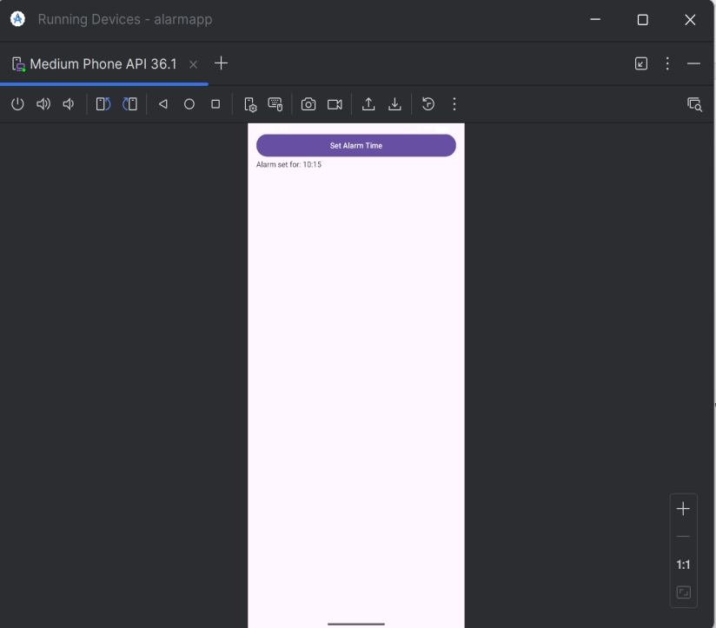
Hours:
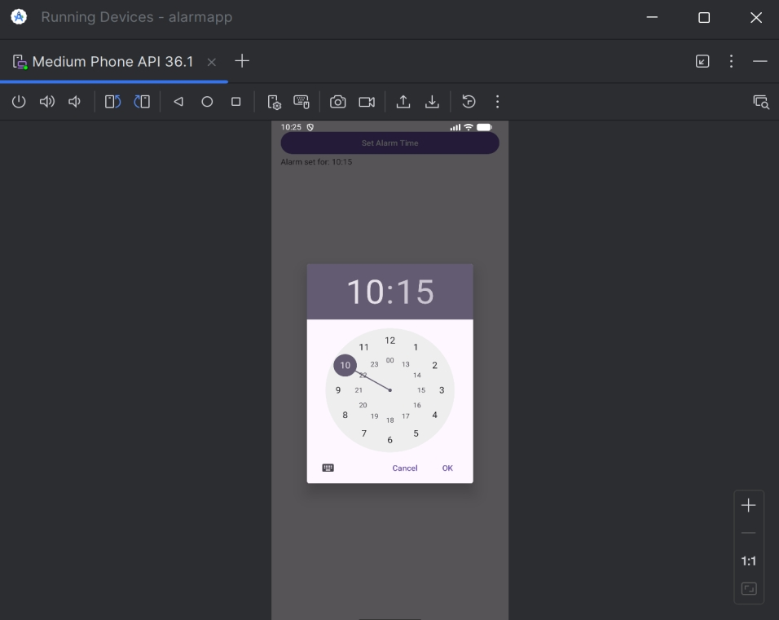
Minitues:
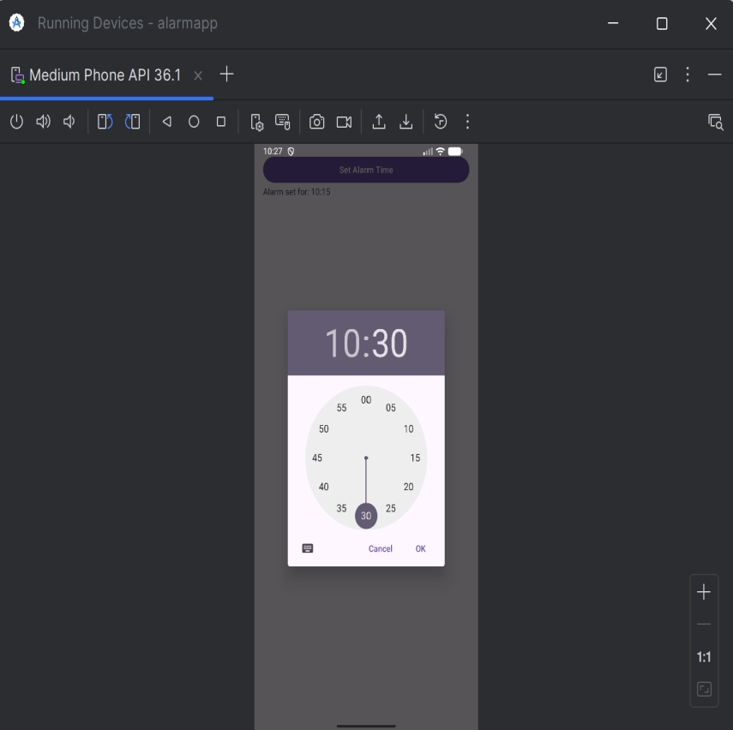
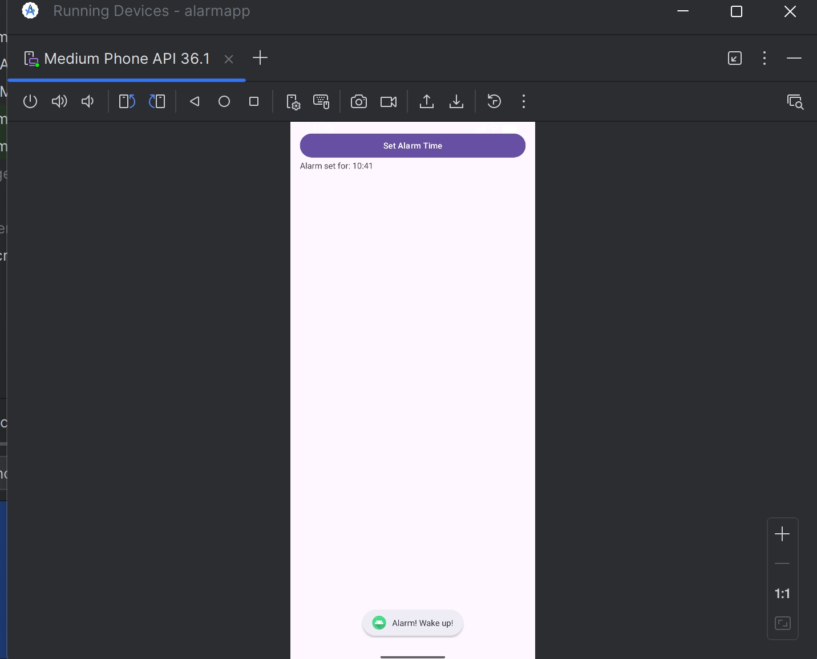

Week-10
Create an application that shows the given URL (from a text field) in a browser
AndroidManifest.xml
<manifest xmlns:android="http://schemas.android.com/apk/res/android" package="com.example.openurlapp">
<application
android:allowBackup="true"
android:label="Open URL App"
android:roundIcon="@mipmap/ic_launcher_round"
android:supportsRtl="true"
android:theme="@style/Theme.AppCompat.Light.NoActionBar">
<activity android:name=".MainActivity">
<intent-filter>
<action android:name="android.intent.action.MAIN"/>
<category android:name="android.intent.category.LAUNCHER"/> </intent -filter>
</activity>
</application> </manifest>
activity_main.xml
<?xml version="1.0" encoding="utf-8"?>
<LinearLayout xmlns:android="http://schemas.android.com/apk/res/android" android:layout_width="match_parent"
android:layout_height="match_parent"
android:orientation ="vertical"
android:padding="24dp"
android:gravity="center">
<EditText
android:id="@+id/editTextUrl"
android:layout_width ="match_parent"
android:layout_height ="wrap_content"
android:hint="Enter URL (e.g. https://www.google.com)" android:inputType="textUri"
android:layout_marginBottom ="16dp" />
<Button
android:id="@+id/btnOpenUrl"
android:layout_width ="wrap_content" android:layout_height ="wrap_content" android:text="Open in Browser"
android:backgroundTint="#4CAF50"
android:textColor="#FFFFFF"
android:padding="10dp" />
</LinearLayout>
MainActivity.java
package com.example.openurlapp;
import androidx.appcompat.app.AppCompatActivity; import android.content.Intent;
import android.net.Uri;
import android.os.Bundle;
import android.widget.Button; import android.widget.EditText; import android.widget.Toast;
public class MainActivity extends AppCompatActivity {
EditText editTextUrl; Button btnOpenUrl;
@Override
protected void onCreate(Bundle savedInstanceState) { super.onCreate(savedInstanceState);
setContentView(R.layout.activity_main);
editTextUrl = findViewById(R.id.editTextUrl); btnOpenUrl = findViewById(R.id.btnOpenUrl);
btnOpenUrl.setOnClickListener(v -> {
String url = editTextUrl.getText().toString().trim();
if (url.isEmpty()) {
Toast.makeText(MainActivity.this, "Please enter a URL", Toast.LENGTH_SHORT).show();
return; }
// Add https:// if missing
if (!url.startsWith("http://") && !url.startsWith("https://")) {
url = "https://" + url; }
try {
Intent intent = new Intent(Intent.ACTION_VIEW, Uri.parse(url)); startActivity(intent);
} catch (Exception e) {
Toast.makeText(MainActivity.this, "Invalid URL!", Toast.LENGTH_SHORT).show();
} }); }
}
Output:
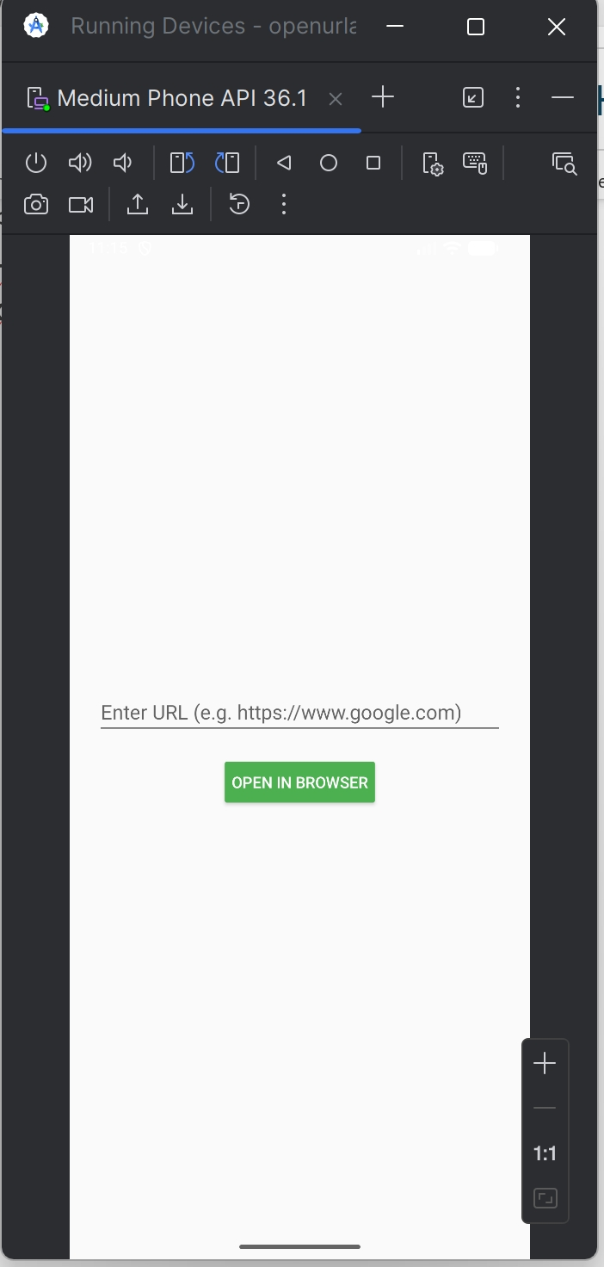
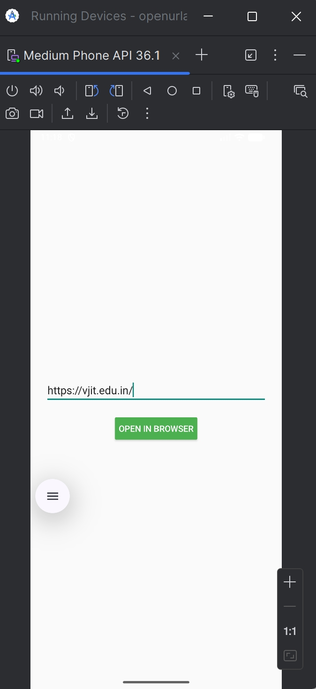
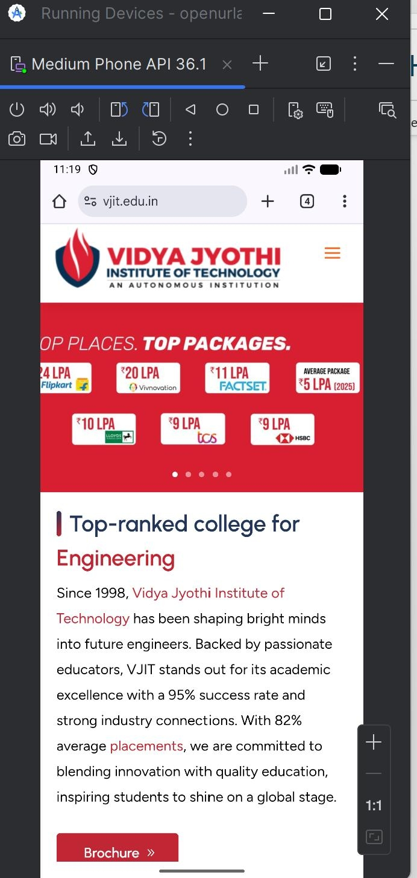

Week-11
Develop a native application that uses GPS location information. activity_main.xml
<LinearLayout xmlns:android="http://schemas.android.com/apk/res/android" android:layout_width="match_parent"
android:layout_height="match_parent"
android:orientation="vertical"
android:padding="16dp">
<Button
android:id="@+id/btnGetLocation"
android:layout_width="match_parent" android:layout_height="wrap_content" android:text="Get Location" />
<TextView
android :id="@+id/tvLocation"
android:layout_width="match_parent"
android:layout_height="wrap_content"
android:text="Location will appear here" android:textSize="18sp"/> </LinearLayout>
MainActivity.java
package com.example.gpslocationapp;
//package com.example.gpslocationapp;
import android.Manifest;
import android.annotation.SuppressLint; import android.content.pm.PackageManager; import android.location.Location;
import android.location.LocationListener; import android.location.LocationManager; import android.os.Bundle;
import android.widget.Button;
import android.widget.TextView;
import android.widget.Toast;
import androidx.annotation.NonNull;
import androidx.appcompat.app.AppCompatActivity; import androidx.core.app.ActivityCompat;
import androidx.core.content.ContextCompat;
public class MainActivity extends AppCompatActivity {
private static final int LOCATION_PERMISSION_CODE = 100; private LocationManager locationManager;
private TextView tvLocation ;
@Override
protected void onCreate(Bundle savedInstanceState) { super.onCreate(savedInstanceState);
setContentView(R.layout.activity_main);
Button btnGetLocation = findViewById(R.id.btnGetLocation); tvLocation = findViewById(R.id.tvLocation );
btnGetLocation.setOnClickListener(v -> getLocation()); }
private void getLocation () {
if (ContextCompat.checkSelfPermission(this, Manifest.permission.ACCESS_FINE_LOCATION) !=
PackageManager. PERMISSION_GRANTED) {
ActivityCompat.requestPermissions(this, new
String[]{Manifest.permission. ACCESS_FINE_LOCATION}, LOCATION_PERMISSION_CODE);
} else {
locationManager = (LocationManager) getSystemService(LOCATION_SERVICE); locationManager.requestLocationUpdates(LocationManager.GPS_PROVIDER, 0, 0, locationListener);
}
}
private final LocationListener locationListener = new LocationListener() { @SuppressLint ("SetTextI18n")
@Override
public void onLocationChanged(Location location) {
double latitude = location.getLatitude();
double longitude = location.getLongitude();
tvLocation.setText("Latitude: " + latitude + "\nLongitude: " + longitude);
locationManager.removeUpdates(this); // Optional: remove after first update
}
@Override public void onStatusChanged(String provider, int status, Bundle extras) {} @Override public void onProviderEnabled (@NonNull String provider) {}
@Override public void onProviderDisabled(@NonNull String provider) {
Toast.makeText(MainActivity.this, "Please enable GPS", Toast.LENGTH_LONG).show();
}
};
@Override
public void onRequestPermissionsResult(int requestCode, @NonNull String[] permissions, @NonNull int[] grantResults) {
super.onRequestPermissionsResult(requestCode, permissions, grantResults); if (requestCode == LOCATION_PERMISSION_CODE) {
if (grantResults. length > 0 && grantResults[0] ==
PackageManager. PERMISSION_GRANTED) {
getLocation();
} else {
Toast.makeText(this, "Location permission denied", Toast.LENGTH_SHORT).show();
}
}
}
}
AndroidManifest.xml
<?xml version="1.0" encoding="utf-8"?>
<manifest xmlns:android="http://schemas.android.com/apk/res/android" xmlns:tools="http://schemas.android.com/tools">
<uses-permission android:name="android.permission.ACCESS_FINE_LOCATION" /> <uses-permission android:name="android.permission.ACCESS_COARSE_LOCATION" />
<application
android:allowBackup="true"
android:dataExtractionRules="@xml/data_extraction_rules"
android:fullBackupContent="@xml/backup_rules"
android:icon="@mipmap/ic_launcher"
android:label="@string/app_name"
android:roundIcon="@mipmap/ic_launcher_round"
android:supportsRtl="true"
android:theme="@style/Theme.Gpslocationapp">
<activity
android :name =".MainActivity"
android :exported ="true">
<intent -filter>
<action android:name="android.intent.action.MAIN" />
<category android:name="android.intent.category.LAUNCHER" /> </intent -filter>
</activity>
</application>
</manifest> Outputs:
