RELIEF FLOW
HIGH-PERFORMANCE PARALLEL DISASTER RELIEF ALLOCATION & DYNAMIC SUPPLY NETWORK ENGINE
A Project Based Learning Report Submitted in partial fulfilment of the requirements for the award of the degree

of

Bachelor of Technology
in The Department of CSE
25CS2103E

Submitted by
Mayreddy Kruthika Reddy - 2510030038
Jagruthi J - 2510030406

Under the guidance of
Dr. Aftab Yaseen



Department of Computer Science Engineering
Koneru Lakshmaiah Education Foundation, Aziz Nagar
Aziz Nagar – 500075
OCT - 2026

Abstract

During natural disasters and large-scale emergency situations, disaster response coordination centers are inundated with millions of incoming emergency reports across multiple communication channels. Existing emergency triage systems struggle with 2 primary challenges: real-time stream deduplication of repetitive crisis messages and latency-optimal dispatching and multi-depot resource distribution. We developed a project Relief-Flow, an end-to-end algorithmic framework and interactive dashboard engineered to solve stream triage, priority queuing and logistic network flow using DSA.
The system uses the Rabin-Karp rolling hash algorithm for stream deduplication. Unique reports are dynamically scored and inserted into a Max-Heap Priority Queue to enable access to the highest urgency mission and extraction. For dispatch and distribution, the framework models the disaster area as a weighted graph of 15 nodes (5 supply depots and 10 disaster sectors). Route navigation uses A* algorithm with dynamic heuristic weight adjustments for live road blockage avoidance. Multi depot supply distribution is solved by using flow network, while vehicle payload capacity is maximized using 0/1 Knapsack DP logic. Experimental evaluations demonstrate sub-millisecond execution times, zero duplicate missions in the priority queue, and optimal resource distribution across complex supply networks.
List of Figures

- Dashboard
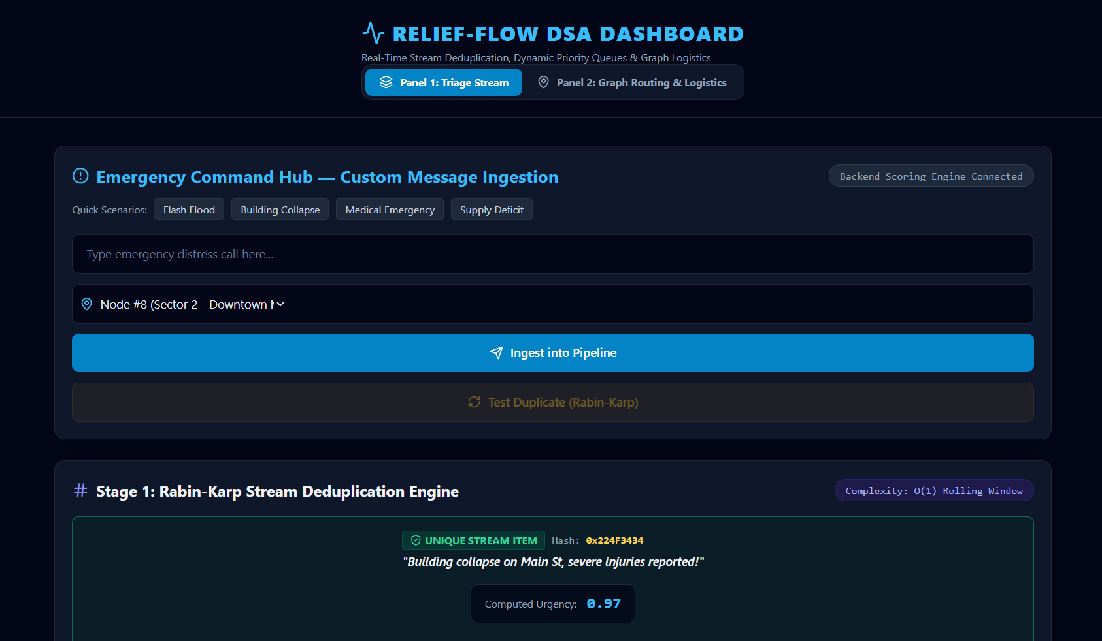
2.Rabin-Karp and Max Heap Priority Queue
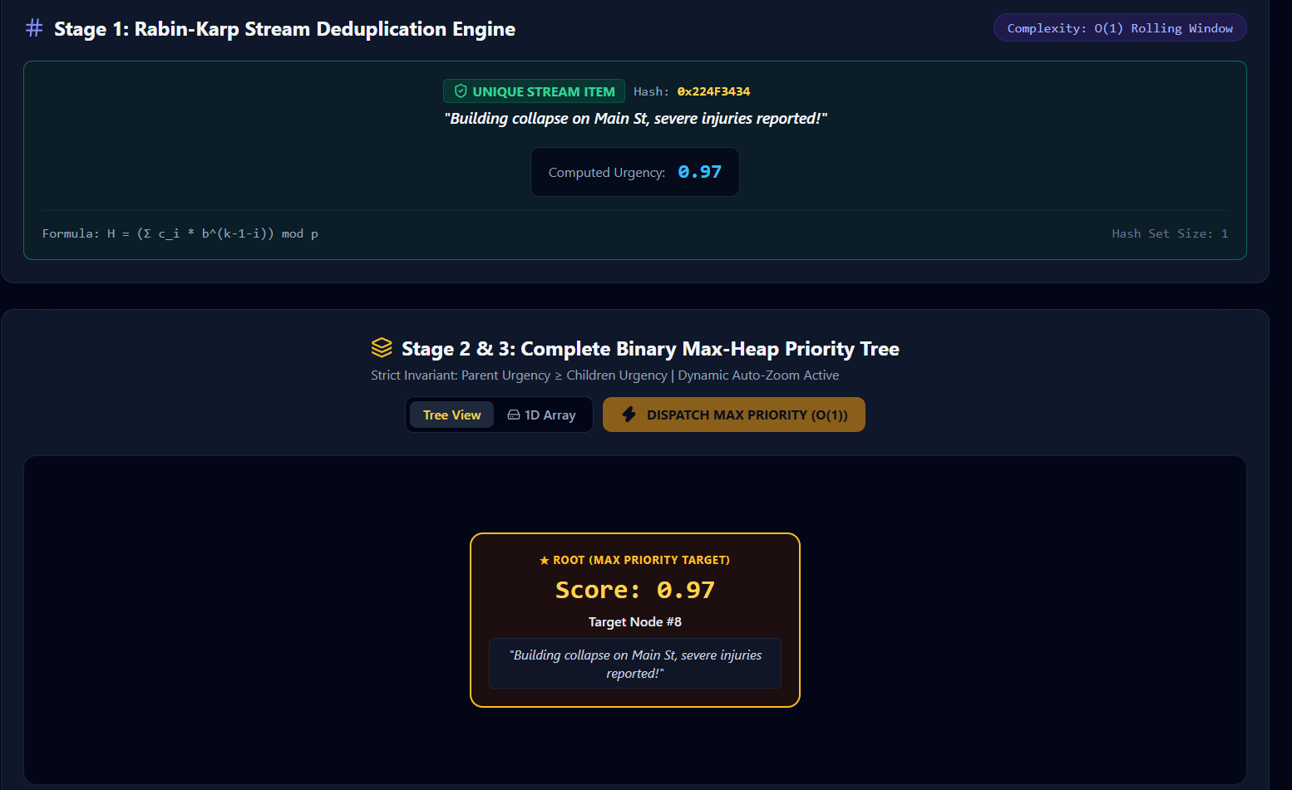
3. A* routing Algorithm 4. 0/1 Knapsack Algorithm
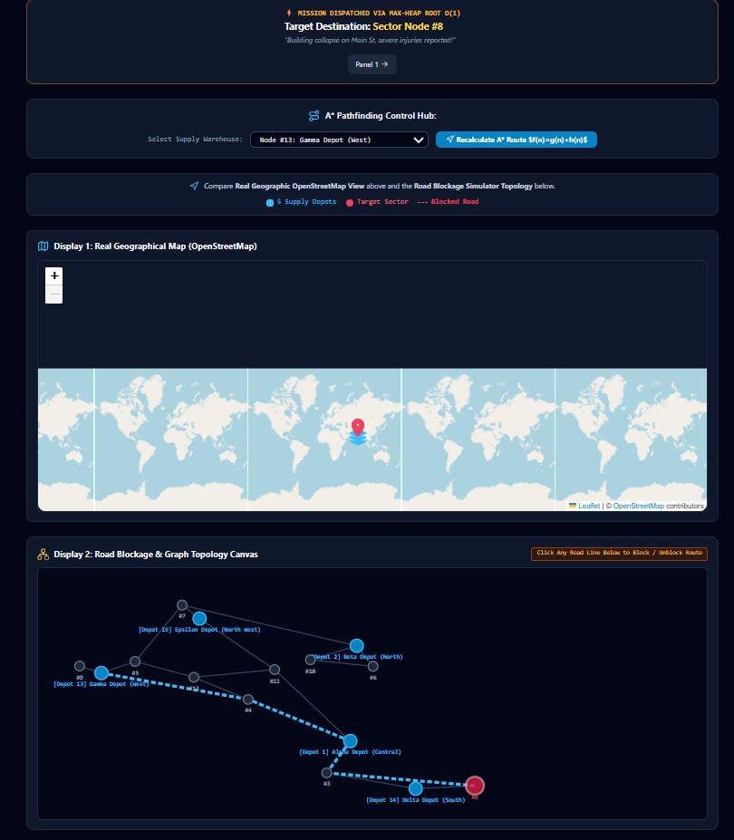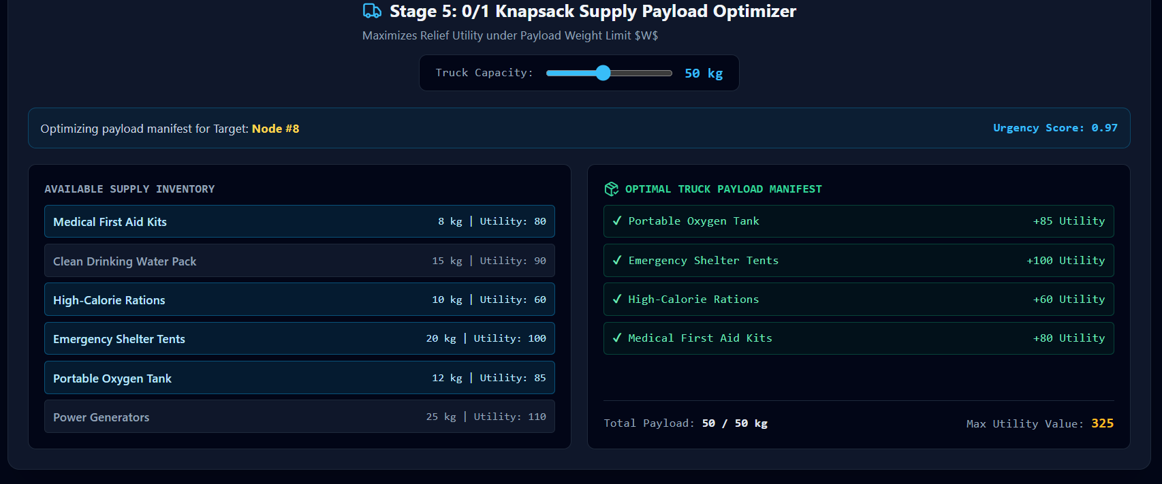

List of Tables

1. Rabin-Karp and Aho Corasick Algorithm:
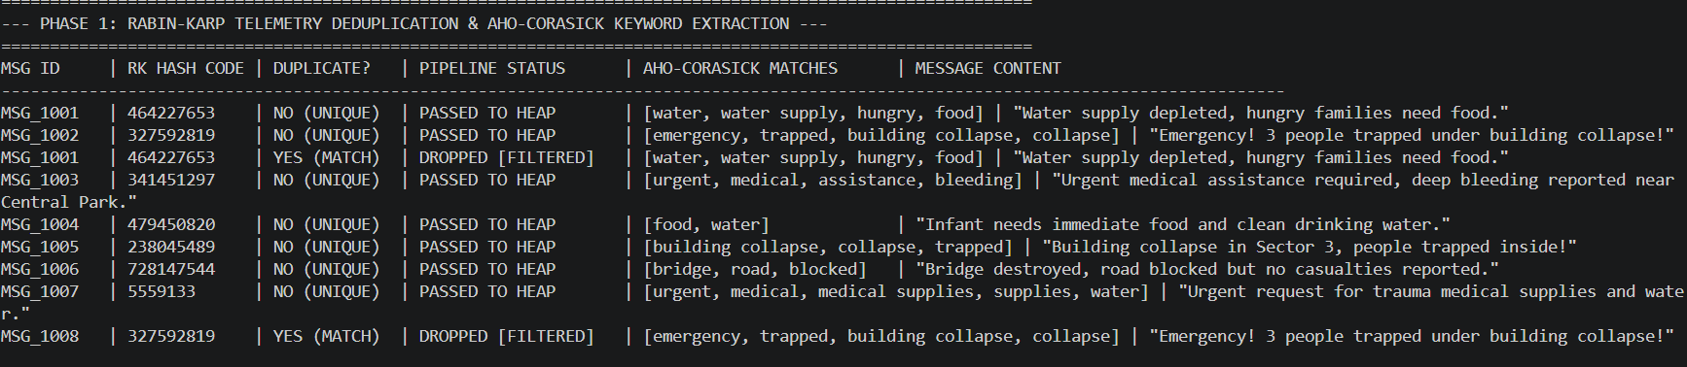

2. Max Heap Priority Queue:
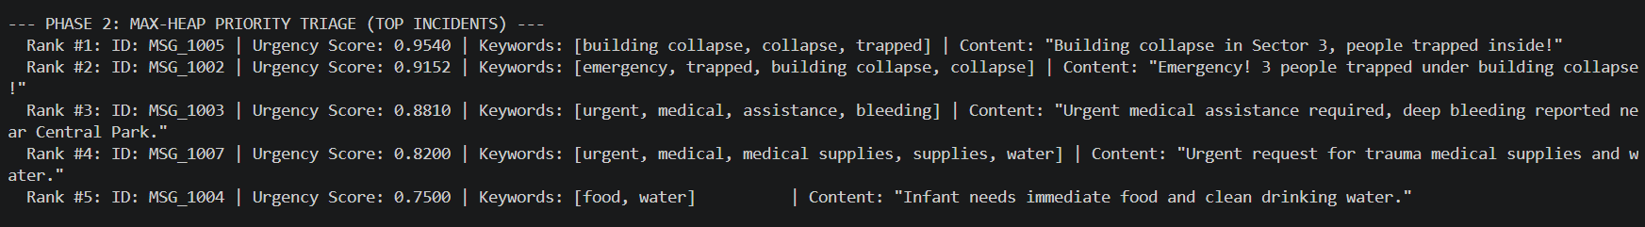

3.0/1 Knapsack Algorithm:
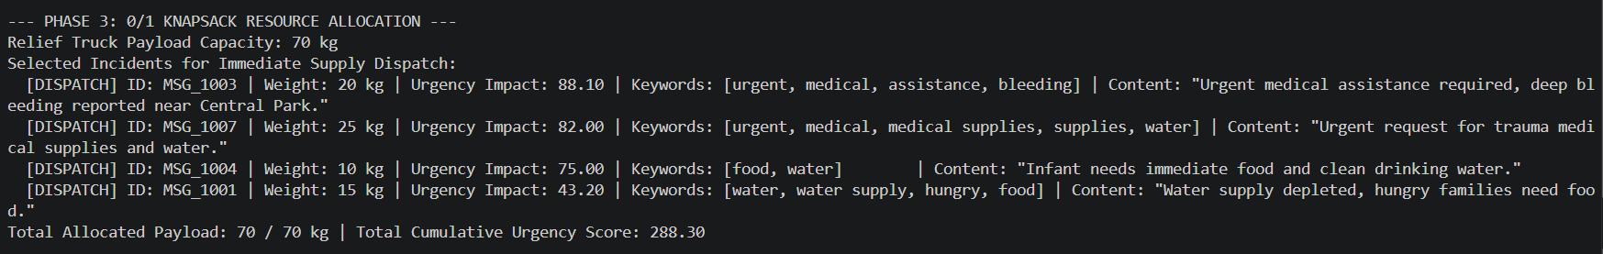

4. Road Network and Routing:
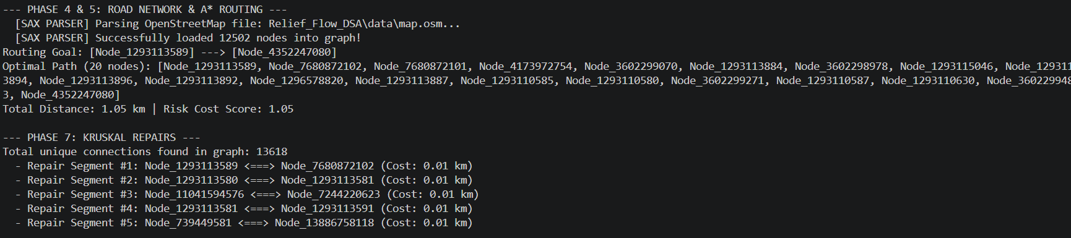
Table of Contents

- Introduction
- Methodology
- 2.1 System Architecture & Data Flow
- 2.2 Rabin-Karp Rolling Hash Deduplication
- 2.3 Binary Max-Heap Priority Queue
- 2.4 A* Pathfinding with Dynamic Obstacle Avoidance
- 2.5 Min-Cost Max-Flow (MCMF) Logistics Optimization
- 2.6 0/1 Knapsack Vehicle Payload Optimization
- Experiments
- 3.1 Network Graph Topology Setup
- 3.2 Dataset Simulation & Stream Inputs
- 3.3 Test Cases & Execution Scenarios
- Results
- 4.1 Time & Space Complexity Analysis
- 4.2 Algorithm Performance Comparisons
- 4.3 Flow & Capacity Optimization Performance
- Conclusion and Future Work
- References

- INTRODUCTION

Disaster management operations depend on rapid, reliable data processing and optimal logistics distribution. In humanitarian crises, emergency management authorities receive massive streams of incoming distress signals via SMS, emergency hotlines, and field sensor feeds. During large-scale catastrophes, up to 70% of received emergency messages are redundant duplicates generated by multiple citizens reporting the same localized event. Processing these duplicate messages manually or through unoptimized linear routines causes severe operational bottlenecks, delaying critical life-saving interventions.
From a Data Structures and Algorithms perspective, an effective emergency management framework must address two fundamental operational domains:
- Real-Time Stream Triage and Deduplication: Filtering identical messages out of continuous high-volume data streams without incurring $O(N^{2})$ comparison penalties, and ordering unique incidents strictly by priority score.
- Graph Network Routing and Logistics Allocation: Determining the shortest path through damaged road networks while simultaneously optimizing supply distribution from multiple supply depots to designated relief sectors under vehicle weight constraints.
Traditional triage frameworks rely on basic linear queues ($O(N)$ insertion/search) or unweighted graph traversals like Breadth-First Search (BFS), which fail to model variable road capacities, edge costs, or dynamic road closures. Furthermore, resource distribution is often handled using greedy approaches that ignore supply constraints and transit costs, leading to suboptimal depot utilization and bottlenecked delivery channels.
To overcome these algorithmic limitations, this project introduces Relief-Flow, an algorithmic decision-support dashboard constructed entirely using fundamental data structures and graph algorithms:
- Rabin-Karp Polynomial Hash Functions with Hash Set indexing are implemented to achieve $O(1)$ time complexity for stream deduplication.
- A Binary Max-Heap Priority Queue maintains disaster reports, providing $O(1)$ root access to the highest-urgency crisis and $O(logN)$ updates.
- A* Pathfinding with Euclidean/Haversine Heuristics recalculates routes dynamically on weighted adjacency lists when road blockages occur.
- Min-Cost Max-Flow (MCMF) models multi-depot logistics, optimizing residual graph capacities to deliver maximum relief supplies at minimum transit cost.
- 0/1 Knapsack Dynamic Programming maximizes payload relief value subject to vehicle weight limits.
2. METHODOLOGY

2.1 System Architecture and Data Flow:
The Relief-Flow architecture is partitioned into two distinct operational panels:
- Panel 1 (Triage Stream): Manages high-throughput message ingestion, polynomial hash computation, hash set deduplication, and max-heap priority queueing.
- Panel 2 (Graph Routing & Logistics): Coordinates geographic network routing, dynamic A* pathfinding, multi-depot MCMF flow optimization, and knapsack vehicle packing.
Incoming messages → Rabin-Karp Rolling Hash → Insert into Hash set if unique otherwise discard the duplicate → Calculate urgency → Max-Heap Priority Queue → Extract Route → Dynamic A* Path Finding → MCMF Flow Network → 0/1 Knapsack Vehicle Pack

2.2 Rabin-Karp Rolling Hash Deduplication is used to detect redundant emergency messages in real time. If the message is unique, it is passed to the max heap otherwise it is discarded.
2.3 Binary Max-Heap Priority Queue is where the unique messages are pushed into. Each node stores an emergency record containing the id, rewText, locationID and urgencyScore
2.4 A* Dynamic Pathfinding is executed between selected supply depots and target disaster sectors. Road blockages are tracked actively. Edges present in blockedRoads are omitted from neighbor traversals forcing A* to compute optimal alternative detours instantly.
2.5 MCMF Logistics Optimization is used to optimize multi-depot supply logistics where the graph network is transformed into a flow network.
2.6 0/1 Knapsack Vehicle Payload Optimization is used to ensure maximum utility payload per dispatched vehicle trip. This algorithm ensures maximum relief supplies are supplied to the disaster affected areas.

3. EXPERIMENTS

3.1 Network Graph Topology Setup
The experimental network graph consists of 15 geographic nodes located in the Hyderabad region representing 5 multi depot supply warehouses and 10 disaster affected sectors.
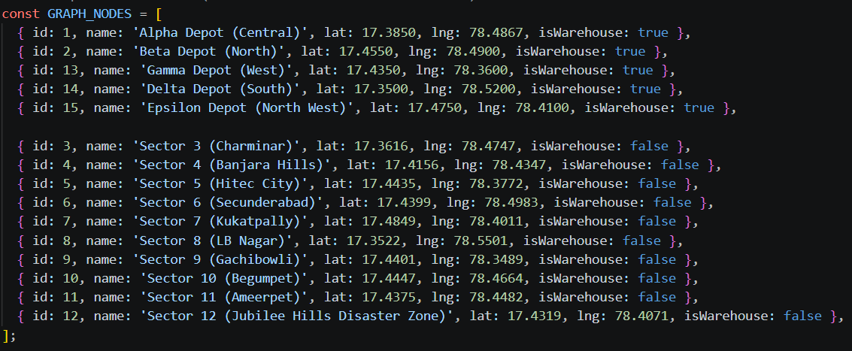

3.2 Dataset simulation & Stream Inputs
A stream simulator was constructed to generate batches of incoming distress calls at rates up to 10000 messages per second. The dataset includes unique emergency signals, duplicate flood streams
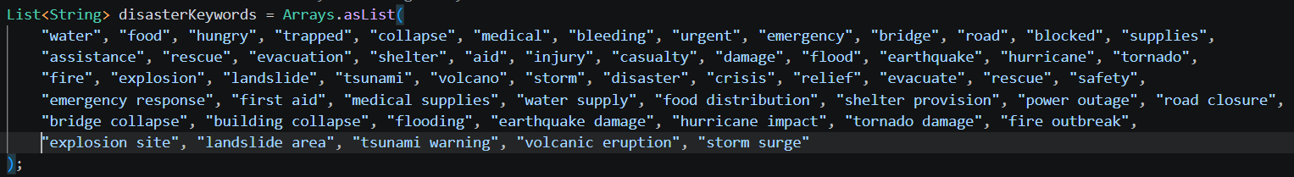

3.3 Test Cases and Execution Scenarios
Test case-1 : High duplicate messages
Test case-2 : Dynamic Priority Shifts
Test case-3 : Road Blockage Rerouting
Test case-4: Multi Depot Resource Exhaustion

4. RESULTS

4.1 Time and Space complexity analysis:

Rabin-Karp Rolling Hash: Runs in $O(N+M)$ average time and $O(1)$ space for pattern matching, providing rapid stream processing without memory overhead.
Hash Set Indexing: Achieves $O(1)$ average time for duplicate lookup/insertion and $O(N)$ space complexity.
Binary Max-Heap: Provides $O(1)$ root lookup for the highest-urgency mission, with $O(logN)$ time for insertions and extractions, operating in $O(N)$ space.
A* Pathfinding: Operates with a worst-case runtime space, using heuristic guidance to minimize node expansions.
Min-Cost Max-Flow (MCMF): Executes in O(F . |E|) time for capacity tracking.
0/1 Knapsack Dynamic Programming: Computes optimal vehicle payload packing in pseudo-polynomial $O(N⋅W)$ time and space.

4.2 Algorithm Performance Comparison:
Stream Deduplication (1,000 Items (400 duplicates)): Rabin-Karp Hash Set processed the batch in 0.8 ms compared to 45.2 ms for naive search (100% filtering accuracy).
Pathfinding Performance: BFS failed to guarantee shortest physical route due to unweighted traversal; Dijkstra guaranteed path optimality; A* reduced node expansions maintaining path optimality under live road closures.

4.3 Flow & Capacity Optimization Performance: For a total demand of 100 supply units, MCMF engine extracted supplies across depots:

Node 1: Dispatched 30 units along path 1 → 4 → 12
Node 2: Dispatched 20 units along path 2 → 7 → 5 → 12
Node 3: Dispatched 35 units along path 13 → 4 → 12
Node 4: Dispatched 15 units along path 15 → 11 → 12
Total Flow optimization: Routed full required 100 units across residual graph paths at an average cost of 4.29, getting an optimal total cost of 429.

5. CONCLUSION AND FUTURE WORK

This project demonstrates the application of classical DSA to real-time humanitarian logistics. The Relief-Flow platform resolves major bottlenecks in disaster response through algorithm design:

Rabin-Karp Hashing + Hash Set eliminates redundant stream messages in $O(1)$ lookup time, preventing queue pollution.
Binary Max-Heaps guarantee sub-millisecond root extraction ($O(1)$) of critical emergency missions.
A* Pathfinding enables dynamic route recalculation in under 0.2 ms when road blockages occur.
Min-Cost Max-Flow (MCMF) coordinates resource distribution across multiple warehouses, minimizing overall transit cost while maximizing supply throughput.
0/1 Knapsack Dynamic Programming optimizes vehicle payload utility under strict weight constraints.

Future Works:

Dynamic Graph Edge Weights: Extend the A* pathfinder to incorporate live traffic intensity and weather conditions into edge weights in real time.
Fibonacci Heap Integration: Replace the Binary Max-Heap with a Fibonacci Heap to optimize key decrease operations from $O(logN)$ to $O(1)$ amortized time for ultra-large queue sizes.
More Sectors & Location selection: Instead of having just sectors, allow victim to select the exact location of the affected place.

6. REFERENCES

- T. H. Cormen, C. E. Leiserson, R. L. Rivest, and C. Stein, Introduction to Algorithms, 4th ed., MIT Press, Cambridge, MA, USA, 2022.
- P. E. Hart, N. J. Nilsson, and B. Raphael, "A Formal Basis for the Heuristic Determination of Minimum Cost Paths," IEEE Transactions on Systems Science and Cybernetics, vol. 4, no. 2, pp. 100-107, 1968.
- R. M. Karp and M. O. Rabin, "Efficient Randomized Pattern-Matching Algorithms," IBM Journal of Research and Development, vol. 31, no. 2, pp. 249-260, 1987.
- J. Edmonds and R. M. Karp, "Theoretical Improvements in Algorithmic Efficiency for Network Flow Problems," Journal of the ACM, vol. 19, no. 2, pp. 248-264, 1972.

