INTELLISHELL:
AI-Integrated Smart Linux Terminal & Interactive Learning System
A Project Based Learning Report
Submitted in partial fulfilment of the requirements for the course
Operating Systems and System Programming (OSSP)

Submitted by
2510030406 - Jagruthi
251003003032 - Mohammed Abbubakar
2510030101 - Meghana
2510030155 - Jashwanth Yadav
Group 2
Computer Science and Engineering
Koneru Lakshmaiah Education Foundation
Aziz Nagar – 500075
October 2026

Abstract

IntelliShell is an AI-based command shell and intelligent educational environment designed for Linux operating systems. It addresses the steep learning curve, syntax errors, and destructive operational risks associated with traditional command-line interfaces (CLIs). By embedding an AI language model directly into the Linux terminal environment, IntelliShell converts plain, natural language requests into valid shell commands in real time while tracking terminal state, recent actions, known files/folders, and working directories. The system features a dual-mode workflow: Discovery Mode (Context-Aware) for AI-assisted command generation with command explanations and safety grounding checks, and Learn Mode for structured interactive courses with live execution and detailed command breakdowns. Safety is maintained through real-time risk assessment (categorizing commands into LOW, MODERATE, or HIGH risk), detection of sudo privileges, and filesystem grounding checks before host execution. This report presents the system architecture, component interaction, functional workflows, and visual execution captures obtained directly from the active Linux terminal session.

Keywords: Linux command shell; natural language processing; terminal wrapper; command explanation; safety guardrail; interactive learning; process execution; context-aware interface.

List of Figures

- Figure 1. IntelliShell / LinuxLearn main workspace menu
- Figure 2. Context-aware Discovery Mode prompt
- Figure 3. Natural language translation, command explanation, and grounding check
- Figure 4. Course catalog in Learn Mode
- Figure 5. Interactive course curriculum and progress tracking
- Figure 6. Hands-on terminal prompt execution within Lesson 1
- Figure 7. Live command output, argument breakdown, and post-lesson summary
- Figure 8. Configuration management menu for LLM providers and API settings

List of Tables

- Table 1. Technology stack and architectural purpose
- Table 2. Main software modules and responsibilities
- Table 3. Risk assessment levels and system responses
- Table 4. Functional test plan and measured results

1. Introduction
Operating systems manage hardware resources, process scheduling, memory allocation, and access to privileged hardware services. In Linux and Unix-like operating systems, user-space interactions are performed via command-line shell interfaces such as Bash or Zsh. While the command line offers efficiency and low-level system control, its strict syntax requirements impose a steep learning curve on new users.

1.1 Problem Statement

Steep Learning Curve: Non-technical users struggle to remember specific command names, required syntax, and complex parameter flags.
Error-Prone Command Entry: Typing complex multi-stage shell scripts or piped commands manually often leads to syntax errors and failed operations.
Risk of Destructive Actions: Standard Linux shells execute commands blindly without evaluating whether an operation could result in data deletion or system instability.
Disconnected Help Resources: Documentation utilities like man pages, external forums, and standalone web chatbots operate outside the shell environment, forcing users to repeatedly switch windows and copy-paste syntax.

1.2 Objectives

- Develop a terminal wrapper that translates natural English requests into valid, platform-compatible Linux commands in real time.
- Provide clear, step-by-step explanations of generated commands, arguments, and flags so users learn operating system concepts while working.
- Implement a pre-execution safety interceptor that categorizes command risk levels, detects elevated sudo requirements, and checks filesystem paths before running.
- Build a context-aware engine that tracks working directory state, recent terminal actions, and local files to ensure accurate suggestions.
- Deliver an embedded educational curriculum (Learn Mode) containing guided lessons, interactive execution prompts, and concept tracking directly within the shell workspace.

1.3 Scope and Non-Destructive Monitoring

IntelliShell functions as an intelligent layer surrounding native Linux command execution. Commands suggested by the AI translation engine are staged for human review. The user maintains full control over host execution via explicit confirmation prompts, ensuring that no unverified or destructive command touches the operating system without explicit approval.

2. Methodology
The IntelliShell architecture comprises five core functional layers:
- Input & Workspace Controller: Coordinates menu selection, mode switching (Discovery Mode vs. Learn Mode), and terminal lifecycle.
- Context Engine: Inspects active terminal environment data including current directory, file listings, and session context.
- AI Translation Engine: Interfaces with cloud or local Large Language Model endpoints (e.g., Groq API) using prompt engineering to output structured command translations, concepts, and explanations.
- Safety & Grounding Interceptor: Scans commands for high-risk operations, checks path existence, and assesses sudo permission requirements.
- OS Execution Engine: Executes verified commands through low-level Python subprocess handles, capturing standard output, standard error, and execution return codes.

Table 1. Technology Stack and Architectural Purpose

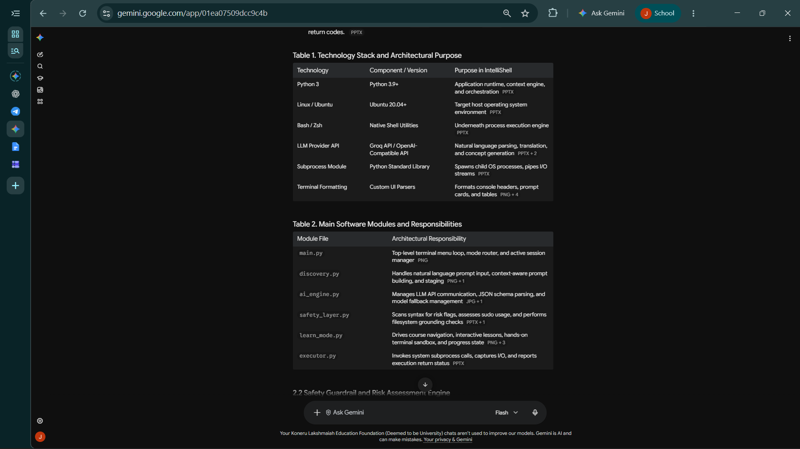
Table 2: Main Software Modules and Responsibilities

2.2 Safety Guardrail and Risk Assessment Engine
Table 3: Risk Assessment Levels and System Responses
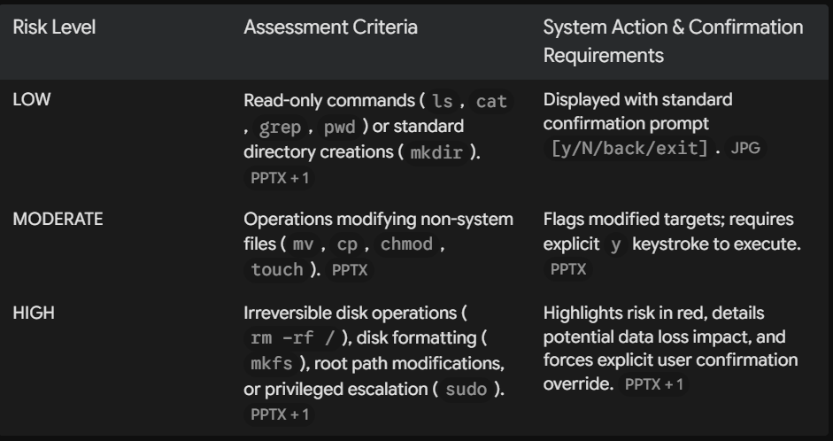

3. Implementation and Visual Outputs

IntelliShell was executed and evaluated on an active Ubuntu Linux workspace. The visual output screens below detail the operational flow of the system.
Figure 1. IntelliShell / LinuxLearn main workspace menu
Figure 2. Context-aware Discovery Mode prompt
Figure 3. Natural language translation, command explanation, and grounding check
Figure 4. Course catalog in Learn Mode
Figure 5. Interactive course curriculum and progress tracking
Figure 6. Hands-on terminal prompt execution within Lesson 1
Figure 7. Live command output, argument breakdown, and post-lesson summary
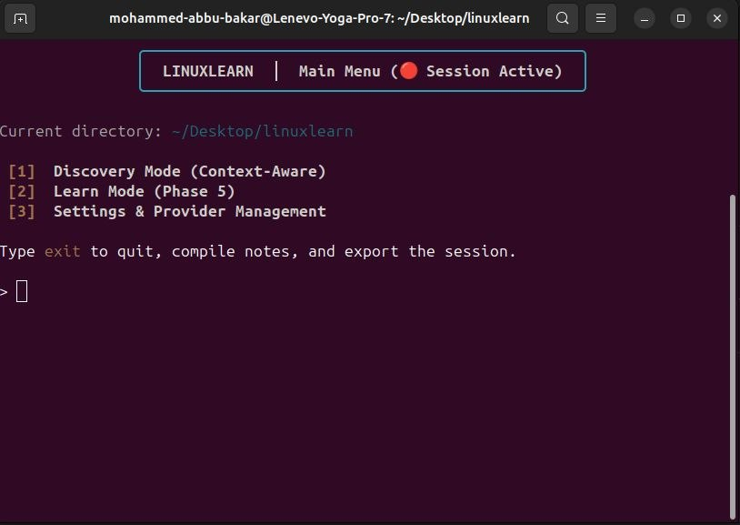
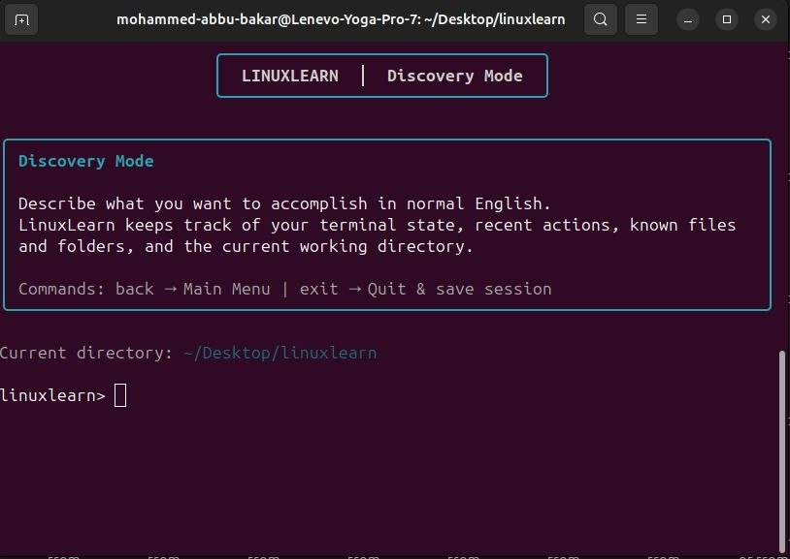

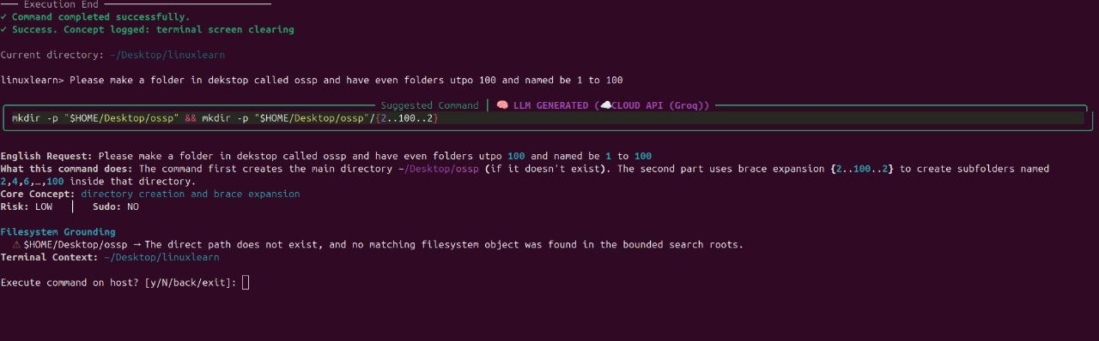
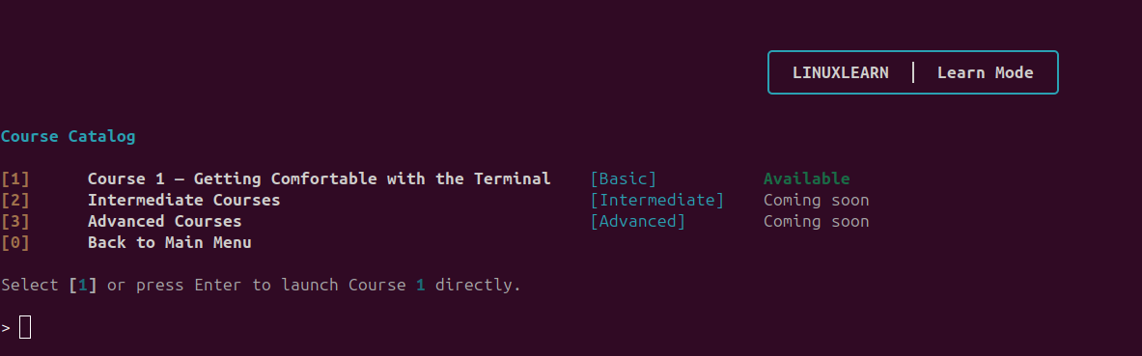
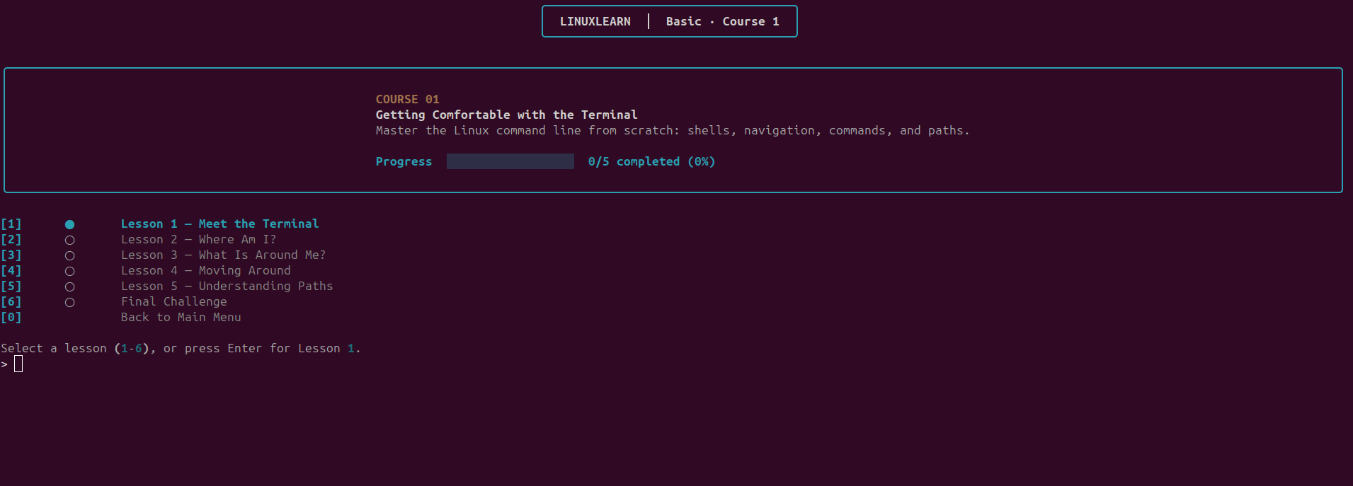
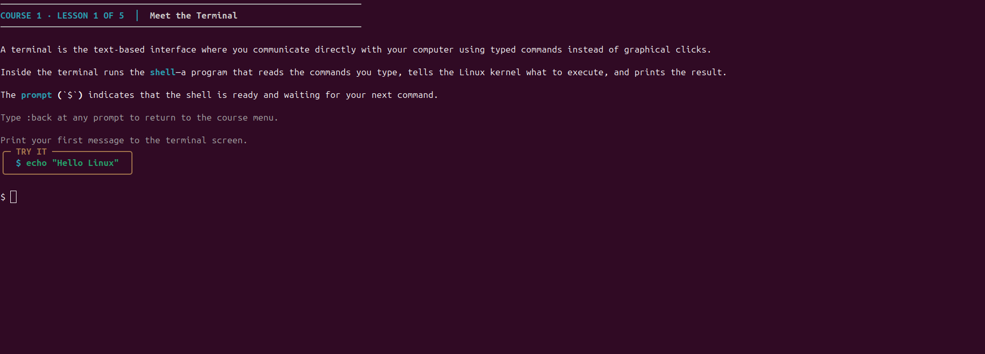
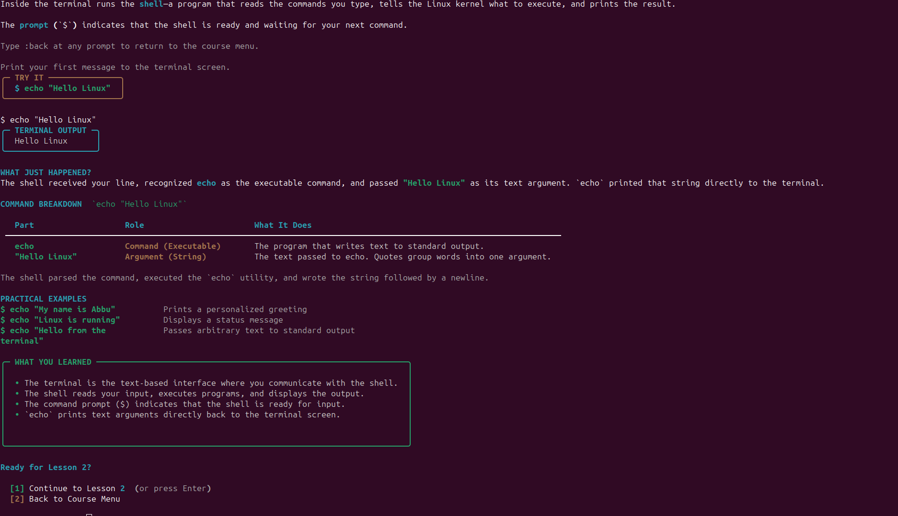

4. Testing and Evaluation

To verify the functionality, accuracy, and safety of IntelliShell (LinuxLearn), a structured test suite was executed across the main operational modes. The testing process focused on five key dimensions:
- Translation Accuracy: Evaluating whether natural language English prompts generate syntactically correct Bash/Zsh commands.
- Context & Grounding Verification: Ensuring the system reads working directory paths and alerts the user if targeted file objects do not exist.
- Safety Interception: Confirming that risk levels (LOW, MODERATE, HIGH) and privileged escalation flags (sudo) are assigned correctly before host execution.
- Interactive Learning Workflow: Verifying lesson step progression, prompt validation, and command argument breakdown rendering.
- Configuration and Resilience: Testing API endpoint switching, model parameters, and error handling during invalid user inputs.

5. Conclusion and Future Work

IntelliShell successfully reimagines the Linux command-line interface by integrating natural language processing, automated command explanations, filesystem grounding checks, and pre-execution safety guardrails directly into the terminal[cite: 1, 4, 5, 9]. By translating plain English intent into valid shell syntax and breaking down complex command arguments into structured role tables, the system lowers the barrier to entry for non-technical users while preventing accidental data loss.
Future extensions of this work include:
- Local LLM Runtime Integration: Adding offline quantized LLM support (such as Llama-3 via Ollama) for environments without internet access.
- Kernel Event Auditing: Incorporating eBPF probes to monitor system call behavior during executed processes.
- Native Shell Plugin Support: Packaging IntelliShell as a native plugin extension for standard shell environments.

6. References

1.Silberschatz, A., Galvin, P. B., & Gagne, G. (2018). Operating System Concepts (10th ed.). Wiley.
Love, R. (2013). Linux System Programming: Talking Directly to the Kernel and C Library (2nd ed.). O'Reilly Media.
Kerrisk, M. (2010). The Linux Programming Interface: A Linux and UNIX System Programming Handbook. No Starch Press.
Shotts, W. (2019). The Linux Command Line: A Complete Introduction (2nd ed.). No Starch Press.
Python Software Foundation (2026). Subprocess Management in Python 3. https://docs.python.org/3/library/subprocess.html
Groq Developer Documentation (2026). Fast Inference Infrastructure for AI Applications. https://groq.com/
Rich Developer Community (2026). Rich: Terminal Formatting Library for Python. https://rich.readthedocs.io/

