**MANDATORY HANDS-ON**

**(includes all other hands-on of week-6)**

**1.ReactJS-HQL**

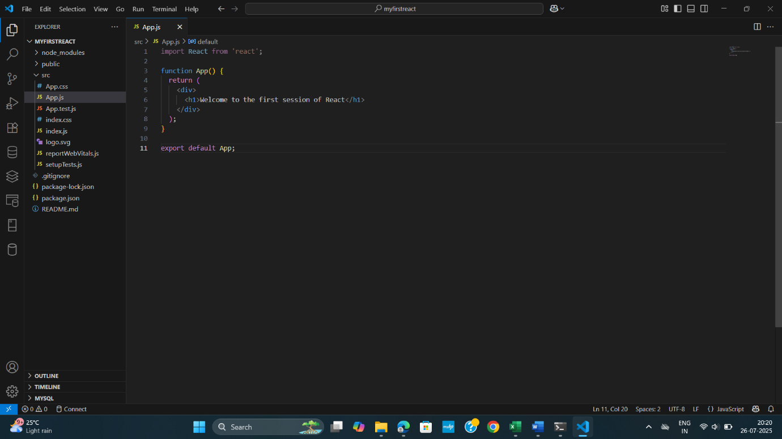

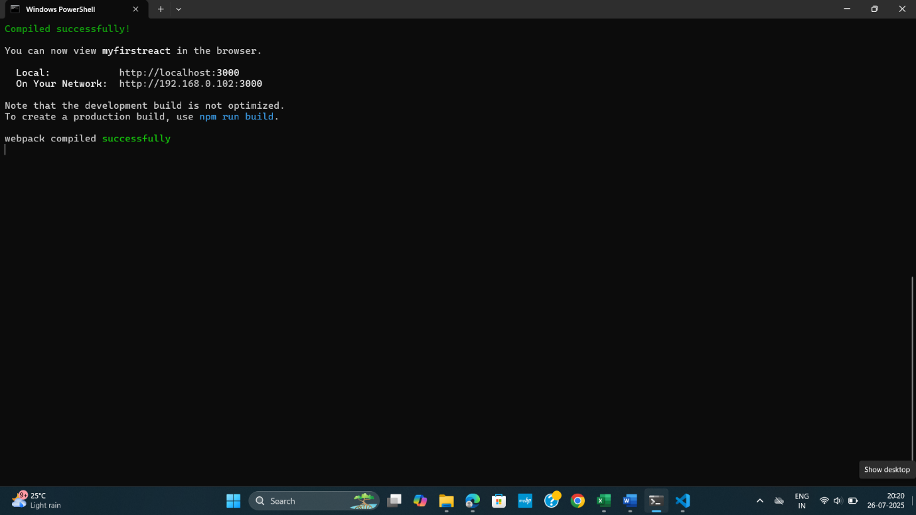

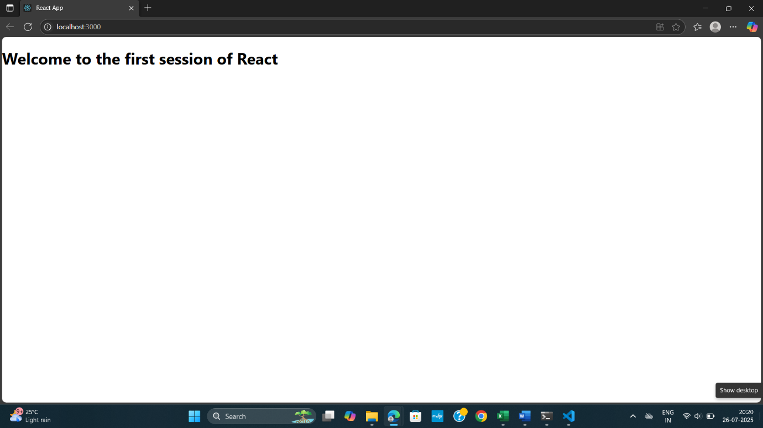

**2.ReactJS-HQL**

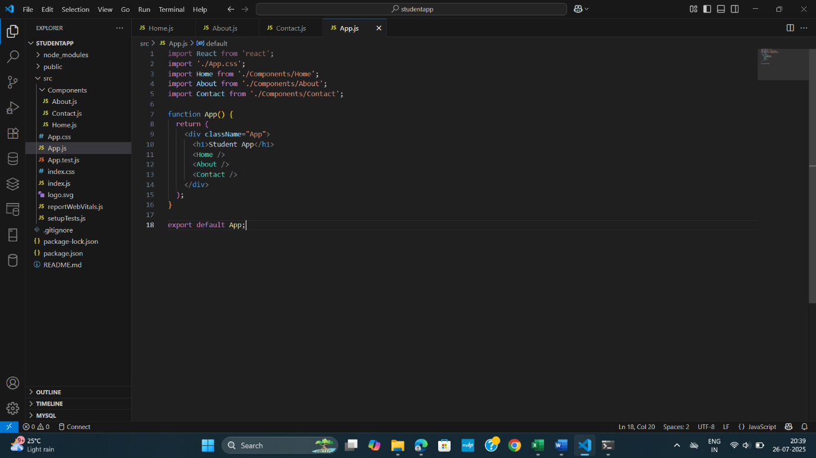

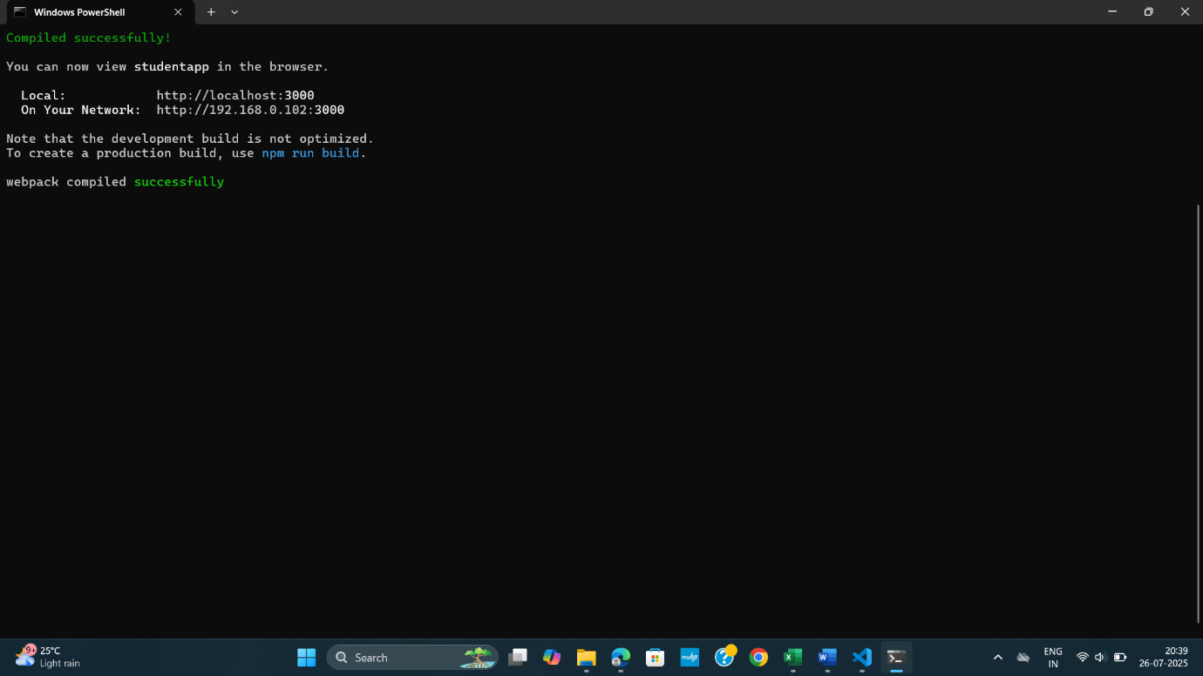

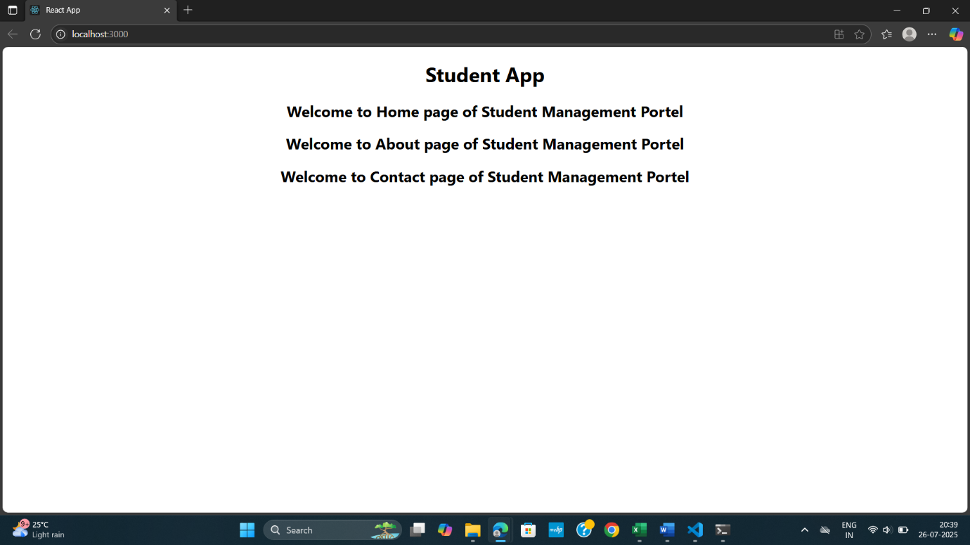

**3. ReactJS-HQL**

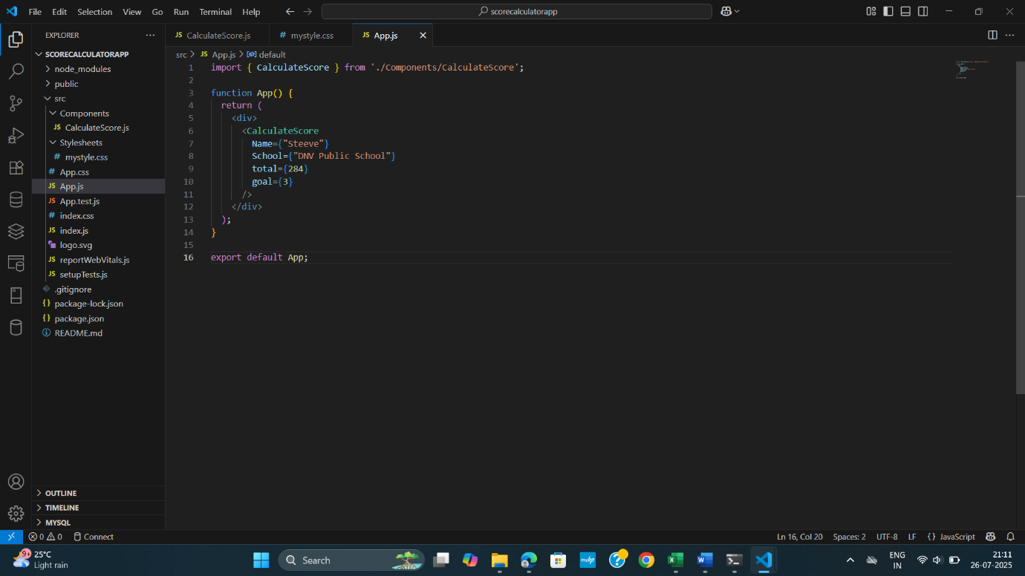

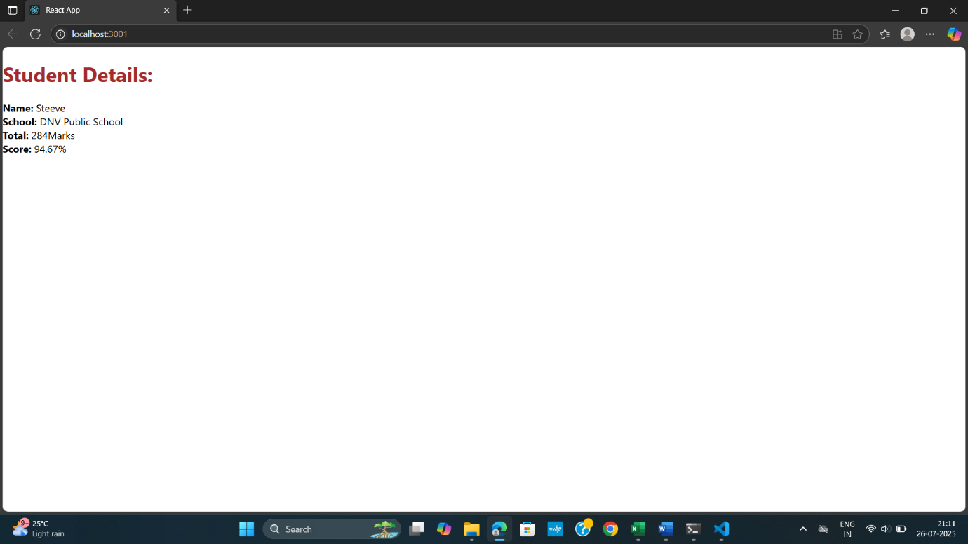

**4. ReactJS-HQL** 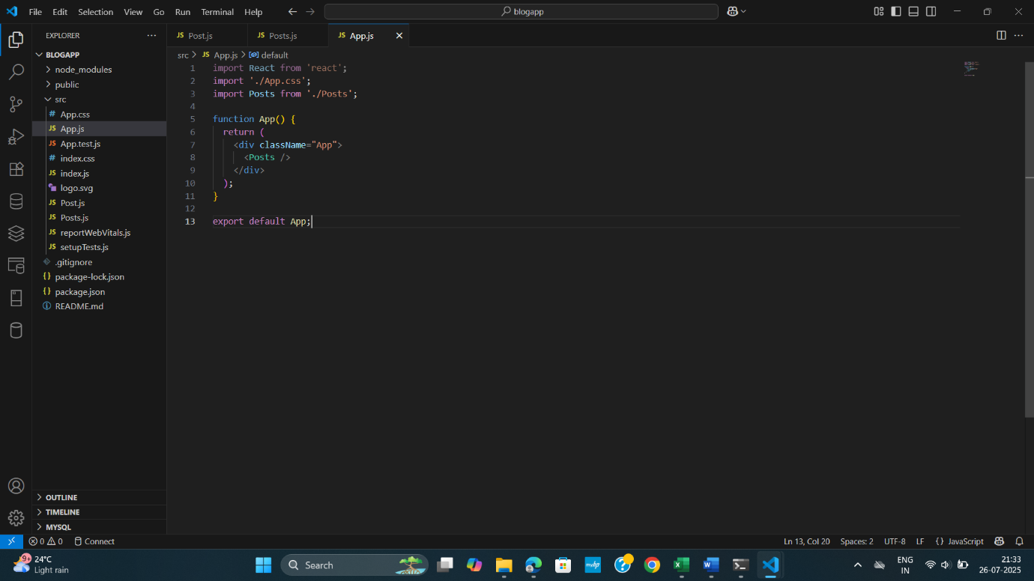

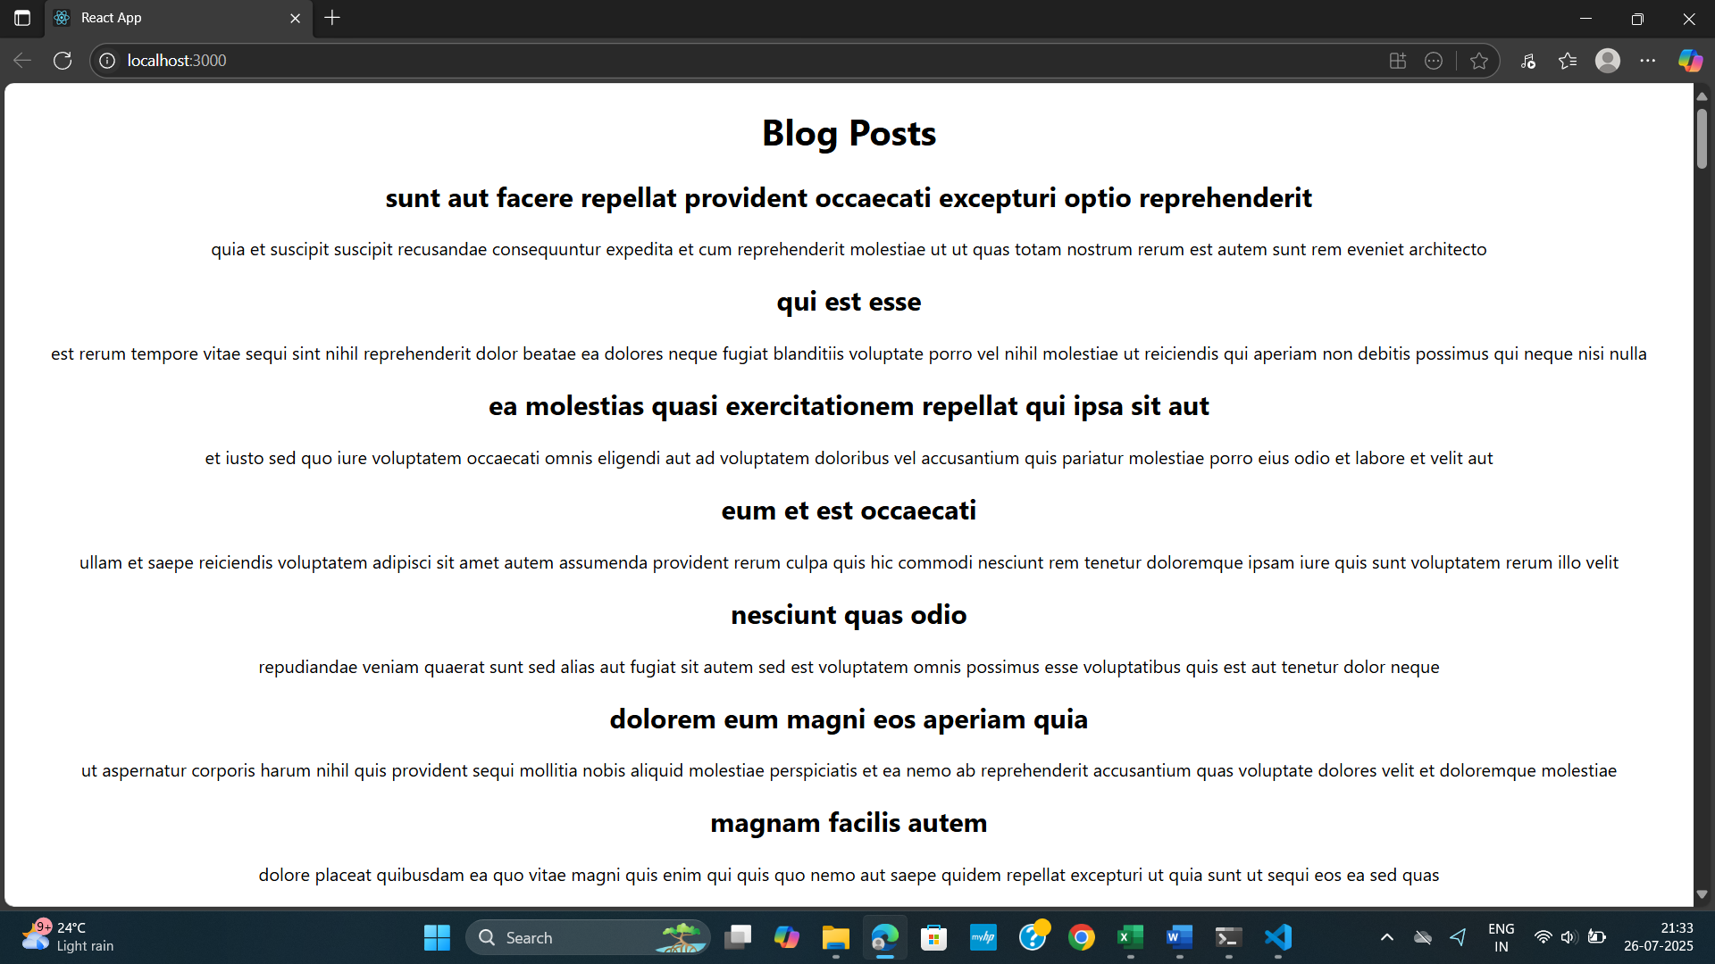

**6.ReactJS-HQL**

Trainer.js

class Trainer {

  constructor(trainerId, name, email, phone, technology, skills) {

    this.trainerId = trainerId;

    this.name = name;

    this.email = email;

    this.phone = phone;

    this.technology = technology;

    this.skills = skills;

  }

}

export default Trainer;

TrainersMock.js

import Trainer from './Trainer';

const trainers = [

  new Trainer(1, "Amit Sharma", "amit@example.com", "9876543210", "Java", ["Spring", "Hibernate", "Microservices"]),

  new Trainer(2, "Nisha Patel", "nisha@example.com", "7890123456", "Python", ["Flask", "Django", "Pandas"]),

  new Trainer(3, "John Doe", "john@example.com", "9123456789", "JavaScript", ["React", "Node.js", "Express"]),

];

export default trainers;

TrainerList.js

import React from "react";

import { Link } from "react-router-dom";

const TrainerList = ({ trainers }) => {

  return (

    <div>

      <h2>Trainers List</h2>

      <ul>

        {trainers.map((trainer) => (

          <li key={trainer.trainerId}>

            <Link to={`/trainer/${trainer.trainerId}`}>{trainer.name}</Link>

          </li>

        ))}

      </ul>

    </div>

  );

};

export default TrainerList;

Home.js

import React from "react";

const Home = () => {

  return (

    <div>

      <h1>Welcome to Cognizant Academy</h1>

      <p>This app maintains a list of trainers and their expertise.</p>

    </div>

  );

};

export default Home;

App.js

import React from "react";

import { BrowserRouter as Router, Routes, Route, Link } from "react-router-dom";

import Home from "./Home";

import TrainerList from "./TrainerList";

import TrainerDetail from "./TrainerDetails";

import trainers from "./TrainersMock";

const App = () => {

  return (

    <Router>

      <div>

        <nav style={{ margin: "10px" }}>

          <Link to="/" style={{ marginRight: "10px" }}>Home</Link>

          <Link to="/trainers">Trainers</Link>

        </nav>

        <Routes>

          <Route path="/" element={<Home />} />

          <Route path="/trainers" element={<TrainerList trainers={trainers} />} />

          <Route path="/trainer/:id" element={<TrainerDetail />} />

        </Routes>

      </div>

    </Router>

  );

};

export default App;

TrainerDetails.js

import React from "react";

import { useParams } from "react-router-dom";

import trainers from "./TrainersMock";

const TrainerDetail = () => {

  const { id } = useParams();

  const trainer = trainers.find((t) => t.trainerId === parseInt(id));

  if (!trainer) {

    return <div>Trainer not found</div>;

  }

  return (

    <div>

      <h2>{trainer.name}</h2>

      <p><strong>Email:</strong> {trainer.email}</p>

      <p><strong>Phone:</strong> {trainer.phone}</p>

      <p><strong>Technology:</strong> {trainer.technology}</p>

      <p><strong>Skills:</strong> {trainer.skills.join(", ")}</p>

    </div>

  );

};

export default TrainerDetail;

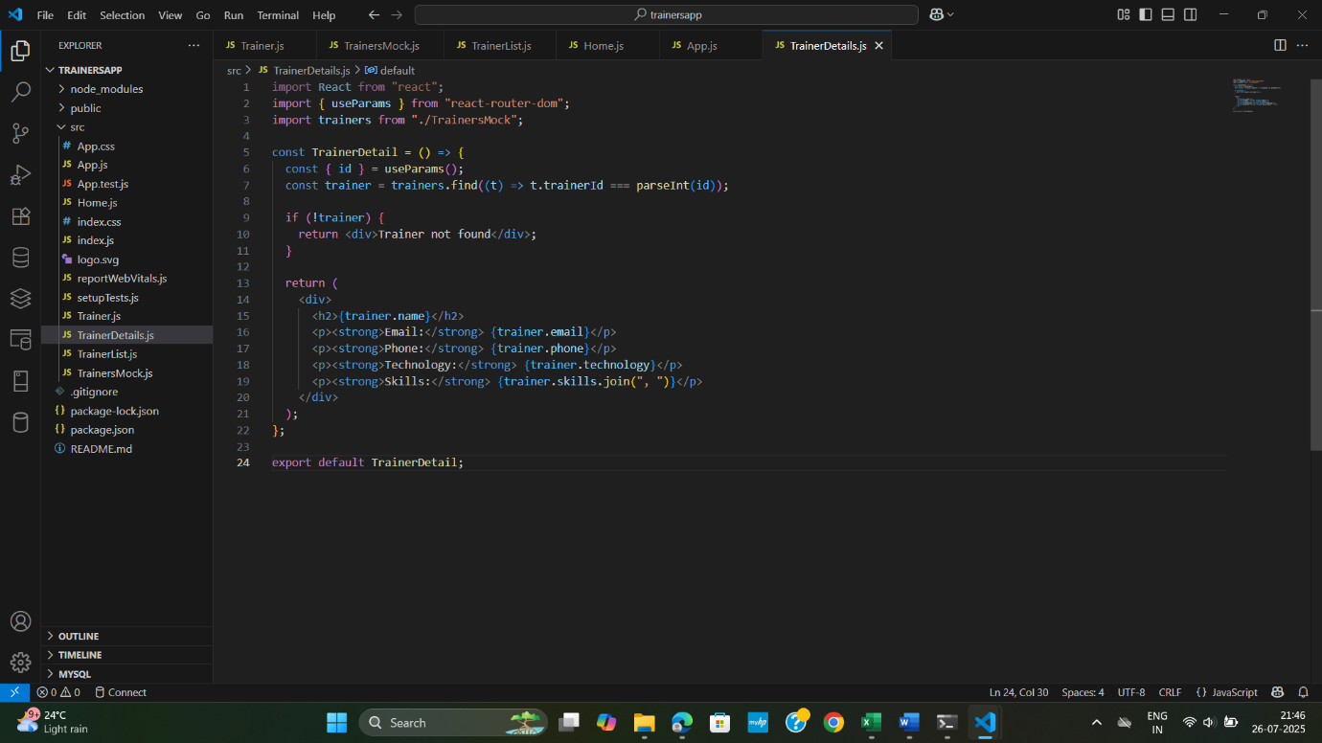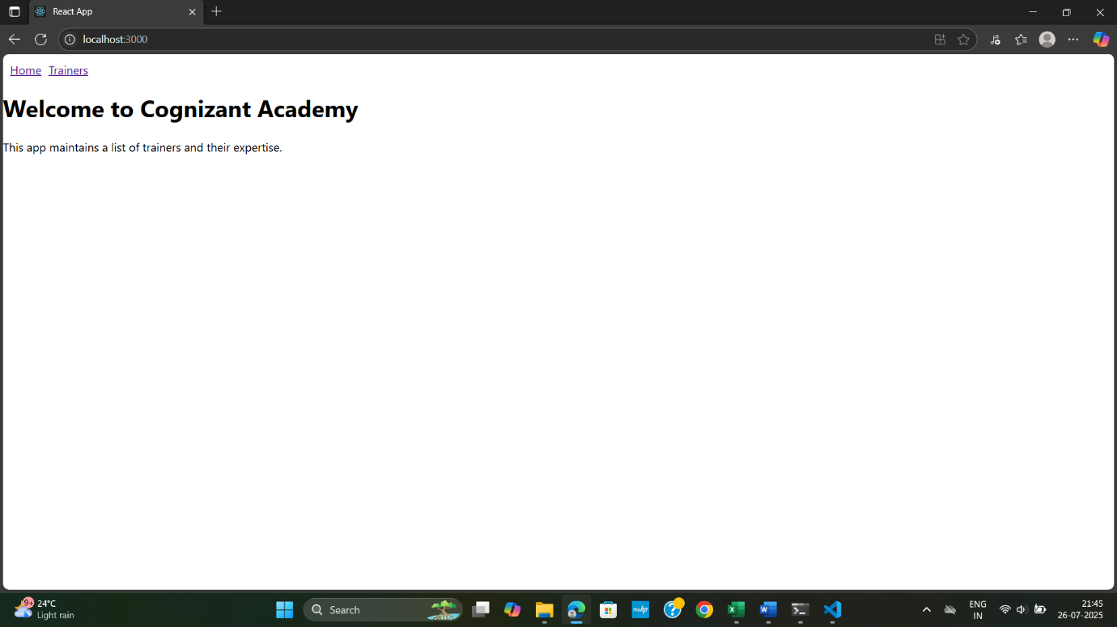

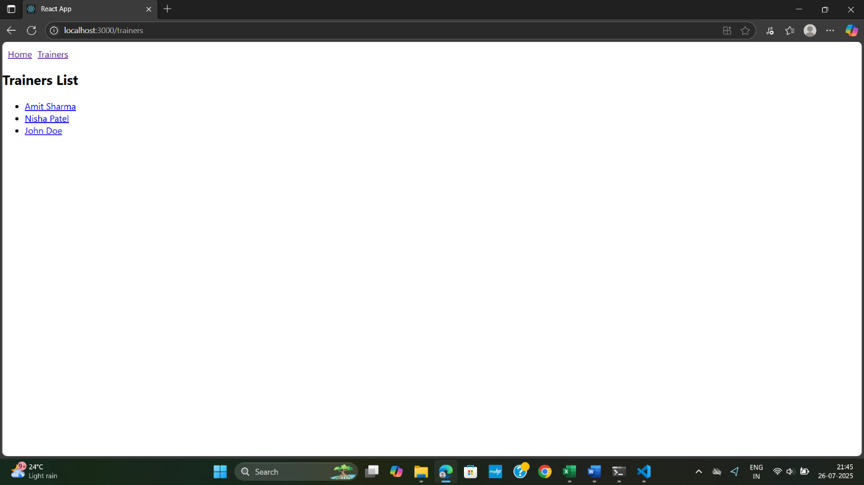

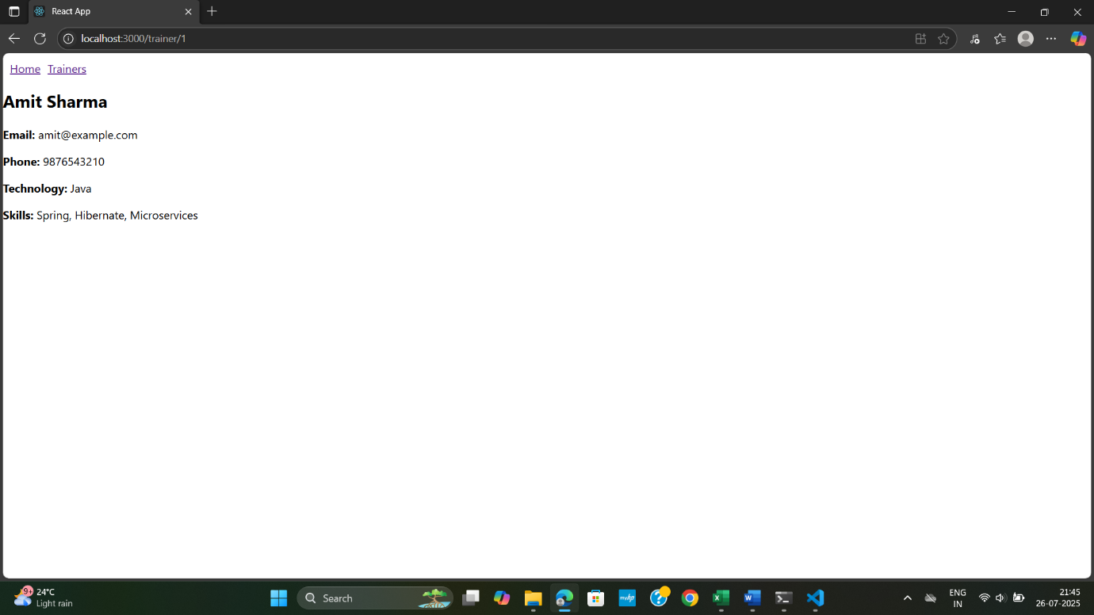

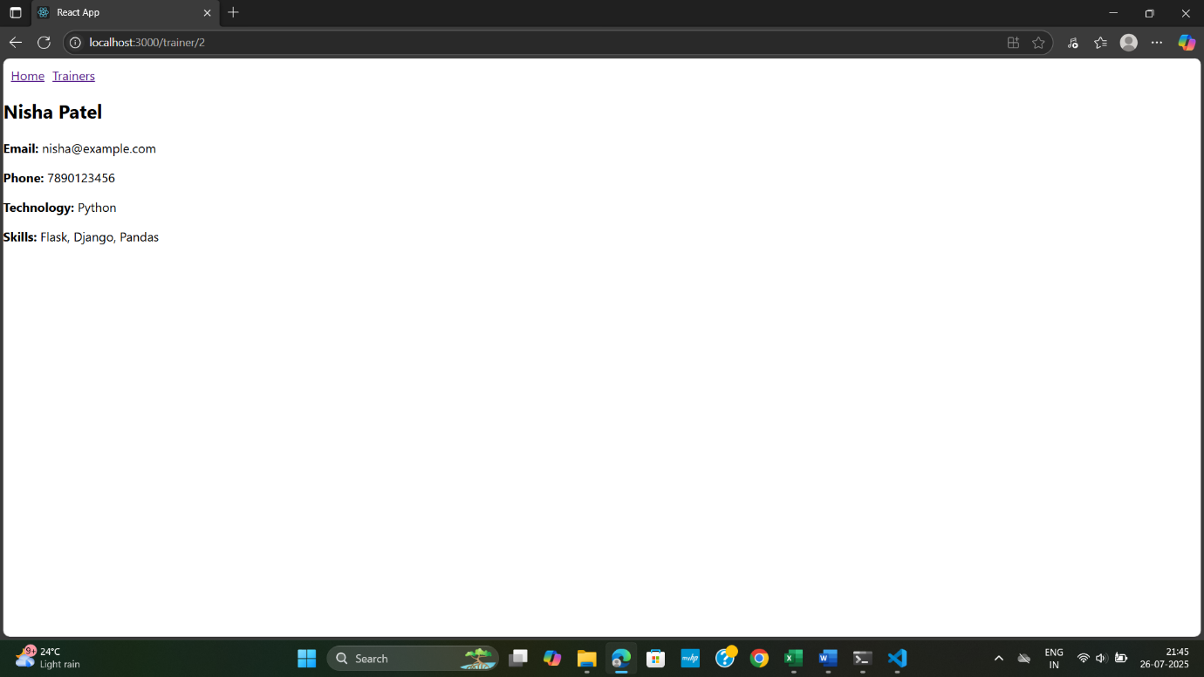

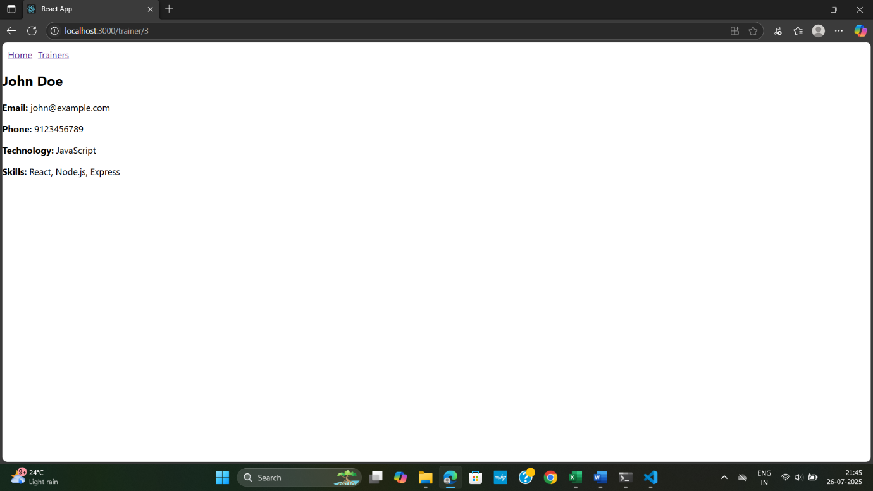

**7. ReactJS-HQL**

**Cart.js**

import React from 'react';

class Cart extends React.Component {

  render() {

    const { itemname, price } = this.props;

    return (

      <div style={{ border: '1px solid gray', margin: '10px', padding: '10px' }}>

        <h3>Item Name: {itemname}</h3>

        <p>Price: ₹{price}</p>

      </div>

    );

  }

}

export default Cart;

**OnlineShopping.js**

import React from 'react';

import Cart from './Cart';

class OnlineShopping extends React.Component {

  constructor() {

    super();

    this.state = {

      items: [

        { itemname: 'Mobile Phone', price: 15000 },

        { itemname: 'Laptop', price: 55000 },

        { itemname: 'Smart Watch', price: 3000 },

        { itemname: 'Headphones', price: 1200 },

        { itemname: 'Backpack', price: 800 }

      ]

    };

  }

  render() {

    return (

      <div>

        <h1>🛒 Online Shopping Cart</h1>

        {this.state.items.map((item, index) => (

          <Cart key={index} itemname={item.itemname} price={item.price} />

        ))}

      </div>

    );

  }

}

export default OnlineShopping;

App.js

import React from 'react';

import OnlineShopping from './OnlineShopping';

function App() {

  return (

    <div className="App">

      <OnlineShopping />

    </div>

  );

}

export default App;

Output:

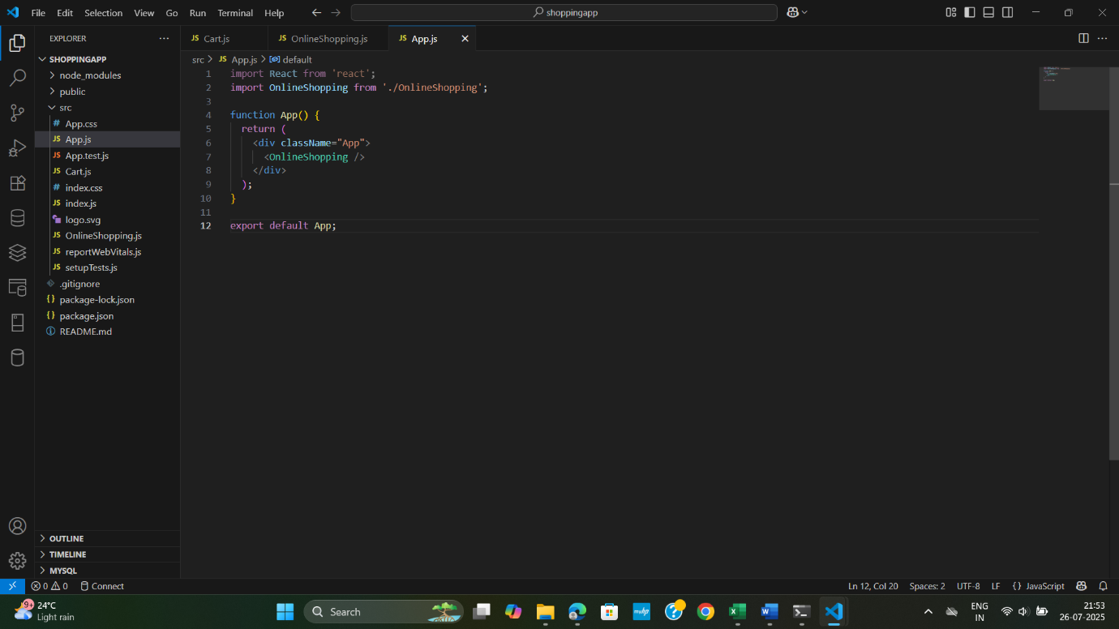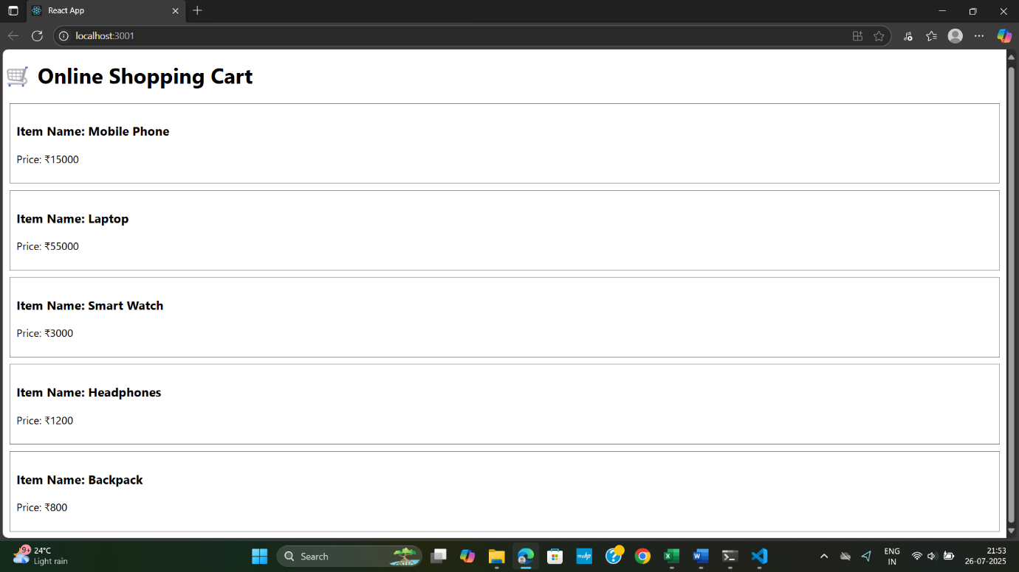

**8. ReactJS-HQL**

Countpeople.js

import React, { Component } from 'react';

class CountPeople extends Component {

  constructor(props) {

    super(props);

    this.state = {

      entryCount: 0,

      exitCount: 0

    };

  }

  UpdateEntry = () => {

    this.setState((prevState) => ({

      entryCount: prevState.entryCount + 1

    }));

  };

  UpdateExit = () => {

    this.setState((prevState) => ({

      exitCount: prevState.exitCount + 1

    }));

  };

  render() {

    return (

      <div style={{ textAlign: 'center', marginTop: '50px' }}>

        <h1>Mall Counter</h1>

        <p><strong>People Entered:</strong> {this.state.entryCount}</p>

        <p><strong>People Exited:</strong> {this.state.exitCount}</p>

        <button onClick={this.UpdateEntry} style={{ marginRight: '10px', padding: '10px 20px' }}>Login</button>

        <button onClick={this.UpdateExit} style={{ padding: '10px 20px' }}>Exit</button>

      </div>

    );

  }

}

export default CountPeople;

App.js

import React from 'react';

import './App.css';

import CountPeople from './CountPeople';

function App() {

  return (

    <div className="App">

      <CountPeople />

    </div>

  );

}

export default App;

Output:

