**PROJECT REPORT ON**

***ICOMPET***

***(Online Competition Portal)***

**FOR**

***VEDANT IT ACADEMY***

**BY**

**NIKHIL SANJAY SAWANT**

**AVINASH JAGDISH GHARE**

**CHINMAY SANJAY JOSHI**

**MASTER OF COMPUTER**

**APPLICATIONS**

**SEMESTER VI**

IBSAR Institute of Management Studies, Karjat

**UNIVERSITY OF MUMBAI**

***Year-2013-2014***

**PROJECTREPORT ON**

***LEAD MANAGEMENT SYATEM***

**FOR**

***VEDANT IT ACADEMY***

**BY**

**CHINMAY SANJAY JOSHI**

**Seat No. 18**

**MASTER OF COMPUTER**

**APPLICATIONS**

**SEMESTER VI**

IBSAR Institute of Management Studies

**UNIVERSITY OF MUMBAI**

***Year-2013-2014***

**Table of Contents**

**1.Introduction**

1.1 Abstract

1.1.1About the Organization3

1.1.2About the Project (Objective & Scope of the Project)4

1.2 Technical Details.

1.2.1Overview of Front End 5

1.2.2Overview of Back End 6

**2.System Analysis**

2.1 Feasibility Study 7

2.1.1Technical 8

2.1.2Operational 9

2.1.3Resource

2.2 Software development model 10

2.3 System planning and scheduling

2.3.1 GANTT Chart 11

**3.System Design**

3.1 Software Requirement Specification

3.1.1Introduction 12

3.1.2Selection of Technology/Specific Requirements 13

3.1.2.1Hardware to be used

3.1.2.2Software to be used

3.1.2.3Tools to be used

3.2 Detailed life Cycle of the Project

3.2.1Modules 14

**4 .Object Oriented Analysis & Design Diagrams**

4.1“*UML Diagrams*“ 15-22

**5.Database**

5.1Database Schema 23-26

5.2I/O Screen Layout 27-44

**6.Testing**

6.1 Testing

6.1.1Testing Types 45-54

6.1.2Unit Testing

6.1.3 Test Report

**7.System Implementation**55

7.1 Hardware required at Client Side

7.2 Software required at Client Side

**8.System Maintenance & Evaluation**56

8.1 Maintenance

8.2 Evaluation

**9.User manual**

9.1.User/OperationalManual 57

9.2 Security Aspects, Access Rights 59

**10.Future Enhancements**60

**11.Limitations**61

**12.Conclusion**62

**13.Bibliography**63

**Introduction**

**1.1Abstract**

**1.1.1 About the Organization**

**Name:** VEDANT IT ACADEMY

**Description :**

* Vedant IT Academy is one of the service providers in India, offering a range of web designing and development, Software development and Internet marketing services. It's our constant endeavour to continue providing our clients, customized web designing, web development, customized software development, SEO and content solutions and services.
* Vedant IT Academy was founded to address the need of cost effective yet powerful and user friendly systems. We have employed high qualified technical team with engineering and computer application education that can understand the customer requirements and convert their vision into reality.
* Vedant IT Academy has a pool of highly dedicated team of software professionals and technocrats with adequate experience and exposure to project development.
* Vedant IT Academy believes in a unique advance approach and ties a business relationship with the customers which differentiate us from other web developers. At Vedant IT Academy., we build technology solutions around core business strategies. is here to serve your business. We serve according to your convenience and time frames, with quality control methods enforced at every level in our organization.
* Specialties :

Website Design/Development

Application/Software Development

Internet Marketing (SEO)

Android Development

Hardware Sales and Services.

* + 1. **About the Project:**

Icompet is a software developed to organize contests and competitions. The main aim of our project is to create an online platform that provides organizers to host a competition online. We provide them with a software where they can manage different types of competition’s online. The software product to be produced is an Online Competition Portal which will manage different types of contests over the web and used to replace old fashioned way of organizing a contest.

The system will create a competition for end user which will be hosted by an organizer. The system provides an organization with an option of where to organize a competition.

Conducting Online Contests on an existing software is easy and cheap as compared to developing a website and then conducting contests. It saves a lot of time and money since you do not need to hire developers, you can just login to the site and create your contest.

**1.1.2Objective and Scope of the Project**

* **1.1.2.1Objective of the Project:**

The main objective of I-COMPET is to provide an online platform to organize or host a competition online. Icompet’s objective is to provide a system to manage different types of competitions online.

* **1.1.2.2 Scope of the Project:**

This project can be said to have the below mentioned scopes:

* The software product to be produced is an Online Competition Portal which will manage different types of contests over the web and used to replace old fashioned way of organizing a competition.
* The system will create a competition for end user which will be hosted by an organizer.
* The system provides an organizer with an option of where to organize a competition.

(e.g. Facebook, twitter or Microsite.)

**1.2 Technical Details**

**1.2.1 Overview of Front End**

**Technology:** PHP (Yii framework)

**Language:** HTML, CSS3, JAVASCRIPT, JQUERY, AJAX.

**About Front end Technologies :**

**Features:**

PHP is programming language which is widely used nowadays it has many features as easy to work on and simple deployment PHP 5.0 is the next generation of PHP 4.0 it is widely used new technology for server-side scripting and also a powerful tool for creating dynamic and interactive web pages. PHP has better language support, a large set of new controls, XML-based components, and better user authentication. Along with PHP many other front end technologies are used for the designing or the validations purpose like jquery, ajax, javascript, html-css.

* OOP on the Internet
* Web Services
* Great XML Support
* Class Library
* Complete Compatibility
* Higher scalability
* Increased performance - Compiled code
* Easier configuration and deployment

**Yii Framework**

**Yii framework also called as "Yes It Is" framework is a high performance PHP framework. Yii framework development**is used in PHP projects to make our work easy and adds features to our website. It is faster as compared to other frameworks which were previously developed and  is easy to understand. It is used to build web applications. It is one of the most secured frameworks. Most developers prefer **yii framework**over other frameworks. This is because it is easier and an advanced version which can be used in real live projects.

While studying yii framework, you need to have basic knowledge of**object oriented concepts and database programming.**Yii includes features such as **Model View Controller(MVC), generation of WSDL service specifications and managing Web Service Request Handling.**It also includes auto code generation for CRUD applications and skeleton application.

**CSS**

Cascading Style Sheets (CSS) is a style sheet language used for describing the presentation semantics (the look and formatting) of a document written in a markup language. Its most common application is to style web pages written in HTML and XHTML, but the language can also be applied to any kind of XML document, including plain XML, SVG and XUL.CSS is designed primarily to enable the separation of document content (written in HTML or a similar markup language) from document presentation, including elements such as the layout, colors, and fonts.

Unlike CSS 2, which is a large single specification defining various features, CSS 3 is divided into several separate documents called "modules". Each module adds new capabilities or extends features defined in CSS 2, preserving backward compatibility. Work on CSS level 3 started around the time of publication of the original CSS 2 recommendation. The earliest CSS 3 drafts were published in June 1999 to the modularization, different modules have different stability and statuses. As of June 2012, there are over fifty CSS modules published from the CSS Working Group  and four of these have been published as formal recommendations.

This separation can improve content accessibility, provide more flexibility and control in the specification of presentation characteristics, enable multiple pages to share formatting, and reduce complexity and repetition in the structural content (such as by allowing for table less web design). CSS can also allow the same markup page to be presented in different styles for different rendering methods, such as on-screen, in print, by voice (when read out by a speech-based browser or screen reader) and on Braille-based,tactile devices. It can also be used to allow the web page to display differently depending on the screen size or device on which it is being viewed.

**HTML5**

HTML5 is a core technology markup language of the Internet used for structuring and presenting content for the World Wide Web. It is the fifth revision of the HTML standard (created in 1990 and standardized as HTML 4 as of 1997) and, as of December 2012, is a candidate recommendation of the World Wide Web Consortium (W3C). Its core aims have been to improve the language with support for the latest multimedia while keeping it easily readable by humans and consistently understood by computers and devices (web browsers, parsers, etc.).

Following its immediate predecessors HTML 4.01 and XHTML 1.1, HTML5 is a response to the observation that the HTML and XHTML in common use on the World Wide Web are a mixture of features introduced by various specifications, along with those introduced by software products such as web browsers, those established by common practice, and the many syntax errors in existing web documents. It is also an attempt to define a single markup language that can be written in either HTML or XHTML syntax.

**1.2.2 Overview of Back End**

**MYSQL:**

MYSQL delivers on the data platform vision by enabling organizations to run their most mission-critical applications while lowering the cost of managing the data infrastructure and delivering insights and information to all users. This platform has the following qualities:

**Trusted**—Enables organizations to run their most critical applications with very high levels of security, reliability, and scalability.

**Productive**—Enables organizations to reduce the time and cost required to develop and manage their data infrastructure.

**Intelligent**—Provides a comprehensive platform that delivers insights and information where your users want it.

**Features:**

* Transparent Data Encryption
* External Key Management
* Enhanced Auditing
* Enhanced Database Mirroring
* Performance data collection
* Extended Events
* Backup compression
* Data compression
* Resource Governor

**System Analysis**

**2.1 Feasibility Study**

A feasibility study focuses in the study of thechallenges, technical problems and solution models of information servicerealization, analyses the potential solutions to the problems against therequirements, evaluates their ability to meet the goals and describes andrationalizes the recommended solution.

The feasibility studies carried out for this project are:

* Technical feasibility
* Operational feasibility
* Resource feasibility

**2.1.1 Technical Feasibility:**

The technologies proposed for the development of this project are PHP and MYSQL These technologies are feasible because they are easily available within the organization.

The technology PHP is feasible due to following reasons:

* Web applications created are easier to create, debug, and deploy because those tasks can all be performed within a single development environment
* Executable portions of a Web application compiled so they execute more quickly than interpreted scripts.
* On-the-fly updates of deployed Web applications without restarting the server.
* Both the softwares are free and open source so they are also economically useful for the company and client.

The technology MYSQL is feasible due to following reasons:

* Better Performance and Scalability
* Better Security
* Open source
* Installation and Configuration
* Lower Administration Costs

**2.1.2 Operational Feasibility:**

The proposed project is operationally feasible due to following reasons:

* The management provided good support for the operations involved in the project.
* The proposed project will enable the user to market his business online with easy-to-use interface.
* It will reduce the users’ time to screening of each and every proposal manually, etc.
* It will be accepted by the users as it provides various operations in a very simpler way that is easy to understand and use.
* The development of the proposed project will prove very beneficial to the user as well as the companies.

**2.1.3 Resource Feasibility:**

The proposed project is resourcefully feasible due to following reasons:

* The proposed project does not interfere with the existing system.
* We have sufficient time to develop the proposed project.
* All the resources required to develop and maintain the project are available and sufficiently provided by the management.

**2.2 Software Development Model**

**Agile Methodology:**

Agile development model is also a type of Incremental model. Software is developed in incremental, rapid cycles. This results in small incremental releases with each release building on previous functionality. Each release is thoroughly tested to ensure software quality is maintained. It is used for time critical applications. Extreme Programming (XP) is currently one of the most well known agile development life cycle model.

**Advantages of the Agile Methodology:**

* + **Flexibility:**

A comparison of the traditional lifecycle to the iterative one reveals that the iterative model is more flexible, as it presents more opportunities to introduce change. In the iterative model, change is an acknowledged, integral component, change. In the iterative model, change is an acknowledged, integral component

* + **Quality Improvement:**

The embrace of source code revision has a profound and positive impact on software quality. When errors are found, they can be corrected at best real-time, at worst in the next iteration. Contrast this to the waterfall model, where software is often released with major defects--because it is too late in the lifecycle to rewrite, or redesign components.

* + **Low Complexity:**

Advantage of the iterative model is that the complexity of implementing the system is never overwhelming. Because elements are designed, developed and integrated in iterations, the "analysis paralysis" that is common on enterprise scope projects is alleviated. In addition, the developers get a chance to grow with the project. Each iteration can leverage the business knowledge gained on the previous and the team gets used to delivering finished software.

* + **The Requirements Phase:**

As with any lifecycle model, during the requirements analysis phase the quality team is engaged in test planning and design. This is nothing new. What would be different from the waterfall model is the vision of how the test plan design will be applied later in the project. For example, the waterfall team would be planning an integration and system test as the last steps to complete before software release.

* + **The Design Phase:**

In the design phase, software architecture and components to meet the requirements are designed. Testing activity here begins to focus on the most atomic element i.e. the unit. In the first iteration of a project, there may not be much to do here. In subsequent iterations, the focus will be on how new or changed components will affect the system i.e. regression testing.

* + **The Implementation Phase**

In all iterations, the implementation phase will be saturated with testing. Additional time will be required in early cycles, as the bulk of the test creation and coding will be perform then. A well-designed automated test will have a lifecycle parallel to, and should be considered a sibling of, the project source code.

**2.3 System Planning and Schedule**

**2.3.1 GANTT Chart:**

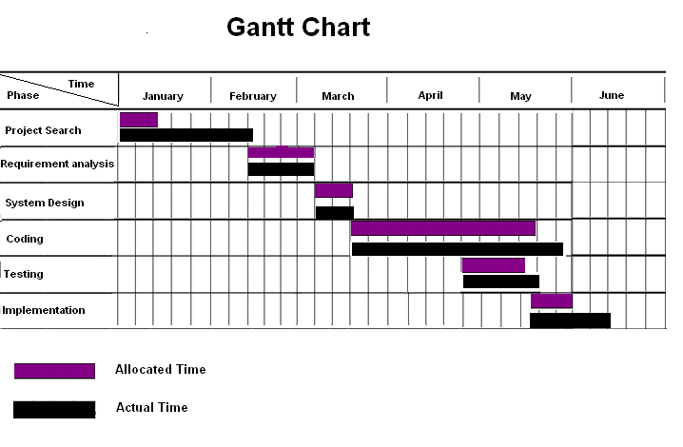

**System Design**

**3.1 Software Requirement Specification**

**3.1.1 Introduction**

**Purpose :** The purpose of project is to develop an online platform to organize and promote contests and meanwhile allowing businesses to increase their customer reach.

**Scope :**

.This project can be said to have the below mentioned scopes:

* Improve brand promotion within your targeted customers.
* Organize competitions online to save time and to be cost effective.
* Allow organizing contest on different social and technical platforms.
* The types of contests that can be organized are photo, video, audio and text based.
* Live contest editor will allow editing and customizing a contest and making it live to your intended audience within few steps.
* Inviting judges to judge a contest and promoting the contest itself is possible with mailers.
* Participant will be able to track its entry and its related stats.
* Anyone can vote for an entry, although it’s not fully possible to make a flawless voting system but it can be achieved to a good level.

**3.1.2 Selection of Technology**

**3.1.2.1Hardware:**

* CPU Type: Pentium-s.
* Base Memory: 1 MB.
* Extended Memory: 1 GB.
* Cache Memory: 2 MB.
* CPU Clock: 800MHz.
* Display Type: VGA/LCD.
* Hard Disk: 10 GB.

**3.1.2.2 Software Interface:**

* Operating System: UNIX, Windows XP/7/8.
* Web Browsers: Mozilla Firefox, Google Chrome, Safari, Internet Explorer 8+, Opera.

**3.1.2.3 Tools:**

* Wamp Server.
* Macromedia Dreamweaver 8.0.
* Adobe Photoshop cs6
* Adobe Illustrator cs6
* Notepad++

**3.2 Detailed life Cycle of the Project**

**3.2.1 Modules:**

The modules of the purposed project are as follows:

**ADMINISTRATOR:**

1. Manage users of system.
2. Business information / details.
3. Define business actions.

**ORGANIZERS:**

1. Manage contests.
2. Invite/judge contest.
3. Decide winners.
4. Make payments.
5. Contest follow-up.
6. Share contests.

**PARTICIPANT::**

1. Visit a contest.
2. Submits relevant entry.
3. Track entries.
4. Claim prizes.

**4.1 Object Oriented Analysis & Design Diagrams**

**4.1.1 Use Case Diagram:**



**4.1.2 Class Diagram:**



**4.1.3. Activity Diagram:**



**4.1.4. State Transition Diagram:**



**4.1.4.Sequence Diagram:**

**( Organizer ) :**



**( Participant ) :**



**4.1.5 Collaboration Diagram:**

**( Login Admin/Organizer ) :**



**( Organizer Interaction ) :**



**( Participant Interaction ) :**



**( Voter/Visitor Interaction ) :**



**4.1.5 Component Diagram:**



**4.1.6 Deployment Diagram:**



**5.1 Database**

**5.1.1 Database Schema**

**Login**:

|  |  |  |  |
| --- | --- | --- | --- |
| **Sr. No** | **Column Name** | **Data Type** | **Constraint** |
| 1 | id | Int | Primary key |
| 2 | Organization_name | Varchar(100) | Not NULL |
| 3 | Password | varchar(100) | Not NULL |

**Administrator**:

|  |  |  |  |
| --- | --- | --- | --- |
| **Sr. No** | **Column Name** | **Data Type** | **Constraint** |
| 1 | id | Int | Primary key |
| 2 | Organization_id | Int | Foreign Key |
| 3 | Name | varchar(100) | Not NULL |
| 4 | Email | varchar(100) | Not NULL |
| 5 | Contact | varchar(13) | Not NULL |
| 6 | Password | varchar(255) | Not NULL |

**Contest**:

|  |  |  |  |
| --- | --- | --- | --- |
| **Sr. No** | **Column Name** | **Data Type** | **Constraint** |
| 1 | Id | Int | Primary key,Autoincrement |
| 2 | Creator_id | Int | Foreign Key |
| 3 | Organization_id | Int | Foreign Key |
| 4 | Title | Varchar(100) | Not NULL |
| 5 | Tagline | Varchar(100) | Not NULL |
| 6 | Slug | Varchar(255) | Not NULL |
| 7 | Type | Int | Not NULL |
| 8 | Description | Varchar(255) | Not NULL |

**Sponsors**:

|  |  |  |  |
| --- | --- | --- | --- |
| **Sr. No** | **Column Name** | **Data Type** | **Constraint** |
| 1 | Id | Int | Primary key |
| 2 | Name | Varchar(100) | Not NULL |
| 3 | Contest_id | Int | Foreign Key |
| 4 | Organization_id | int | Foreign Key |

**Judges**:

|  |  |  |  |
| --- | --- | --- | --- |
| **Sr. No** | **Column Name** | **Data Type** | **Constraint** |
| 1 | Id | Int | Primary key,Autoincrement |
| 2 | Name | varchar(100) | Not NULL |
| 3 | Email | Varchar(100) | Not NULL |
| 4 | Designation | Varchar(255) | Not NULL |
| 5 | Photo_id | Int | Foreign Key |
| 6 | Contest_id | Int | Foreign Key |

**Organization**:

|  |  |  |  |
| --- | --- | --- | --- |
| **Sr. No** | **Column Name** | **Data Type** | **Constraint** |
| 1 | Id | Int | Primary key, Autoincrement |
| 2 | Name | varchar(100) | Not NULL |
| 3 | About | varchar(255) | Not NULL |
| 4 | Plan | Int | Not NULL |
| 5 | Logo_id | Int | Not NULL |
| 6 | Website | varchar(255) | Not NULL |
| 7 | Subdomain | varchar(255) | Not NULL |

**Entry**:

|  |  |  |  |
| --- | --- | --- | --- |
| **Sr. No** | **Column Name** | **Data Type** | **Constraint** |
| 1 | id | Int | Primary key, Autoincrement |
| 2 | Contest_id | Int | Foreign Key |
| 3 | name | varchar(45) | Not NULL |
| 4 | email | varchar(45) | Not NULL |

**Vote**:

|  |  |  |  |
| --- | --- | --- | --- |
| **Sr. No** | **Column Name** | **Data Type** | **Constraint** |
| 1 | entry_id | Int | Foreign key |
| 2 | ipaddress | varchar | Not NULL |
| 3 | User_agent | varchar(255) | Not NULL |
| 4 | Browser_plugins | varchar(255) | Not NULL |
| 5 | Time_zone | varchar(25) | Not NULL |
| 6 | Screen_size_color | varchar(25) | Not NULL |
| 7 | System_fonts | Varchar(255) | Not NULL |

**winner**:

|  |  |  |  |
| --- | --- | --- | --- |
| **Sr. No** | **Column Name** | **Data Type** | **Constraint** |
| 1 | entry_id | Int | Foreign key |
| 2 | position | Int | Not NULL |
| 3 | prize_id | Int | Foreign key |

**Prize**:

|  |  |  |  |
| --- | --- | --- | --- |
| **Sr. No** | **Column Name** | **Data Type** | **Constraint** |
| 1 | Id | Int | Primary key, Auto increment |
| 2 | Item | varchar(25) | Not NULL |
| 3 | Description | Varchar(255) | Not NULL |
| 4 | Photo_id | Int | Foreign Key |
| 5 | Contest_id | Int | Foreign Key |
| 6 | Rank | Int | Not NULL |
| 7 | Quantity | Int | Not NULL |

**Media**:

|  |  |  |  |
| --- | --- | --- | --- |
| **Sr. No** | **Column Name** | **Data Type** | **Constraint** |
| 1 | Id | Int | Primary key,Autoincrement |
| 2 | Type | Int | Not NULL |
| 3 | Alt | Varchar(255) | Not NULL |
| 4 | file_name | Varchar(255) | Not NULL |
| 5 | file_type | Varchar(45) | Not NULL |
| 6 | file_size | Int | Not NULL |
| 7 | Organization_id | Int | Foreign Key |

**5.2Screen Layouts**

**Login Page :**

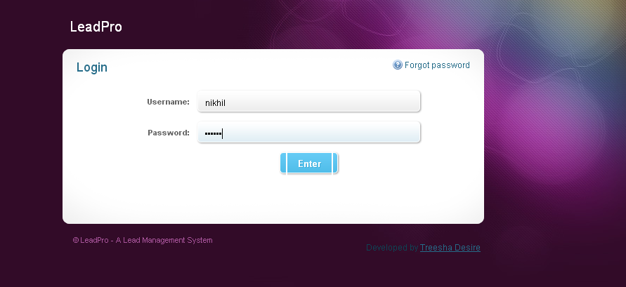

**Admin Home Page:**

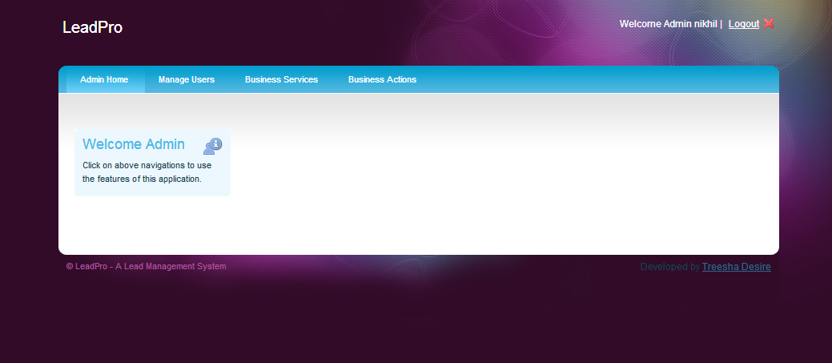

**Admin Manage User:**

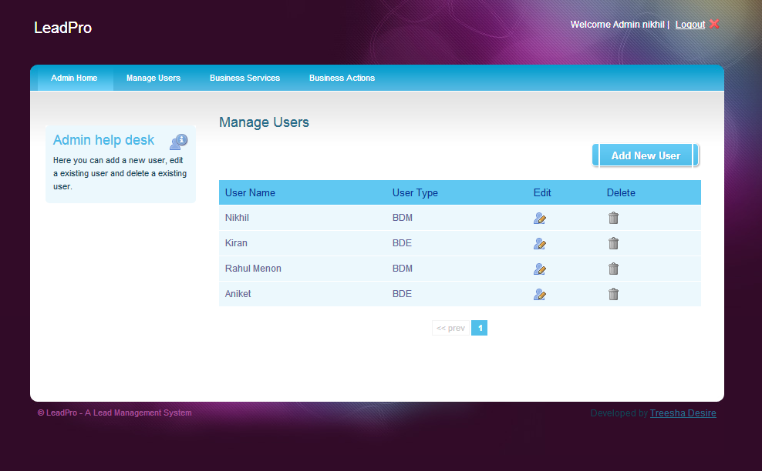

**Admin Edit User:**

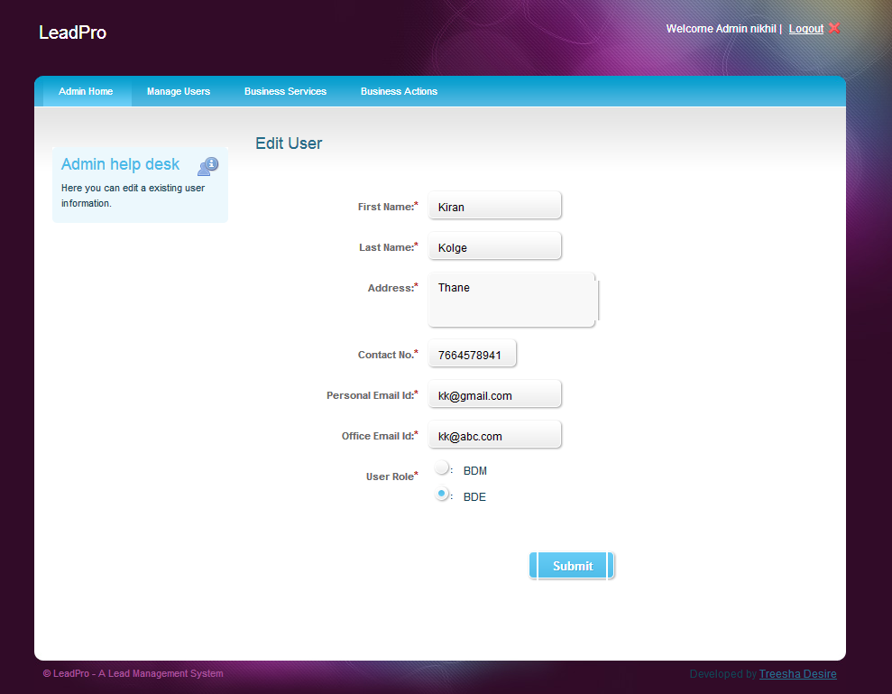

**Admin Manage Business Service:**

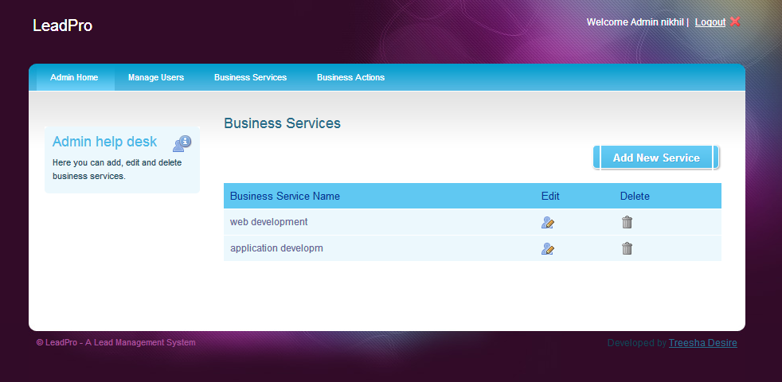

**Admin Manage Business Action:**

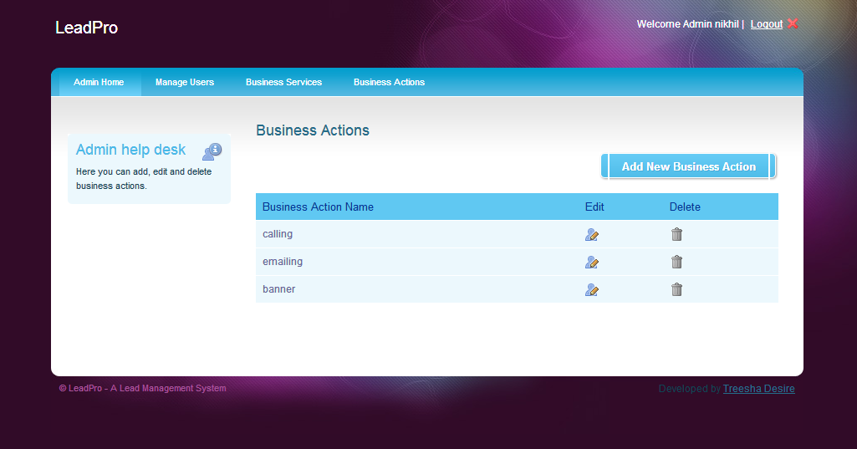

**BDM Home Page:**

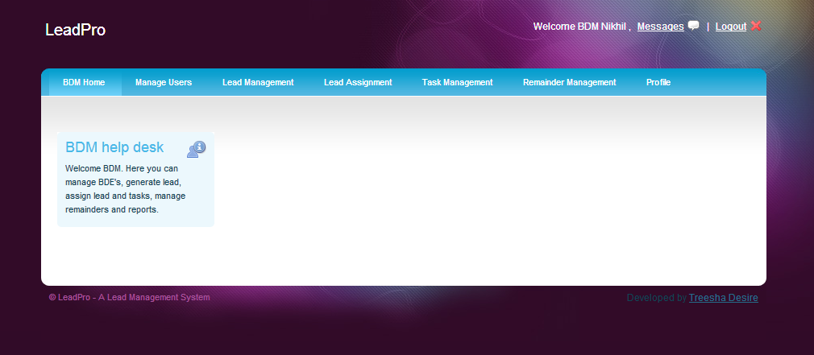

**BDM Manage BDE:**

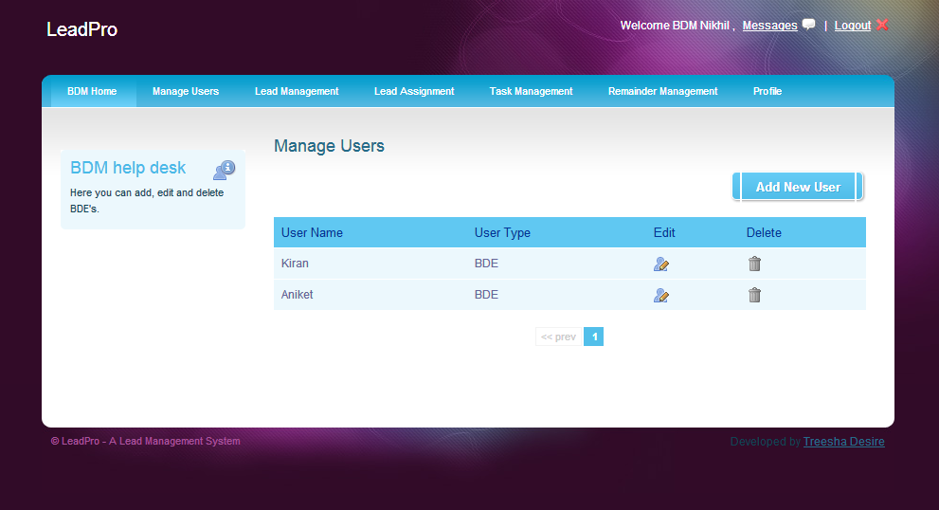

**BDM Generate Lead:**

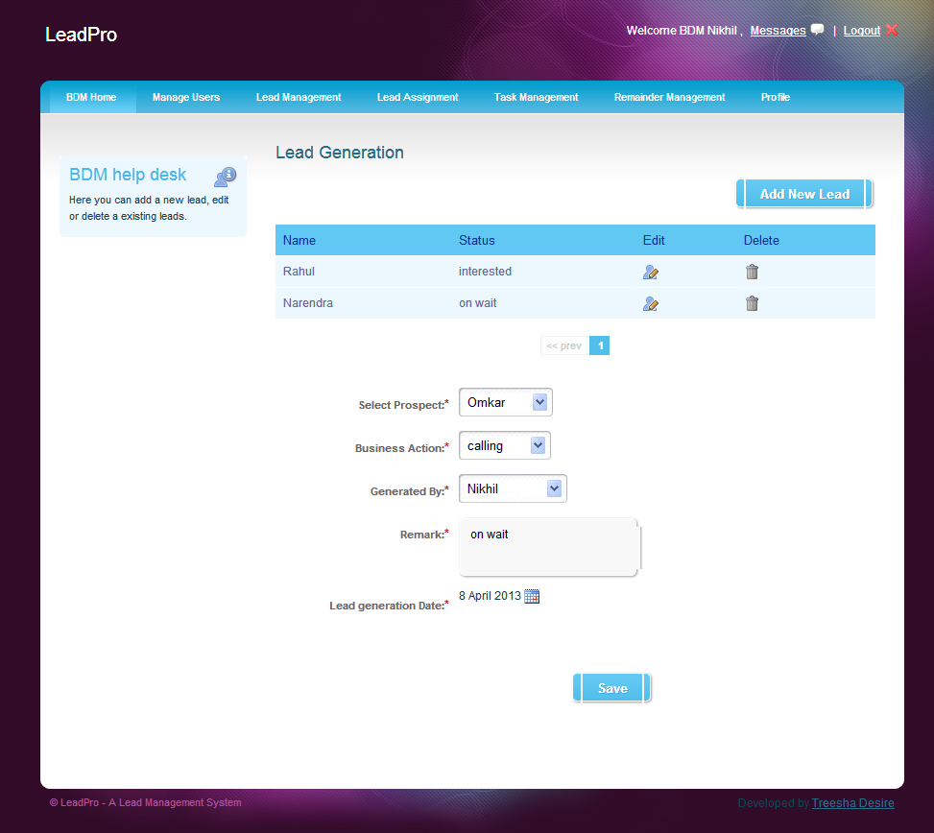

**BDM Assign Lead:**

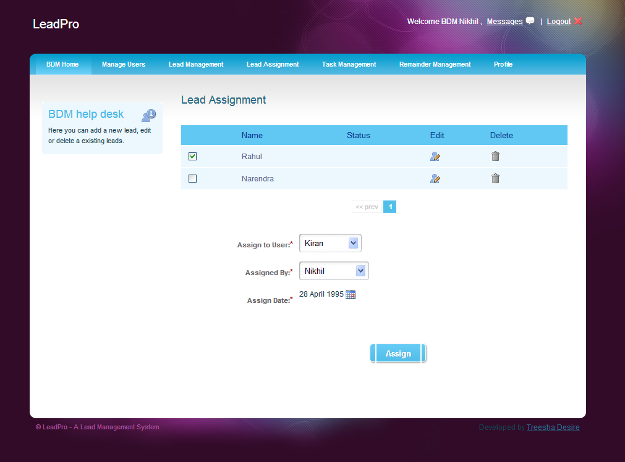

**BDM Assign Task:**

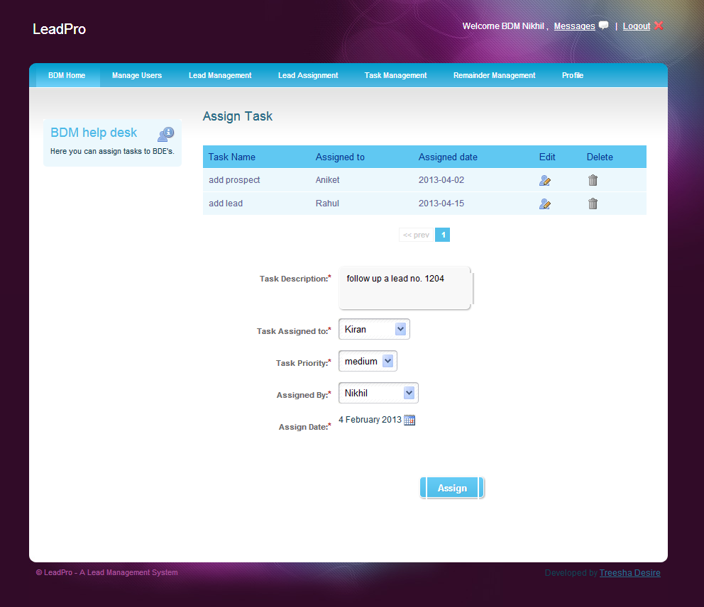

**BDE Home Page:**

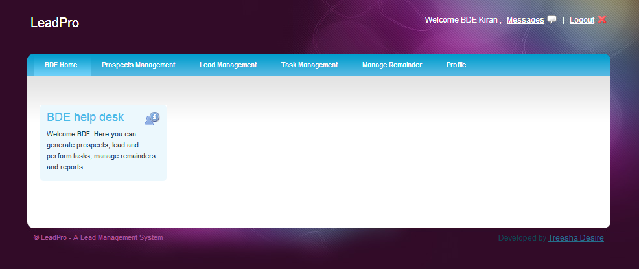

**BDE Manage Prospect:**

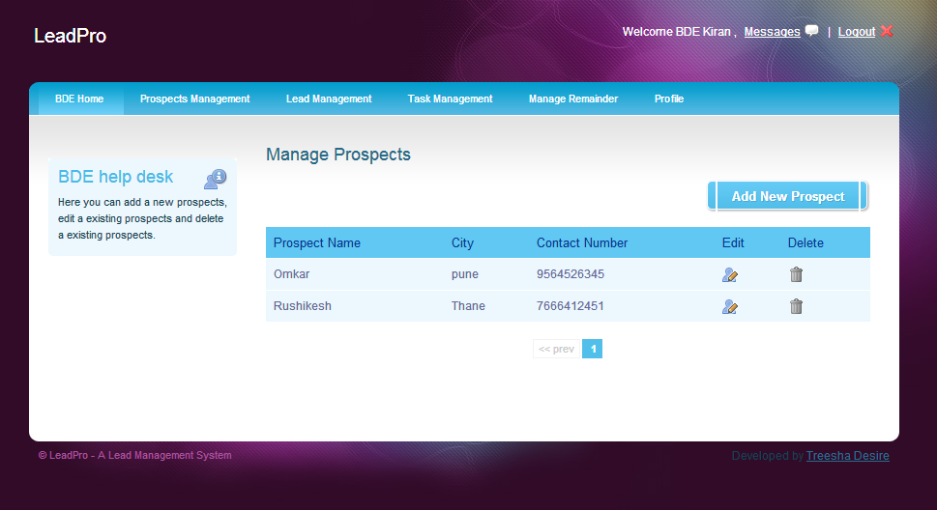

**BDE Add Prospect:**

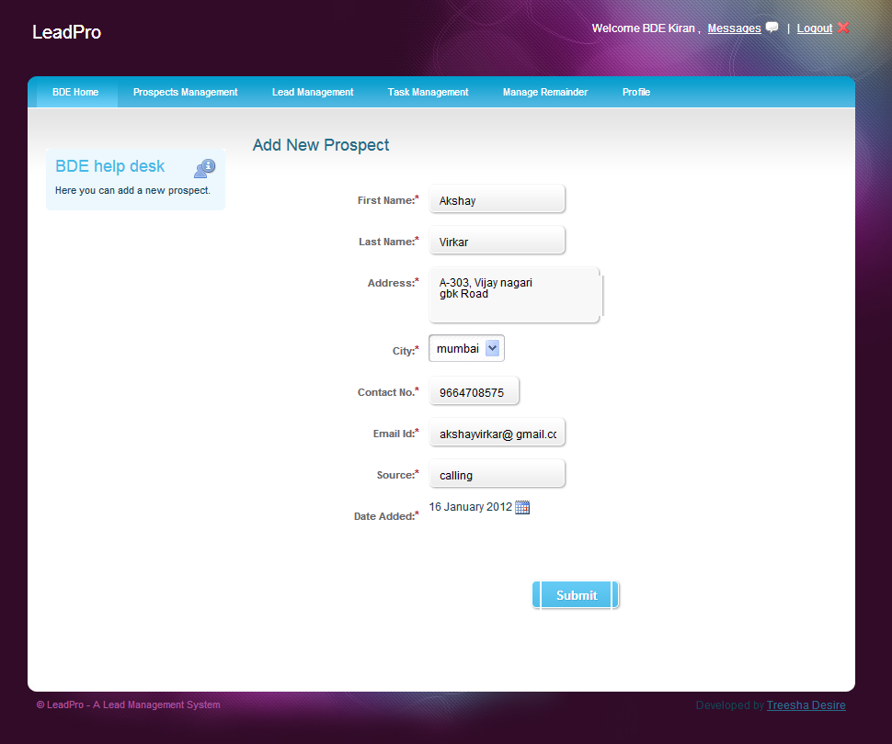

**BDE Lead follow-up:**

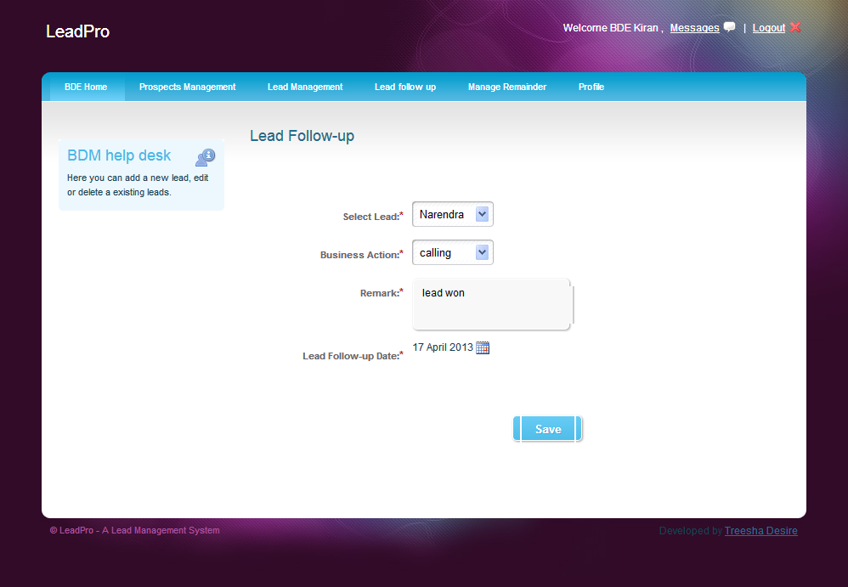

**Profile:**

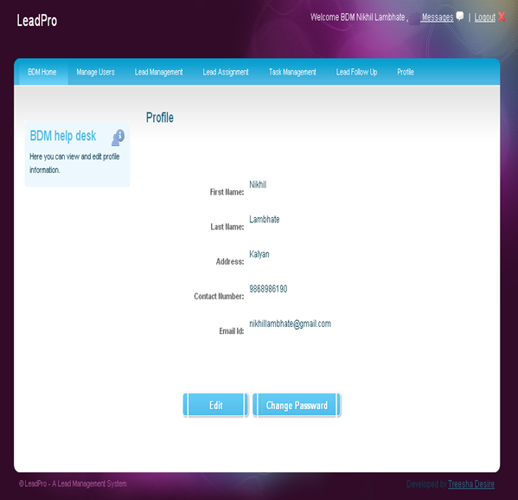

**Change Passward:**

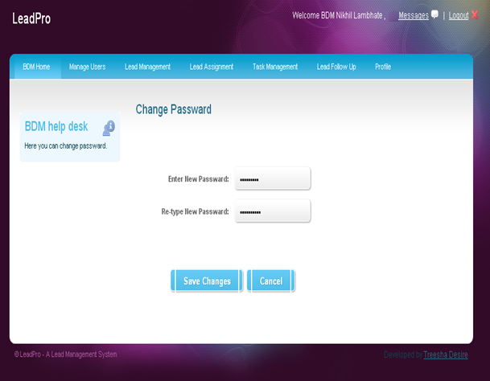

**Delete Prospect:**

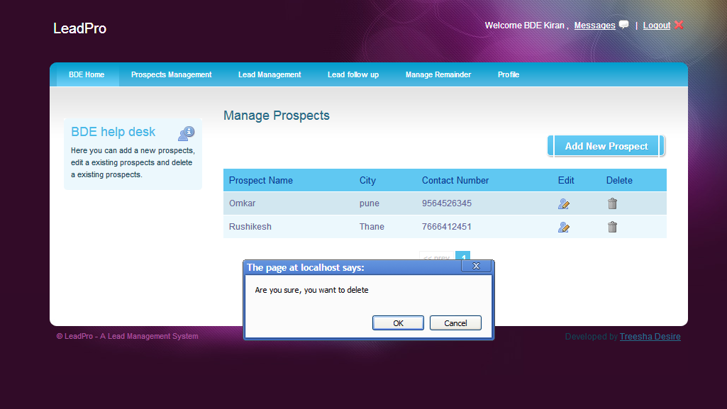

**Testing**

|  |  |  |  |  |  |  |  |  |  |  |  |  |  |  |  |  |  |  |  |  |  |  |  |  |  |  |  |  |  |  |  |  |  |  |  |  |  |  |  |  |  |  |  |  |  |  |  |  |  |  |  |  |  |  |  |  |  |  |  |  |  |  |  |  |  |  |  |  |  |  |  |  |  |  |  |  |  |  |  |  |  |  |  |  |  |  |  |  |  |  |  |  |  |  |  |  |  |  |  |  |  |  |  |  |  |  |  |  |  |  |  |  |  |  |  |  |  |  |  |  |  |  |  |  |  |  |  |  |  |  |  |  |  |  |  |  |  |  |  |  |  |  |  |  |  |  |  |  |  |  |  |  |  |  |  |  |  |  |  |  |  |  |  |  |  |  |  |  |  |  |  |  |  |  |  |  |
| --- | --- | --- | --- | --- | --- | --- | --- | --- | --- | --- | --- | --- | --- | --- | --- | --- | --- | --- | --- | --- | --- | --- | --- | --- | --- | --- | --- | --- | --- | --- | --- | --- | --- | --- | --- | --- | --- | --- | --- | --- | --- | --- | --- | --- | --- | --- | --- | --- | --- | --- | --- | --- | --- | --- | --- | --- | --- | --- | --- | --- | --- | --- | --- | --- | --- | --- | --- | --- | --- | --- | --- | --- | --- | --- | --- | --- | --- | --- | --- | --- | --- | --- | --- | --- | --- | --- | --- | --- | --- | --- | --- | --- | --- | --- | --- | --- | --- | --- | --- | --- | --- | --- | --- | --- | --- | --- | --- | --- | --- | --- | --- | --- | --- | --- | --- | --- | --- | --- | --- | --- | --- | --- | --- | --- | --- | --- | --- | --- | --- | --- | --- | --- | --- | --- | --- | --- | --- | --- | --- | --- | --- | --- | --- | --- | --- | --- | --- | --- | --- | --- | --- | --- | --- | --- | --- | --- | --- | --- | --- | --- | --- | --- | --- | --- | --- | --- | --- | --- | --- | --- | --- | --- | --- | --- | --- | --- |
| **6.1.1Methodologies used for Testing**  **W Model:**  Paul Herzlich introduced the W-Model approach in 1993. The W-Model  attempts to address shortcomings in the V-Model. Rather than focus on specific dynamic test stages, as the V-Model does, the W-Model focuses on the development products themselves. Essentially, every development activity that produces a work product is “shadowed” by a test activity. The purpose of the test activity specifically is to determine whether the objectives of a development activity have been met and the deliverable meets its requirements. In its most generic form, the W-Model presents a standard development lifecycle with every development stage mirrored by a test activity. On the left hand side, typically, the deliverables of a development activity (for example, write requirements) is accompanied by a test activity “test the requirements” and so on. If your organization has a different set of development stages, then the W-Model is easily adjusted to your situation. The important thing is this: the W-Model of testing focuses specifically on the product risks of concern at the point where testing can be most effective.  **Advantages of W-Model :**   * More time to plan, test and set-up the test enviornments. * Clean documentation of the code. * Closer co-operation between development and testing activities exist. * Testers and developers are given the same responsibilities and are treated as equals. * It avoids conflicts between developers and clients since the client is involved from start.   **4.2 Types of Testing**  **4.2.1 White Box Testing:**  **White-box testing** is a method of testing software that tests internal structures or workings of an application, as opposed to its functionality. In white-box testing an internal perspective of the system, as well as programming skills, are required and used to design test cases. The tester chooses inputs to exercise paths through the code and determine the appropriate outputs.  White-box testing can be applied at the unit, integration and system levels of the software testing process; it is usually done at the unit level. It can test paths within a unit, paths between units during integration, and between subsystems during a system level test. Though this method of test design can uncover many errors or problems, it might not detect unimplemented parts of the specification or missing requirements.  Using the white-box testing techniques, a software engineer can design the following test cases:   * Exercise independent paths within a module or unit; * Exercise logical decisions on both their true and false side; * Execute loops at their boundaries and within their operational bounds; and * Exercise internal data structures to ensure their validity   **4.2.2Black Box Testing:**  **Black Box testing** takes an external perspective of the test object to derive test cases. These tests can be functional or non-functional, though usually functional. The test designer selects valid and invalid inputs and determines the correct output.  Black-box testing implies that a tester doesn't know how an application is designed at the code level that is, it involves dynamic testing of compiled applications. The tester interacts with the software system via its interface and analyzes the application reaction.  Black box testing, concrete box or functional testing is used to check that the outputs of a program, given certain inputs, conform to the functional specification of the program.The advantages of this type of testing include:   * The test is unbiased because the designer and the tester are independent of each other. * The tester does not need knowledge of any specific programming languages. * The test is done from the point of view of the user, not the designer. * Test cases can be designed as soon as the specifications are complete. * The disadvantages of this type of testing include: * The test can be redundant if the software designer has already run a test case. * The test cases are difficult to design. * Testing every possible input stream is unrealistic because it would take a inordinate amount of time; therefore, many program paths will go untested.   **6.1.2 Unit Testing**   |  | | --- | | **Form Name:** Login |  |  |  |  |  |  |  |  | | --- | --- | --- | --- | --- | --- | --- | | Test Case No | Description /  Scenario | Step to be Executed | Test data if any | Expected Result | Actual Result | Test Result | | IC_101 | Log in Page | 1. Leave all fields blank and click log-in button | - | 1. By leaving all fields as blank and on click Login button then error should appear in box. | 1.By leaving all fields as blank and on click Log-in button then error should appear in box. | Pass | | IC_102 | Invalid user name & password | 1. Enter invalid user name in first text field.  2. Enter invalid password in second text field. | User name: admin  Password: password | 1. By entering invalid user name and password, error should as “Invalid user name /password” appear . | 1. By entering invalid user name and password, error should as “Invalid user name /password” appear in box. | Pass | | IC _103 | Valid user name & password | 1. Enter valid user name in first text field.  2. Enter valid password in second text field. | User name: admin  Password: admin | On click " Log-in", page should redirect to the main home page | On click " Log-in", page should redirect to the main home page | Pass |   **Page Name:** Register User   |  |  |  |  |  |  |  | | --- | --- | --- | --- | --- | --- | --- | | Test Case No | Description /  Scenario | Step to be Executed | Test data if any | Expected Result | Actual Result | Test Result | | IC _201 | Fill register user form | 1. Leave all fields blank and click Submit button | - | 1. By leaving all fields as blank and on click Submit button then error should appear. | 1. By leaving all fields as blank and on click Submit button then error should appear. | Pass | | IC _202 | This test case would check for a valid User Name. | 1 Open the Register User Form. Enter valid User Name. | User Name | User name should be accepted. | User name should be accepted. | Pass | | IC_203 | This test case would check for a valid Password. | 1 Open the Register User Form. Enter valid Password. | Password | Password should be accepted. | Password should be accepted. | Pass | | IC_204 | This test case would check for a valid email id | Open the Register User Form. Enter valid email id | Email id | Email id should be accepted. | Email id accepted. | Pass | | IC_205 | This testcase would check for a invalid email id | Open the Register User Form. Enter invalid email id | Email id | Email id should not be accepted. | Email id not accepted. | Pass |   **Page Name:** Create Contest   |  |  |  |  |  |  |  | | --- | --- | --- | --- | --- | --- | --- | | Test Case No | Description /  Scenario | Step to be Executed | Test data if any | Expected Result | Actual Result | Test Result | | IC_301 | Fill the contest title field. | 1. Leave field blank and click continue button | - | 1. By leaving field as blank and on click Continue button then error should appear. | 1. By leaving field as blank and on click Continue button then error should appear. | Pass | | IC _302 | Fill the contest tagline field. | 1. Leave field blank and click continue button | - | 1. By leaving field as blank and on click Continue button then error should appear. | 1. By leaving field as blank and on click Continue button then error should appear. | Pass | | IC _303 | Fill the contest description field. | 1. Leave field blank and click continue button | - | 1. By leaving field as blank and on click Continue button then error should appear. | 1. By leaving field as blank and on click Continue button then error should appear. | Pass | | IC _304 | Fill the contest start date field. | 1. Leave field blank and click continue button | - | . 1. By leaving field as blank and on click Continue button then error should appear. | 1. By leaving field as blank and on click Continue button then error should appear. | Pass | | IC _305 | Fill the contest end date field. | 1. Leave field blank and click continue button | - | . 1. By leaving field as blank and on click Continue button then error should appear. | 1. By leaving field as blank and on click Continue button then error should appear. | Pass | | IC _306 | Fill the contest voting start date field. | 1. Leave field blank and click continue button | - | . 1. By leaving field as blank and on click Continue button then error should appear. | 1. By leaving field as blank and on click Continue button then error should appear. | Pass | | IC _306 | Fill the contest voting end date field. | 1. Leave field blank and click continue button | - | . 1. By leaving field as blank and on click Continue button then error should appear. | 1. By leaving field as blank and on click Continue button then error should appear. | Pass | | IC _307 | Fill the contest winners announcement date field. | 1. Leave field blank and click continue button | - | . 1. By leaving field as blank and on click Continue button then error should appear. | 1. By leaving field as blank and on click Continue button then error should appear. | Pass | | IC _308 | Fill the contest price title field. | 1. Leave field blank and click continue button | - | . 1. By leaving field as blank and on click Continue button then error should appear. | 1. By leaving field as blank and on click Continue button then error should appear. | Pass | | IC _309 | Fill the contest judge name field. | 1. Leave field blank and click continue button | - | . 1. By leaving field as blank and on click Continue button then error should appear. | 1. By leaving field as blank and on click Continue button then error should appear. | Pass | | IC _310 | Fill the contest judge designation field. | 1. Leave field blank and click continue button | - | . 1. By leaving field as blank and on click Continue button then error should appear. | 1. By leaving field as blank and on click Continue button then error should appear. | Pass | | IC _311 | Fill the contest judge description field. | 1. Leave field blank and click continue button | - | . 1. By leaving field as blank and on click Continue button then error should appear. | 1. By leaving field as blank and on click Continue button then error should appear. | Pass | | IC _312 | Fill the contest sponsors name field. | 1. Leave field blank and click continue button | - | . 1. By leaving field as blank and on click Continue button then error should appear. | 1. By leaving field as blank and on click Continue button then error should appear. | Pass | | IC _313 | Fill the contest sponsors description field. | 1. Leave field blank and click continue button | - | . 1. By leaving field as blank and on click Continue button then error should appear. | 1. By leaving field as blank and on click Continue button then error should appear. | Pass |   **4.4 Test Report**   * Test case ID: IC_103 * Test Case Description: This test case would check for a valid User name and invalid password for Login form. * Module Name: Login (unit testing) * Before Retesting Result: FAIL * Developer has Checked/Not: Checked |

|  |
| --- |
|  |
|  |
|  |
|  |
|  |
|  |
|  |

**System**

**Implementation**

**5.1 Hardware Required at Client-Side**

The user must have a computer system with internet connectivity and following minimum specifications:

* **Processor:** 800 MHz Pentium III or Athlon (Minimum); 1GHz Pentium processor or equivalent (Recommended)
* **Ram:** 256MB (Minimum); 512MB (Recommended)
* **Display:** 800 x 600, 256 colors (Minimum); 1024 x 768 high color, 32-bit (Recommended)

**5.2Software Required at Client-Side**

* All latestWeb browser(IE 7 and above).

**System Maintenance**

**And**

**Evaluation**

**8.1 Maintenance**

Once the website is successfully uploaded on the web server it may undergo some changes. This may occur due to a change in the requirements, change in operational environment or an error in software, which has not been fixed while testing. The proper follow up of the system and error solving in post implementation phase is what is called as maintenance.

Maintenance is a very important phase. As our website is based on Telecom Service the management would require to maintain it to keep it up-to-date with customers requirements. The maintenance of website will require:

* Testing and dispatch are done after Customer complaints being rectified or fulfill the customer accessories requirements
* Also new templates will have to be added to the existing categories.
* The management will have to evaluate the feedbacks of the customers and make necessary changes in application.

**8.2 Evaluation**

In the present day market situation, there are several alternatives available when a customer wants to purchase a product or adopt a software system that meets the customer’s requirements. Software technologies have been evolving rapidly and for a given set of functional and non-functional requirements there usually exist several competing software products. The present day users are faced with a challenging situation that requires evaluation and selection of a suitable software product that satisfies the users’ operational and business needs. Unfortunately this evaluation is usually carried on in an ad-hoc and informal way and with various degree of success.

Software evaluation methodologies can be divided into two categories.

The First category is used to evaluate software development methodology or processes such as those used to evaluate various agent-based development methodologies.

The Second category is used to evaluate software products such as Cost evaluation and selection methodologies.

System Evaluation recognizes and integrates the important features of other frameworks, overcomes any obvious deficiencies, and adopts new features that generalize and extend its usability.

The evaluation stage of the software development process requires the client and developer to review the software.

Broadly speaking, they evaluate against the following questions:

1. Does this software meet the user requirements?

2. Is it fit for purpose?

**Evaluation - Criteria:**

To answer these questions, the original aims of the software must be evaluated against the

Following criteria:

1. Robustness

2. Reliability

3. Portability

4. Efficiency

5. Maintainability

**Evaluation - When:**

The software should be evaluated by client and developer at all stages in the process, not just when the software is complete.

**User/Operational**

**Manual**

1) This is a guide for the user of this system.

2) This contains all the relevant screen display that will help the user to understand the system.

3) There are proper uses of comments that will help the user to understand in case of error.

4) Proper validation is done and message box are prompted to the user before entering data into the database.

5) The comments describe what exactly the code block does.

**Security Aspects, Access Rights**

Does the software protect itself and its data against unauthorized access and use? Does it allow its operator to enforce security policies? Are appropriate security mechanisms in place? Are those security mechanisms implemented correctly? Can the software withstand attacks that must be expected in its intended environment? Is the software free of errors that would make it possible to circumvent its security mechanisms? Does the architecture limit the impact of yet unknown errors? Security testing is any develop system is about finding loops and weaknesses of the system

Administrator has a right to access all the web forms of the project.

Normal user also has the permission to access the web forms of the Details Menu and the maps which shows the history.

**User's perspective:**

In addition to the technical qualities of software, the end user's experience also determines the quality of software. This aspect of software quality is called usability. It is hard to quantify the usability of a given software product. Some important questions to be asked are:

* Is the user interface intuitive?
* Is it easy to perform easy operations?
* Is it feasible to perform difficult operations?
* Does the software give sensible error messages?
* Do widgets behave as expected?
* Is the software well documented?
* Is the user interface self-explanatory/ self-documenting?

**Back Up’s**

In information technology, backup refers to making copies of data so that these additional copies may be used to restore the original after a data loss event. These additional copies are typically called "backups." Backups are useful primarily for two purposes. The first is to restore a state following a disaster (called disaster recovery). The second is to restore small numbers of files after they have been accidentally deleted or corrupted. Backups aretypically that last line of defense against data loss, and consequently the least granular and the least convenient to use.

Since a backup system contains at least one copy of all data worth saving, the data storage requirements are considerable. Organizing this storage space and managing the backup process is a complicated undertaking. There are also many different ways in which these devices can be arranged to provide geographic redundancy, data security, and portability. Before data are sent to their storage location, they are selected, extracted, and manipulated.

Many organizations and individuals try to have confidence that the process is working as expected and work to define measurements and validation techniques. It is also important to recognize the limitations and human factors involved in any backup scheme.

Due to a considerable overlap in technology, backups and backup systems are frequently confused with archives and fault-tolerant systems. Backups differ from archives in the sense that archives are the primary copy of data and backups are a secondary copy of data. Backup systems differ from fault-tolerant systems in the sense that backup systems assume that a fault will cause a data loss event and fault-tolerant systems assume a fault will not.

* + Database Backups is taken by Admin on weekly basis.
  + Backups help in Data Integrity.

I

**Future Enhancements**

The future enhancements that can be applied to the website are as follows:

* The new types of contests that can be organized can be work on.
* Collaborative work can be done, with add co-organizer facility.
* More security measures can be applied.
* Enhancing contest customization.

**Limitations**

The limitations of the website are as follows:

* The user has to be computer literate.
* Website will not work in case of internet unavailability
* The website will not work in case of power failure.
* Maintenance costs are high and expensive to fabricate.

**Conclusion**

We have tried to create a software where contests can be organized as well as it can be customized according to the client’s needs. All the latest technology and framework have been used to create this software.

The objective of this project was to build a software where people just have to create a contest rather than developing the entire software. This saves their time and effort. All types of competitions can be organized on Icompet. The main objective of the software was that it should be user-friendly and easily accessible to all. We have tried our best in achieving this objective.

As with every software, Icompet also has room for improvement. The important thing is that the software is flexible enough for future modifications. The system is adaptable to changes in the future. All efforts are taken to make the software secure and user-friendly.

**Goals achieved:**

* **User-friendly:** The software developed is easy to understand and user-friendly. Interaction between the user and system is less complex.
* **Security:** Proper Safety measures have been ensured so that the software cannot be hacked for malpractices or other uses.
* **Quality standards achieved:** We have managed to produce a quality software with the latest technology and frameworks.
* **Rigorous testing:**  The software has gone through rigorous tests and that has ensured its robustness.
* **Affordable cost:**  Even with the latest technology and frameworks used, the software is available to all at an affordable cost.

**Bibliography**

**Reference Books:-**

* + PHP 5.1 for beginners.

*Author: - Ivan Bayross and Sharanam Shah*

* + Head First PHP and MYSQL

*Author: - Lynn Beingley and Micheal Morrison.*

**Websites:-**

* *www.php.net*
* *www.w3schools.com*
* *www.tizag.com*
* [*www.stackoverflow.com*](http://www.stackoverflow.com)
* [*www.bootstrap.com*](http://www.bootstrap.com)
* [*www.jquery.com*](http://www.jquery.com)
* [*www.yiiframework.com*](http://www.yiiframework.com)

###### **Epilogue**

Although extensive effort has been put by myself to develop this project and full code is debugged numerous times by me, but you see there are times when things doesn’t go the way one expects them to go!

Hence in case of mistake physical or logical I hope that you will be kind enough to make me aware of my mistakes and will overlook it.

I will ensure that I will try to check that the mistakes are not repeated in future!!

**THANKING YOU!!**

**Nikhil D. Sawant**

**Chinmay S. Joshi**

**Avinash J. Ghare**