**Practical no:05**

Aim:To study Sequence diagram for Online Shopping Processing System



**Practical no:06**

Aim:To study Collaboration diagram for Online Shopping Processing System

Login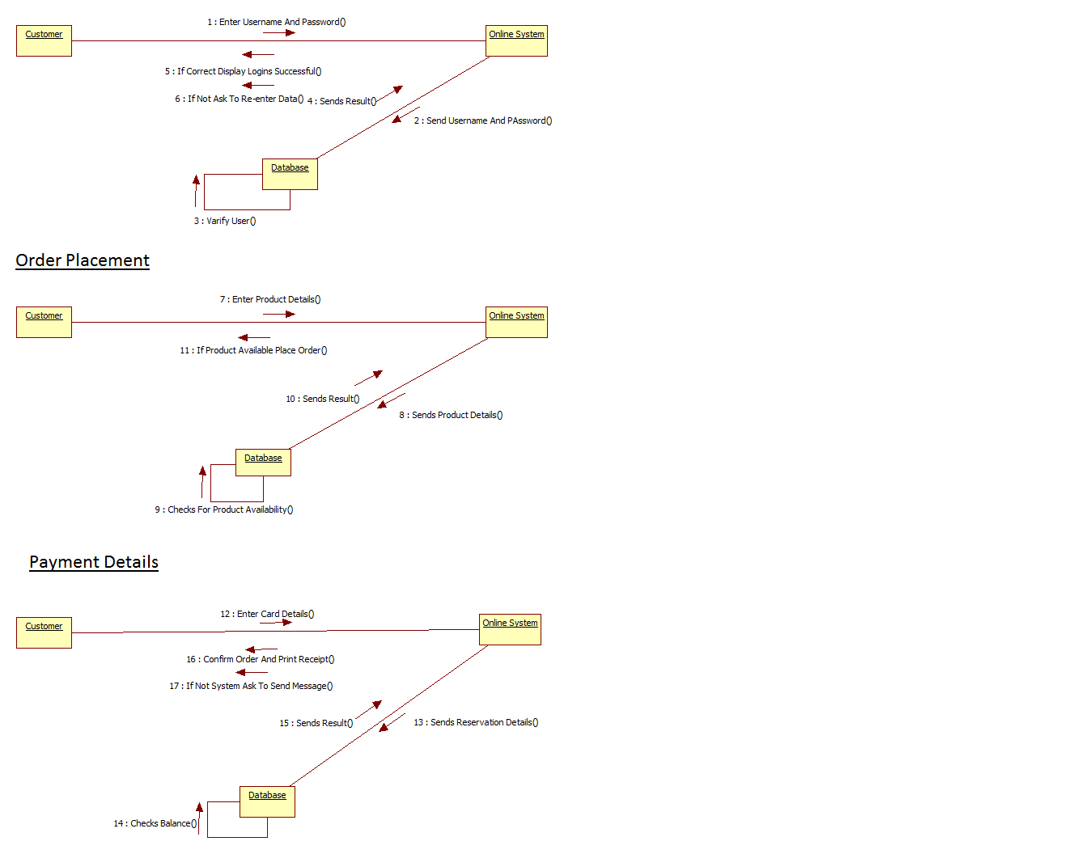

**Practical no:07**

Aim:To study Component diagram for Online Shopping Processing System



**Practical no:08**

Aim:To study Deployment diagram for Online Shopping Processing System

