**Sequence diagram**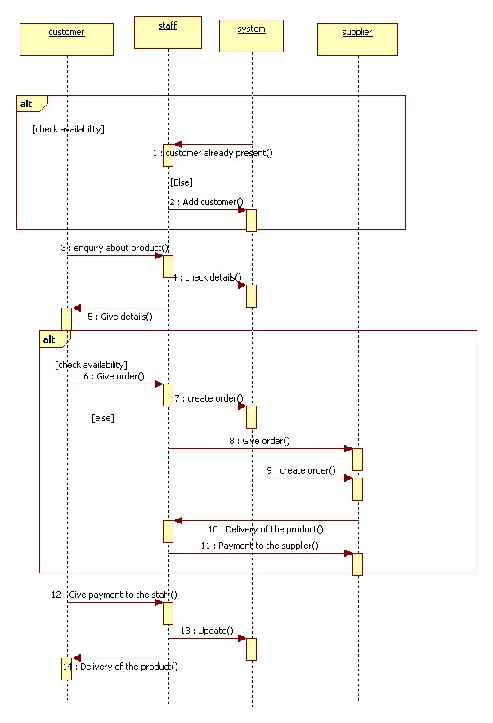

**Collaboration diagram**



**Component diagram**



**Deployment diagram**

