**1. create Lifecycle rule to move only files in logs folder to other storage class.**

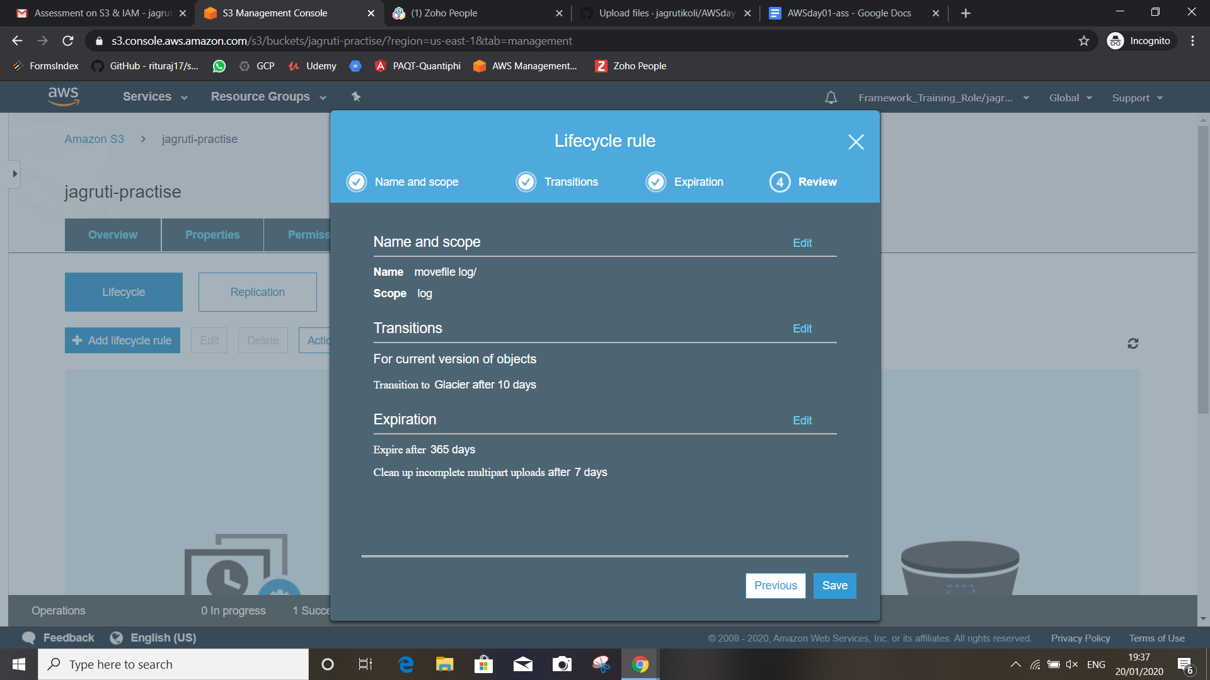

**2. Set up CORS between two buckets in two different regions.**

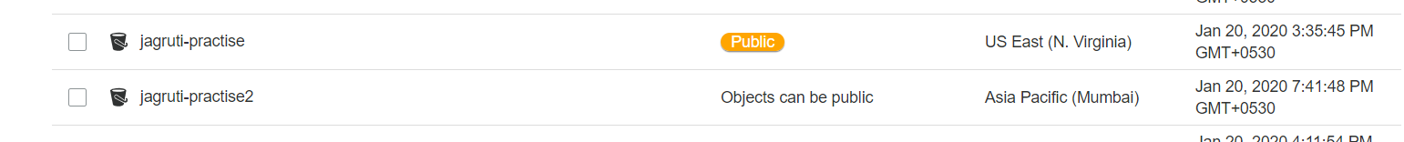

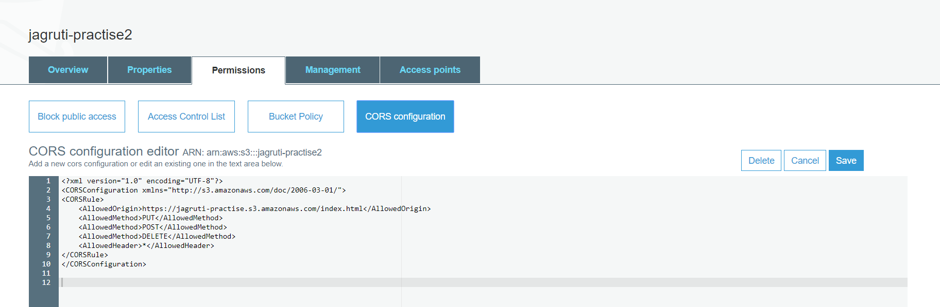

**3. Create event notification to trigger lambda function (as and when put event occurs, use any existing lambda function.)**

