**Ques1**

Steps to host a Static Website

1. Create a bucket in GCS

2. Upload a html file (staticwebsite.html)

3. In the file options, click on Edit Permissions

4. Click on Add Item

5. Enter the following in the respective columns

Entity-User

Name-allUsers

Access- Reader

6. Click on Save

7. Public Access is assigned to the file

8. Click on the IP generated

Our static website is hosted

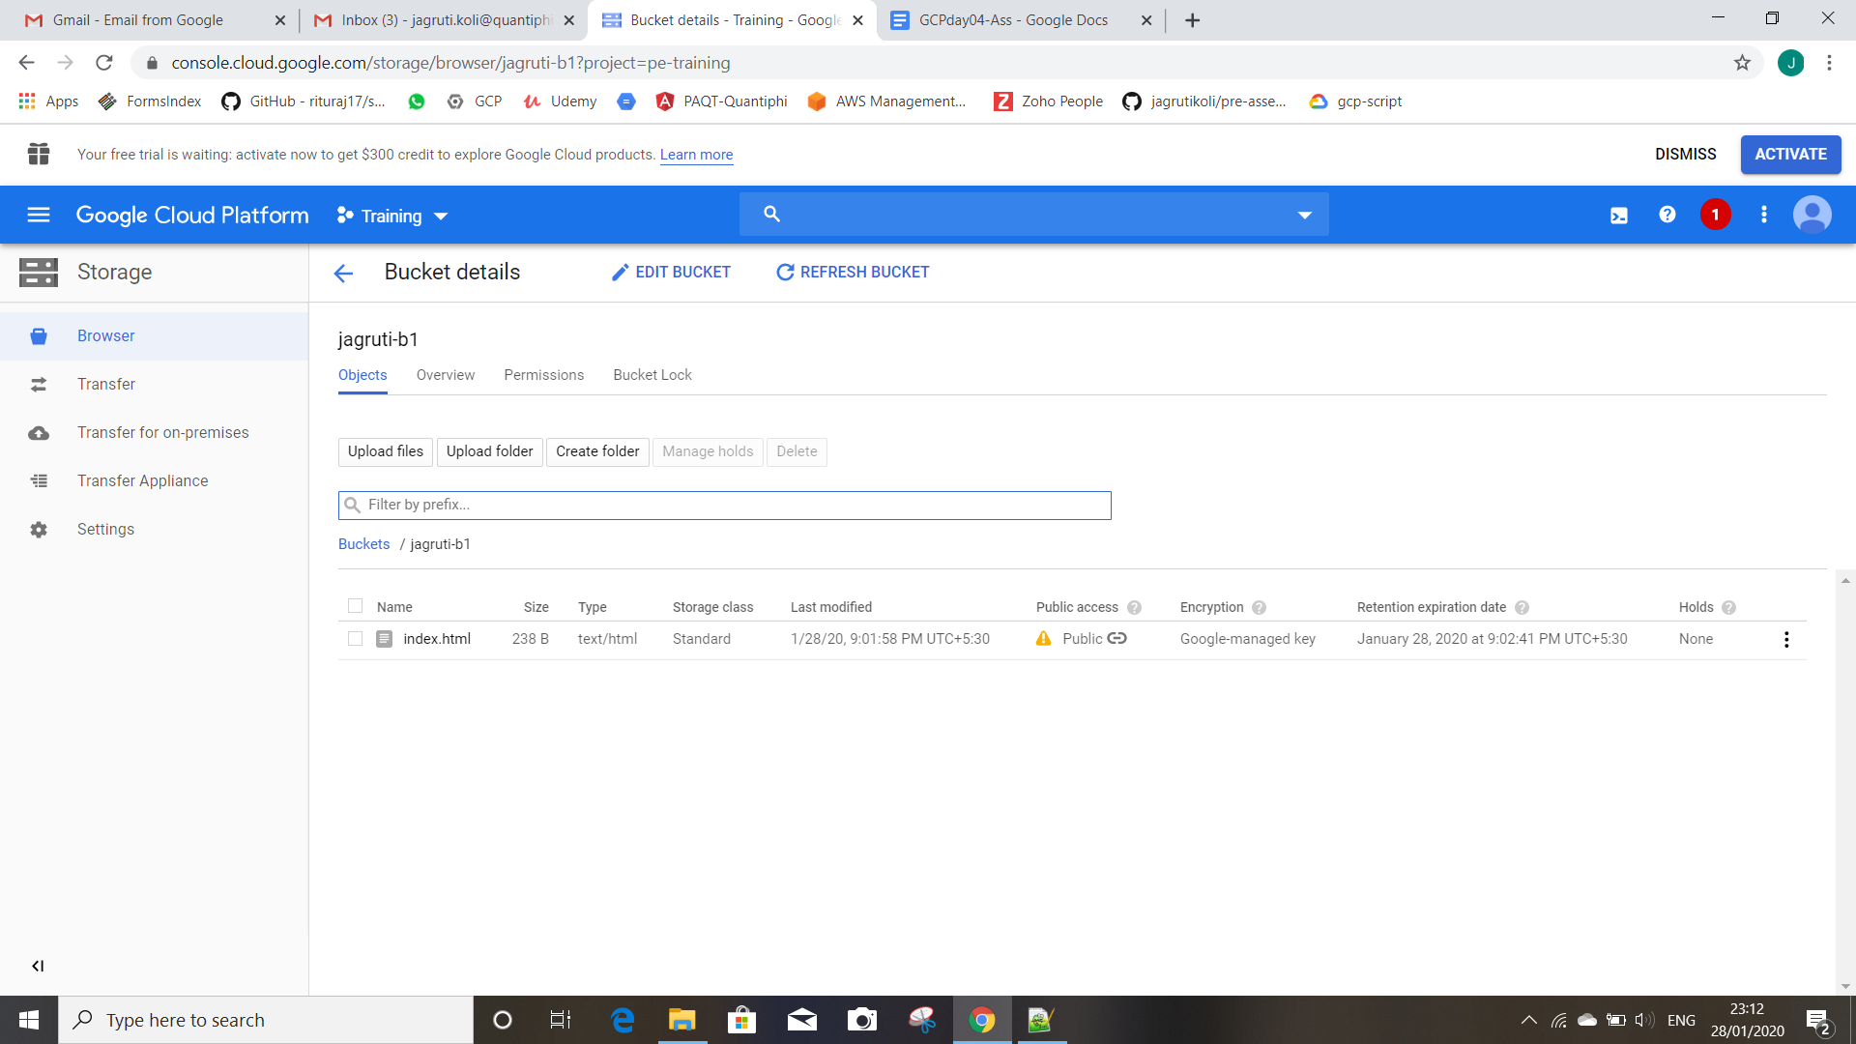

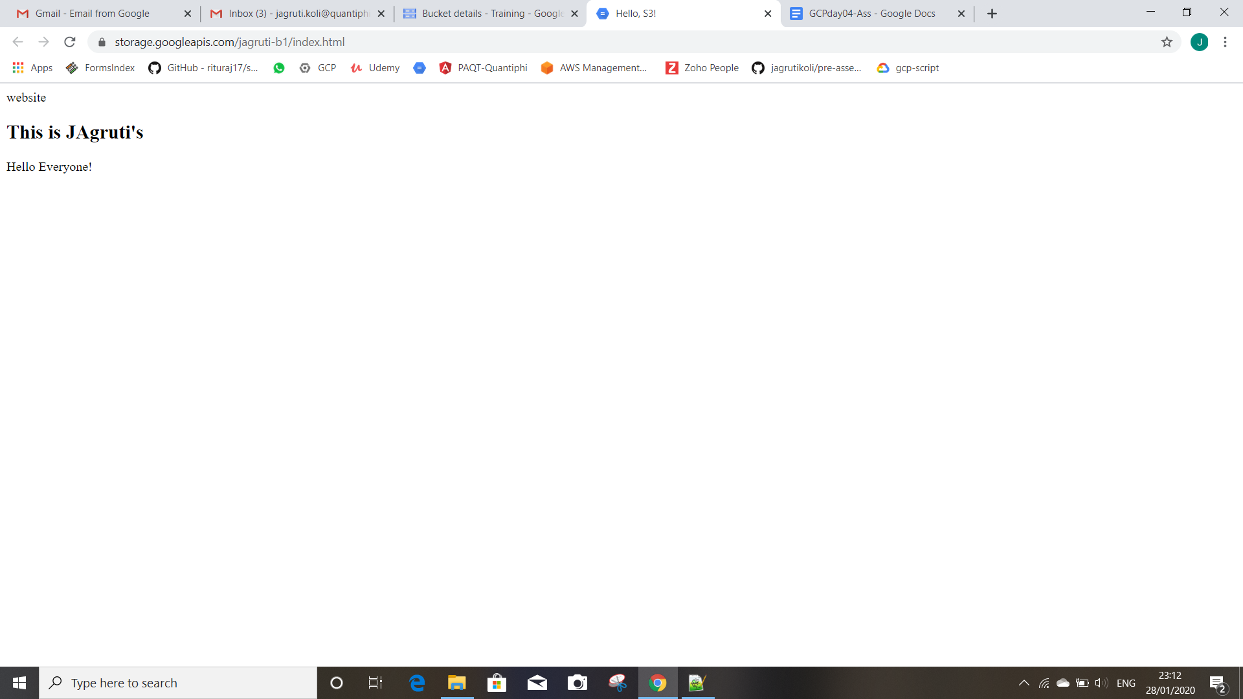

**Ques 2:**

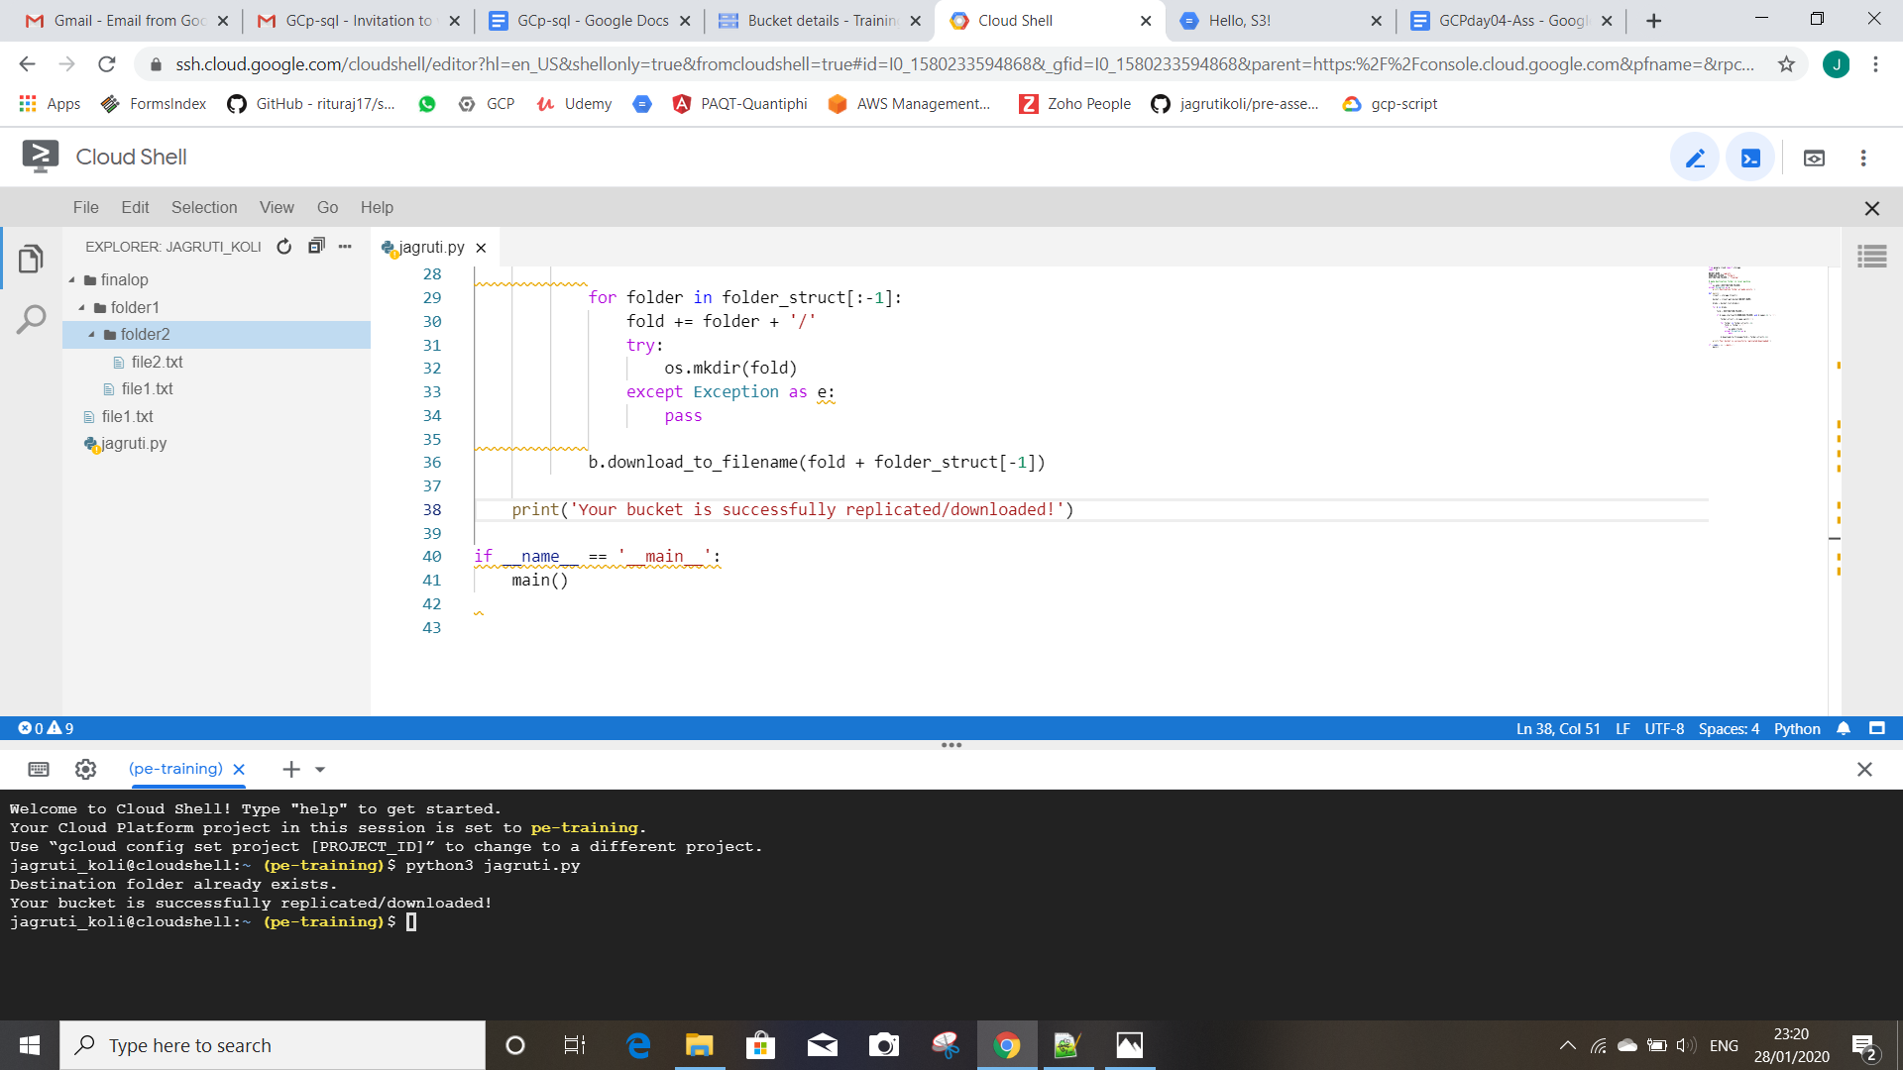

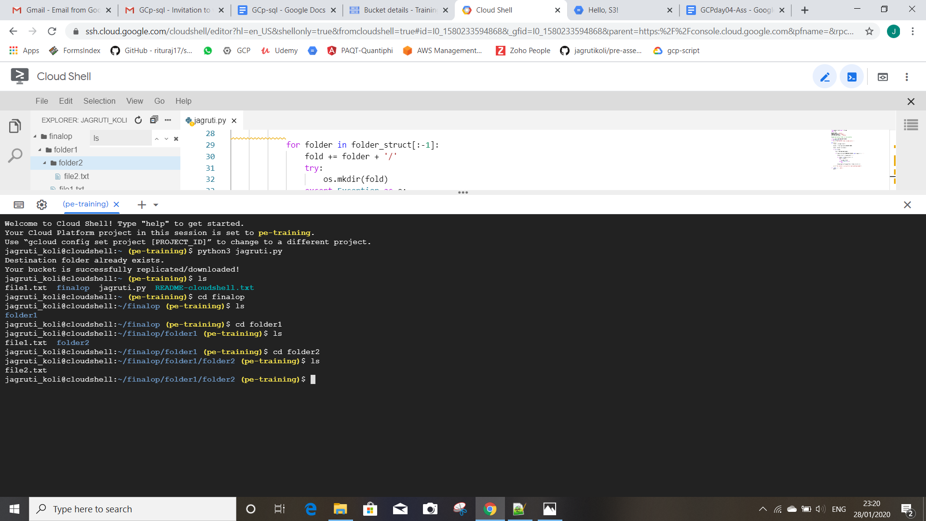

Code:

from google.cloud import storage

import os

BUCKET_NAME = 'jagruti’'

DOWNLOAD_FOLDER = 'folder1'

DESTINATION_FOLDER = 'finalop/'

# make destination folder in local machine

try:

os.mkdir(DESTINATION_FOLDER)

except Exception as e:

print('Destination folder already exists.')

def main():

client = storage.Client()

bucket = client.get_bucket(BUCKET_NAME)

blobs = bucket.list_blobs()

for b in blobs:

fold = DESTINATION_FOLDER + ''

if b.name.startswith(DOWNLOAD_FOLDER) and b.name[-1] != '/':

folder_struct = b.name.split('/')

for folder in folder_struct[:-1]:

fold += folder + '/'

try:

os.mkdir(fold)

except Exception as e:

pass

b.download_to_filename(fold + folder_struct[-1])

print('Your bucket is successfully replicated/downloaded!')

if __name__ == '__main__':

main()