**Installation**

**1.** Install Graphviz, for your respective platform

<http://www.graphviz.org/Download_windows.php>

**2.**  JAVA Version: JAVA 1.7 or above

**3.** Other Dependencies

(https://drive.google.com/folderview?id=0BxO1sjjWjgG2V09tX1l6MGRqMlk&usp=sharing)

1. JavaParser jar (1.0.8) 2. PlantUML jar

4. Project URL

https://drive.google.com/a/sjsu.edu/folderviewid=0BxO1sjjWjgG2V19PM0p6VmZCYjQ&usp=sharing#

**Usage**

**1. Command line** (javatouml.jar is uploaded in the project folder link provided above)

java -jar javatouml.jar <input_folder_path> <output-file-name>

e.g: java -jar javatouml.jar /home/jagruti/temp/tests/uml-parser-test-1/uml-parser-test-5 test5

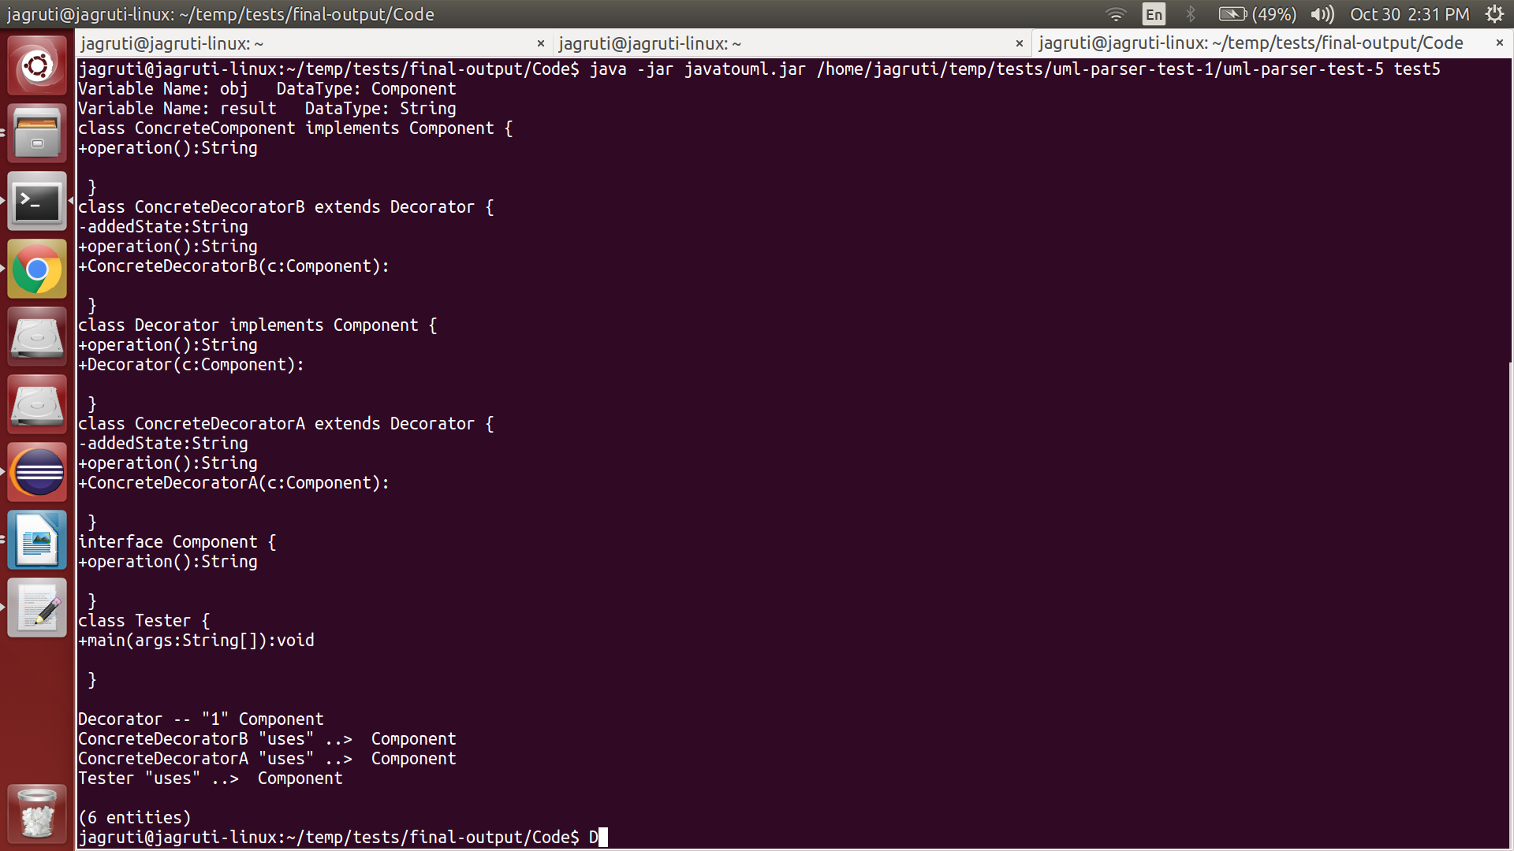

**2. Running through Eclipse**

1. Import the java project

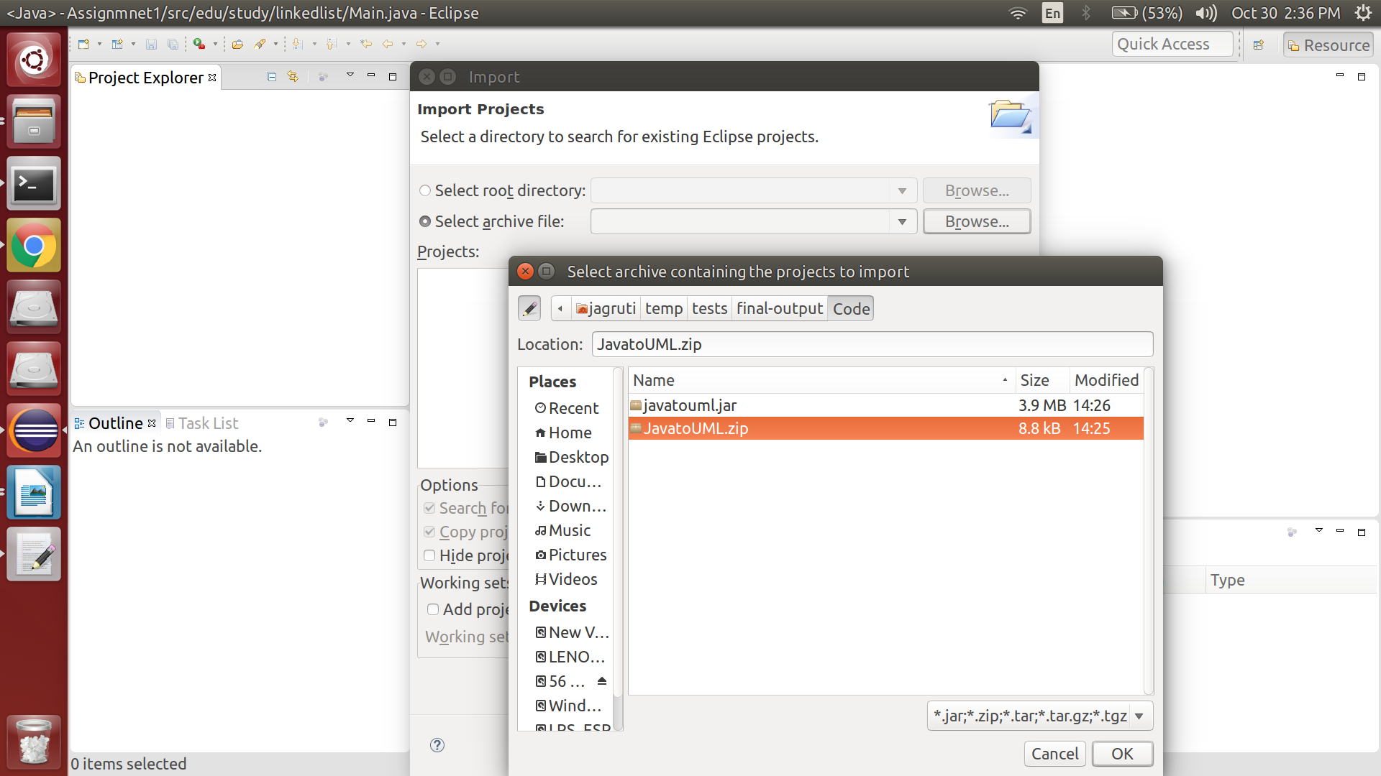

2. Resolve Dependencies

Dependencies URL: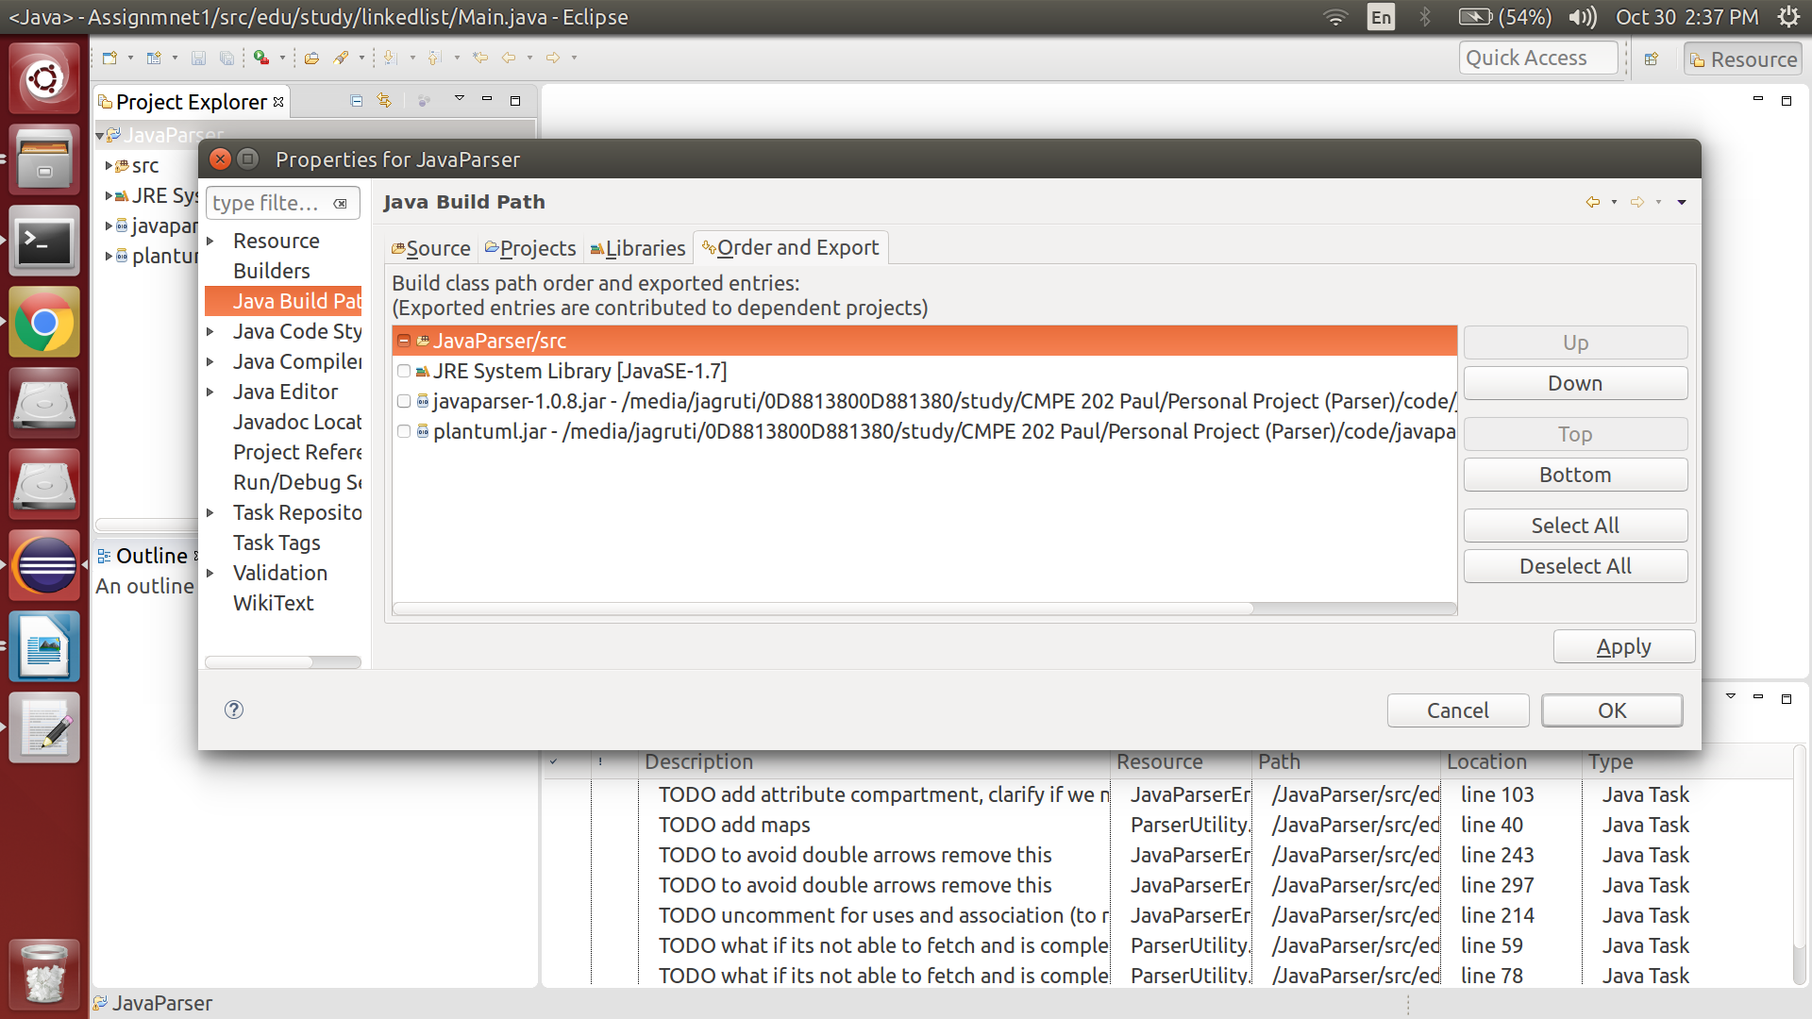 https://drive.google.com/folderviewid=0BxO1sjjWjgG2V09tX1l6MGRqMlk&usp=sharing

3. Run Configuration

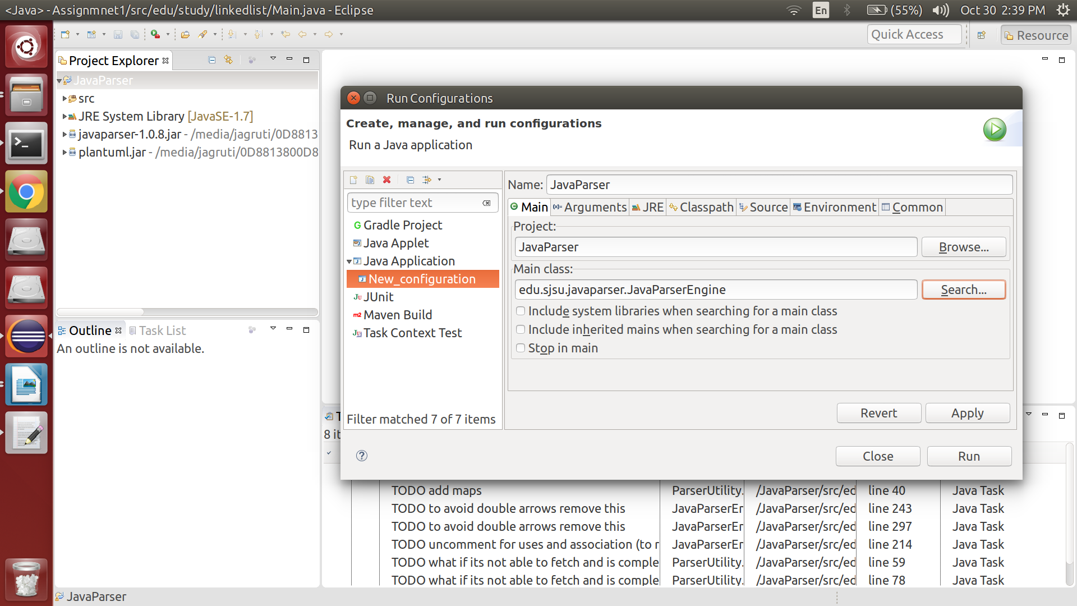

4. Set Command Line arguments

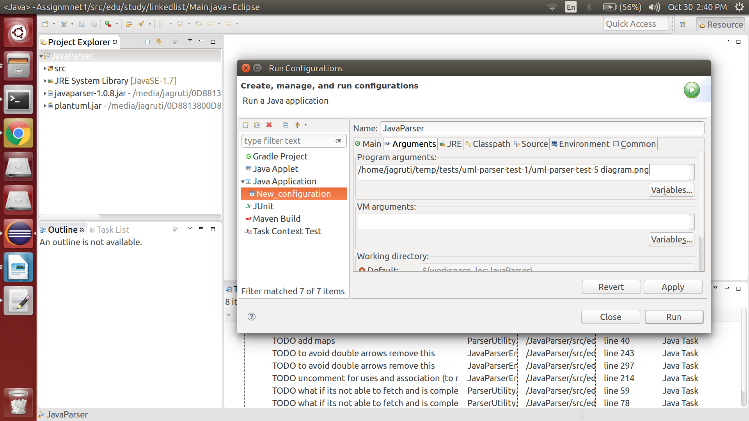

Apply this run configuration and run the project. Your output file will be generated in your classpath folder with extension “.png”.