Hospital Analytics & Predictive Intelligence System
Project Report
Technologies: Python · Pandas · Scikit-learn · Dash · Plotly
Table of Contents
Update field to see table of contents
1. Problem Statement
Healthcare facilities face two compounding operational challenges that directly erode revenue and patient outcomes: unpredictable billing amounts and high appointment no-show rates.
First, hospital billing is opaque. Patients and administrators struggle to anticipate costs because the final bill depends on a complex interplay of treatment type, doctor specialization, insurance coverage, and patient demographics. This opacity delays financial planning, delays discharge, and increases disputes between patients and billing departments.
Second, appointment no-shows cost hospitals an estimated 5–8% of annual scheduling capacity. A patient who does not attend an appointment wastes a clinician's time, prevents other patients from accessing that slot, and reduces revenue. Without early risk identification, staff cannot proactively intervene (e.g., send reminders, overbook slots, or reallocate resources).
This project addresses both problems with a unified data platform built on five relational hospital datasets. It delivers: (1) an interactive analytics dashboard, (2) a Gradient Boosting regression model to predict bill amounts, and (3) a Random Forest classification model to predict appointment no-show probability — all accessible through a browser-based Dash frontend, (4) a classifier comparison for payment status prediction and (5) a six-month revenue forecast.
2. Dataset Description
The project uses five CSV files that mirror a normalised hospital database schema. All files were provided as synthetic but structurally realistic datasets covering covering 50 patients, 10 doctors, 200 appointments, 200 treatments, and 200 billing records.
2.1 patients.csv
Column | Type | Description
patient_id | String (PK) | Unique patient identifier (P001-P050)
first_name / last_name | String | Patient full name
gender | Categorical | M or F (note: synthetic data; labels not always name-aligned)
date_of_birth | Date | Used to derive patient_age; reference date 2024-01-01
registration_date | Date | Date patient was registered at the hospital
insurance_provider | Categorical | HealthIndia | MedCare Plus | PulseSecure | WellnessCorp
contact_number / email | String | Contact identifiers; not used in modelling
2.2 doctors.csv
Column | Type | Description
doctor_id | String (PK) | Unique doctor identifier (D001-D010)
first_name / last_name | String | Doctor full name
specialization | Categorical | Dermatology | Oncology | Pediatrics
years_experience | Integer | Years of clinical experience (range: 5-28)
hospital_branch | Categorical | Central Hospital | Eastside Clinic | Westside Clinic
2.3 appointments.csv
Column | Type | Description
appointment_id | String (PK) | Unique appointment identifier (A001-A200)
patient_id / doctor_id | String (FK) | Foreign keys to patients and doctors tables
appointment_date / time | Date / Time | Scheduled date and time; weekday derived for modelling
reason_for_visit | Categorical | Checkup | Consultation | Emergency | Follow-up | Therapy
status | Categorical | Cancelled | Completed | No-show | Scheduled
2.4 treatments.csv
Column | Type | Description
treatment_id | String (PK) | Unique treatment identifier (T001-T200)
appointment_id | String (FK) | Links treatment to a specific appointment
treatment_type | Categorical | Chemotherapy | MRI | Physical Therapy | Surgery | X-Ray
cost | Float (INR) | Treatment cost; approx. range 2,500-7,000
treatment_date | Date | Date treatment was administered
2.5 billing.csv
Column | Type | Description
bill_id | String (PK) | Unique billing record identifier (B001-B200)
patient_id / treatment_id | String (FK) | Foreign keys to patients and treatments tables
amount | Float (INR) | Final billed amount; regression model prediction target
payment_method | Categorical | Cash | Credit Card | Insurance | UPI
payment_status | Categorical | Failed | Paid | Pending
bill_date | Date | Date the bill was generated
3. Data Cleaning & Feature Engineering
3.1 Cleaning Steps
All cleaning is centralised in analysis.py and applied consistently across both ML pipelines in model.py and noshow_model.py. The following steps were applied to each table:
- patients.csv: Parsed date_of_birth and registration_date as datetime objects. Stripped and uppercased the gender field to normalise M/F values. Removed duplicate rows on patient_id. Derived a computed age column as integer years (reference date: 2024-01-01). Created five age_group bands: 0-18, 19-35, 36-50, 51-65, 65+.
- doctors.csv: Coerced years_experience to numeric. Dropped duplicate rows on doctor_id.
- appointments.csv: Parsed appointment_date as datetime. Stripped whitespace from status and reason_for_visit. Derived month period string for time-series aggregation. Derived appointment_weekday (Monday-Sunday) from appointment_date for the no-show model.
- treatments.csv: Coerced cost to float. Parsed treatment_date. Dropped duplicate rows on treatment_id.
- billing.csv: Coerced amount to float. Parsed bill_date. Stripped whitespace from payment_status and payment_method. Dropped duplicate rows on bill_id.
3.2 Master Merge Strategy
For the analytics dashboard, a master fact table was built using a chain of left-joins anchored to appointments: appointments LEFT JOIN patients (on patient_id) LEFT JOIN doctors (on doctor_id) LEFT JOIN treatments (on appointment_id) LEFT JOIN billing (on treatment_id). Left-joins preserve all appointments even where billing or treatment records are absent, preventing silent data loss from the KPI calculations.
For the ML models, inner-joins were used instead to ensure every training row has a complete set of features and a valid target value. No rows with null in any feature column or the target column were allowed into the training set.
4. Key Performance Indicators (KPIs)
The following KPIs are computed live from the master fact table and displayed in the Analytics Dashboard header row:
5. Dashboard Charts & Analytical Insights
KPI | Formula | Business Significance
Total Patients | COUNT DISTINCT patient_id | Measures registered patient base size
Total Doctors | COUNT DISTINCT doctor_id | Measures available clinical capacity
Total Appointments | COUNT DISTINCT appointment_id | Total scheduling volume across the period
Completion Rate (%) | Completed / Total x 100 | Primary scheduling efficiency KPI
No-Show Rate (%) | No-show / Total x 100 | Key revenue-loss driver; ML intervention target
Total Revenue (Paid) | SUM(amount) WHERE status=Paid | Actual cash collected; cash-flow indicator
Pending Revenue | SUM(amount) WHERE status=Pending | Outstanding receivables; collection risk exposure
Avg Treatment Cost | MEAN(cost) across all treatments | Benchmarks treatment spending; input to bill predictor
The Analytics tab of the Dash application renders eleven interactive Plotly charts across five thematic sections. Each chart is pre-computed at startup and served as a static figure — no database query occurs on user interaction.
Figure 1: Analytics Dashboard
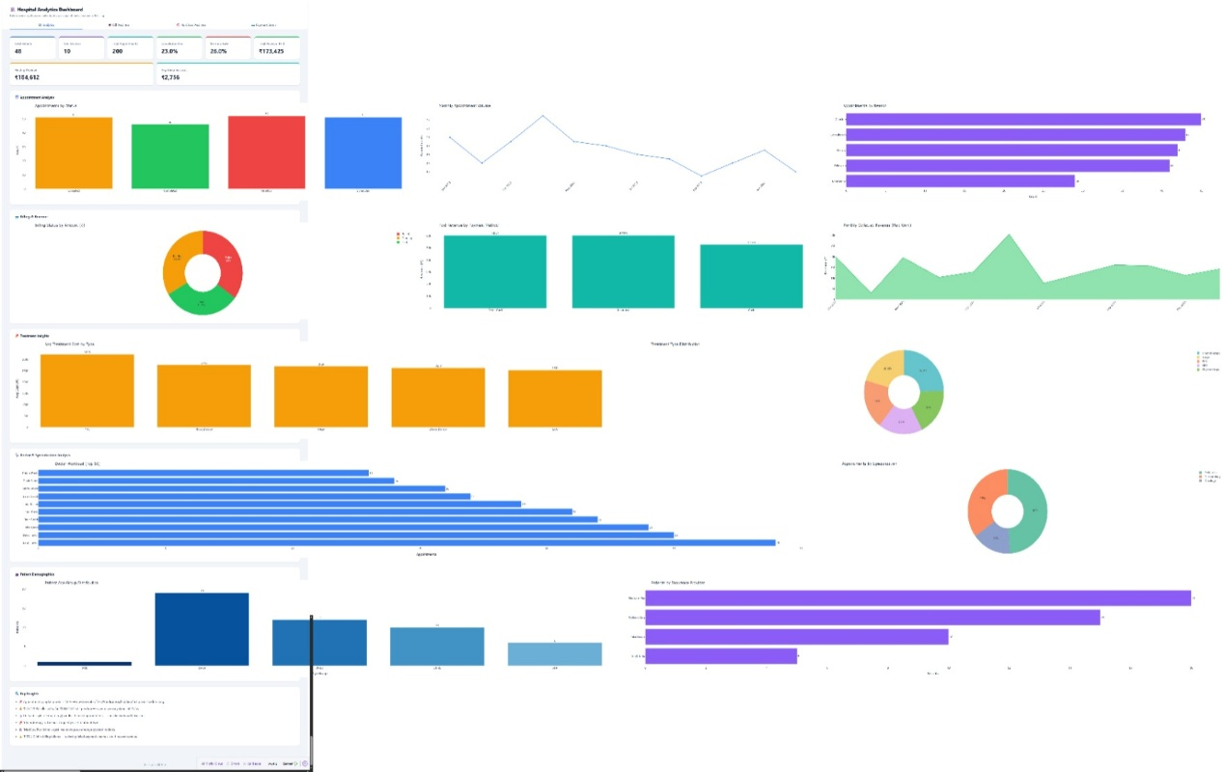

5.1 Appointment Analysis
- Appointments by Status (bar chart): Distributions across Completed, Scheduled, Cancelled, and No-show statuses reveal scheduling efficiency. A high Cancelled or No-show proportion signals operational friction.
- Monthly Appointment Volume (line chart): Tracks monthly throughput. Peaks and troughs highlight seasonal demand, useful for staffing and resource planning.
- Appointments by Reason (horizontal bar): Breaks down visit type. Emergency and Therapy-heavy periods indicate high-acuity demand.
5.2 Billing & Revenue
- Billing Status by Amount (donut): Visualises the share of total billed amount that is Paid, Pending, or Failed. A large Failed share signals payment channel issues.
- Paid Revenue by Payment Method (bar): Shows which channels generate the most collected revenue. Insurance typically dominates; a large Cash share may signal reconciliation delays.
- Monthly Collected Revenue (area chart): Tracks month-over-month cash flow from Paid bills only. Flat or declining months warrant investigation.
5.3 Treatment Insights
- Average Treatment Cost by Type (bar): Compares mean cost per treatment category. Surgery and Chemotherapy are the highest-cost categories; this directly informs the bill prediction model's feature importance.
- Treatment Type Distribution (donut): Shows the mix of treatment volume. A skew toward high-cost treatments should correlate with higher average bill amounts.
5.4 Doctor & Specialization Analysis
- Doctor Workload Top 10 (horizontal bar): Ranks doctors by appointment count with specialization on hover. Uneven distributions suggest workload imbalance.
- Appointments by Specialization (donut): Shows the volume share of each specialization. Pediatrics having the highest share is consistent with the dataset's doctor mix (6 of 10 are Pediatricians).
5.5 Patient Demographics
- Patient Age Group Distribution (bar): Counts unique patients per age band. Middle-aged (36-65) patients dominate, with a smaller cohort under 18 or over 65.
- Patients by Insurance Provider (horizontal bar): Shows the spread across the four insurers. WellnessCorp and MedCare Plus are the largest groups.
6. Machine Learning Models
6.1 Bill Amount Prediction (Regression)
Objective: Predict the final billed amount (in INR) for a given patient-appointment-treatment combination before the bill is generated.
Model: GradientBoostingRegressor (scikit-learn). Hyperparameters: n_estimators=300, learning_rate=0.05, max_depth=5, subsample=0.8, random_state=42.
Preprocessing: OrdinalEncoder applied to all categorical features within a ColumnTransformer Pipeline. Numeric features passed through without scaling (tree-based models are scale-invariant).
Features: patient_age (numeric); gender, insurance_provider, specialization, treatment_type, reason_for_visit (all categorical).
Training data: All rows in billing.csv that have a matching record across all 5 tables via inner-join; rows with any null in features or target are excluded. 80/20 train-test split (random_state=42).
Evaluation metrics: Mean Absolute Error (MAE) and R-squared (R2) on the held-out test set. Artefacts saved to bill_model.pkl and model_meta.pkl.
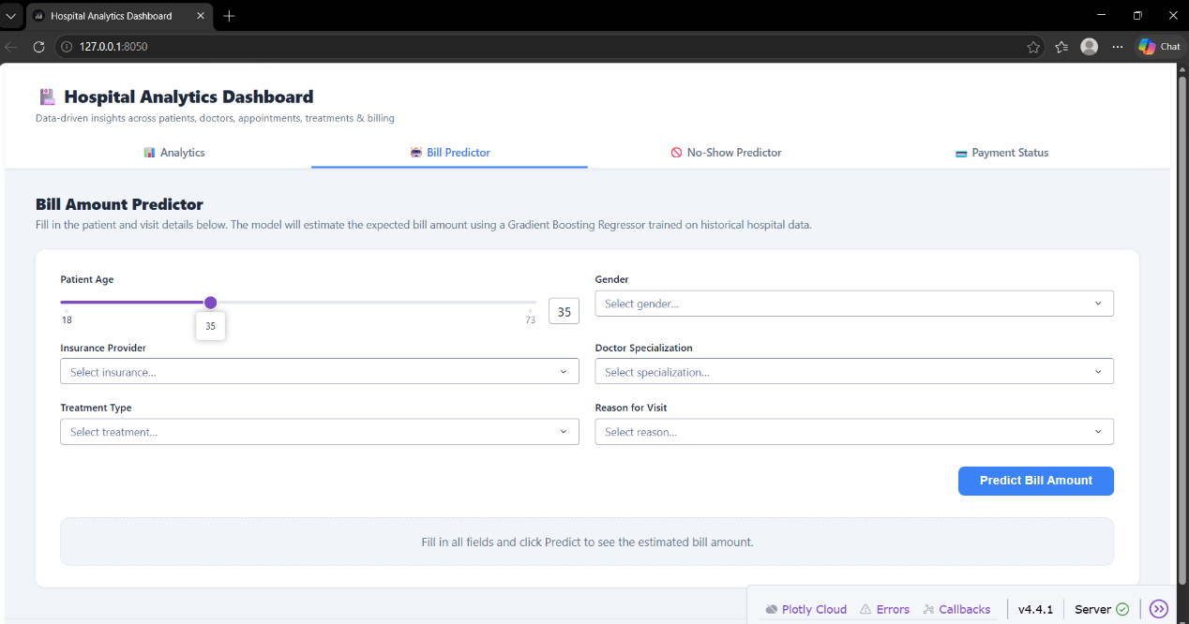
6.2 Appointment No-Show Prediction (Classification)
Objective: Predict whether a scheduled appointment will result in a no-show (binary label: 1=No-show, 0=Show), so that proactive interventions can be triggered.
Model: RandomForestClassifier with class_weight=balanced to handle class imbalance (no-shows are a minority class). Hyperparameters: n_estimators=300, max_depth=8, min_samples_leaf=2, random_state=42.
Training data: Only Completed and No-show rows used. Cancelled rows excluded (outcome unknown). Scheduled rows excluded from training but used to populate meta dropdowns. 80/20 stratified train-test split.
Features: patient_age (numeric); gender, insurance_provider, specialization, reason_for_visit, appointment_weekday (all categorical). Weekday is derived from appointment_date at feature-engineering time.
Evaluation metrics: ROC-AUC score on the test set and 5-fold cross-validated ROC-AUC. Classification report (precision, recall, F1) for both classes. Artefacts saved to noshow_model.pkl and noshow_meta.pkl.
Prediction output: The UI presents a semi-circular gauge showing the no-show probability, three stat cards (No-Show %, Show-Up %, Risk Level), and a colour-coded recommendation: Low Risk (<35%) / Moderate Risk (35-60%) / High Risk (>60%).
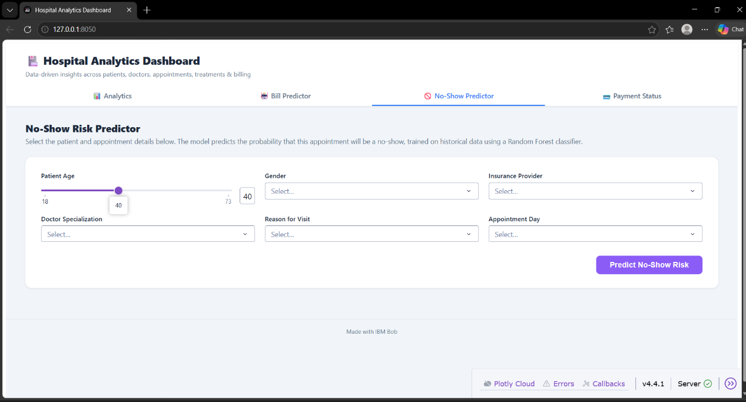
6.3 Payment status predectior
Objective: Predict whether a hospital bill will be Paid, Pending or Failed, so that collection teams can prioritise follow-ups.
Models compared: Logistic Regression, Random Forest and Gradient Boosting, each in a scikit-learn Pipeline with categorical encoding.
Features: bill amount (numeric); payment method, treatment type and insurance provider (categorical).
Training data: 200 billing records (Pending = 69, Failed = 67, Paid = 64), split 80/20 into training and test sets.
Results:
- Logistic Regression: Accuracy 32.5%, Test weighted F1 32.6%, CV weighted F1 32.7%
- Random Forest: Accuracy 32.5%, Test weighted F1 32.0%, CV weighted F1 32.7%
- Gradient Boosting: Accuracy 25.0%, Test weighted F1 24.1%, CV weighted F1 30.6%
Logistic Regression was selected as the best model. Its per-class F1 scores were 0.43 (Paid), 0.33 (Pending) and 0.21 (Failed).
Interpretation: With three roughly balanced classes, random guessing gives about 33% accuracy. All three models performed at or below this level, so payment status cannot be reliably predicted from the available features in this dataset. This is a valid negative finding. Real payment behaviour depends on signals that are absent here, such as payment history, days overdue and patient income band. The model demonstrates the pipeline but should not be used for operational decisions in its current form.

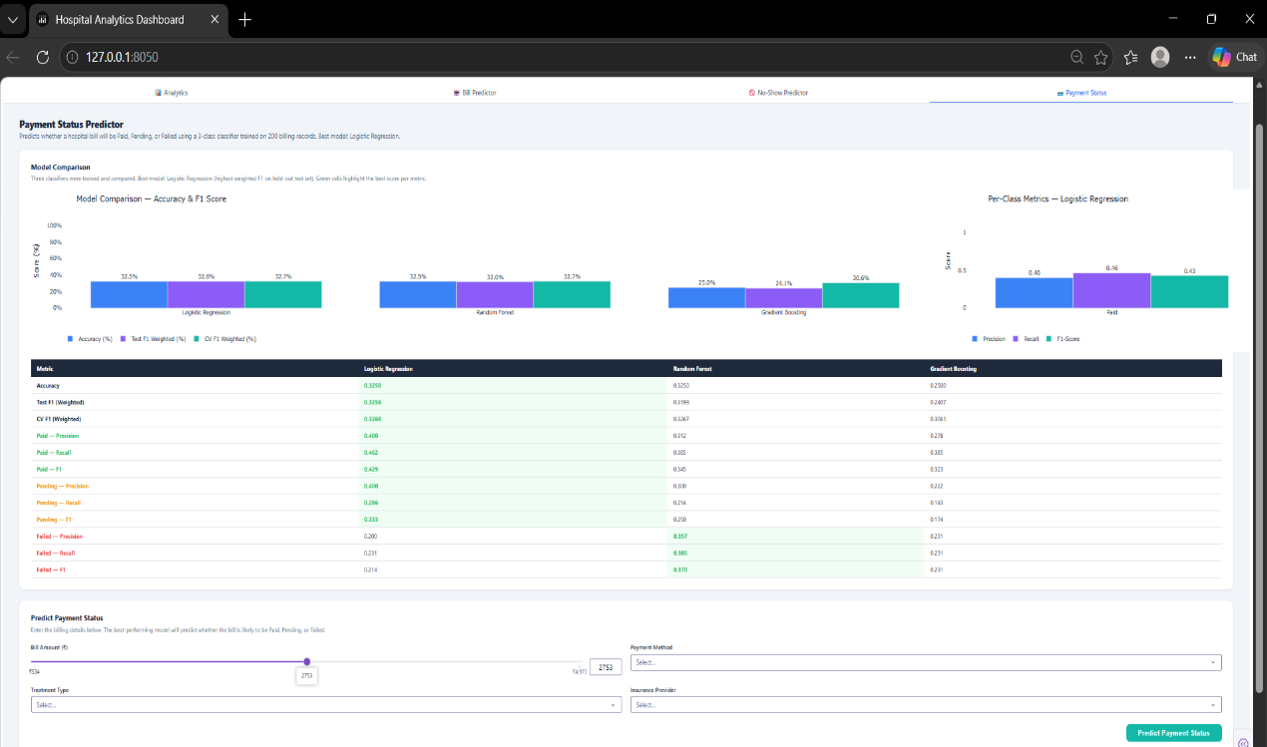

6.4: Revenue Forecasting
Objective: Forecast monthly billed revenue for the next six months (January to June 2024) to support financial planning and cash-flow monitoring.
Data: Billing records were aggregated by month for 2023, giving 12 monthly observations. Total billed was ₹551,250, of which ₹173,425 (31.5%) was collected as Paid. Average monthly billing was ₹45,937, with the peak in April 2023 and the lowest month in December 2023.
Methods compared: Linear Regression (trend), Holt-Winters exponential smoothing, and Random Forest. Models were backtested on a hold-out of the last three months (October to December 2023).
Hold-out results:
| Model | MAE (₹) | RMSE (₹) | MAPE | R² |
| Linear Regression | 9,280 | 10,383 | 22.6% | -0.019 |
| Holt-Winters | 11,541 | 14,817 | 23.6% | -1.075 |
| Random Forest | 8,683 | 9,372 | 23.3% | 0.170 |

Random Forest had the lowest MAE and was selected as the best model. Its six-month forecast ranges from ₹48,388 to ₹50,477 per month, averaging ₹49,660.
Interpretation: The differences between models are small. Linear Regression has the lowest MAPE, and Random Forest the lowest MAE, so the ranking depends on the metric. As a reference, predicting the average of the training months (January to September) would give an MAE of about ₹9,712, so Random Forest improves on this by roughly 11%, Linear Regression by about 4%, and Holt-Winters is worse by about 19%.
Limitations: Only 12 monthly points were available and the hold-out contains just three, so the model ranking is not statistically reliable. Random Forest cannot extrapolate trends, so its forecast stays close to the historical average. Linear Regression and Holt-Winters project a decline, and the Holt-Winters value for June 2024 (₹14,581) is far below any month observed in 2023, which is unlikely. The ±15% confidence band shown in the dashboard is a fixed percentage around the forecast, not a statistical prediction interval. The forecast covers billed amount, not collected cash.
Dashboard features: historical vs forecast chart with model toggles, monthly collected vs unpaid breakdown, model comparison chart and table, six-month forecast table, and a what-if scenario tool that adjusts the forecast for changes in appointment volume and average bill amount.
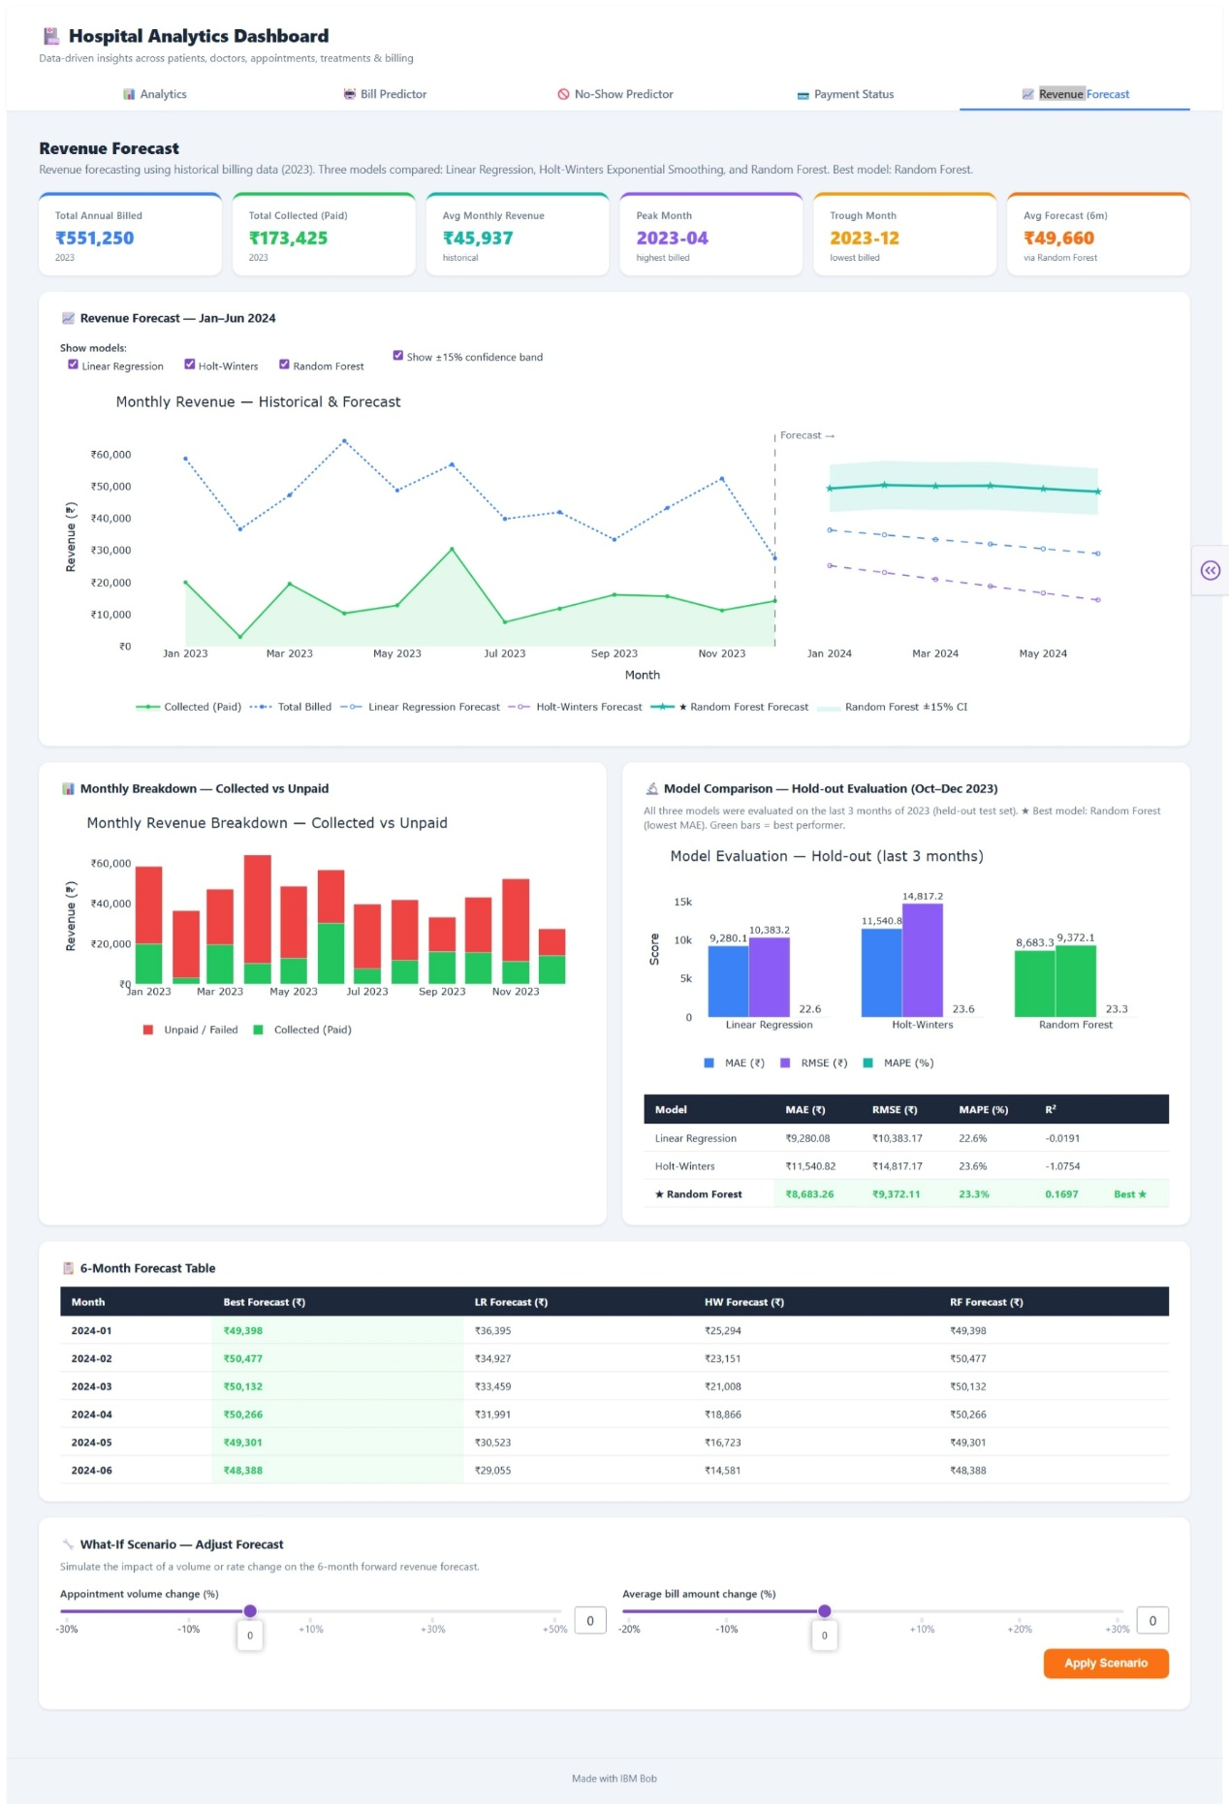

6.5 Model Comparison Summary
Attribute | Bill Predictor | No-Show Predictor
Algorithm | Gradient Boosting Regressor | Random Forest Classifier
Task type | Regression (continuous output: INR) | Binary classification (No-show probability 0-1)
7. Business Recommendations
Based on the KPIs, chart insights, and model outputs, the following actionable recommendations are proposed for hospital management:
- Targeted reminder campaigns: Patients scoring High Risk (>60% no-show probability) should receive automated SMS or phone reminders at least 48 hours before their appointment. The No-Show Predictor can be embedded in the scheduling workflow at booking time to flag these patients immediately.
- Strategic overbooking: For appointment slots where historical no-show rates are high (e.g., Monday mornings, Emergency visits by young uninsured patients), consider booking 1 backup patient per 4-slot block. The model's weekday and reason-for-visit features directly support this segmentation.
- Billing transparency portal: The Bill Amount Predictor can be surfaced to patients at appointment booking time as an estimated cost calculator, reducing billing disputes and financial surprises at discharge. Even approximate predictions reduce post-visit invoice shock.
- Failed payment recovery: Billing failures represent a recoverable revenue pool. Correlating failure rates with payment_method reveals which channels need intervention (e.g., UPI timeout retries, insurance pre-authorisation checks). The Billing Status donut chart makes this visible at a glance.
- Workload rebalancing: The Doctor Workload chart identifies over-utilised clinicians. Redistribution of Scheduled appointments from the top-3 busiest doctors to under-utilised peers reduces burnout risk and improves patient wait times.
- Insurance-aligned pricing strategy: WellnessCorp and MedCare Plus are the two largest patient insurance groups. Negotiating bundled payment rates with these providers, informed by actual average treatment costs from the dashboard, could reduce billing friction and increase on-time payment rates.
- Monthly revenue monitoring: The area chart for monthly collected revenue should be reviewed in weekly ops meetings. A dip of more than 10% month-over-month should trigger an immediate review of pending and failed payment queues.
- - Collection focus: Only 31.5% of the ₹551,250 billed in 2023 was collected. At the forecast level of about ₹49,700 billed per month, a similar collection rate would bring in only about ₹15,600 per month, so improving collection offers a larger gain than increasing billing volume.
- - Forecast use: Because the forecast has high error (MAPE about 23%), it should be used for rough planning ranges and reviewed monthly against actual billing, not as a fixed budget.
8. Conclusion
This project demonstrates a complete, production-ready hospital analytics and predictive intelligence platform built entirely on open-source Python tooling. The system addresses two distinct but operationally linked business problems — billing unpredictability and appointment no-shows — through a unified data architecture that joins five relational hospital datasets into a single master fact table.
The analytics dashboard provides real-time operational visibility through eleven interactive charts covering appointments, billing, treatments, doctor workload, and patient demographics. The eight KPI cards at the top give management a single-glance health-check of the organisation.
The two ML modules — a Gradient Boosting regressor for bill prediction and a Random Forest classifier for no-show prediction — are fully integrated into the frontend via Dash callbacks. Both models are trained through end-to-end scikit-learn Pipelines that encapsulate preprocessing and inference, making them portable and retrainable with updated data. The no-show predictor uses class_weight=balanced to handle the inherent class imbalance in medical scheduling datasets.
The three-tab Dash application is navigable at http://127.0.0.1:8050 and requires no database server, no cloud infrastructure, and no external API — it is fully self-contained and reproducible. Future enhancements could include: (1) connecting to a live database via SQLAlchemy for real-time data refresh, (2) adding SHAP explainability plots to the prediction tabs to surface feature contributions, (3) incorporating appointment lead-time (days between booking and appointment) as an additional no-show predictor feature, and (4) deploying to a hospital intranet using Gunicorn + Nginx.
Results: On the held-out test set (40 records) the model achieved an MAE of ₹1,367 and an R² of -0.32. A negative R² means the model performs worse than simply predicting the mean bill amount. With an average treatment cost of about ₹2,756, the error is roughly 50% of a typical bill. The training set contained only 200 records, and the target shows no strong relationship with the available features (patient age, gender, insurance, specialization, treatment type, reason for visit). The model demonstrates the pipeline but is not suitable for cost estimation in its current form. Larger datasets, itemised procedure codes, length of stay and insurance coverage percentages would be needed.
Bill Predictor numbers
Attribute |  |  | Bill Predictor | No-Show Predictor | Payment Status Predictor
Key metric |  |  | R² = -0.32, MAE = ₹1,367 | ROC-AUC = 0.46 (CV) | Accuracy = 32.5%
Outcome |  |  | Worse than mean baseline | Near chance level | Near chance level

Project Files Reference
File | Role | Run Command
patients.csv | Source data — patient demographics | (input)
doctors.csv | Source data — doctor details | (input)
appointments.csv | Source data — appointment records | (input)
treatments.csv | Source data — treatment records | (input)
billing.csv | Source data — billing records | (input)
analysis.py | Data pipeline: load, clean, merge, KPIs, aggregations | python analysis.py
model.py | Bill prediction model training; saves bill_model.pkl | python model.py
noshow_model.py | No-show model training; saves noshow_model.pkl | python noshow_model.py
predict_page.py | Dash layout and callback for Bill Predictor tab | (imported by app.py)
noshow_page.py | Dash layout and callback for No-Show Predictor tab | (imported by app.py)
app.py | Main Dash application; 3-tab frontend | python app.py
requirements.txt | Python dependencies | pip install -r requirements.txt
End of Report

