**CSP595 - Assignment 11**

Name: Jagruti Vichare

Email ID: [jvichare@hawk.iit.edu](mailto:jvichare@hawk.iit.edu)

CWID: A20378092

**Exercise 1**

Command: create ‘cs595Tbl’, ‘cf1’, ‘cf2’

Describe command output:

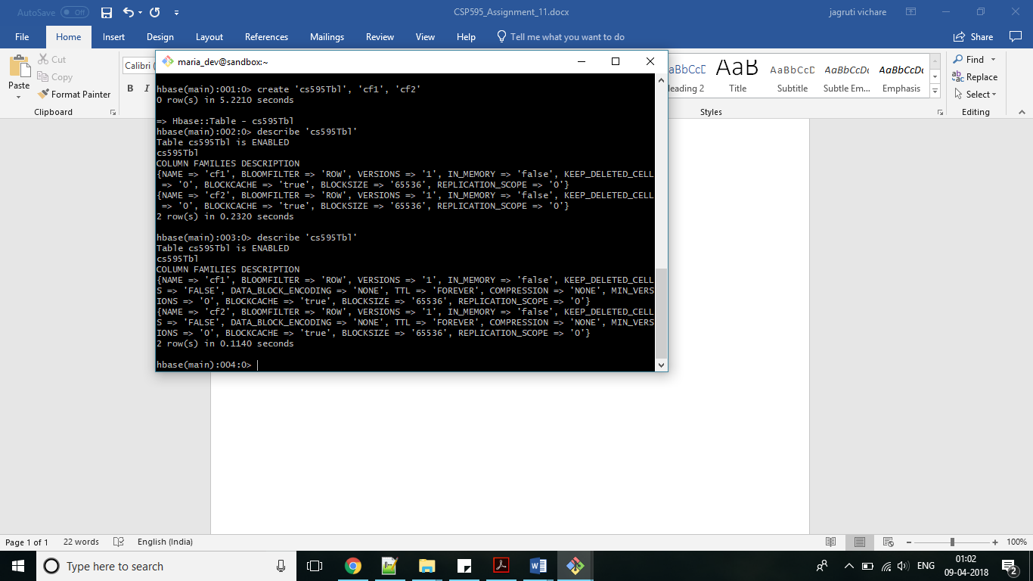

**Exercise 2**

Put commands:

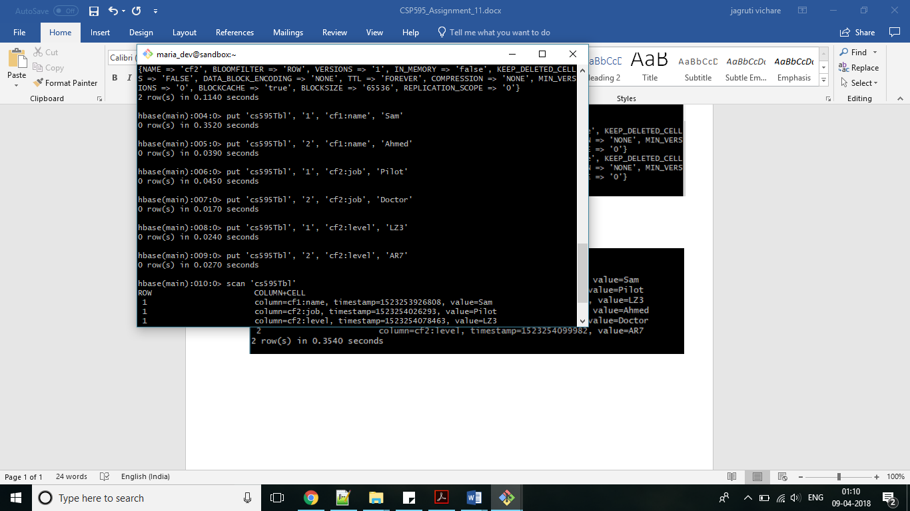

Scan command output:

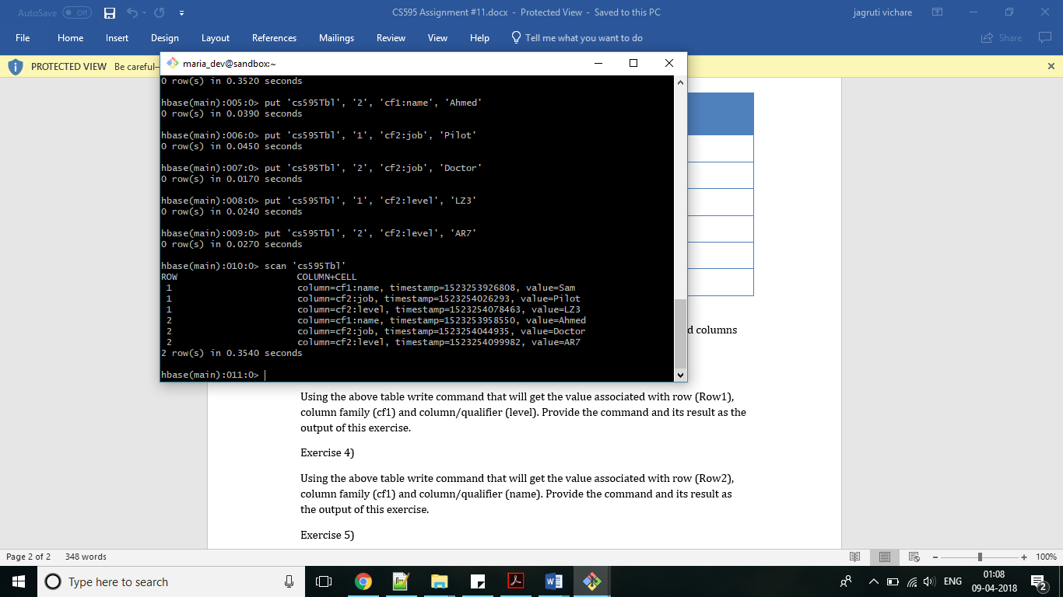

**Exercise 3**

Note: Assuming column family cf2 instead of cf1

Command:get 'cs595Tbl', '1', {COLUMN => 'cf2:level'}

Output:

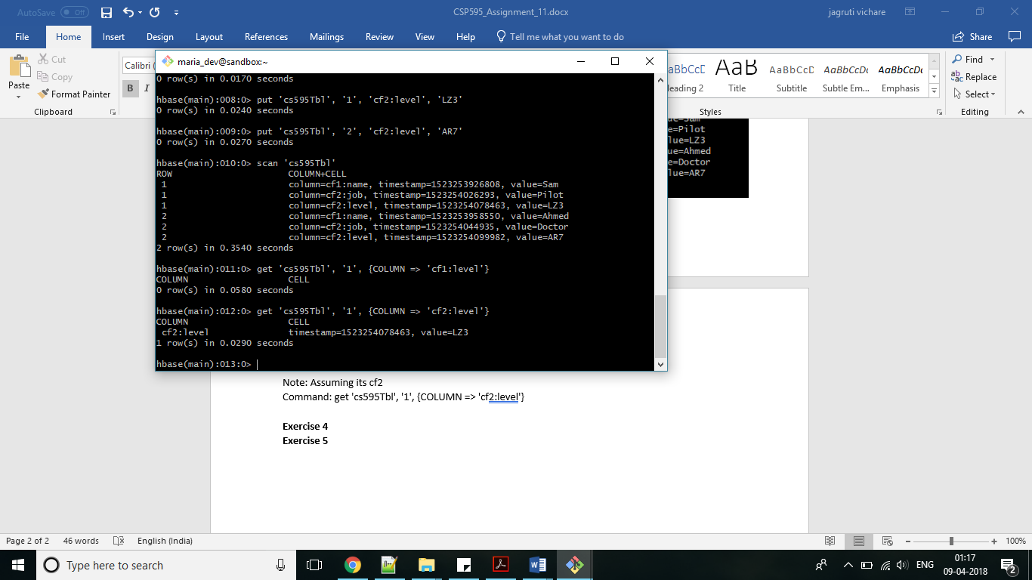

**Exercise 4**

Command:get 'cs595Tbl', '2', {COLUMN => 'cf1:name'}

Output:

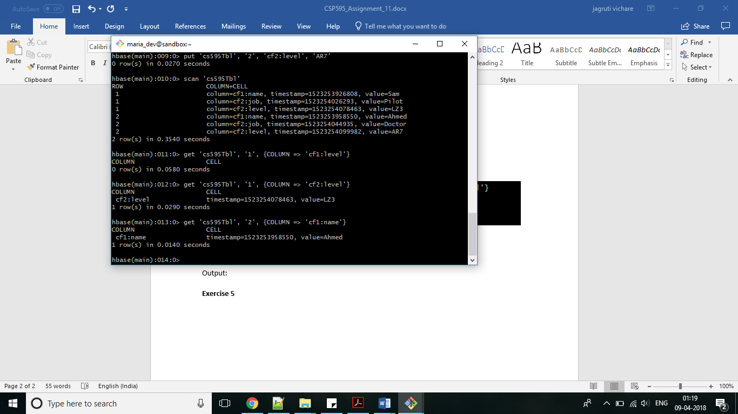

**Exercise 5**

Command:scan ‘cs595Tbl’, {LIMIT => 1}

Output:

