**CS 595 - Assignment 2**

Name: Jagruti Vichare

Email ID: [jvichare@hawk.iit.edu](mailto:jvichare@hawk.iit.edu)

CWID: A20378092

**Question 10:**

Command 🡪 *hadoop fs -ls /*

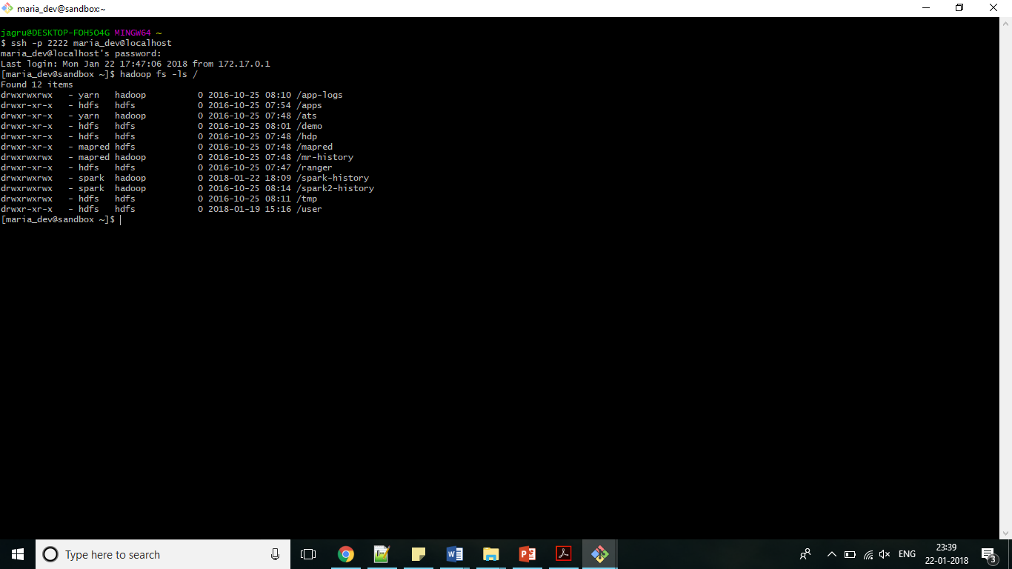

**Question 11:**

Command 🡪 *hadoop fs -ls /user*

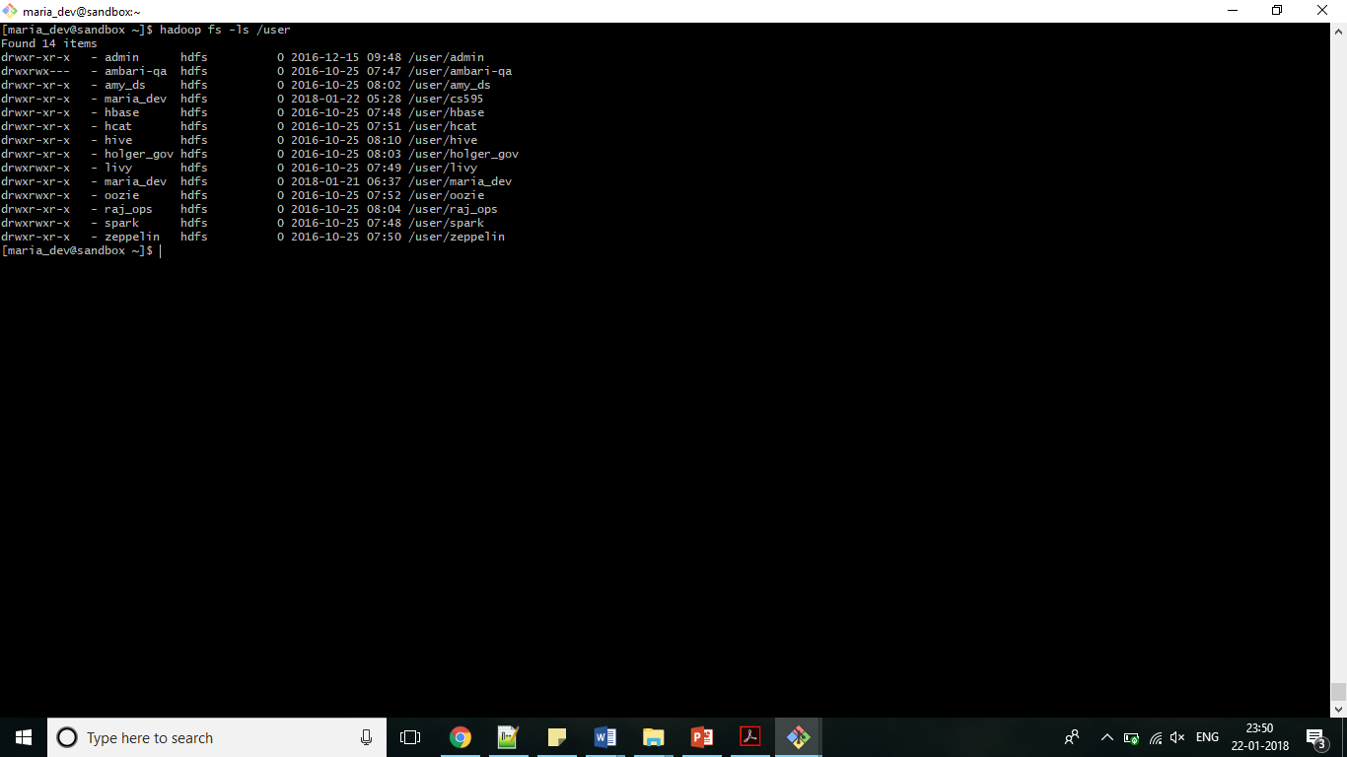

**Question 12:**

Command 🡪 *hadoop fs -mkdir /user/cs595/jagrutivichare*

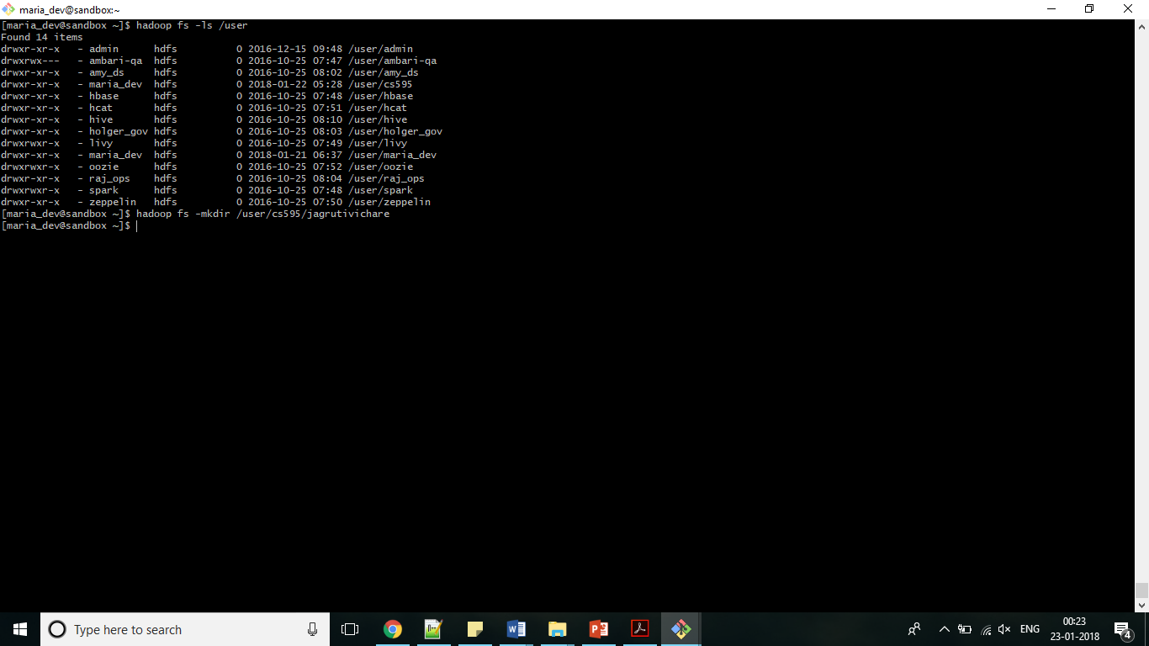

**Question 13:**

Command 🡪 *hadoop fs -copyFromLocal /home/maria_dev/cs595doc.txt /user/cs595/jagrutivichare*

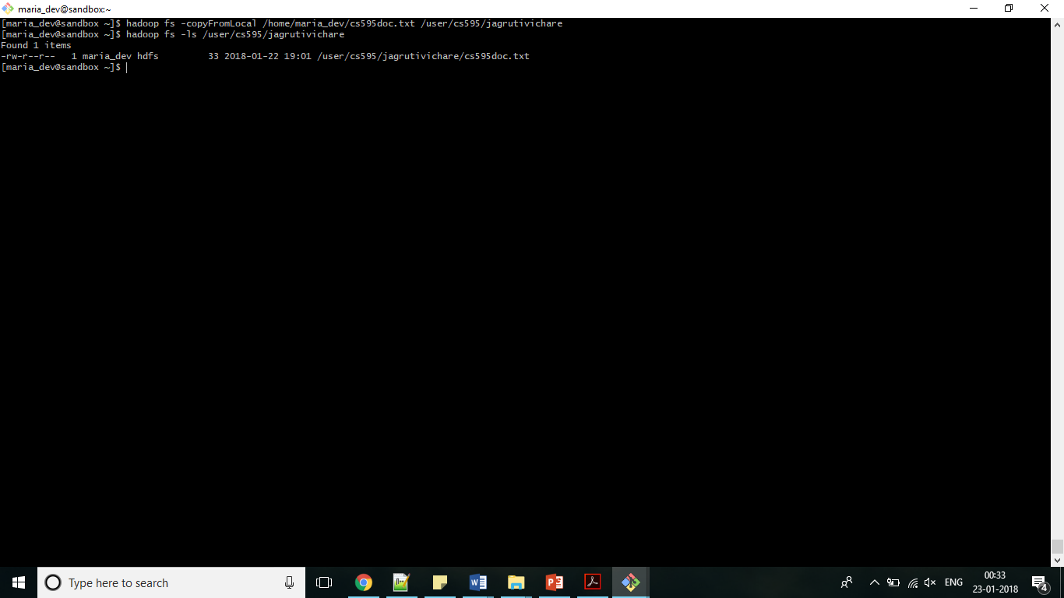

**Question 14:**

Command 🡪 *hadoop fs -cp /user/cs595/cs595doc2.txt /user/cs595/jagrutivichare*

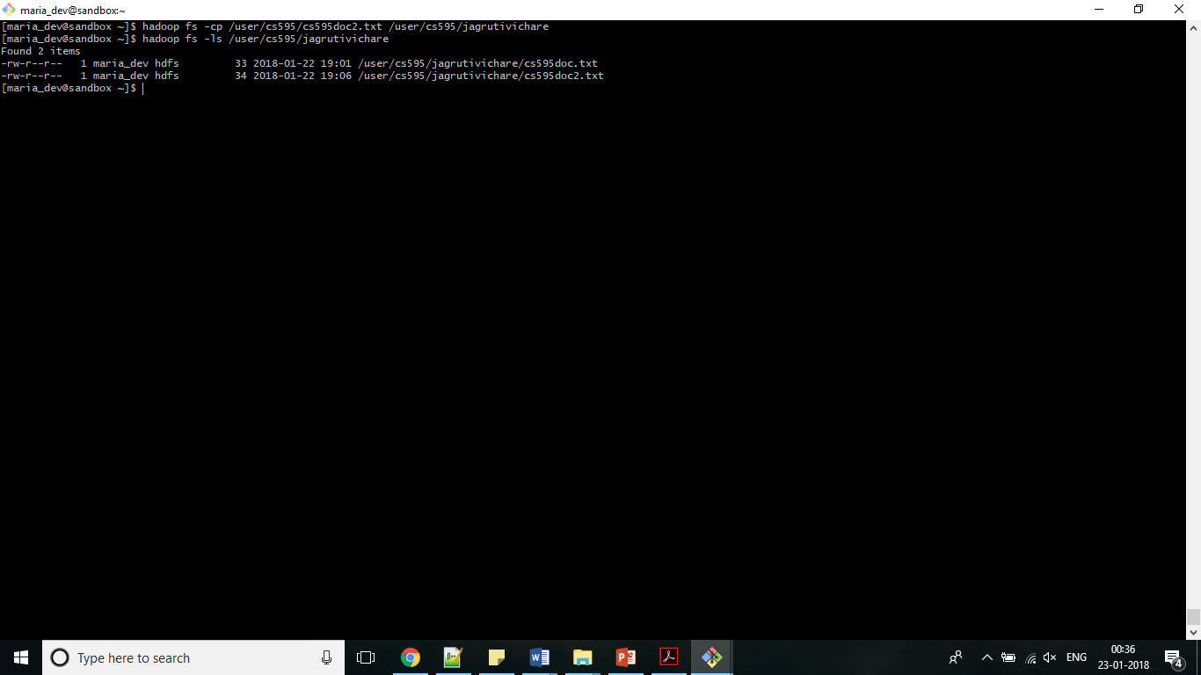

**Question 15:**

1. Created file jagruti_vichare.txt and copied it to maria_dev account

Command 🡪 *scp -P 2222 /d/jagruti_vichare.txt maria_dev@localhost:/home/maria_dev*

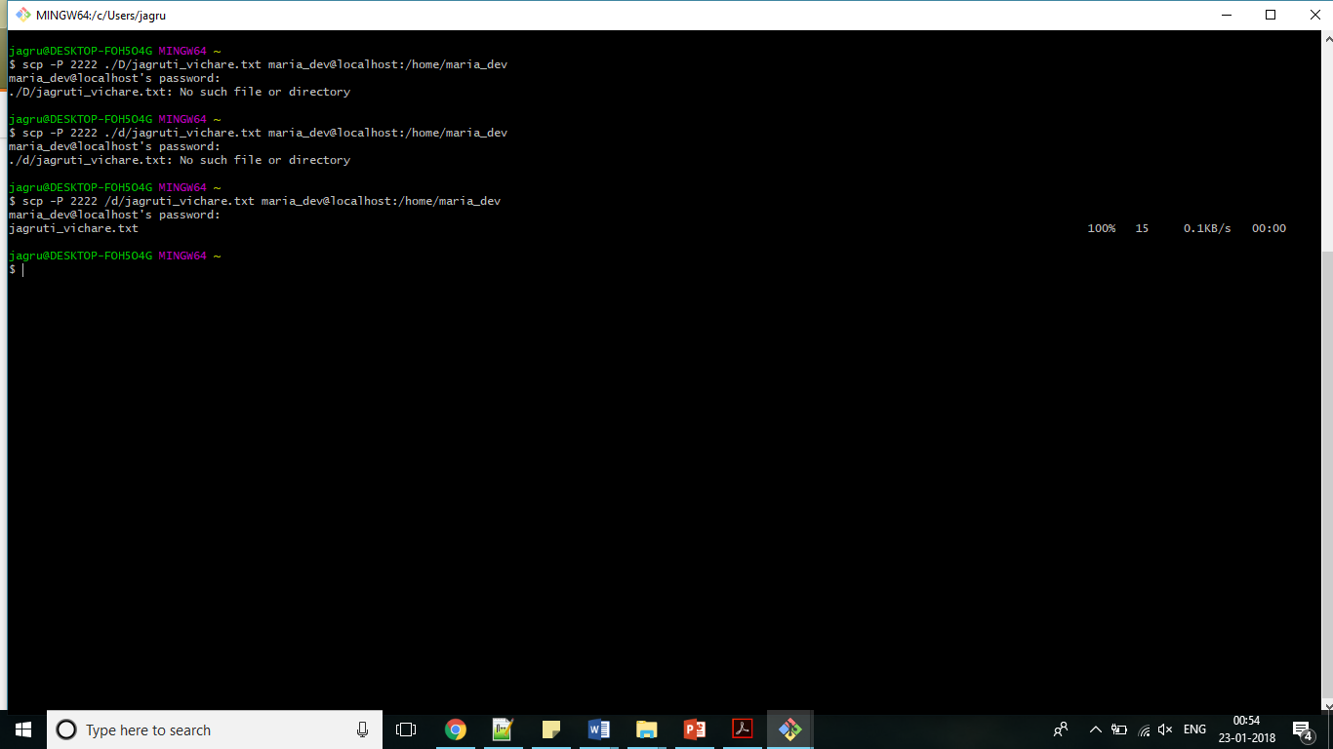

1. Copied file jagruti_vichare.txt from maria_dev account to hdfs directory

Command 🡪 *hadoop fs -copyFromLocal /home/maria_dev/jagruti_vichare.txt /user/cs595/jagrutivichare*

