**CS 595 - Assignment 3**

Name: Jagruti Vichare

Email ID: [jvichare@hawk.iit.edu](mailto:jvichare@hawk.iit.edu)

CWID: A20378092

**Question 6**

The output of the program WordCount2.py is highlighted below in red

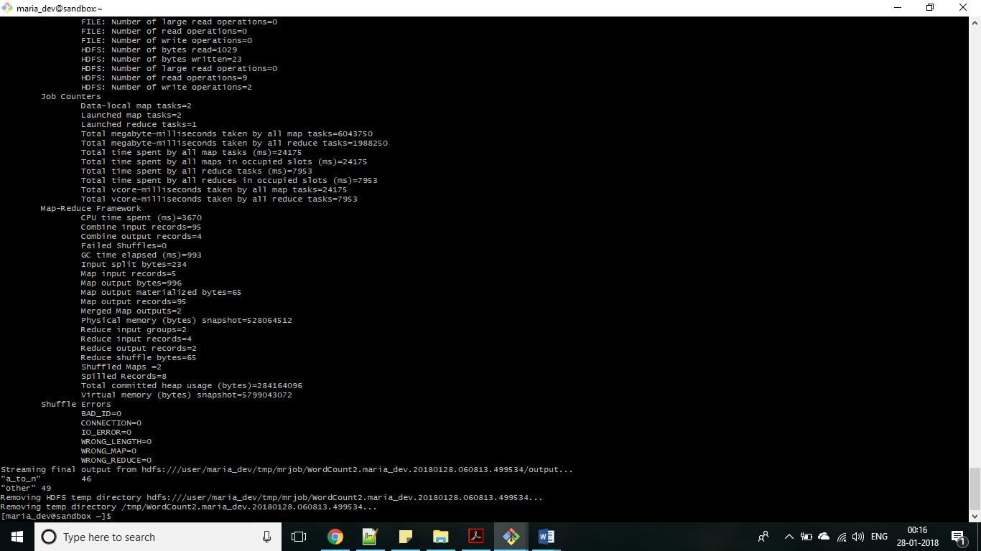

**Question 10**

The output of the program Salaries2.py is highlighted in red below

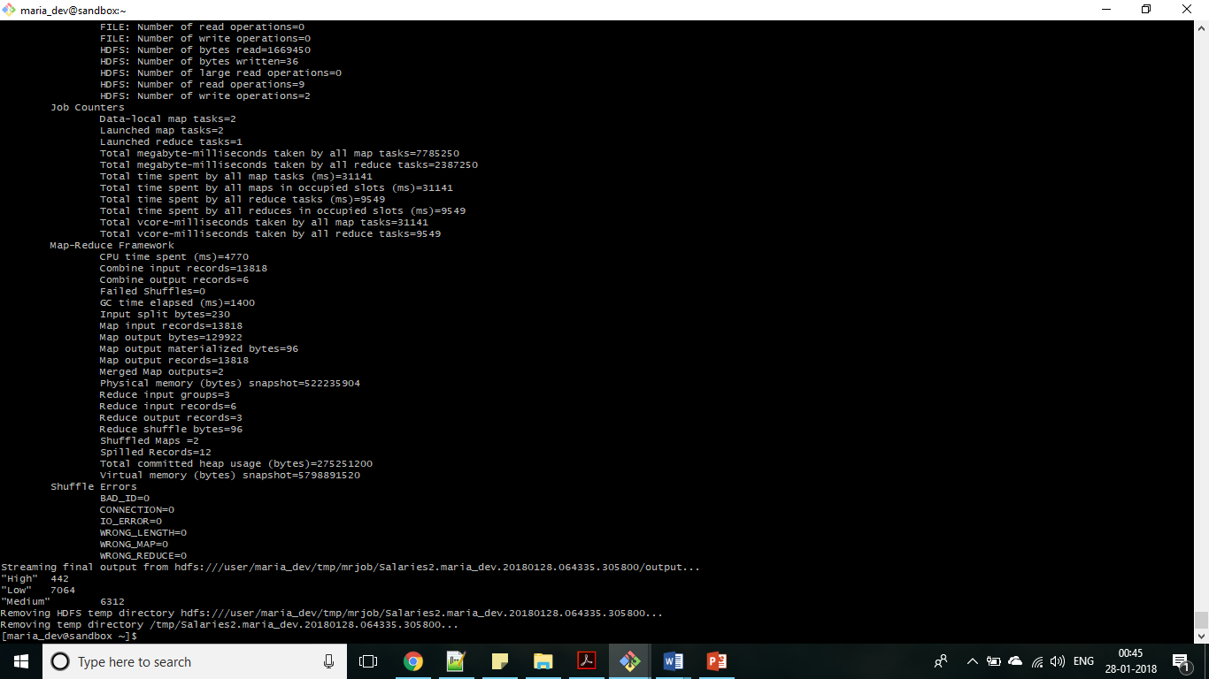

**Question 12**

The first few lines of the output of program MovieCount.py is shown below

