**CSP 595 - Assignment 7**

Name: Jagruti Vichare

Email ID: [jvichare@hawk.iit.edu](mailto:jvichare@hawk.iit.edu)

CWID: A20378092

**Exercise 1**

Step A

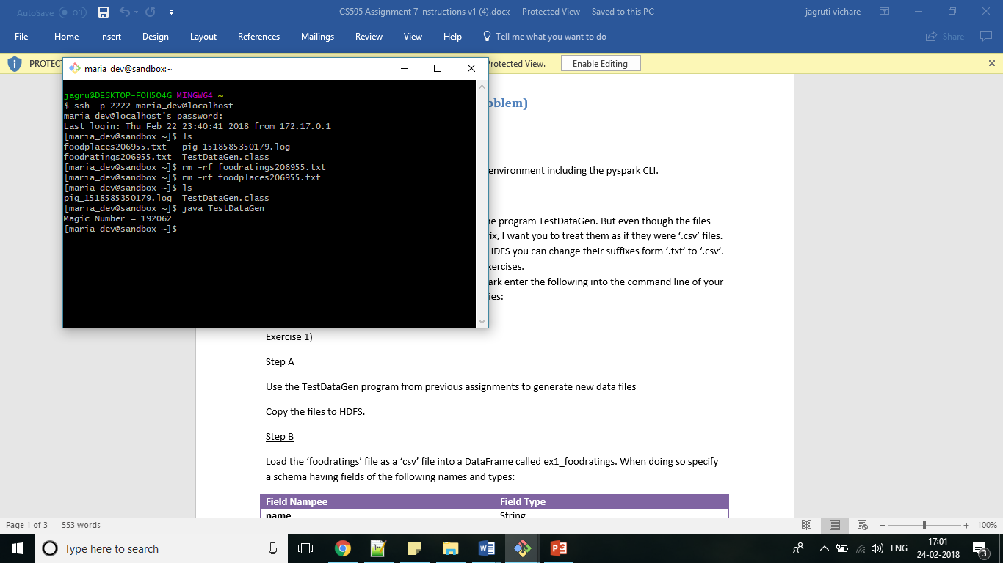

Step B

from pyspark.sql.types import *

foodratingstruct = StructType(

[

StructField("name", StringType(), True),

StructField("food1",IntegerType(), True),

StructField("food2",IntegerType(), True),

StructField("food3",IntegerType(), True),

StructField("food4",IntegerType(), True),

StructField("placeid",IntegerType(), True)

]

)

ex1_foodratings=spark.read.schema(foodratingstruct).csv('/user/maria_dev/foodratings192062.txt')

ex1_foodratings.printSchema()

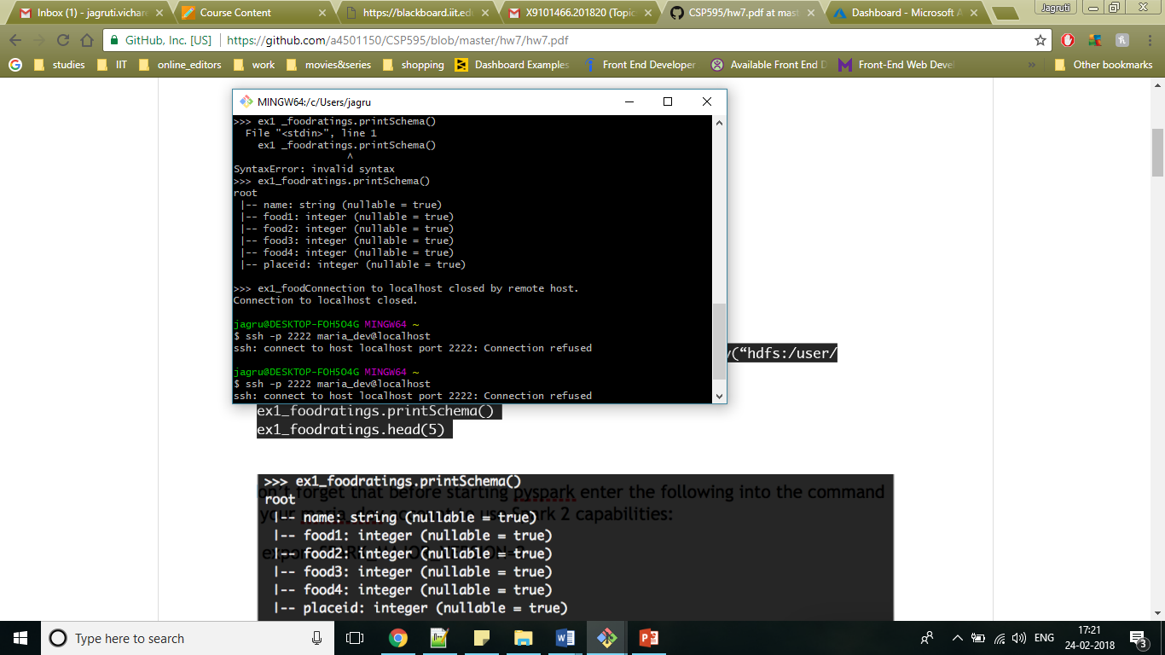

ex1_foodratings.head(5)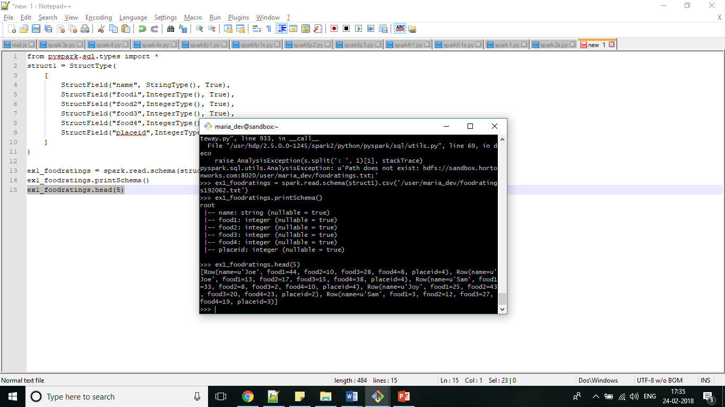

**Exercise 2**

from pyspark.sql.types import *

foodplacestruct = StructType(

[

StructField("placeid", IntegerType(), True),

StructField("placename", StringType(), True)

]

)

ex2_foodplaces = spark.read.schema(foodplacestruct).csv('/user/maria_dev/foodplaces192062.txt')

ex2_foodplaces.printSchema()

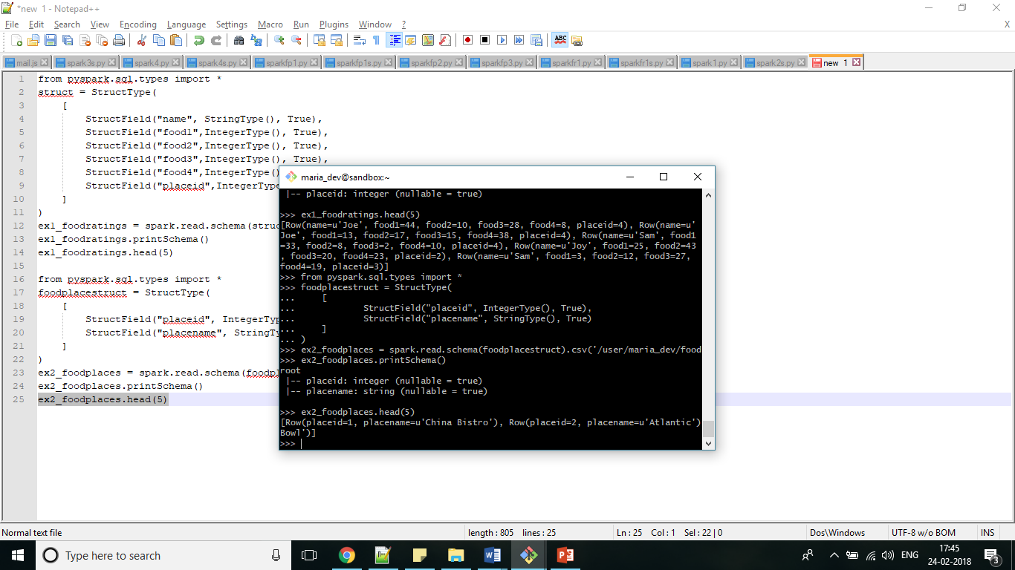ex2_foodplaces.head(5)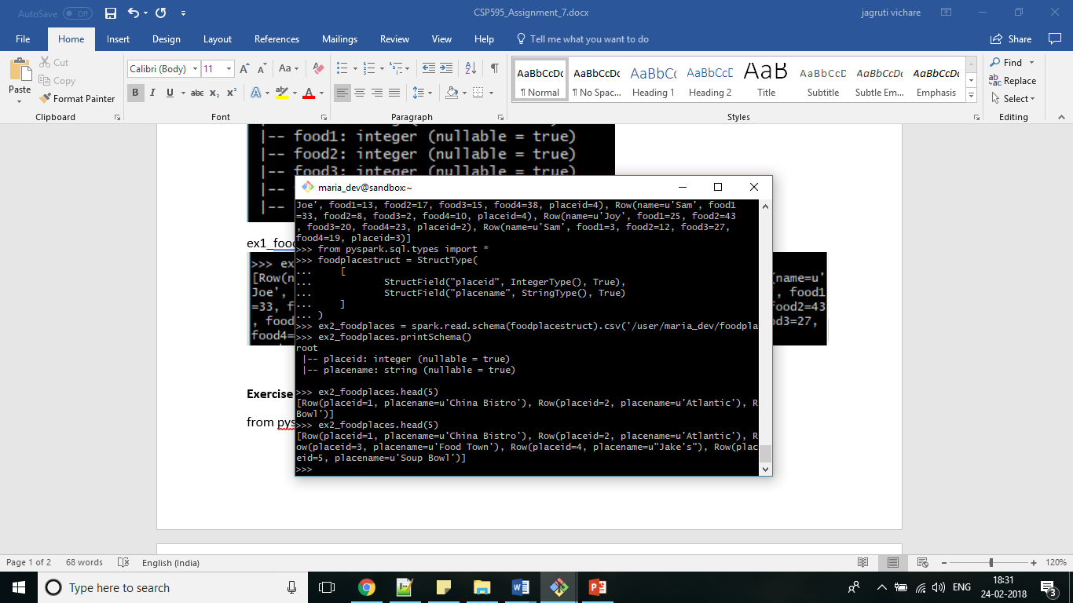

**Exercise 3**

Step A

from pyspark.sql.types import *

ex1_foodratings.createOrReplaceTempView("foodratingsT")

ex2_foodplaces.createOrReplaceTempView("foodplacesT")

Step B

foodratings_ex3 = spark.sql("SELECT * FROM foodratingsT WHERE food2 < 25 AND food4 > 40")

foodratings_ex3.printSchema()

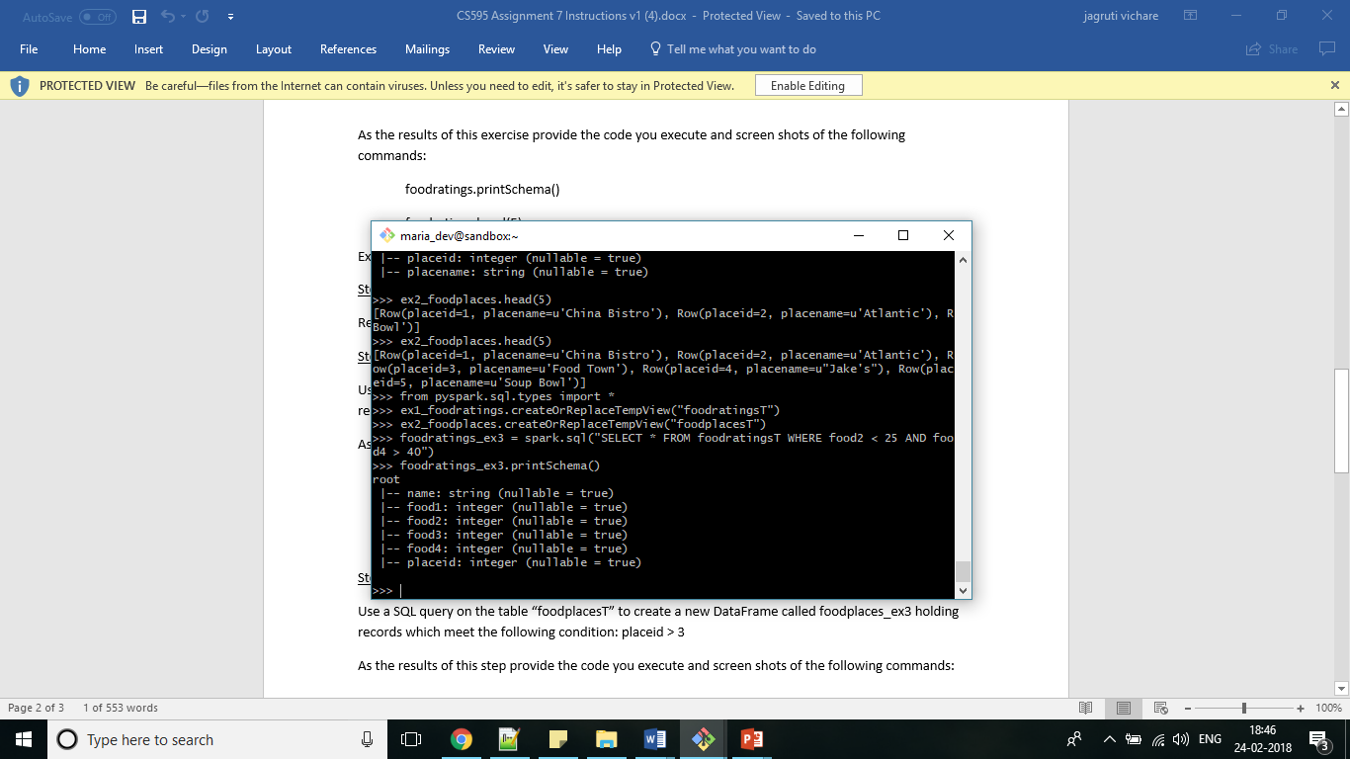

foodratings_ex3.head(5)

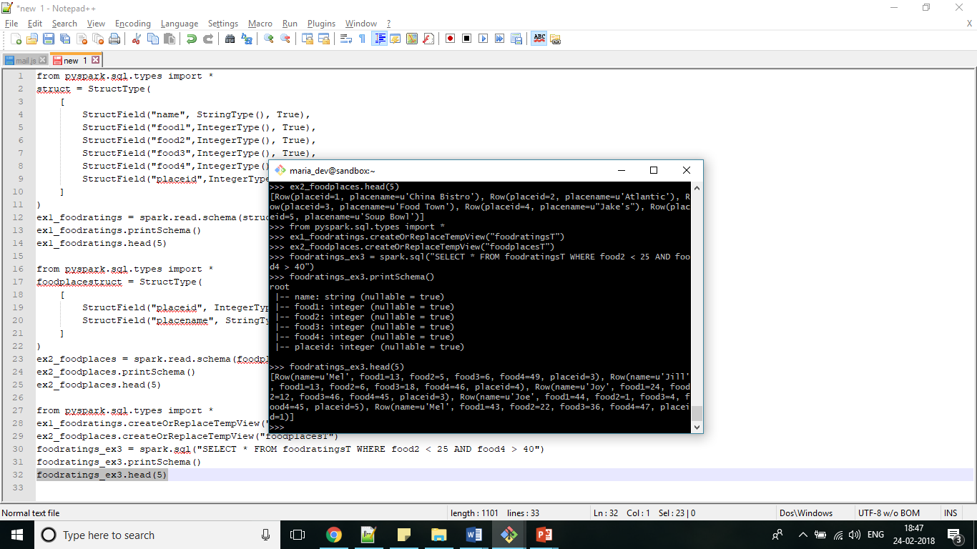

Step C

foodplaces_ex3 = spark.sql("SELECT * FROM foodplacesT WHERE placeid > 3")

foodplaces_ex3.printSchema()

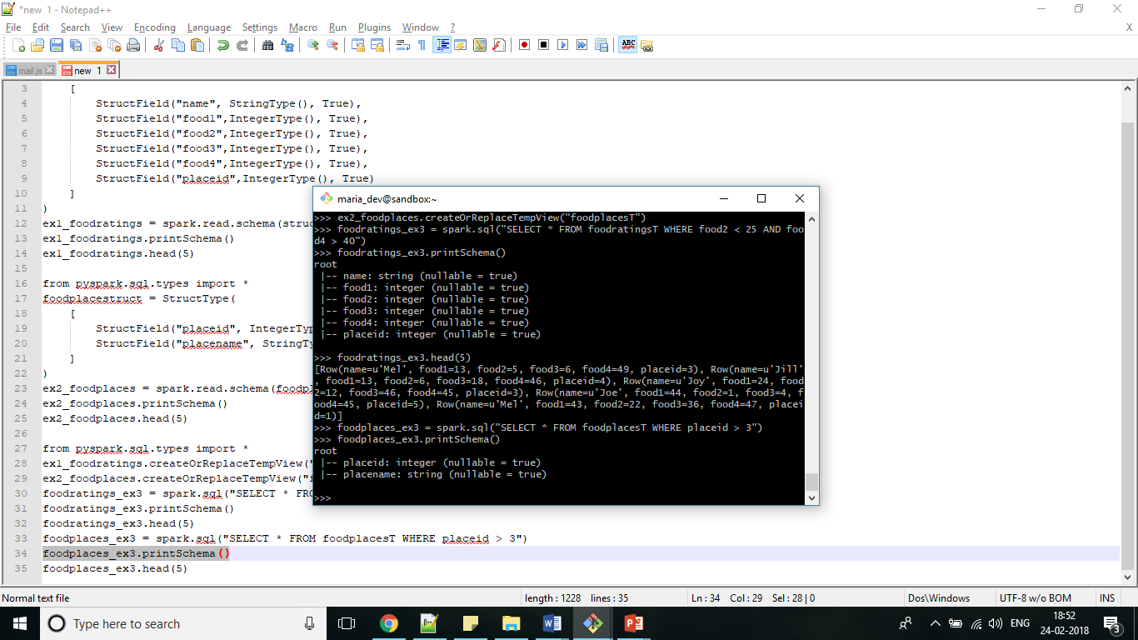

foodplaces_ex3.head(5)

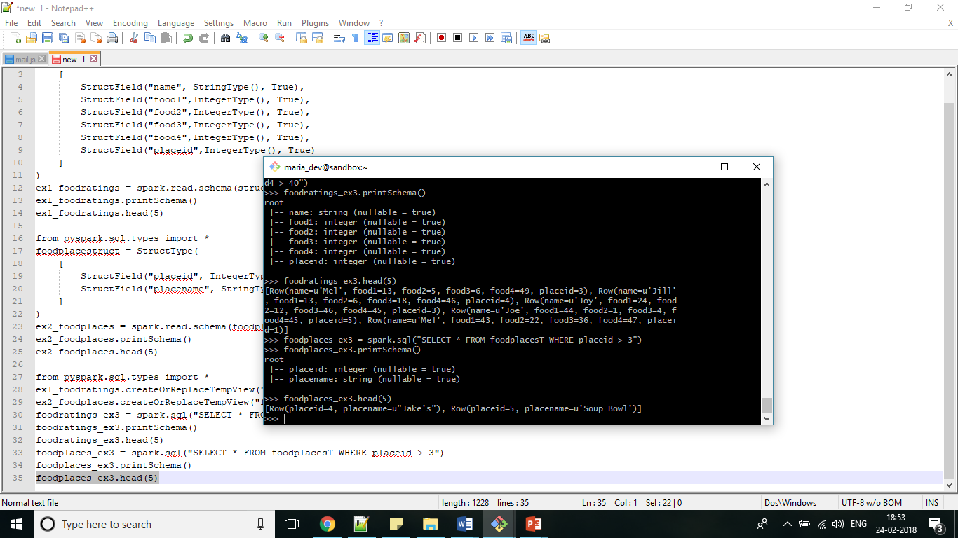

**Exercise 4**

foodratings_ex0 = ex1_foodratings.filter(ex1_foodratings.name=="Mel")

foodratings_ex4 = foodratings_ex0.filter(ex1_foodratings.food3<25)

foodratings_ex4.printSchema()

foodratings_ex4.head(5)

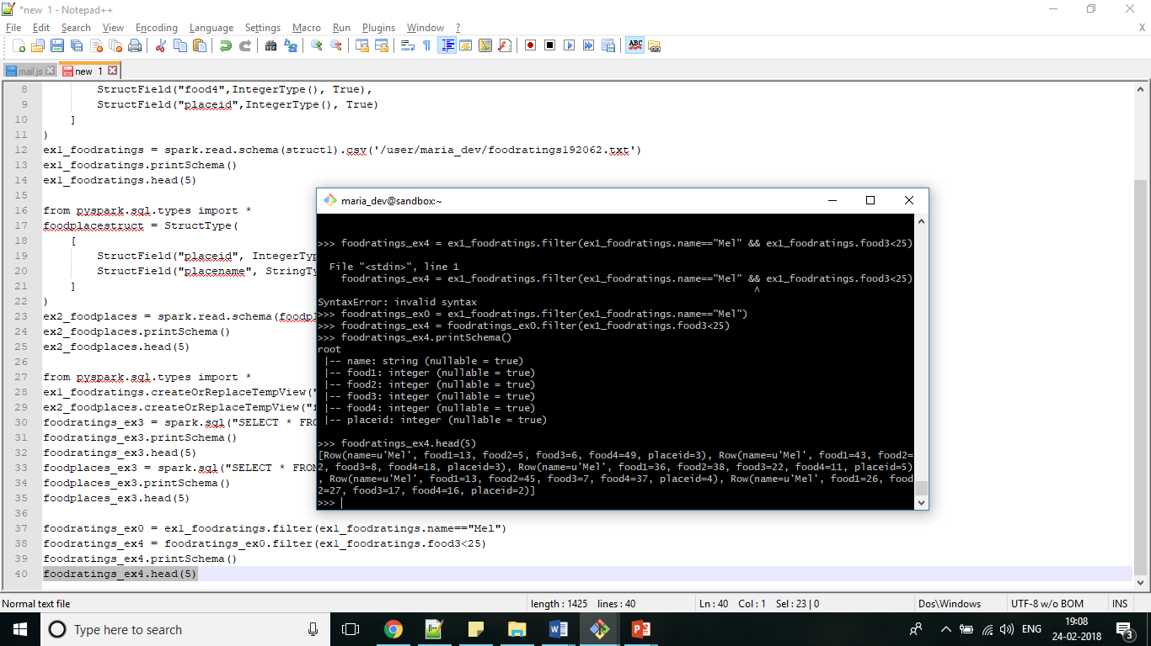

**Exercise 5**

foodratings_ex5 = ex1_foodratings.select('name','placeid')

foodratings_ex5.printSchema()

foodratings_ex5.head(5)

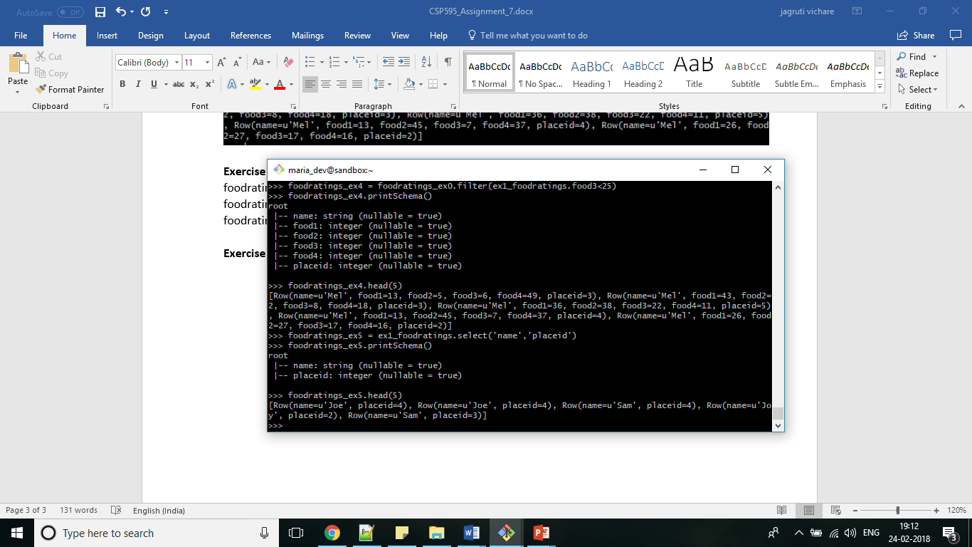

**Exercise 6**

ex6=ex1_foodratings.join(ex2_foodplaces,ex1_foodratings.placeid==ex2_foodplaces.placeid,'inner')

ex6.printSchema()

ex6.head(5)

