

End User

Request



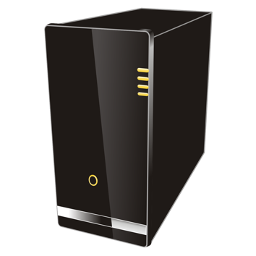

Server

Response



 

Heroku

Manual Deploy

Auto Deploy



Push



Build. Commit Changes

Developer



[This Photo](https://stackoverflow.com/users/5855374/linuxartisan) by Unknown Author is licensed under [CC BY-SA](https://creativecommons.org/licenses/by-sa/3.0/)

Local Environment