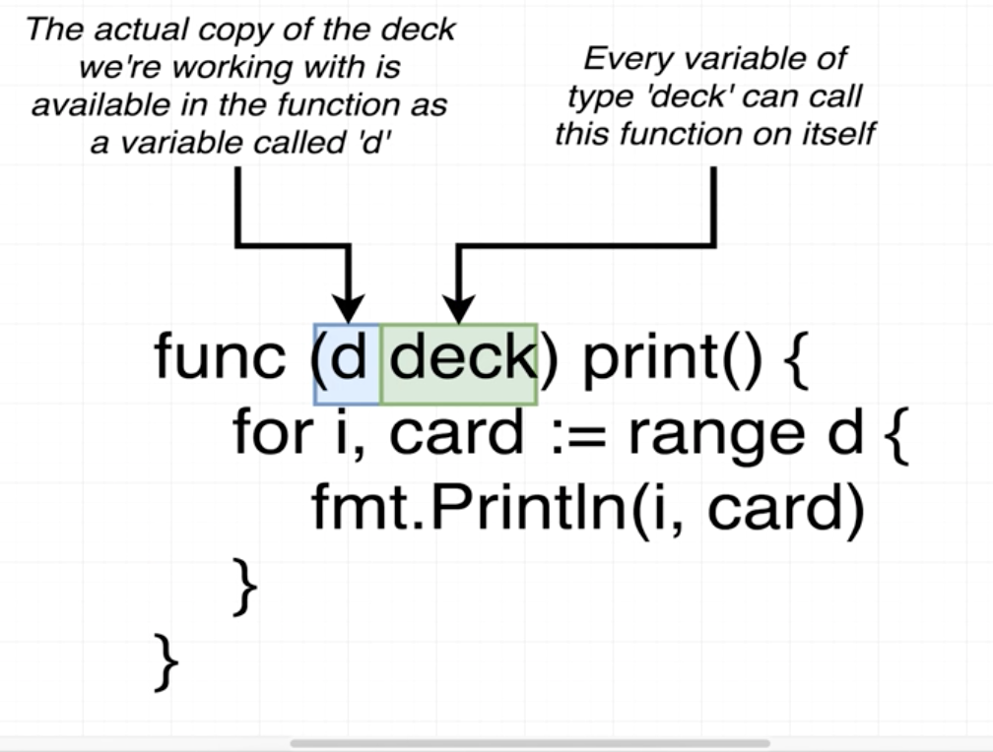

Receivers are nothing but it is kind of **“this” pointers** like in c++.

Here it is called function as :

cards. print() /// where cards declared as -> type **deck** [] string -> **cards** := deck {“Diamond”, “squre” }

So, here it is not pass as any parameter , it is cards is object of deck.

So it is called as cards.print , below is its definition

