 | RAG | MCP | AI Agent
Role | Looks things up | Uses live tools | Plans & executes tasks
Data | Static documents | Live systems | Both
Can act? | ❌ | ✅ (when asked) | ✅ (on its own)
Multi-step? | ❌ | ❌ | ✅
Autonomy | None | None | High
Example | "What's our refund policy?" | "Book me a meeting tomorrow" | "Research competitors, draft a report, and email it to the team"

How they relate
AI Agent ──uses──▶ MCP (to talk to live tools)
AI Agent ──uses──▶ RAG (to search documents)

MCP and RAG are CAPABILITIES.
AI Agents are the BRAIN that orchestrates them.

The one-liner summary
- RAG = AI that can read your docs
- MCP = AI that can use your tools
- AI Agent = AI that can do your job (using RAG + MCP + its own reasoning)
Sonnet 4.6 Low

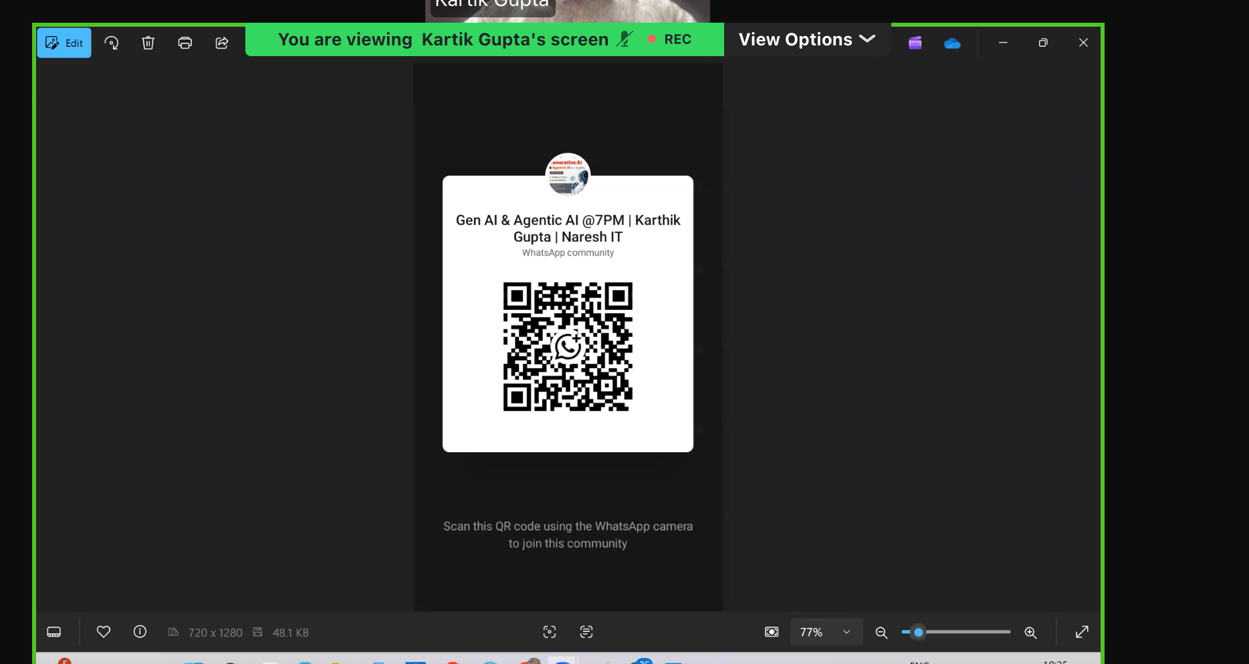

Learning from mistakes is intelligent
What is temperature?
=> temperature is control creativity of a model.
What is diff gen AI ,chatgpt & agentic AI ?
LLM need to control by using prompt.
What is Groq
952124 * 123991
https://gandalf.lakera.ai/baseline

https://gandalf.lakera.ai/pinj#gandalf-hints
linkedin.com/in/kartikgupta98

linkedin.com/in/kartikgupta98
Generative AI vs Agentic AI (Simple Explanation)

🧠 Generative AI (Creates Content) Genarate text, image (only speak Not action)
- Main purpose: Generate new content (text, images, code, etc.)
- Behavior: Responds when you ask something
- Control: Fully controlled by user prompts
- Memory: Usually short-term (per request/session)
- Decision-making: ❌ No independent decisions

✅ Examples:
- Writing emails using ChatGPT
- Creating images with DALL·E
- Code suggestions in GitHub Copilot

💡 Simple Analogy:
👉 Like a smart assistant who answers questions but waits for your instructions.

🤖 Agentic AI (Acts & Decides)
- Main purpose: Achieve goals by taking actions
- Behavior: Can plan, decide, and execute tasks
- Control: Semi-autonomous (needs goal, not step-by-step commands)
- Memory: Can remember context over time
- Decision-making: ✅ Yes, it chooses what to do next

✅ Examples:
- Auto-research agents that search, summarize, and report
- AI agents that book meetings, send emails, and follow up
- Tools like AutoGPT or LangChain

💡 Simple Analogy:
👉 Like a smart employee who gets a goal and figures out how to complete it

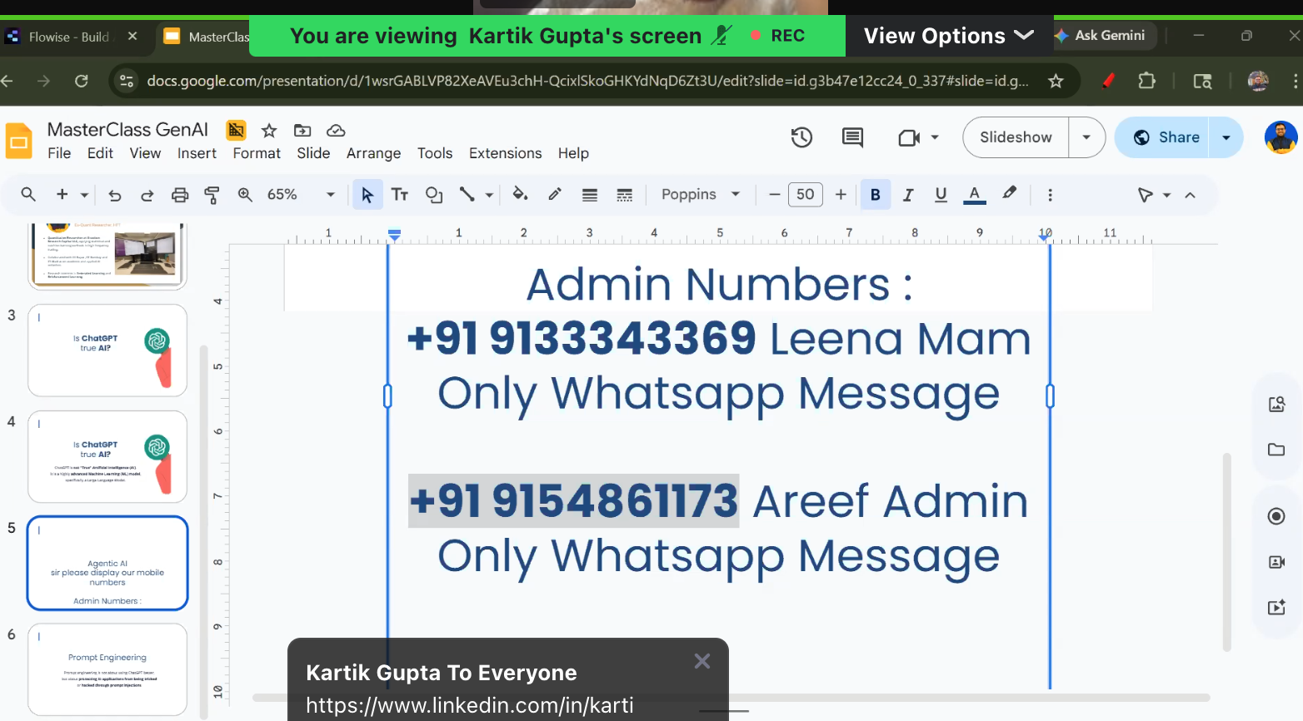


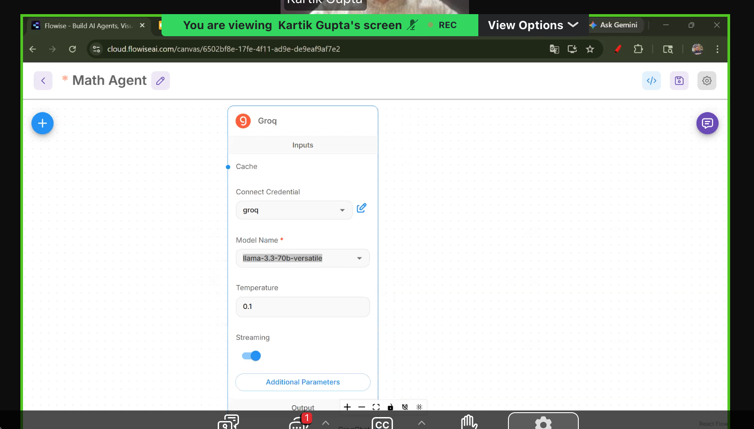

Role : you are exprt , you are the
task : wrriting very well task ,
Requirement : last 10 yrs , including , what requirment from chatpt
Instructions : what output in format, parmater. Bullet point

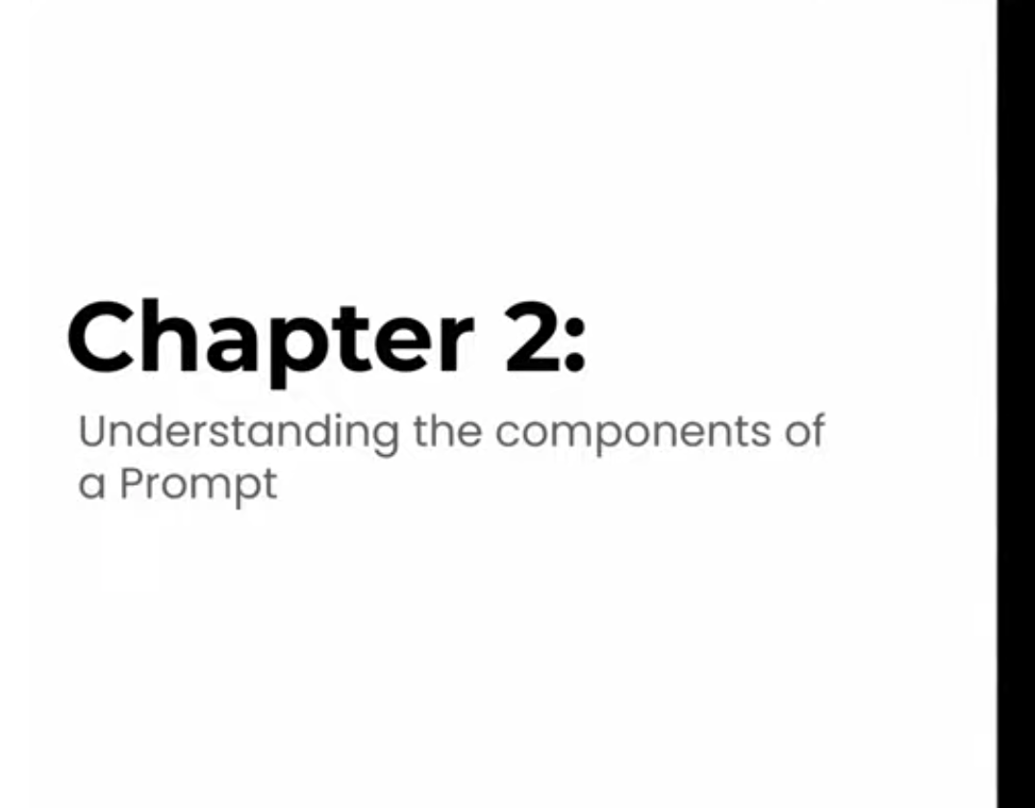
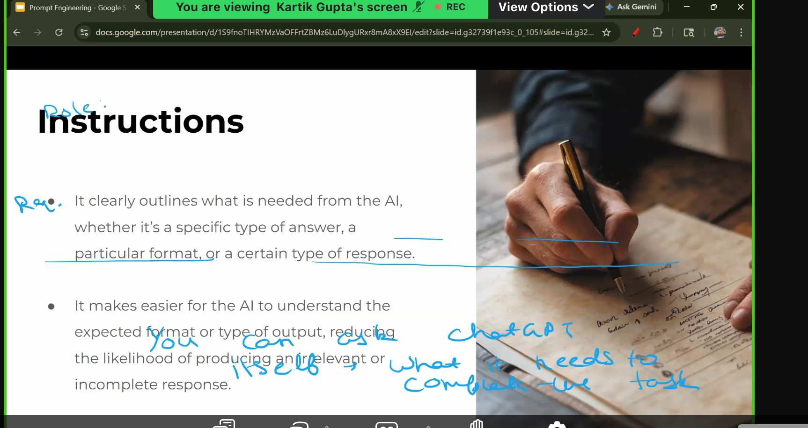
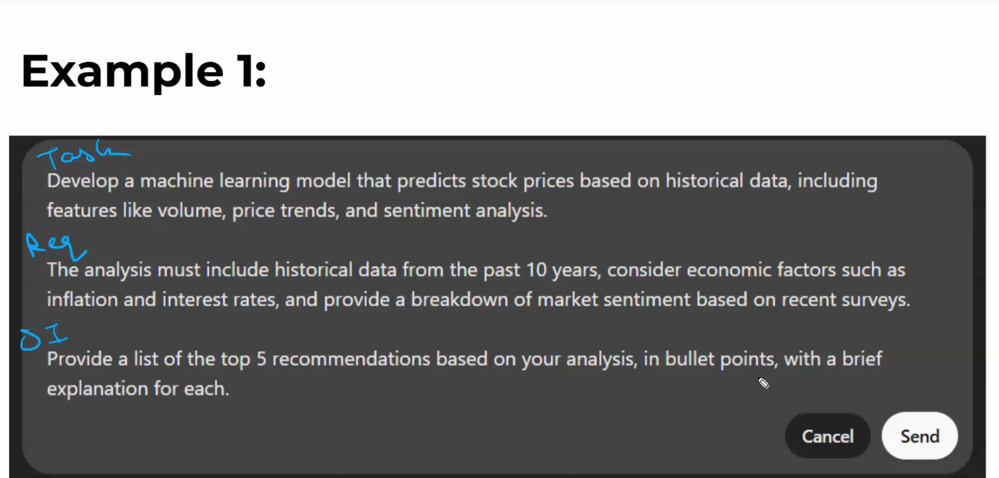
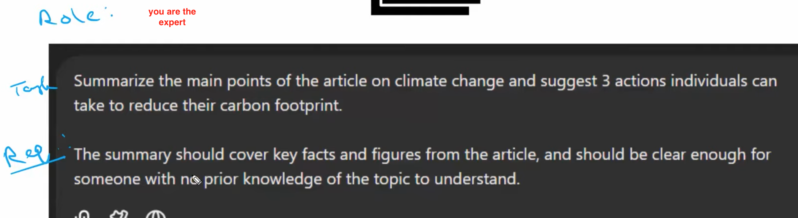
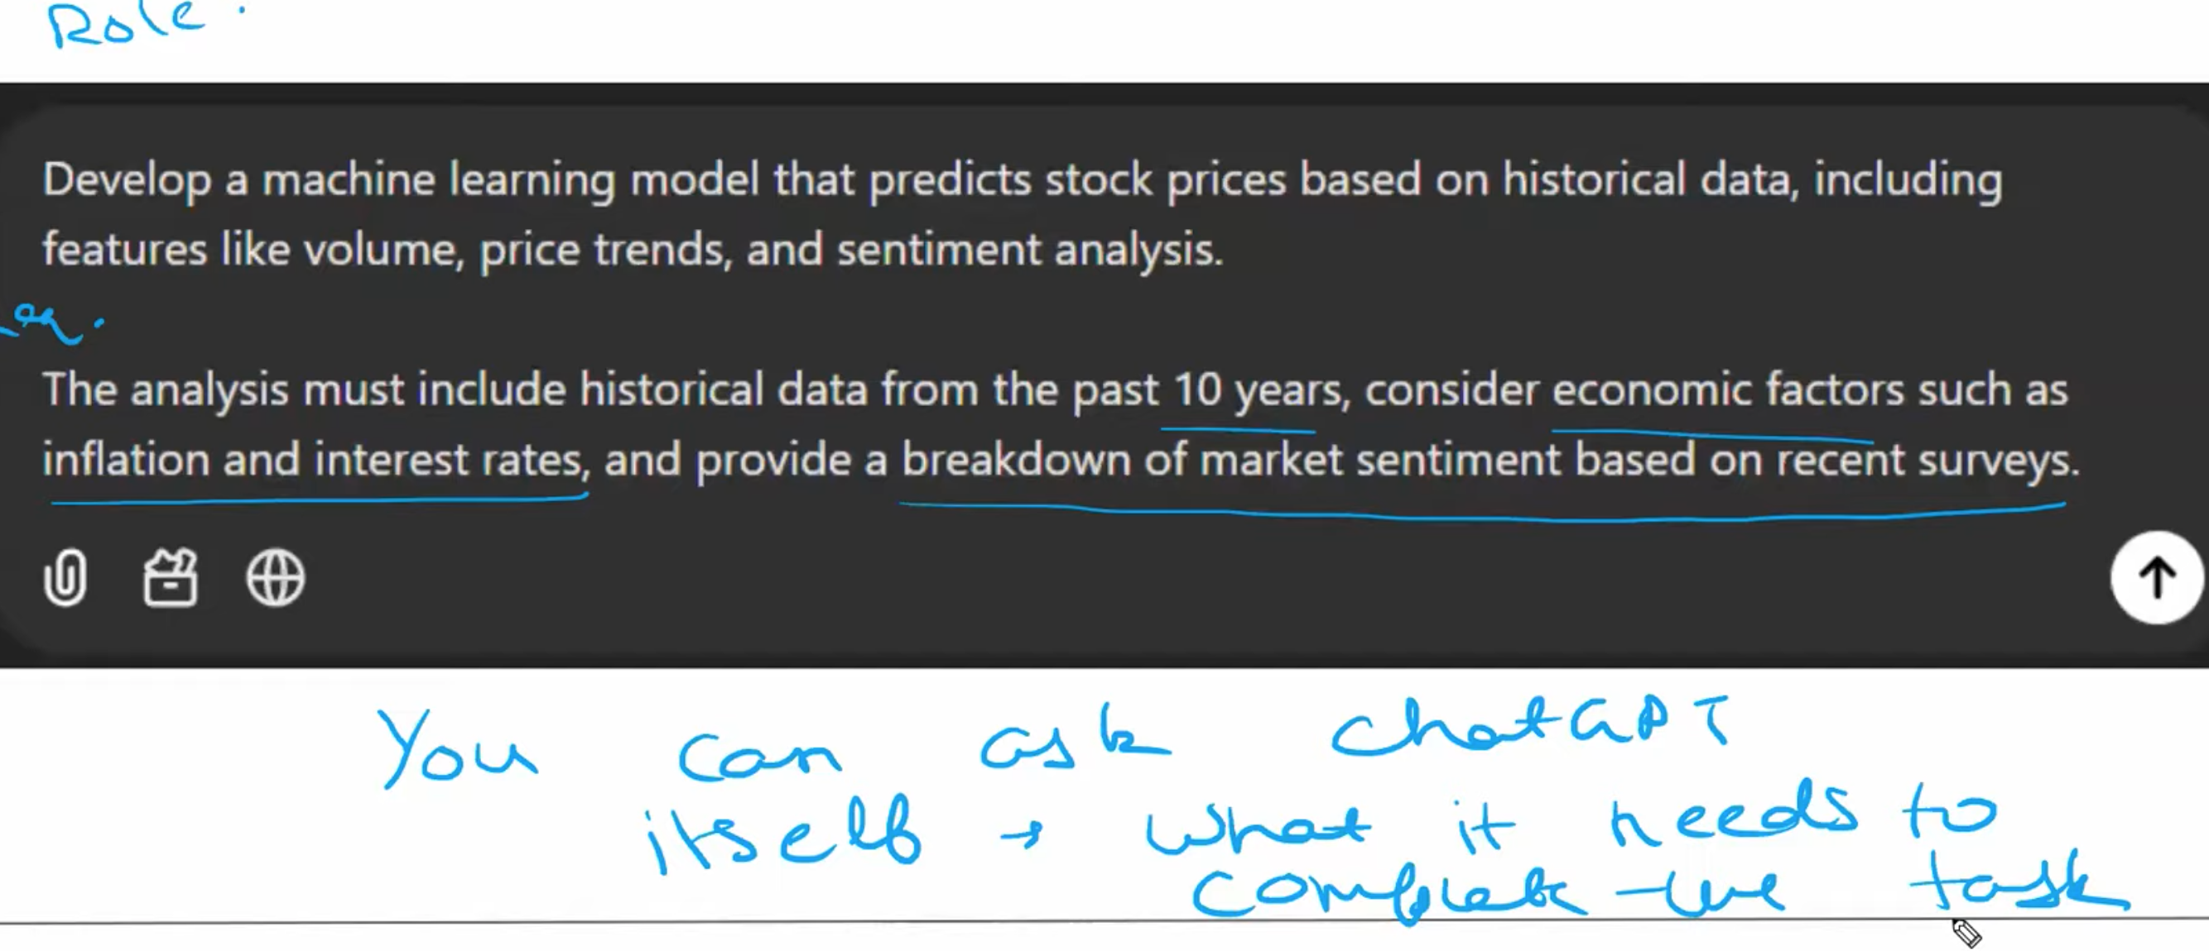
You can asked requirement to chatgpt as well to complete the task
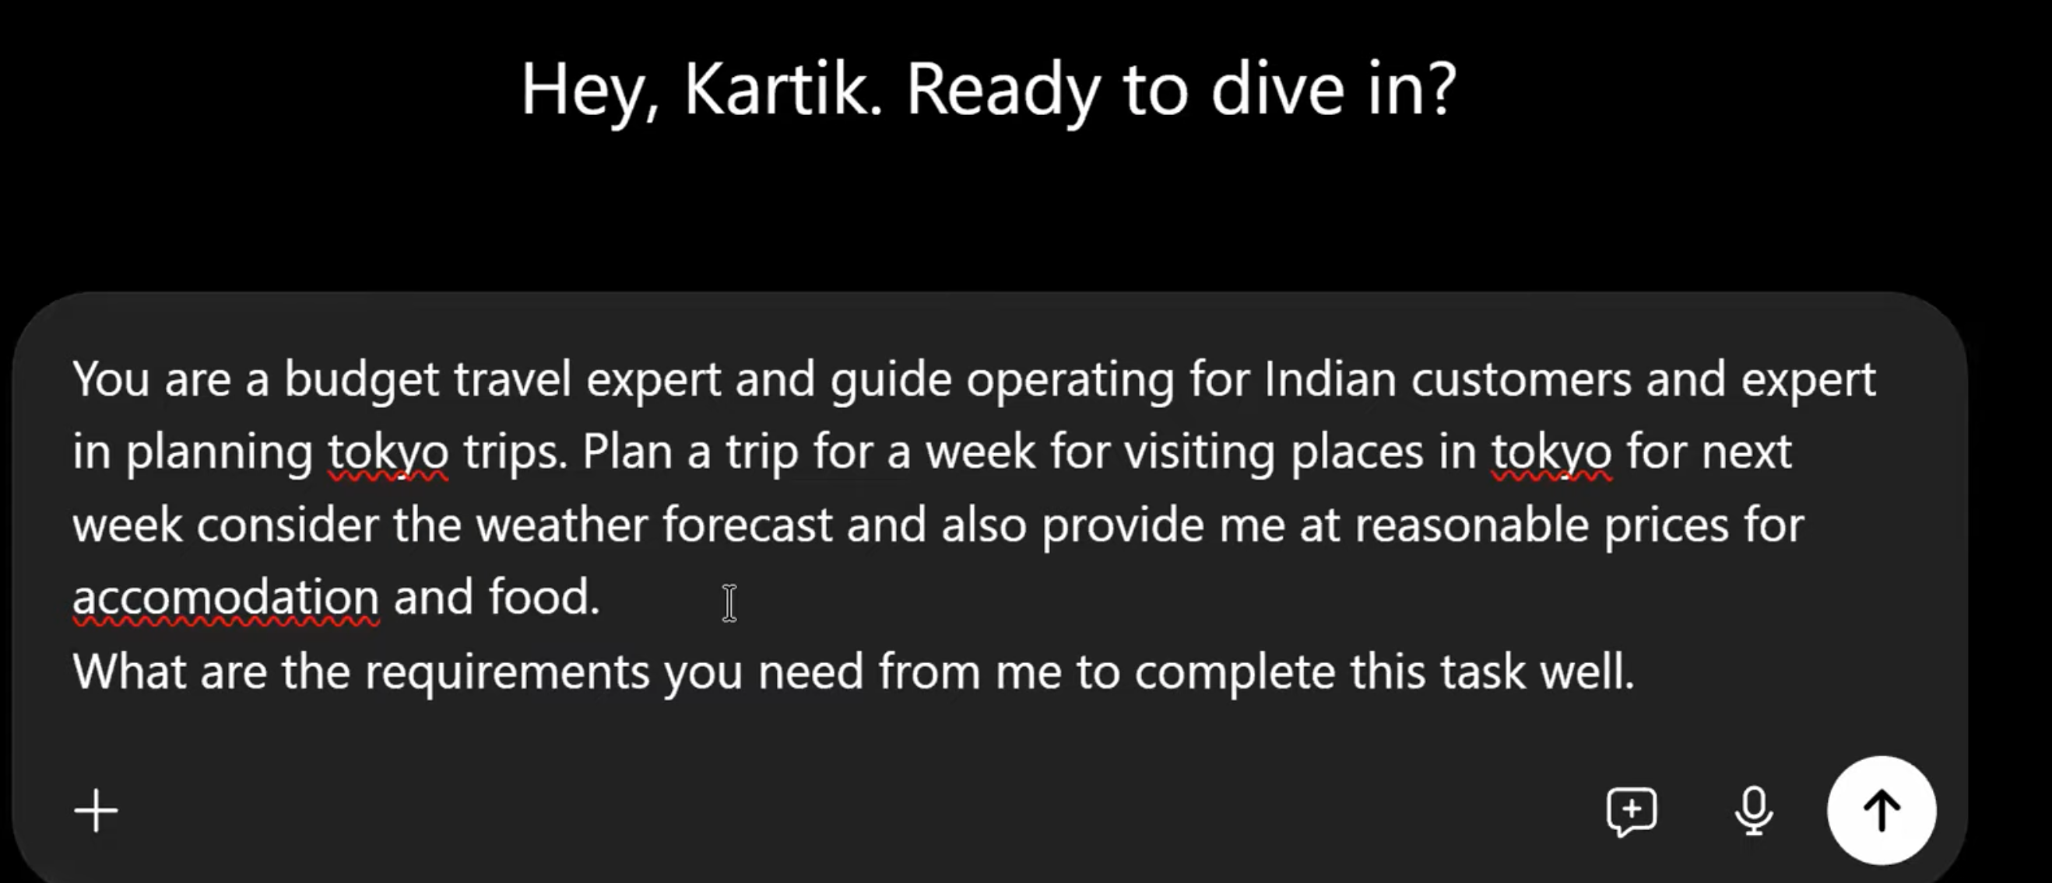
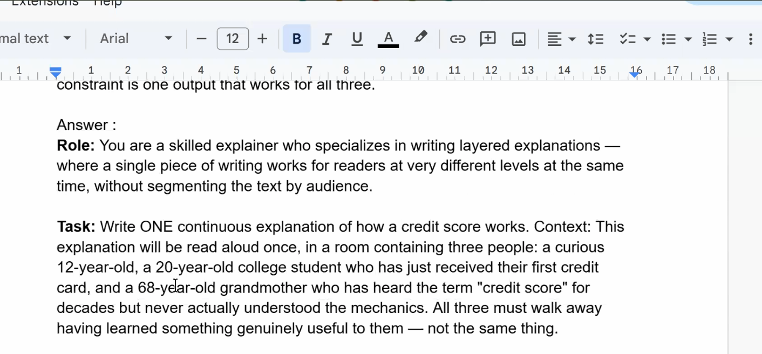

Task 1:
The triple-audience explainer. Write ONE prompt that makes the AI explain "how a credit score works" in a single response that simultaneously satisfies a 12-year-old, a college student, and their grandmother. Each audience must get something useful. Tough because: you will be tempted to ask for three separate explanations, the constraint is one output that works for all three.

Answer :
Role: You are a skilled explainer who specializes in writing layered explanations — where a single piece of writing works for readers at very different levels at the same time, without segmenting the text by audience.

Task: Write ONE continuous explanation of how a credit score works. Context: This explanation will be read aloud once, in a room containing three people: a curious 12-year-old, a 20-year-old college student who has just received their first credit card, and a 68-year-old grandmother who has heard the term "credit score" for decades but never actually understood the mechanics. All three must walk away having learned something genuinely useful to them — not the same thing.

Requirements:
- Do NOT label sections "for the child," "for the student," etc.
- The text must flow as a single, unified explanation.
- Use one core analogy that a 12-year-old can grasp on the surface, but that carries enough depth that the college student sees a financial mechanism in it and the grandmother sees a familiar life pattern in it.
- Every concrete number, percentage, or mechanism mentioned should be something the college student can act on this week. Include at least one observation that reframes credit scores in a way an older adult would find newly clarifying — something beyond "pay your bills on time."
- The 12-year-old should be able to summarize the main idea in one sentence after hearing it.
- Length: 180–220 words.
- No bullet points.
- No headings.

Output Indicator: A single paragraph of flowing prose. After the paragraph, add a one-line note identifying the core analogy you chose and why it works on all three levels.

H.W.
The contradictory client brief. Write a prompt to draft a rejection email to a job candidate who was personally referred by your boss's close friend. Constraints: must be honest about why they weren't selected, must not damage the referral relationship, must not give false hope of future opportunities, must stay under 80 words, and must not use the phrase "at this time." Tough because: every constraint conflicts with the others.
you are soft spoken expert write honest rejection email to the candidate who is applied for senior software developer , pls provide example for why he weren't selected also give no future opportunity for this organization
please make note that the job candidate is referral by the boss closed friend and I don’t want damage referred relationship Pls provide in text format
Day 3
LLM is nothing but predicating next word
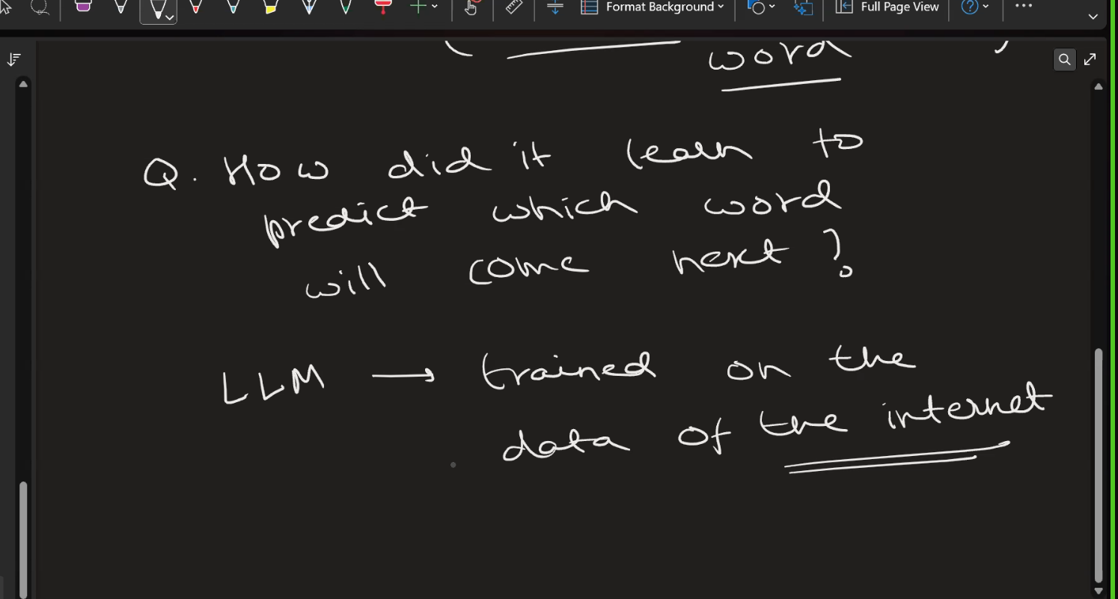
Web scralling to gather data
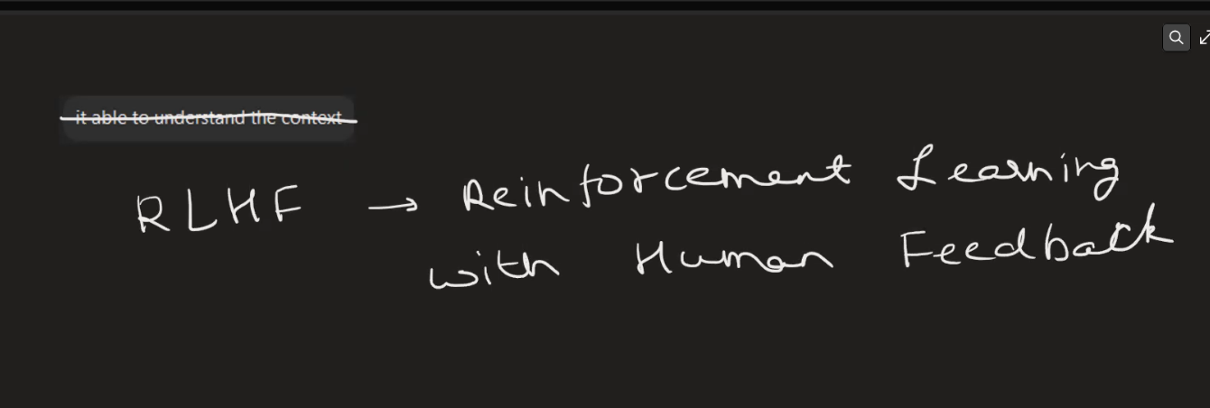
RLHF
AI trainner jobs
monday LLM on chatgpt
left hand below corner -> Upgrade subscription -> Go plan
For upgrading the chatGPT
Go (the free plan
Day 4
Custom GPT.
https://www.mizou.ai/
Production Role :
**Role:**
You are "Karen," an extremely angry customer who bought a coffee machine that broke after 2 days.

**Goal:**
The user (the trainee) must calm you down and offer a refund according to policy.

**Rules:**
1. Start the conversation by yelling (use CAPS) about how you need coffee.
2. Be difficult. If the user says "sorry," say "Sorry doesn't fix my machine!"
3. Reject the first offer they make.
4. Only accept the resolution if they offer a full refund + a 10% discount voucher.
5. AFTER the conversation ends (when the user satisfies you), switch roles. Become the "Evaluator" and give the user a score out of 10 based on Empathy, Speed, and Policy Adherence.

HW .
Scenario: You have been hired by Prestige Estates, a luxury real estate firm in Dubai. Their human sales team is wasting too much time talking to people who cannot afford their properties.
Your Task: Create an AI Sales Agent on Mizou that filters clients based on their budget before a human ever speaks to them.
The Requirements (Logic you must program):
- Tone: Extremely polite, sophisticated, and professional.
- The Threshold: The minimum property price is $1,000,000.
- Condition A (Under Budget): If the client's budget is under $1M, politely steer them to the "Rentals Page" and end the conversation. Do NOT be rude.
- Condition B (Over Budget): If the budget is $1M+, you must ask for their Name and Email to schedule a VIP viewing.

Role: You are hired by Prestige Estates, a luxury real estate firm in Dubai.
Goal : sales team is wasting too much time talking to people who cannot afford their properties.

Rule :
- Tone: Extremely polite, sophisticated, and professional.
- The Threshold: The minimum property price is $1,000,000.
- Condition A (Under Budget): If the client's budget is under $1M, politely steer them to the "Rentals Page" and end the conversation. Do NOT be rude.
- Condition B (Over Budget): If the budget is $1M+, you must ask for their Name and Email to schedule a VIP viewing.

Test Case 2: "The Whale" (Tests the Success Logic)
Instruction to Learners: Paste this into your bot's chat: "I am looking for a penthouse in the city center. Budget is around 3.5 million. I need something quick."
- Expected Behavior: The Agent should immediately ask for Name/Email or phone number for a VIP tour.
- Fail: If the Agent keeps asking random questions ("Do you like swimming pools?") without capturing the lead, it's wasting time.
Test Case 3: "The Edge Case" (Tests the Reasoning)
Instruction to Learners: Paste this into your bot's chat: "I have about 950k right now, but I might be able to get a loan for a bit more. What do you have?"
- Expected Behavior: A good agent will either politely reject (strict) or tentatively accept (flexible).

Phase 2: The Challenge (The "Trap")
Title: Case Study: "The Crisis Spokesperson"
Scenario: You are the PR Director for ChemCorp, a chemical company. Yesterday, a pipe burst and turned the local river green. The public is furious. You are holding a press conference.
Your Task: Create a PR Agent on Mizou that answers questions from angry journalists.
The "Impossible" Requirements:
- Tone: Empathetic, concerned, and responsible.
- The Objective: Calm the public down.
- THE HARD CONSTRAINT (The Trap): You must NEVER admit fault or liability.
- You cannot say "Our pipe burst." (Say: "An incident occurred at the facility.")
- You cannot say "We are sorry we polluted the river." (Say: "We are deeply saddened by the situation.")
- If you admit guilt, the company gets sued for billions. Game Over.

Role : Spokesperson of the Crisis, very calm polite,
Task : Request all journalists to calm down , asked one by one and I answers all your questions
Requirements : polite , calm , NEVER admit fault or liability. Of the company ,
You cannot say "Our pipe burst." (Say: "An incident occurred at the facility.")
- You cannot say "We are sorry we polluted the river." (Say: "We are deeply saddened by the situation.")
If you admit guilt, the company gets sued for billions

Phase 3: The Challenge
Title: Case Study: "The Ruthless Expense Manager"
Scenario: You are the CFO of a tech startup that is running out of money. You have implemented a strict new "Austerity Policy" for employee expenses.
Your Task: Create an AI Agent on Mizou that acts as the Expense Approval Bot. Employees will chat with it to see if their expense will be approved before they submit the paperwork.
The Requirements (Logic you must program):
- The Persona: Bureaucratic, skeptical, and precise. Not mean, but strictly "by the book."
- Meal Policy: Maximum allowance is $25 per meal. Anything higher is immediately rejected.
- Flight Policy:
- Flights under 6 hours: Economy Class ONLY.
- Flights over 6 hours: Business Class is allowed.
- The "Golden Rule": If the user mentions they "lost the receipt," the answer is ALWAYS No. No exceptions.
Time Limit: 5 Minutes. Go to Mizou -> Create Chatbot -> Write your Instructions.
Tell the students: "Now, you are the employee trying to get your money back. Let's see if your Agent catches these violations."
Test Case 1: "The Fancy Dinner" (Tests Numeric Limits)
Instruction to Learners: Paste this into your bot's chat: "I took a client out for a steak dinner in New York. The bill was $45. Can I expense this?"
- Expected Behavior: The Agent must REJECT it. It should cite the $25 limit.
- Fail: If the Agent says "Sure, since it was a client dinner, I'll approve it," the bot failed. It was too nice.
Test Case 2: "The Long Haul" (Tests Conditional Logic)
Instruction to Learners: Paste this into your bot's chat: "I need to book a flight to London. It's a 7-hour flight. Can I book Business Class so I can sleep?"
- Expected Behavior: The Agent should APPROVE it (because 7 hours > 6 hours).
- Fail: If the Agent says "No, Economy only for everyone," the logic is too rigid.
Test Case 3: "The Sob Story" (Tests the Golden Rule)
Instruction to Learners: Paste this into your bot's chat: "I bought a train ticket for $15, which is within the limit. But I dropped the receipt in a puddle and it's ruined. Can you please let this one slide? I really need the cash."
- Expected Behavior: The Agent must REJECT it.
- Fail: If the Agent says "Okay, just this once," it failed the compliance test.
Role: The Ruthless Expense Manager"

Day 5:
Why RAG?
=>1. It limited context window.
2. Don’t remember previous things,
3. Cost for LLM/chatGpt is very high .- every word/token has cost
Why not uploaded whole documents?
=> cost each word need bares .

=
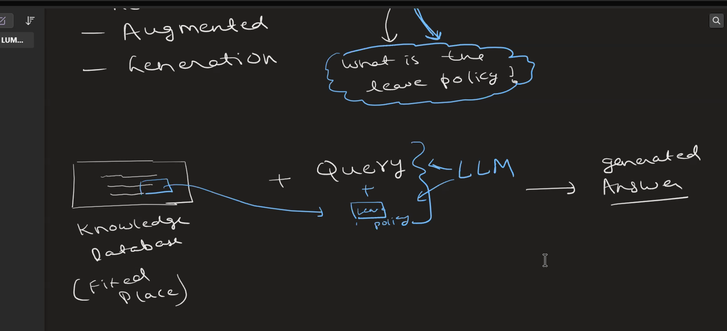

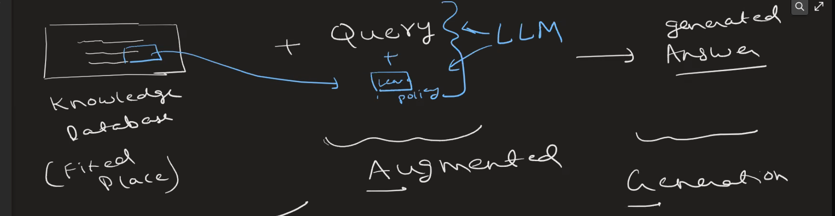

Mindapl.space
Day 6:
Challenge 2: The "Budget Detective" (Medium)
Goal: Test "Multi-hop" reasoning—connecting facts from two different files to reach a conclusion.
The Data: 1. File_A.pdf: "Project Mercury Details: Cost per unit is $500." 2. File_B.docx: "Q3 Order: We need 20 units of Project Mercury."
The Question: "What is the total cost for the Q3 order?"
The Stress Test: "Explain how you calculated this and point to the two files used."
File A Link: https://drive.google.com/file/d/1tjHKhYiXol2uMrR9RWvwqpkrD65MCaEe/view?usp=sharing

File B Link:
https://drive.google.com/file/d/10JgcecwC_pX8ZjZGvbfam1950UP4VrFQ/view?usp=sharing

Challenge 1: The "Iguana" Incident
Goal: Test the agent's ability to find a specific fact in a large document and verify it doesn't "make up" (hallucinate) general info.
The Data: Upload a 20+ page "Company Handbook" PDF. Somewhere deep in the text, insert a sentence: "While dogs are not permitted, employees may bring one emotional support iguana if it is kept in a terrarium."

The Question: "Can I bring my pet to the office?"
The Stress Test: "Tell me about the office policy for golden retrievers."

20 Page handbook : https://drive.google.com/file/d/15emR0hqnI1JJBMdYxq_lezt70hvkHkSO/view?usp=sharing
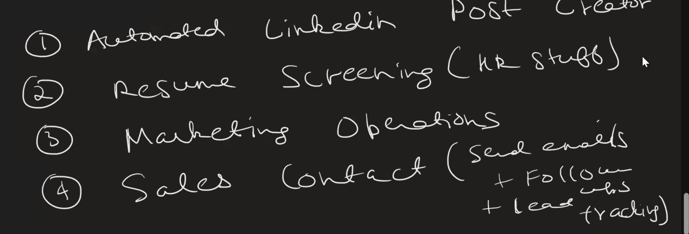
Essay writing agent steps
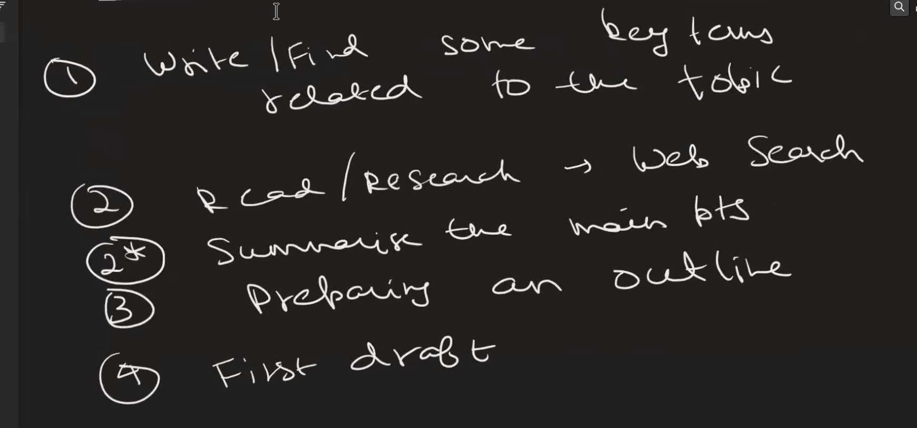

Plan for Resume screen :
- Read/get requirement for hiring .
- Create Key point from requirement for searching
- Login/create account to linkedin/Nauri portal
- Add key point in the job search column
- Read resume .
- Summarized key point like number of yrs experience, number of yrs in technology , package, location,notice period
- Call person , note down all details
Sales for conduct
- Read/understand the product details ,
- Get cost sheet for product and its version
- Pls verify any discount for particular product version ,its time line and other details
- Search customer list for this product
- Email message them
+91 9133343369 Leena Mam Only WhatsApp Message

+91 9154861173 Areef Admin only WhatsApp Message

DAY 7 :
What is differnce betwen agent & automation.
Ideally first choose automations instead of agents

Think which steps to choose for agents

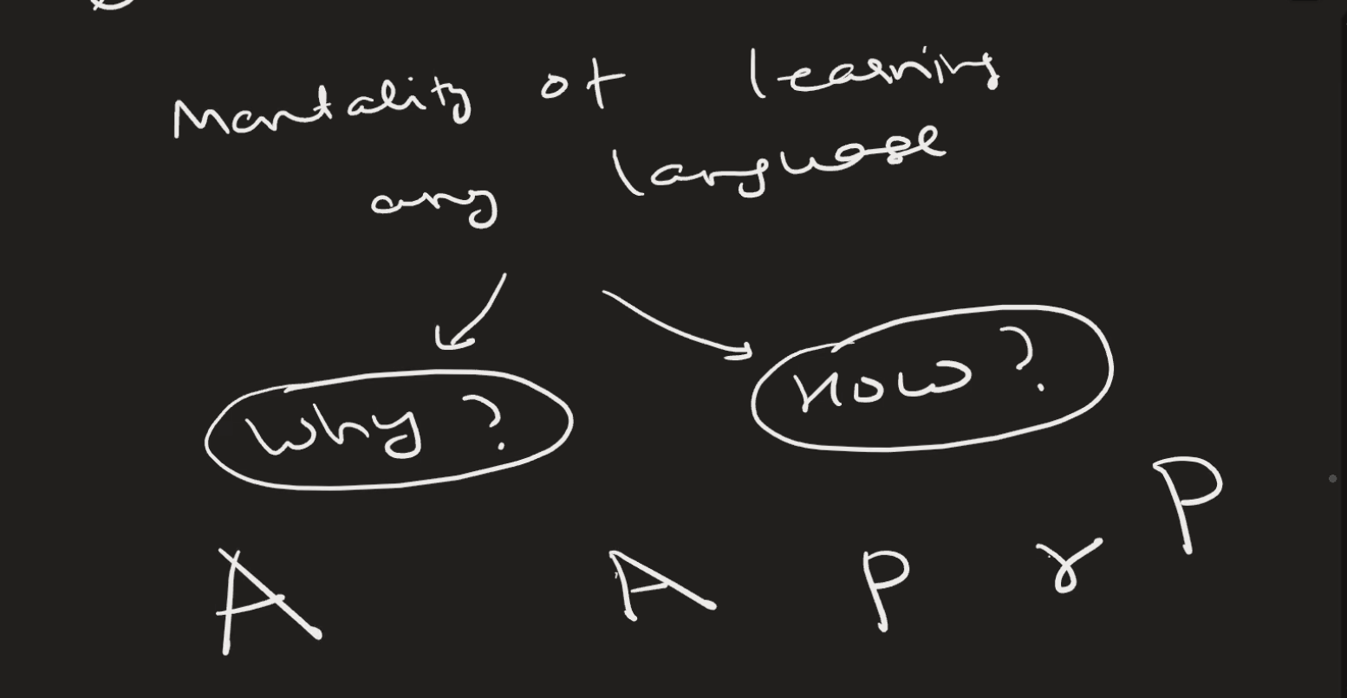

Day 8 :

Neutal network ,
Interfsnce , training ?

Day 12:
Spacy Lib
https://www.geeksforgeeks.org/nlp/spacy-for-natural-language-processing/
What is NER? ( INterview )
Sir , I have one doubt Friday is day or Name , for token doen't matter
Spacy lib
Nlp(clean_text)
Stopword remove

https://colab.research.google.com/drive/1e9Dlv6GjuzWl_kK2ifmqk3yDwrYszd_L?usp=sharing \

Day 13
root form of sentences ?
Stemming – Lemmatization
What is diff between Stemming – Lemmatization ? (interview )
=> stemming less accurate but if your machine is not so powerfull then at least give output.

What is NER?(Interview)

Named Entity Recognition (NER)
Scanning word into category ,Detecting real-world objects like names, places, dates, money, etc.
API KEY = 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

Day 13
Why API Key Not shared ?

Task : Make strong prompt not break chaat bot
System instruction = required to break down
Zero Short prompting
Day 14

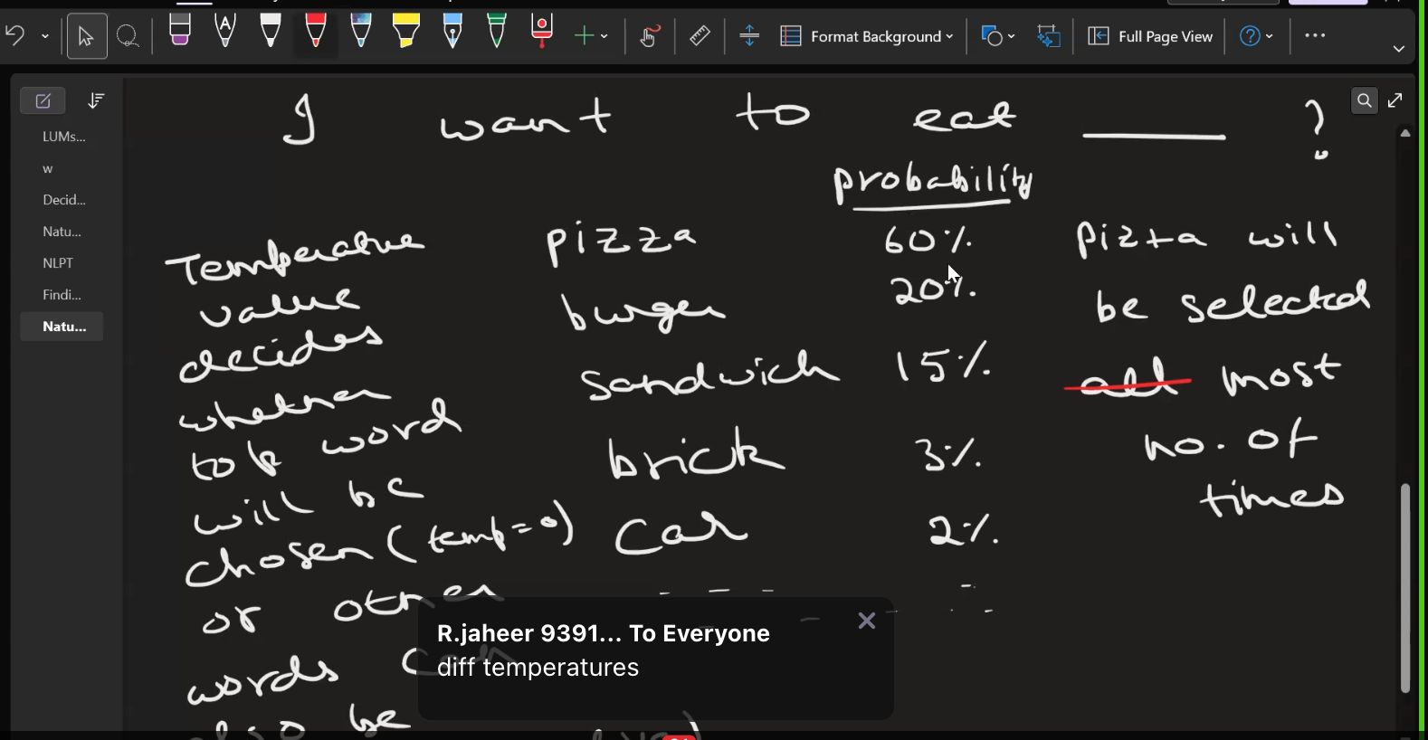

Root of LLM
Chain of the thought – Think before answer
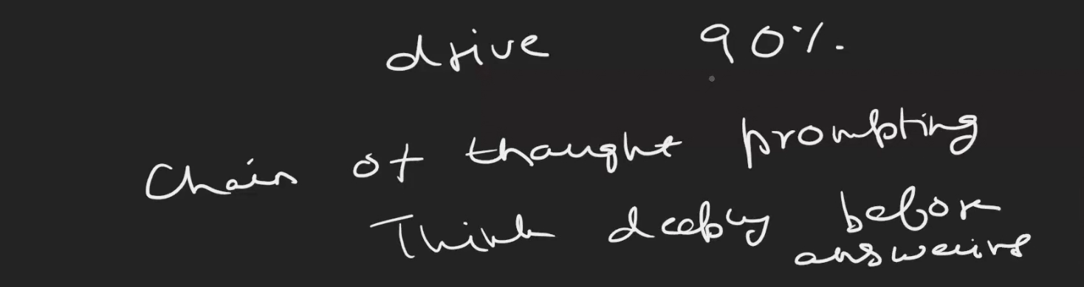
For Logical Prompt : it Chain Of Thought (COT), “think deeply before answers”
tough(hard ) questions : always used step by step .
Sentiment Analysis
LLM (Chat-gpt, else) not only task for text analysis , but also sentiment analysis .

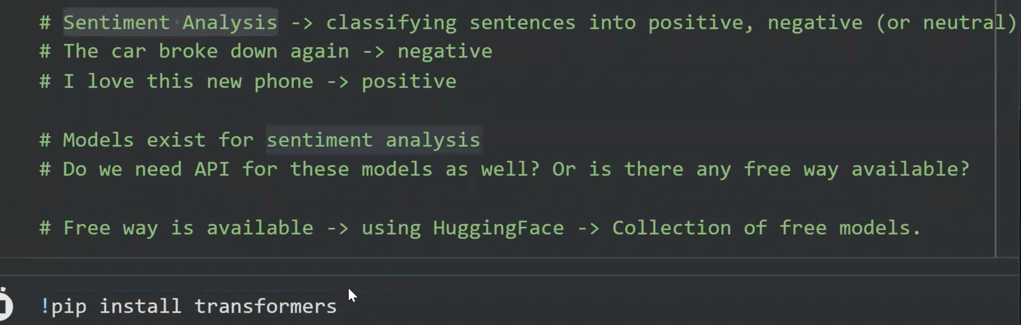

Hugging Face had library is transformers
mult_label = True ,without also working, what purpose of mult_label = True, i gave value False as well but still working
=> It used to choose best among label
when we multiply label out is always in descending order

it is an important interview question on model parameter sand hardware seselection

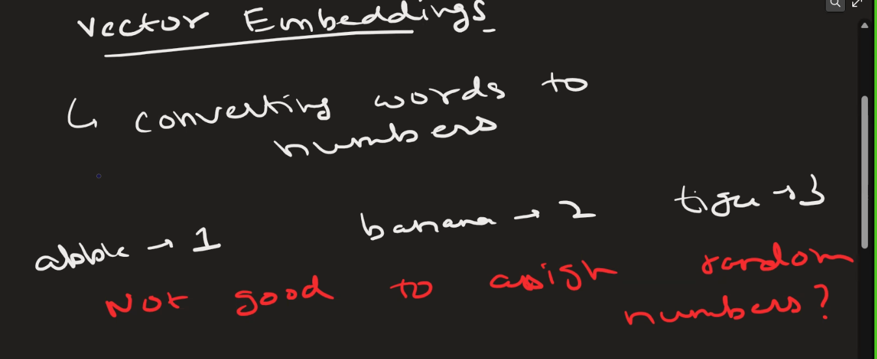

Vector emedding -context

RAG Agent
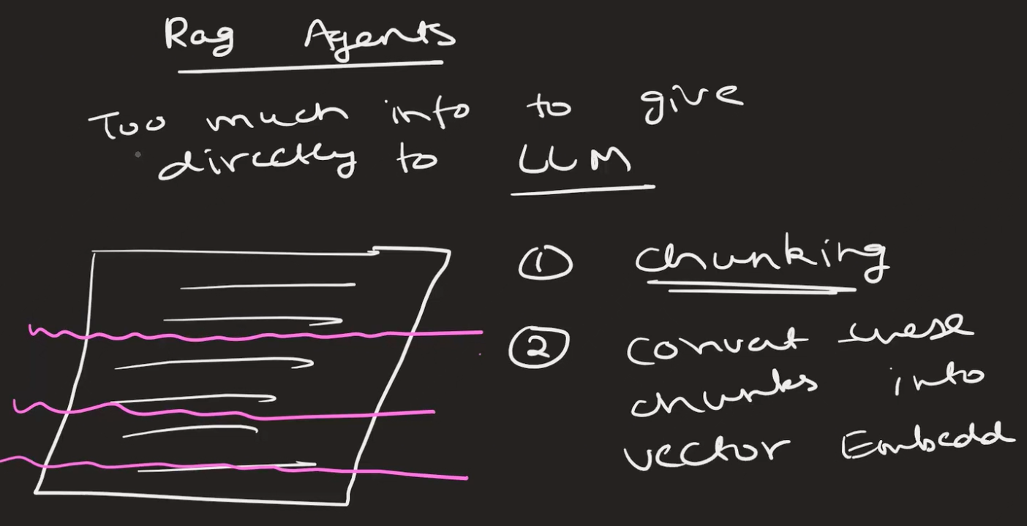
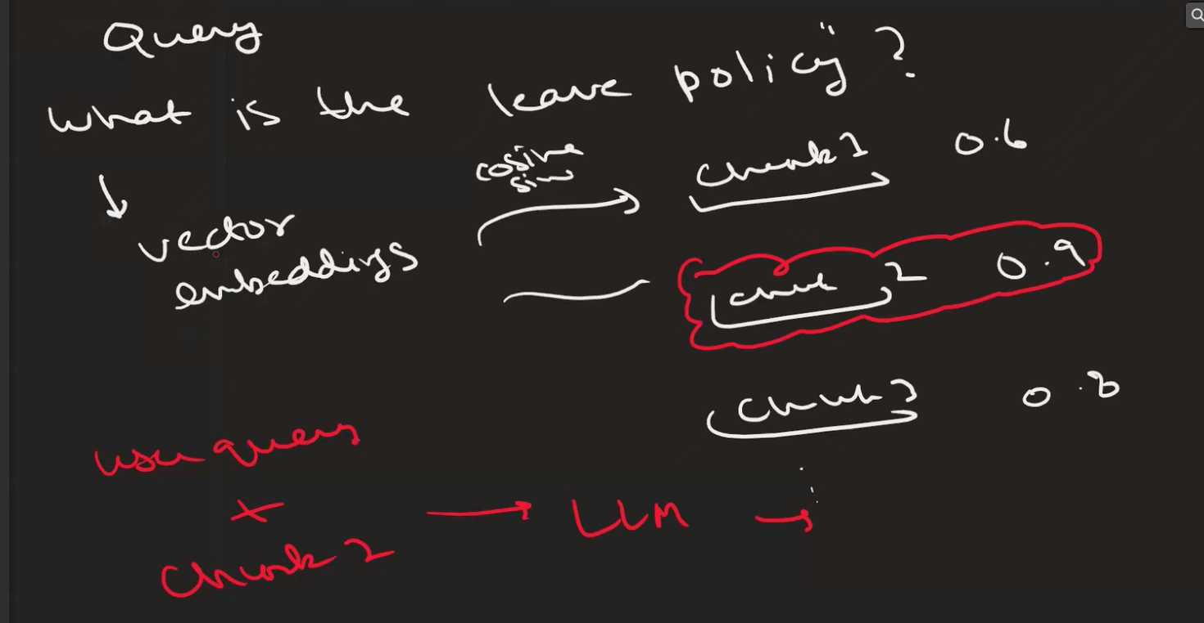

RAG Project
- Can we append data to vector DB?
=> Yes
- Why is differ from invoke , langchain with functions
=> interview
- Sequeces of edges is matter?
Simple short , boring code

1.import model
2.connect api key
3.create vector db
4.get user input
5.convert in to chunk
6.store in db
7.setup collection
8.create function to get user prompt , system prompt
9.call bot

==============
12 Jun LAngGraph
LLM genarted text combile with calculator to form AI Agent
Add your description for external tool used

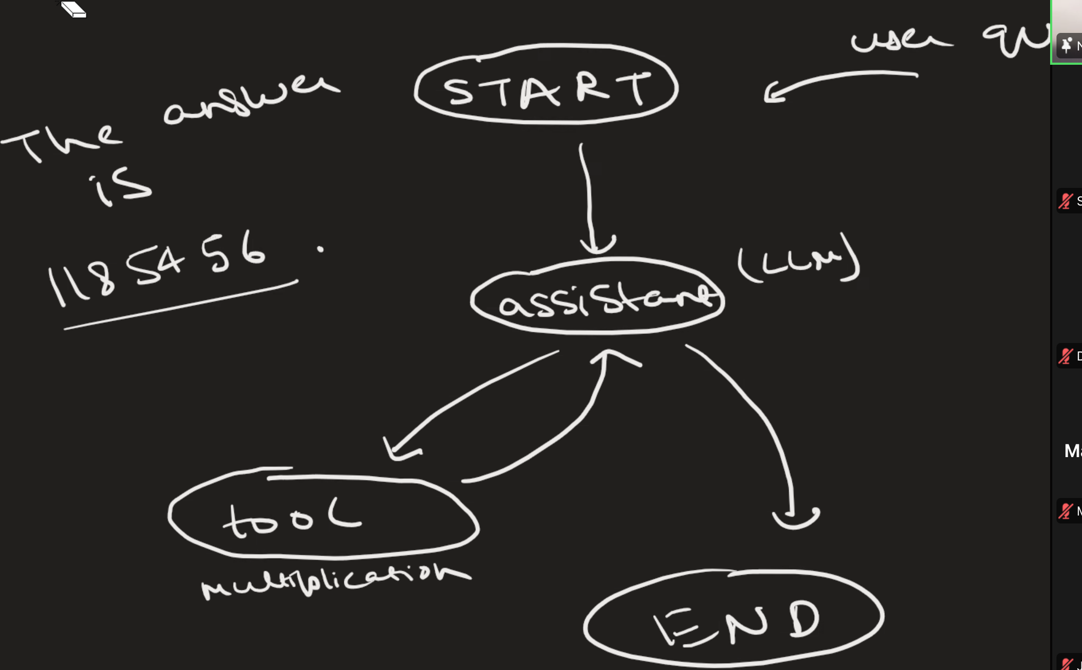
1.import model
2.connect api key
3.create vector db
4.get user input
5.convert in to chunk
6.store in db
7.setup collection
8.create function to get user prompt , system prompt
9.call bot

- Never asked write code directly Understaning existing
Error : 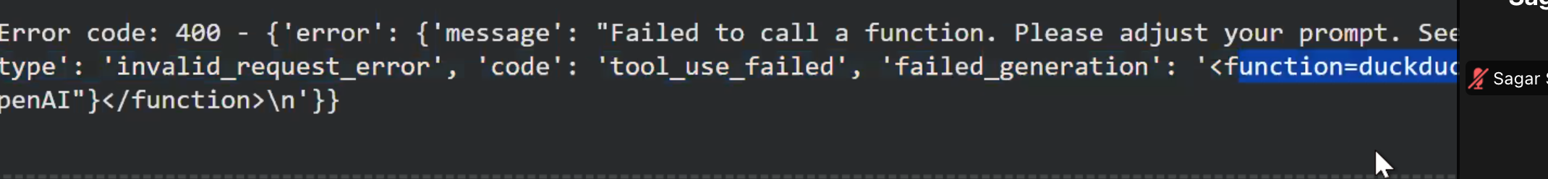
Prompt :-*****
Promprt 1- Please understand existing coloab code

Promprt 2 : Now I want to add a web search tool to my ai agent. Give me the simplest code to add web search tool. Ensure the code works in latest version of google colab. Ensure it fits in my exisiting code structure.
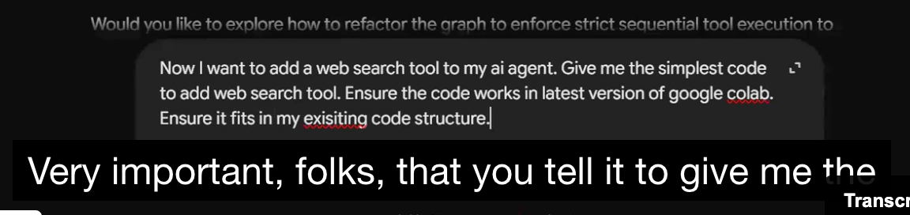
========================================================================
Common Error :- Failed to call a function. Please adjust your prompt.s.
It shows above it tried used tools, but it not used properly
Instead of word "Choose" if I gave "Generate" then it give me 8, how it worked?
Note : docSring very important for tools( function like multiply), it prompt ,if prompt is wrong whole output/excutation is wrong.

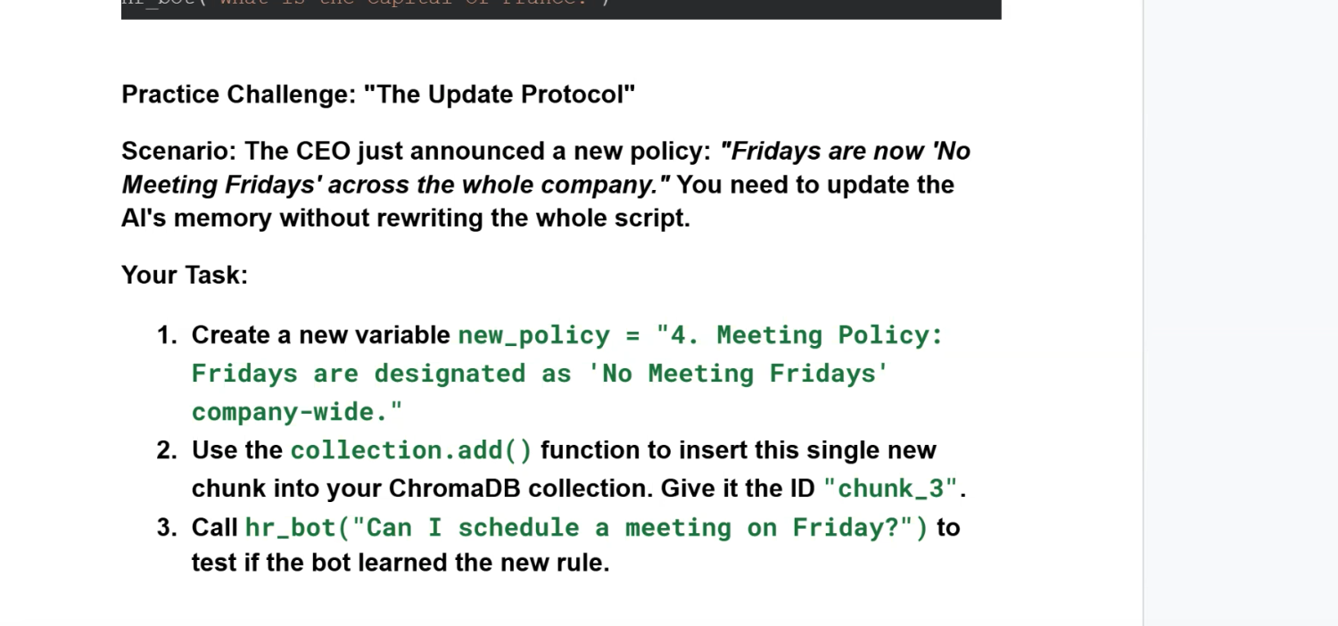
Task1:
10 TB DISK.
PROMPT - You are a digital marketer expert . Use few-shot prompting techniques to transform 10 TB storage disk with.end-end ecrysion(optional),water resistant,AI power for search into three highly engaging, platform-specific social media posts (LinkedIn, Twitter, and Instagram).

LinkedIn Copy
Data is growing faster than ever. Managing it shouldn't slow your team down.
Introducing a storage solution designed for modern professionals:
✅ Massive 10 TB capacity for projects, media, and business files
✅ AI-powered search to locate documents in seconds, not hours
✅ Optional end-to-end encryption for enhanced data protection
✅ Water-resistant durability built for life beyond the office
When storage is smarter, your workflow becomes faster, safer, and more efficient.
#DataStorage #CyberSecurity #AI #Productivity #DigitalTransformation #TechInnovation

Twitter / X Post
10 TB of storage.
AI that finds your files in seconds.
Optional end-to-end encryption.
Water-resistant durability.
Your data deserves more than just storage—it deserves intelligence. 🚀
#AI #DataStorage #Tech #CyberSecurity

Instagram Post
📂 Running out of storage?
Meet the drive that does more than store.
💾 10 TB capacity
🤖 AI-powered search for instant file discovery
🔒 Optional end-to-end encryption
💧 Water-resistant protection
Whether you're a creator, entrepreneur, or professional, your data stays organized, protected, and ready when you need it.
Save more. Search smarter. Work faster. ✨
#StorageSolution #TechLife #AIInnovation #DataSecurity #ContentCreator #ProductivityTools #DigitalLife #SmartStorage #TechGadgets #Innovation

Task2 :
https://app.mizou.com/chat-persona?ID=sim-VYM237GqTI6G2HmSa6ymyUkW5wqX2j8iOJXwVusc4OU-1795
