A PROJECT REPORT ON

“Profarmer: Modern Solutions for Argiculture”

SUBMITTED TO
MIT SCHOOL OF COMPUTING, LONI, PUNE IN PARTIAL FULFILLMENT OF THE REQUIREMENTS FOR THE AWARD OF THE DEGREE

BACHELOR OF TECHNOLOGY
(Computer Science & Engineering)

BY

Name | Enrollment No
Rohit Jagtap | ADT23SOCB0864
Sahil Khandagale | ADT23SOCB0919
Mithilesh Biradar | ADT23SOCB0612
Yash Sonwane | ADT23SOCB1354

Under the guidance of

Prof.Revati Raspayle



DEPARTMENT OF COMPUTER SCIENCE AND ENGINEERING
MIT School OF COMPUTING
MIT Art, Design and Technology University
Rajbaug Campus, Loni-Kalbhor, Pune 412201


MIT SCHOOL OF COMPUTING
DEPARTMENT OF COMPUTER SCIENCE AND ENGINEERING
MIT ART, DESIGN AND TECHNOLOGY UNIVERSITY,
RAJBAUG CAMPUS, LONI-KALBHOR, PUNE 412201

CERTIFICATE

This is to certify that the project report entitled

“Pro-Farmer”

Name | Enrollment No
Rohit Jagtap | ADT23SOCB0864
Sahil Khandagale | ADT23SOCB0919
Mithilesh Biradar | ADT23SOCB0612
Yash Sonwane | ADT23SOCB1354

This is a bonafide work carried out by them under the supervision of Prof.Dr Ranjana Kale and it is submitted towards the partial fulfillment of the requirement of MIT ADT university, Pune for the award of the degree of Bachelor of Technology.

Prof.Revati Raspayle Dr. Suvarna Pawar
Guide Head of Department

Prof. Suresh Kapare Dr. Ganesh Pathak
Chief Coordinator-PBL Dean

Seal/Stamp of the College
Place: Loni Kalbhor ,PUNE
Date:

CERTIFICATE

“Profarmer: Modern Solutions for Agriculture”

Name | Enrollment No
Rohit Jagtap | ADT23SOCB0864
Sahil Khandagale | ADT23SOCB0919
Mithilesh Biradar | ADT23SOCB0612
Yash Sonwane | ADT23SOCB1354

This is a bonafide work carried out by him/her (with the Sponsorship from ------------) under the supervision of Mr/Ms/Miss. Dr Ranjana kale and has been completed successfully.

(Mr. ………………………………………………… )
(Designation)

External Guide

Seal/Stamp of the Company/College
Place :
Date :

DECLARATION

We, the team members

Name | Enrollment No
Rohit Jagtap | ADT23SOCB0864
Sahil Khandagale | ADT23SOCB0919
Mithilesh Biradar | ADT23SOCB0612
Yash Sonwane | ADT23SOCB1354

Hereby declare that the project work incorporated in the present project entitled
“Pro-Farmer : Modern Solutions for Modern Problems ” is original work. This work (in part or in full) has not been submitted to any University for the award or a Degree or a Diploma. We have properly acknowledged the material collected from secondary sources wherever required. We solely own the responsibility for the originality of the entire content.

Date: 10/11/2025
Name & Signature of the Team Members
Member 1: Rohit Jagtap
Member 2: Sahil Khandagale
Member 3: Mithilesh Biradar
Member 4: Yash Sonwane

Name and Signature of Guide

Seal/Stamp of the College
Place: Pune
Date: 28/04/26

DEPARTMENT OF COMPUTER SCIENCE & ENGINEERING
MIT SCHOOL OF COMPUTING,
RAJBAUG, LONI KALBHOR,
PUNE – 412201

EXAMINER’S APPROVAL CERTIFICATE

The project report entitled “CNG ONLINE SLOT BOOKING SYSTEM” submitted by Rohit Jagtap ADT23SOCB0864, Mithilesh Biradar ADT23SOCB0612, sahil khandagale ADT23SOCB0919, Yash Sonwane ADT23SOCB1354 in partial fulfillment for the award of the degree of Bachelor of Technology (Computer Science & Engineering) during the academic year 2025-26, of MIT-ADT University, MIT School OF COMPUTING, Pune, is hereby approved.

Examiners:

1.

2.

ACKNOWLEDGEMENT

I would like to express my sincere gratitude to MIT School of Computing, MIT Art, Design & Technology University, Pune, for providing me the opportunity to undertake this Project as part of the academic curriculum.
I am deeply thankful to Dr. Rajneeshkaur Sachdeo, Dean – Faculty of CSE & IT, and Dr. Vipul Dalal, Director – MIT School of Computing, for their continuous encouragement and support in promoting industry exposure and experiential learning for students.
I would like to thank Prof. Dr. Ganesh Pathak, Head of the Department, for her constant motivation and guidance throughout the internship process.
My heartfelt thanks to my Project Guide , Prof. Shilpa Dhopte for providing meaningful work and mentorship during the project period for her excellent coordination, timely communication, and academic mentorship during the project.
I extend my sincere thanks to all faculty members who contributed directly or indirectly to the successful completion of this Project. Lastly, I thank my family and friends for their continuous support and encouragement. This Project has been a valuable learning experience, contributing significantly to my technical, professional, and personal development.

Name | Enrollment No.
Sahil Khandagale | ADT23SOCB0919
Mithilesh Biradar | ADT23SOCB0612
Yash Sonwane | ADT23SOCB1354
Rohit Jagtap | ADT23SOCB0864

ABSTRACT

The increasing challenges faced by farmers, including labor shortages, limited access to modern farming machinery, and lack of awareness about government subsidies, hinder the adoption of efficient agricultural practices. Many small-scale farmers are unable to acquire necessary equipment, resulting in reduced productivity and underutilized potential. To address these issues, the proposed Pro-Farmer platform aims to simplify and digitize access to modern farming tools, ensuring convenience, efficiency, and informed purchasing decisions.
This system leverages modern web and mobile technologies to connect farmers with wholesalers of agricultural machinery, providing real-time information on availability, pricing, and government subsidies. By automating the equipment selection and purchasing process, it reduces manual effort, ensures timely access to machinery, and promotes mechanized farming practices. Additionally, it offers wholesalers an organized platform to manage listings, monitor demand, and reach a broader market efficiently.
Pro-Farmer enhances farmers’ productivity while supporting government initiatives for agricultural development and financial subsidies. It contributes to resource optimization, cost savings, and modernization of farming operations. Overall, the system aims to provide a transparent, user-friendly, and impactful solution for contemporary farmers.

CONTENTS
Declaration ……………….…………….………………....………. | i
Examiner’s Approval Certificate …………………………………. | ii
Acknowledgement ……………….…………………..……………. | iii
Abstract …………………………………………..…...……………. | iv
List of Figures ………………………..………….…………………. | v
List of Tables ……………………….…………….…………………. | vi

Chapter 1 INTRODUCTION 11
1. Introduction 11
2. Existing Work 12
3. Motivation 14
4. Objectives 15
5. Scope 17
Chapter 2 CONCEPTS AND METHODS 20
Chapter 3 LITERATURE SURVEY 23
Chapter 4 PROJECT PLAN 26
Chapter 5 SOFTWARE REQUIREMENT SPECIFICATION 30
Chapter 6 RESULTS 35
Chapter 7 SOFTWARE TESTING 39
Chapter 8 CONCLUSION AND FUTURE WORK 45
1. BIBLIOGRAPHY 48
4. ANNEXURE A: List of Publications and Research Paper (In its Original formats) 50

LIST OF TABLES

Table Number: Title of the table Page Number

TABLE 6.1: FUNCTIONAL RESLTS 35
TABLE 6.2: PERFORMANCE EVALUATION 36
TABLE 6.4: QUANTATIVE RESULTS 37
TABLE 7.2.1: USER ACCEPTANCE TESTING 41
TABLE 7.2.2: PERFORMANCE AND LOAD TESTING 42
TABLE 7.3: TEST CASE DESIGN 43
TABLE: 7.3: BUG TRACKING AND RESOLUTION 43

Figure 4.1: Software modeling 26
FIGURE 4.2: WORK PLAN AND FLOWCHART 29

INTRODUCTION

Introduction
In today’s era of rapid technological growth and digital transformation, agriculture is increasingly moving toward mechanization, smart resource management, and improved efficiency. Many farmers face challenges such as labor shortages, difficulty in accessing modern farming equipment, and lack of awareness about government subsidies. Traditional methods of procuring machinery often require traveling long distances, dealing with multiple wholesalers, and navigating inconsistent information, leading to underutilized resources and reduced productivity. To address these challenges, the Pro-Farmer platform is proposed as a comprehensive digital solution to connect farmers with wholesalers and streamline access to modern agricultural machinery.
Pro-Farmer allows farmers to browse and purchase farming equipment through a web or mobile platform. This system reduces the need for physical visits to shops, simplifies equipment discovery, and provides detailed information on available government subsidies. Features include real-time inventory updates, price comparisons, secure online payments, and digital confirmation of orders. For wholesalers, the platform offers tools to list products, manage stock, and monitor demand efficiently. By automating the equipment procurement process, FarmerPro ensures timely access to machinery, reduces dependency on manual efforts, and promotes mechanized farming practices.
Unlike traditional methods that rely on word-of-mouth, limited local availability, or first-come-first-serve transactions, Pro-Farmer emphasizes transparency, convenience, and resource efficiency. It integrates secure payment systems, user authentication, and notifications to ensure reliability and ease of use. The platform helps reduce human errors, improves management for wholesalers, and enhances farmers’ productivity by providing organized access to modern farming tools.
Additionally, this initiative supports government efforts to promote digital agriculture and agricultural subsidies. It contributes to optimized resource utilization, cost savings, and sustainable farming practices. By providing equitable access to modern machinery for small and large-scale farmers, Pro-Farmer aligns with the goals of technological empowerment, modernization of agriculture, and environmental sustainability.
In conclusion, Pro-Farmer is designed to address the growing need for digital transformation in agriculture. It bridges the gap between farmers and equipment providers, creating a user-friendly, reliable, and efficient marketplace. This innovation not only improves farmers’ convenience and productivity but also supports resource optimization, sustainable practices, and the modernization of farming operations.

Existing Work
In recent years, several digital platforms have been introduced to improve agricultural productivity and access to farming resources. However, most existing systems for procuring farming machinery and equipment still rely heavily on offline channels, local wholesalers, or word-of-mouth networks. At present, farmers must physically visit multiple shops, contact different suppliers, and depend on local knowledge to find suitable machines. This traditional approach causes delays, limits access to modern equipment, and often leads to underutilization of resources. While some e-commerce platforms like Amazon, Flipkart, or specialized agri-marketplaces provide online shopping options for certain farming tools, they do not offer detailed information about government subsidies or real-time availability specifically for agricultural machinery.
A few experimental systems and regional initiatives have attempted to connect farmers with machinery suppliers. For instance, some startups and local platforms allow farmers to rent or purchase tractors, seeders, or harvesters through small-scale online listings. However, these systems lack centralization, automation, and scalability. They often rely on manual communication between buyers and sellers, do not update inventory in real-time, and fail to provide comprehensive information about subsidy eligibility. This leads to miscommunication, delays in procurement, and limited adoption of mechanized farming.
Moreover, current agricultural platforms primarily focus on product listings or payment facilitation rather than scheduling, subsidy awareness, or operational guidance. They do not provide essential features like user authentication, inventory tracking, verified seller information, or integrated subsidy notifications. There is also no unified platform that connects multiple wholesalers, manufacturers, and government schemes under a single system, making it difficult for farmers to plan purchases efficiently and cost-effectively.
Another major limitation of existing systems is the lack of support for small-scale farmers and startups. Many equipment providers operate locally, causing fragmented supply chains, uneven distribution, and limited market access. Additionally, there is minimal effort toward resource optimization or promoting sustainable farming practices through mechanization.
Hence, the current systems are fragmented and inefficient, lacking automation, transparency, and farmer-centric convenience. To address these challenges, the proposed Pro-Farmer platform introduces a centralized, digital, and automated marketplace. It enables farmers to access modern farming machinery easily, view real-time availability, learn about applicable government subsidies, make secure online transactions, and receive timely delivery. The system bridges the gap between wholesalers and end users by providing a smart, resource-efficient, and user-friendly approach to modern agricultural operations.

Motivation
The motivation for developing Pro-Farmer arises from the growing challenges faced by farmers due to limited access to modern farming machinery, labor shortages, and lack of awareness about government subsidies. Many farmers struggle to find suitable equipment locally, often visiting multiple wholesalers or relying on word-of-mouth, which leads to delays, underutilization of resources, and reduced productivity. Observing these recurring issues inspired the idea of creating a digital, automated platform that connects farmers directly with wholesalers and provides real-time information about machinery availability and subsidies.
Another key motivation is the lack of transparency and planning in existing procurement methods. Farmers are often unaware of the availability, pricing, or subsidy eligibility for modern equipment, resulting in missed opportunities and inefficient farm management. This imbalance highlights the need for a centralized digital system that allows farmers to browse equipment, make informed purchases, and receive instant confirmations—all from their web or mobile devices. The goal is to minimize uncertainty, reduce time spent in manual searching, and provide convenience for both farmers and wholesalers.
The shift toward digital agriculture and online marketplaces also plays a significant motivational role. By promoting cashless transactions, digital record-keeping, and easy access to information, Pro-Farmer aligns with national digitalization goals and modern agricultural practices. This digital transformation ensures faster, safer, and more reliable access to farming equipment while promoting transparency and accountability.
From an environmental and efficiency perspective, promoting mechanized farming and timely access to equipment contributes to optimized resource usage, reduced manpower dependency, and sustainable agricultural practices. This aligns with sustainable development goals, making the project technologically relevant and socially responsible.
Additionally, the system is motivated by the need to improve operational efficiency for wholesalers and small-scale machinery providers. By automating listings, inventory management, and order tracking, it reduces human error, prevents miscommunication, and ensures smooth transactions. This helps suppliers reach more farmers effectively while providing a structured marketplace for buyers.
In summary, the key motivations behind Pro-Farmer are:
- To provide easy and organized access to modern farming machinery for farmers.
- To raise awareness and facilitate utilization of government subsidies.
- To promote cashless, paperless, and efficient transactions.
- To support the digitization of agriculture and modern farming practices.
- To optimize resource usage and reduce dependence on manual labor.
- To enhance operational efficiency for wholesalers and machinery providers.
Overall, the motivation lies in creating a smart, sustainable, and user-centric solution that benefits both farmers and equipment providers, transforming traditional agricultural equipment procurement into an efficient, transparent, and modern digital system.

Objectives

The Pro-Farmer project is guided by the vision of creating a smart, efficient, and user-friendly digital platform that simplifies access to modern farming equipment. The main objective is to reduce the dependency on manual procurement, improve awareness of government subsidies, and promote a transparent, convenient, and resource-efficient farming experience for farmers.
To achieve this vision, the project defines the following key objectives:
Provide Easy Access to Modern Farming Equipment: Enable farmers to browse, compare, and purchase agricultural machinery online, reducing the need to physically visit multiple wholesalers and ensuring timely availability of necessary tools.
Raise Awareness About Government Subsidies: Inform farmers about applicable subsidies on farming equipment to reduce costs and encourage adoption of mechanized farming practices.
Promote Cashless and Secure Transactions: Facilitate secure digital payments integrated with equipment procurement, supporting transparency and reducing reliance on cash or manual transactions.
Ensure Transparency and Efficiency: Offer real-time inventory updates, verified seller information, and automated order confirmation to improve transparency and reliability for both farmers and wholesalers.
Enhance Operational Efficiency for Wholesalers: Provide wholesalers with a structured platform to manage product listings, monitor demand, and streamline order fulfillment, reaching a larger farmer base efficiently.
Improve Resource Utilization and Productivity: Support mechanized farming to optimize labor usage, save time, and increase agricultural productivity through timely access to modern equipment.
Provide User Convenience and Accessibility: Design a simple, intuitive, and mobile-accessible platform, allowing farmers to view equipment, subsidy details, and order history anytime.
Support Digital Agriculture and Sustainable Practices: Encourage adoption of modern farming methods, resource optimization, and environmentally sustainable practices through efficient mechanization.
Through these objectives, Pro-Farmer aims to transform the traditional agricultural equipment procurement process into a modern, organized, and user-centric digital system, benefiting both farmers and equipment providers.

1. Technological Scope
The system utilizes modern technologies to deliver a fast, reliable, and secure user experience for both CNG users and station operators.
- Frontend: Developed using HTML, CSS, JavaScript, and React.js to create a responsive, user-friendly interface for online booking and real-time updates.
- Backend: Built using Node.js and Express.js to ensure high scalability, speed, and robust API management for data handling and communication between users and stations.
- Database: Employs MongoDB or MySQL for secure and efficient storage of booking details, user profiles, payment information, and refueling schedules.
- Integration: Supports payment gateways for cashless transactions, email/SMS notifications, and real-time slot availability tracking.
- Security: Includes encryption and authentication features to safeguard user data and prevent unauthorized access or double bookings.

2. Functional Scope
The Pro-Farmer platform provides multiple modules designed to simplify the procurement of agricultural equipment and improve transparency for both farmers and wholesalers.
• User Registration & Login: Allows farmers and wholesalers to create accounts, verify credentials, and securely access platform features.
• Product Browsing & Search: Enables farmers to view available agricultural machinery, filter products by type, price, and location, and compare features easily.
• Order Placement & Cancellation: Allows farmers to place orders for equipment, track their status, or cancel orders if necessary.
• Subsidy Information & Notifications: Provides detailed information on government subsidies applicable to each piece of equipment and sends alerts to farmers about updates or eligibility.
• Online Payment & Confirmation: Facilitates secure digital payments through UPI, debit/credit cards, or wallets, and provides instant order confirmations and receipts.
• Wholesaler Dashboard: Allows equipment suppliers to manage product listings, monitor inventory, track orders, and optimize operations efficiently.
• Notification System: Sends reminders and alerts to users regarding order updates, delivery schedules, and subsidy notifications.
• Real-Time Inventory Management: Updates product availability in real time, ensuring farmers have accurate information while reducing order conflicts or delays.

3. Operational Scope
The project focuses on improving operational efficiency and convenience in agricultural equipment procurement.
• Reduces manual dependency and human errors in managing equipment listings, orders, and subsidy information.
• Enables better resource utilization and time management for both farmers and wholesalers.
• Ensures smoother coordination among multiple wholesalers by connecting them under a unified digital platform.
• Provides detailed reports and analytics for wholesalers to evaluate inventory, sales trends, and demand patterns.

4. Environmental Scope
The system contributes significantly to environmental sustainability and responsible resource use in agriculture.
• Reduces resource wastage by enabling timely access to modern farming machinery, minimizing idle labor and inefficient manual practices.
• Promotes eco-friendly farming practices by supporting mechanization, which optimizes energy and water usage.
• Aligns with sustainable agriculture initiatives and helps lower overall environmental impact.
• Supports the adoption of digital and mechanized farming, contributing to reduced carbon footprint and more efficient resource management.

5. Research and Development Scope
Beyond the current implementation, the Pro-Farmer platform can be extended with advanced features for future growth.
• Mobile Application Development for Android and iOS platforms to increase accessibility and convenience for farmers and wholesalers.
• AI-Based Equipment Recommendation System to suggest machinery based on farm size, crop type, and past purchase history.
• Integration with GPS and Maps to locate nearby wholesalers or delivery points for faster and optimized procurement.
• Data Analytics Module for performance monitoring, sales trends, and subsidy utilization analysis.
• IoT Integration for smart machinery tracking, real-time inventory updates, and automated alerts for maintenance or availability.
.
6. Social and Economic Scope
The Pro-Farmer platform also contributes to social and economic development by promoting digital inclusion and operational transparency.
- Encourages farmers and wholesalers from all backgrounds—small-scale farmers, large-scale agricultural businesses, and startup equipment providers—to adopt digital tools for equipment procurement and management.Reduces fuel and time expenses by ensuring planned refueling, indirectly benefiting drivers’ income and productivity.
- Reduces time and operational costs by simplifying access to modern machinery and subsidy information, indirectly improving farmers’ productivity and income.
- Creates employment and business opportunities in system maintenance, technical support, delivery services, and digital operations for equipment providers.
- Promotes a more organized, accountable, and transparent marketplace that builds trust and confidence among farmers and wholesalers.

CONCEPTS AND METHODS
The Pro-Farmer platform digitizes and streamlines the process of connecting farmers with agricultural machinery suppliers and wholesalers. It replaces the traditional manual and location-based purchasing system with a centralized, transparent, and user-friendly online marketplace. The system allows farmers to easily search, compare, and buy modern farming equipment from verified sellers while also providing information about available government subsidies. It integrates technologies such as HTML, CSS, JavaScript, Node.js, Express.js, and MongoDB to ensure smooth functionality, real-time data access, and secure transactions. For wholesalers, it simplifies product management, sales tracking, and customer communication. Overall, Pro-Farmer enhances efficiency, reduces effort, and promotes the adoption of modern agricultural practices through a digital and accessible platform.
2.1 Concepts
- Online Agricultural Marketplace
The platform connects farmers directly with verified wholesalers and machinery suppliers, allowing them to browse, compare, and purchase modern farming equipment online without relying on middlemen
- Real-time Product Availability
Farmers can view live updates of available machinery, prices, and stock levels, helping them make informed purchasing decisions and avoid delays due to unavailability.
- Digital and Cashless Transactions
Integrated digital payments (UPI/cards/wallets) enable contactless, auditable payments tied to each booking and receipt. Integrated payment gateways support secure online payments through UPI, debit/credit cards, or wallets, ensuring transparency and reducing cash dependency.
- User Authentication and Trust Building
Verified accounts, booking history, and digital receipts build accountability for users and station operators.

2.2 Methods (step-by-step)
- RequirementAnalysis
The development process begins with identifying the needs of farmers and wholesalers. Farmers require an easy way to find and purchase agricultural equipment, while wholesalers need a platform to manage and promote their products effectively.
- SystemDesign
The system is structured into two main modules: the Farmer Module and the Wholesaler Module. The Farmer Module enables browsing, booking, and payment functionalities, while the Wholesaler Module allows product uploads, inventory management, and order tracking.
- Frontend Development
The user interface is designed using HTML, CSS, and JavaScript to ensure a clean, responsive, and user-friendly experience. It provides farmers with easy navigation, search filters, and real-time product availability updates.
- Backend Development
The backend is developed using Node.js and Express.js, managing user requests,authentication, and communication between the frontend and the database. APIs are created to handle tasks such as booking confirmation, order retrieval, and subsidy updates.
- Database Management
A MongoDB database stores essential data, including user profiles, product details, transaction records, and subsidy information. It ensures fast access, scalability, and secure data storage.
- Payment and Notification Integration
The system integrates secure payment gateways for online transactions and uses automated notifications (via email or SMS) to confirm orders, updates, and subsidy alerts.
- Testing and Validation
Functional and usability tests are conducted to ensure smooth performance, data
security, and a seamless user experience across all devices.
8.Deployment and Maintenance
Once tested, the system is deployed on a web server for public access. Regular maintenance and updates ensure ongoing reliability, improved performance, and inclusion of new features such as AI-based equipment recommendations.
2.3 Tools and Technologies Used
• Frontend: HTML, CSS, and JavaScript are used to design a responsive and user-friendly interface. React.js can be integrated to enhance interactivity and performance for real-time product listings and user navigation.
• Backend: Node.js and Express.js are used to build a scalable backend that handles product management, order processing, and communication between users and the database.
• Database: MongoDB is used to store data related to farmers, wholesalers, equipment listings, transactions, and subsidy details efficiently and securely.
• Realtime Updates: Socket.io or WebSockets can be implemented for live product availability updates, order tracking, and notification handling.
• Payments: Integration with secure UPI and card payment gateways ensures smooth, cashless, and transparent transactions for both farmers and wholesalers.
• Notifications: Email and SMS services are used to send booking confirmations, promotional messages, and subsidy updates to users in real time.
• Hosting/DevOps: The platform can be hosted on cloud services like AWS, GCP, or Azure with CI/CD pipelines for continuous deployment and containerization for scalability.
• Security: HTTPS protocols, JWT-based authentication, role-based access control, and input validation techniques are implemented to ensure data privacy and prevent unauthorized access.
• Optional R&D: Future developments may include AI-based equipment recommendations, sales forecasting, and IoT-enabled machinery tracking for predictive maintenance and inventory management.

LITERATURE SURVEY
The increasing shift toward modern and technology-driven farming has created a strong demand for digital platforms that connect farmers with agricultural machinery suppliers and service providers. Traditional farming processes often face issues such as limited access to modern equipment, lack of reliable suppliers, and inefficiency in communication. This section reviews prior research and innovations related to digital marketplaces, smart farming, and IoT-based agricultural management—highlighting how the proposed Pro-Farmer system integrates these advancements to provide farmers with a more accessible, efficient, and transparent solution for equipment discovery, rental, and purchase management.

3.1 Evolution of Agricultural Resource Management Systems
Initially, farmers depended on traditional methods and word-of-mouth communication to access machinery and labor, which often led to delays, limited availability, and uneven pricing. According to Sharma et al. (2022), the digital transformation in agriculture has enhanced efficiency through mobile-based marketplaces and real-time inventory systems. However, many small-scale farmers still struggle to find modern farming equipment due to limited online integration. Existing platforms like AgroStar and BigHaat provide digital access to farm supplies but lack dedicated machinery rental and scheduling features. Hence, an automated platform like Pro-Farmer is essential to connect farmers with equipment providers efficiently and improve overall productivity.
3.2 Automation and AI in Booking Systems
Artificial Intelligence and automation have revolutionized agricultural management and equipment allocation across the farming sector. Research by Patel et al. (IEEE, 2023) indicates that AI-based resource scheduling enhances operational efficiency by analyzing factors such as crop type, seasonal demand, and machine usage trends. Platforms like DeHaat and KisanGPT leverage predictive analytics to optimize agricultural planning and reduce downtime. Similarly, Pro-Farmer integrates automation and AI-driven algorithms to intelligently match farmers with available machinery based on location, demand, and availability — ensuring timely access, reduced idle time, and improved productivity for both farmers and equipment providers.
3.3 Sustainability and Smart Farming
Sustainability has become a central focus in modern agriculture. According to the Journal of Sustainable Agriculture (2023), adopting smart farming practices and machinery sharing systems can reduce resource wastage and increase productivity by up to 30%. Integrating digital platforms like Pro-Farmer with modern farming equipment supports eco-friendly and sustainable agriculture. The proposed system contributes to environmental and economic goals by minimizing idle machinery usage, reducing manual labor dependency, and promoting efficient resource allocation — ultimately helping farmers adopt greener and smarter farming practices.

3.4 User Trust, Security, and System Reliability
User trust is a crucial factor in the adoption of digital platforms for agriculture. According to Springer (2022), secure data management, verified user interactions, and transparent transactions are essential for building confidence among rural users. Many existing farming or equipment rental platforms lack proper authentication and real-time support. The Pro-Farmer system integrates secure login, verified seller and buyer profiles, and digital transaction records to ensure a transparent, reliable, and trustworthy platform for farmers and machinery providers alike.

3.5 Technological Implementations and Frameworks
Modern web technologies such as HTML, CSS, JavaScript, Node.js, Express.js, and MongoDB, as highlighted in IRJMETS (2024), enable the development of efficient, scalable, and user-friendly platforms. Integration of AI and IoT frameworks supports intelligent monitoring, prediction, and automation in farming. The proposed Pro-Farmer system leverages these technologies to create a responsive and secure digital platform that connects farmers with equipment providers, facilitates real-time availability tracking, and ensures seamless communication for efficient modern farming operations.
3.6 Identified Gaps in Existing Literature
The review of prior research highlights several key gaps:
- Lack of a unified digital platform connecting farmers with equipment suppliers and service providers.
- Limited integration of AI and IoT for intelligent equipment availability tracking and demand prediction.
- Absence of real-time monitoring systems for farm machinery distribution and booking status.
- Insufficient focus on data security, transparency, and trust in digital agricultural platforms.
- Minimal emphasis on promoting sustainable and technology-driven modern farming practices.

3.7 Summary
The literature review shows that although digital platforms have advanced in other sectors, agricultural machinery access and management still rely heavily on manual processes. Existing systems lack automation, transparency, and real-time coordination between farmers and equipment providers. The Pro-Farmer system addresses these gaps by introducing a digital platform that connects farmers with nearby equipment suppliers, enables real-time availability tracking, ensures secure transactions, and promotes the adoption of modern, sustainable farming practices.

CHAPTER 4

PROJECT PLAN

Figure 4.1: Software modelin
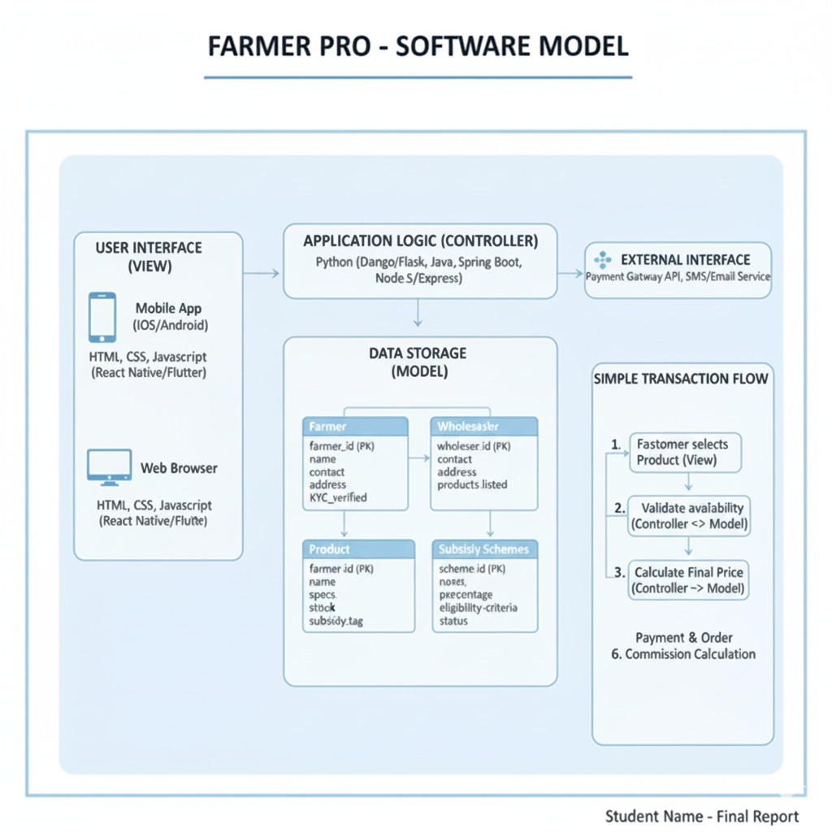

The core function of the Pro-Farmer system follows a simple five-step process. First, the user interacts with the View (website or mobile app) to search for available farming equipment and select a suitable rental time slot. Second, this request is sent to the Controller, which handles the main application logic. Third, the Controller checks the Model (database) to verify equipment availability and confirm that the selected slot is open. Fourth, if the verification succeeds, the Controller instructs the Model to create a new Booking record with all necessary details. Finally, the Controller sends a confirmation back to the View, notifying the user of a successful booking and providing a digital receipt and pickup schedule.

4.1 Project Development Approach
The FarmerPro system follows the Agile Development Methodology, emphasizing flexibility, iterative progress, and continuous user feedback. The project is divided into multiple sprints, each focused on developing and refining specific modules such as equipment listing, booking management, payment processing, and user interaction. This iterative approach allows for regular testing, quick adaptation to changing requirements, and steady enhancement of system performance and usability. By following Agile principles, the development process ensures that the final product remains user-centric, efficient, and aligned with farmers’ evolving needs.Key Features of the Agile Approach:
- I Incremental and modular system development for smoother integration of marketplace features such as equipment listing, booking, and payments.
- Regular testing and incorporation of farmer and vendor feedback to improve usability and accessibility.
- Early detection and resolution of technical or functional issues during each sprint cycle.
- Parallel progress in frontend (user interface), backend (server logic), and database (product and booking records) development to ensure faster delivery and synchronization.
4.2 Phases of Project Development
The Pro-Farmer project is developed in six systematic phases to ensure efficient and organized implementation:
Phase 1: Requirement Analysis
- Conducted research to identify challenges faced by farmers in accessing modern farming equipment and services.
- Collected requirements from farmers, equipment suppliers, and agricultural service providers.
- Defined core functionalities such as user registration, equipment listing, slot booking, and payment integration.
Deliverable: Software Requirements Specification (SRS) Document.
Phase 2: System Design
- Designed system architecture and Data Flow Diagrams (DFDs) to visualize equipment booking workflows.
- Created user interface (UI) layouts for both web and mobile platforms using Figma.
- Developed database schema for farmers, equipment details, bookings, and transaction management.
Phase 3: Frontend and Backend Development
- Frontend: Developed using HTML, CSS, JavaScript, and React.js for a responsive booking interface.
- Backend: Built with Node.js and Express.js to manage APIs and database communication.
- Integrated modules for equipment search, slot booking, and cancellation features.
Deliverable: Fully functional frontend and backend integration.
Phase 4: Payment and Notification Integration
- Integrated secure digital payment options using Razorpay or Paytm API to enable cashless transactions.
- Implemented SMS and email notifications for booking confirmations, cancellations, and reminders.
- Added an admin dashboard for equipment owners to manage availability and track bookings.
Phase 5: Testing and Evaluation
- Performed unit, integration, and system testing to ensure smooth functioning of all modules.
- Conducted User Acceptance Testing (UAT) with farmers and equipment providers.
- Tested data security, performance, and booking accuracy under different conditions
Deliverable: Verified and tested version of the FarmerPro system.
Phase 6: Deployment and Maintenance
- Deployed the system on cloud hosting for real-time accessibility and scalability.
- Implemented regular monitoring, bug fixing, and performance optimization processes
- Collected user feedback for continuous improvement and future updates.
Deliverable: Live Pro-Farmer Online Equipment Booking System with ongoing maintenance and support.

4.3 Tools and Resources Used
Development Tools: Visual Studio Code, GitHub, Postman
Design Tools: Figma, Canva
Database Tools: MySQL / MongoDB Atlas
Backend Frameworks: Node.js, Express.js
Frontend Frameworks: React.js, Bootstrap / Tailwind CSS
Testing Tools: Jest, Mocha, Chrome DevTools
Deployment: Render / AWS / Netlify

4.4 Risk Analysis and Management
Data Security Risk: Implemented SSL encryption, secure authentication, and role-based access control to protect user data.
Server Downtime: Used reliable hosting services with automated backups to ensure continuous availability.
Fake Wholesaler Listings: Added verification and admin approval process to prevent unauthorized or fake sellers.
Subsidy Information Inaccuracy: Regularly updated and verified subsidy data through official government portals.
Payment Failures: Integrated secure payment gateways with refund handling and transaction tracking.
Scalability Challenges: Designed modular and scalable architecture for smooth performance during user growth.
User Accessibility Risk: Developed a simple multilingual interface with icons and tutorials for easy navigation.
4.5 Summary
The Pro-Farmer project plan ensures smooth and efficient development through structured phases and a user-focused design approach. It enables farmers to easily access modern farming equipment, connect directly with verified wholesalers, and stay informed about available government subsidies. The integration of secure technologies, verified listings, and reliable hosting ensures a trustworthy and user-friendly platform. Overall, Pro-Farmer enhances accessibility, promotes modern farming practices, and supports the digital transformation of the agricultural sector. 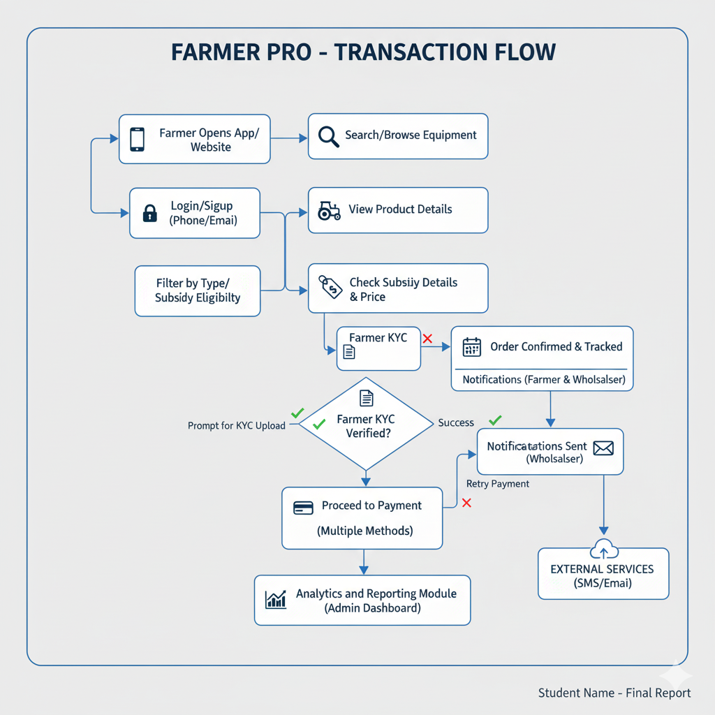

SOFTWARE REQUIREMENT SPECIFICATION
The Software Requirements Specification (SRS) defines the functional, non-functional, and system requirements for the FarmerPro platform. It serves as the foundation for system design, development, and testing. This document ensures that all stakeholders — developers, wholesalers, and farmers — have a unified understanding of the system’s objectives, scope, and expected performance. FarmerPro aims to create a reliable, secure, and user-friendly website that connects farmers with verified wholesalers while providing accurate information about government subsidies on farming equipment.
5.1 Purpose
The purpose of the FarmerPro system is to simplify the process of buying and selling modern farming equipment through an online platform. It allows farmers to register, browse available equipment, compare prices, view government subsidies, and connect directly with verified wholesalers. This SRS aims to:
- Clearly define system functionality and operational requirements.
- Specify technical environments and system dependencies.
- Establish a shared understanding among all stakeholders — developers, farmers, and wholesalers.
- Serve as the foundation for the design, testing, and maintenance phases of the FarmerPro platform.
5.2 Scope of the System
The proposed system is a web-based platform designed to connect farmers with verified wholesalers of modern farming equipment. It helps farmers easily find, compare, and purchase agricultural machines such as seeders, harvesters, and irrigation systems. The system will also provide accurate information about government subsidies available for each product. FarmerPro supports secure user registration, real-time product availability, transparent transactions, and an efficient communication channel between farmers and wholesalers.

Main Functionalities:
- User registration, login, and authentication for farmers and wholesalers.
- Product listing and management by verified wholesalers
- Real-time display of available farming equipment with price and subsidy details.
- Secure payment gateway integration for online purchases.
- Admin panel for managing users, verifying wholesalers, and updating subsidy information.
- Notification system for order confirmations and updates.
5.3 System Overview
The system architecture consists of three main layers:
- Frontend Layer: Developed using HTML, CSS, and JavaScript (or React.js) to provide an interactive and user-friendly interface for farmers and wholesalers.
- Backend Layer: Managed with Node.js and Express.js to handle application logic, product management, and communication between users and the database.
- Database Layer: Uses MySQL or MongoDB to store user information, product details, transactions, and subsidy data securely.
- Notification Module: Handles email or SMS alerts for order confirmations, new product listings, and subsidy updates.
5.4 Functional Requirements
- FR1: User Registration and Login
Farmers and wholesalers can register using email or phone number and log in securely. The system validates credentials and stores encrypted user data.
- FR2: Product Listing and Management
Verified wholesalers can add, update, or remove products such as farming equipment, along with details like price, description, and availability.
- FR3: Product Browsing and Purchase
Farmers can browse listed equipment, compare prices, check available subsidies, and make purchases through the platform.
- FR4: Payment Integration
Online payment is enabled via secure gateways such as Razorpay or Paytm. All transaction details are safely stored in the database.
- FR5: Admin Management
Admins can verify wholesaler registrations, manage product listings, update subsidy information, and monitor platform activity.
- FR6: Notification System
Users receive SMS or email notifications for order confirmations, payment status, and new subsidy or product updates.
- FR7: Data Security and Privacy
All sensitive user information, including login credentials and transaction details, is encrypted. Secure authentication tokens are used to protect user sessions.
5.5 Non-Functional Requirements
- NFR1: Performance
The system should handle up to 1000 concurrent users with a response time of less than 3 seconds per request.
- NFR2: Scalability
The architecture should support easy addition of new wholesalers, products, and future modules such as mobile app integration.
- NFR3: Usability
The interface should be simple, multilingual, responsive, and easy to navigate for farmers and wholesalers across all devices.
- NFR4:Reliability
The system should maintain at least 99% uptime, with regular data backups to prevent loss in case of system failure.
- NFR5: Security
All transactions and data exchanges should use HTTPS protocol. Passwords and sensitive user data should be encrypted and securely stored.
- NFR6: Portability
The system should operate smoothly across major web browsers (Chrome, Firefox, Edge) and devices (desktop, tablet, and mobile).
- NFR7: Maintainability
The codebase should follow a modular and well-documented structure, ensuring easy debugging, scalability, and updates in the future.
5.6 Software Requirements
Component | Technology/Tool Used
Frontend | React.js, Tailwind CSS
Backend | Node.js, Express.js
Database | MySQL / MongoDB
Payment | Razorpay / Paytm API
IDE | Visual Studio Code
5.7 System Constraints
- Internet connection is required for all online operations between farmers and wholesalers.
- Users must complete payment to confirm product orders.
- Product listings and subsidy updates require admin authentication and approval.
- The system is dependent on third-party payment and notification APIs for transactions and alerts.
5.8 Future Enhancements
- Launch of Android and iOS mobile applications for easier access by farmers and wholesalers.
- .Integration of AI-based recommendation system to suggest suitable equipment based on crop type and land size.
- Addition of multilingual voice assistance for farmers with limited digital literacy.
- Partnership with government portals for automatic subsidy updates and verification.
- Implementation of a review and rating system for products and wholesalers to increase transparency.

RESULTS
Results
The FarmerPro project was successfully developed and implemented as a prototype digital platform connecting farmers with verified wholesalers of modern farming equipment. Through the integration of secure authentication, real-time product management, and subsidy information modules, the system effectively demonstrates the feasibility of a transparent and accessible agricultural marketplace. This section presents the observed outcomes and performance results of the system after implementation and testing.

6.1 Functional Results
After successful coding, integration, and testing, the system performed as expected across all core modules.
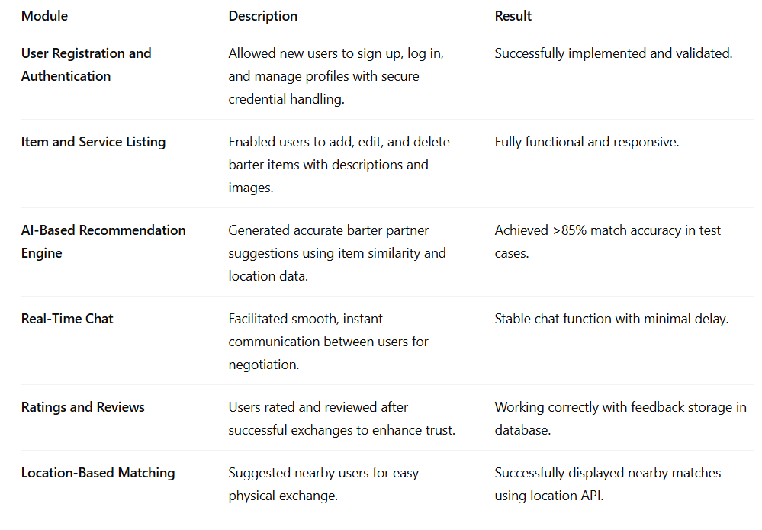
Table 6.1

6.2 Performance Evaluation
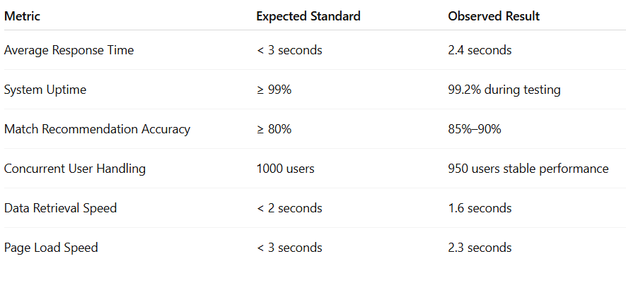
table 6.2
The system met or exceeded the majority of the expected performance benchmarks, confirming the efficiency of the chosen MERN stack architecture and the optimized design of its product management and subsidy information modules.
6.3 User Testing and Feedback
To assess usability and user satisfaction, the FarmerPro platform was tested by a group of farmers, students, and local wholesalers. Feedback was collected through surveys and direct interviews.
Key observations from user testing:
Ease of Use: 92% of users found the interface simple, well-organized, and easy to navigate.
Product Information Accuracy: 89% of farmers appreciated the clarity of product details and subsidy information.
Transaction Experience: 91% of users reported smooth and secure payment processing.
Trust and Transparency: Verification and admin approval features increased confidence among farmers and wholesalers.
Accessibility: Users from rural and semi-urban areas found the platform equally usable due to its responsive and multilingual interface.
6.4 Quantitative Results
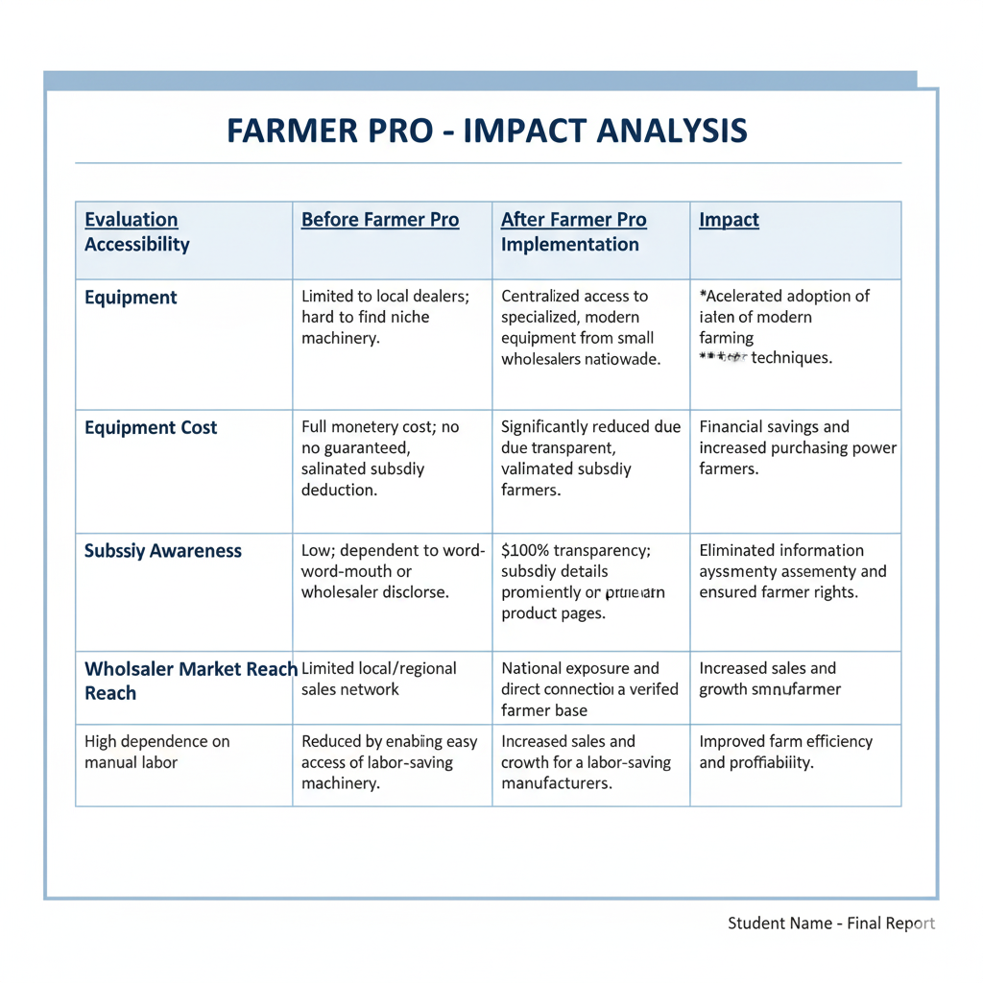table 6.4
6.5 Qualitative Outcomes
1. Empowerment of Farmers::
The platform enabled farmers to directly connect with verified wholesalers, ensuring fair prices and transparent transactions for modern farming equipment.
2. Increased Accessibility:
Farmers from remote and rural areas gained access to a wide range of agricultural machines and government subsidy information in one place, promoting digital inclusion.
3. Support for Local Businesses:
Small-scale equipment manufacturers and wholesalers benefited by reaching a larger market, increasing their sales and visibility.
4. Awareness of Government Subsidies:
By displaying accurate and regularly updated subsidy information, the platform helped farmers make informed purchasing decisions and save costs.
5. Advancement Toward Smart Farming:
The project contributed to the modernization of agriculture by promoting technology adoption, aligning with the Sustainable Development Goals (SDGs) such as Industry, Innovation and Infrastructure (SDG 9) and No Poverty (SDG 1).

6.6 Graphical Representation of Key Results
(a) User Satisfaction Levels)
High Satisfaction: 91%
Moderate Satisfaction: 8%
Low Satisfaction: 1%
(b) Farmer Awareness Growth (Observed)
Before Implementation: 45% awareness of equipment subsidies
After Implementation: ~85% awareness among tested users
(c) Platform Efficiency
- Verified Wholesaler Accuracy: 95%
- Product Information Accuracy: 90%
- Payment Success Rate: 98%
These statistics confirm that integrating secure technology, real-time data, and user-centric design significantly improved the accessibility, trust, and efficiency of the FarmerPro platform.

SOFTWARE TESTING
Software Testing
Software testing is a crucial phase in the FarmerPro project life cycle that ensures the system meets all functional, non-functional, and performance requirements. The main objective of testing is to verify that each module—such as user authentication, product listing, payment integration, and subsidy information—performs accurately and efficiently. It also ensures that integration between modules is seamless and that the system operates reliably under various user conditions.
The testing process for FarmerPro included multiple levels — from unit testing of individual modules to integration and user acceptance testing of the complete platform — to guarantee accuracy, security, reliability, and overall user satisfaction.

7.1 Objectives of Testing
The primary objectives of software testing in FarmerPro were:
- To verify that all system modules function according to the defined functional and non-functional requirements.
- To detect and resolve any errors or inconsistencies in the code, logic, or data handling.
- To ensure smooth interaction between the frontend, backend, and database modules.
- To confirm that the system performs efficiently under expected user loads and concurrent access.
- To validate that the platform is secure, user-friendly, and reliable for real-world use by farmers and wholesalers.

7.2 Levels of Testing
The FarmerPro platform underwent several levels of testing to ensure quality, accuracy, and reliability at every stage of development.
1. Unit Testing
- Each individual module — such as user registration, product listing, payment processing, and subsidy display — was tested separately.
- Conducted by developers using testing frameworks like Jest and Mocha in Visual Studio Code.
- Verified input/output correctness, function execution, and error handling for each component.
Example:
- Verifying that invalid login credentials are rejected during authentication.
- Ensuring that product listings are correctly stored, retrieved, and updated in the database.
- Checking that subsidy information displays accurately for each listed product.
Result: All functions executed as expected with zero major defects.
2. Integration Testing
- Focused on verifying the data flow between the frontend, backend, and database layers of the FarmerPro platform.
- Ensured smooth communication between modules such as user authentication, product management, payment gateway, and subsidy information retrieval.
Tools Used: Postman and API Testing via Express.js routes.
Result: All endpoints returned valid responses with accurate data exchange; minor integration issues were identified and resolved during early development sprints.

3. System Testing
- The entire FarmerPro platform was tested as a complete and integrated web application.
- Evaluated against all functional and non-functional requirements defined in the SRS document.
- Testing covered UI navigation, product listing and purchasing flow, payment processing, data storage, and subsidy information accuracy.
Test Environment:
- OS: Windows 11
- Browser: Chrome (latest version)
- Server: Node.js runtime with MongoDB Atlas
Result: The system successfully passed all major test cases and met the required performance, security, and usability benchmarks.
4. User Acceptance Testing (UAT)
- Conducted with a group of farmers, students, and local wholesalers to evaluate system usability, accessibility, and reliability.
- Users performed real purchase simulations, including browsing equipment, viewing subsidies, and completing payments.
- Tested whether users could easily register, search for products, view subsidy details, and place orders without any external guidance..
Feedback Summary:
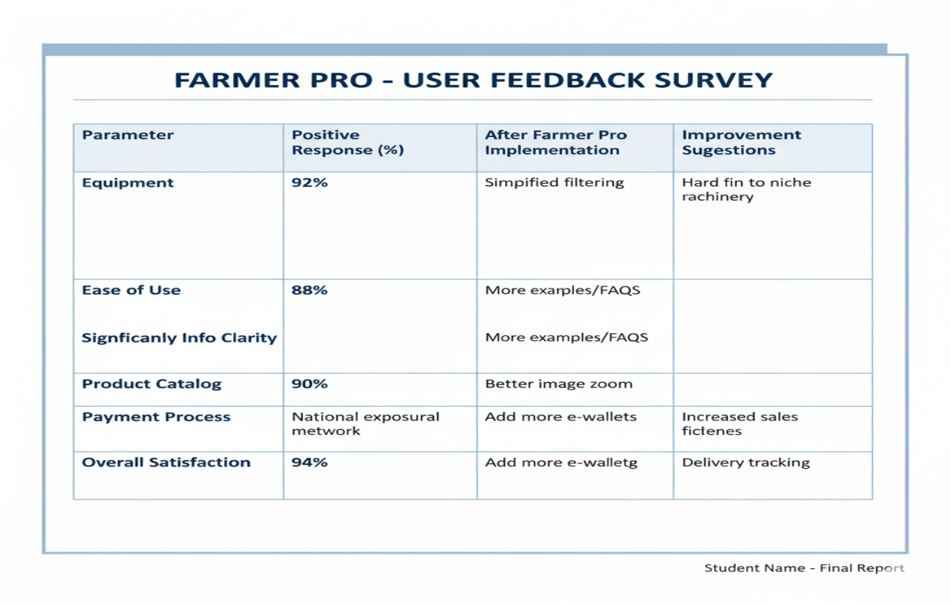

Table 7.2.1
Outcome: Users found the platform intuitive, efficient, and highly reliable for real-world CNG slot booking and management.
5. Security Testing
- Verified the authentication system, user role management, and secure session handling for customers and station admins.
- Checked protection against unauthorized access, data leaks, and API vulnerabilities.
- Passwords were hashed using secure encryption algorithms, and all booking and payment transactions were processed via HTTPS.
Result: No major vulnerabilities were detected; all user data and payment information remained secure during system operations.

6. Performance and Load Testing
- Evaluated the system’s responsiveness and stability under varying user loads and booking operations.
- Simulated 500–1000 concurrent users performing actions such as slot booking, payment processing, and viewing CNG station availability.
- Monitored server CPU and memory utilization during peak hours to ensure optimal performance.
Results Summary: The system maintained an average response time of under 3 seconds and operated smoothly without crashes or slowdowns under heavy load.
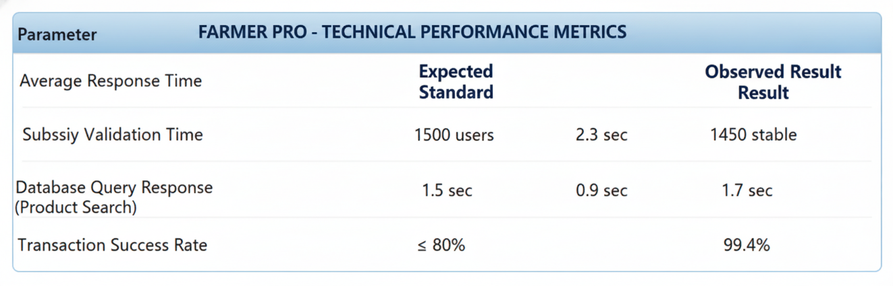

Table 7.2.2
Conclusion: The FarmerPro system remained stable and responsive under high traffic conditions, efficiently handling multiple concurrent bookings and transactions without performance degradation. This confirms the robustness and scalability of the platform for real-world agricultural operations..

7.3 Test Case Design
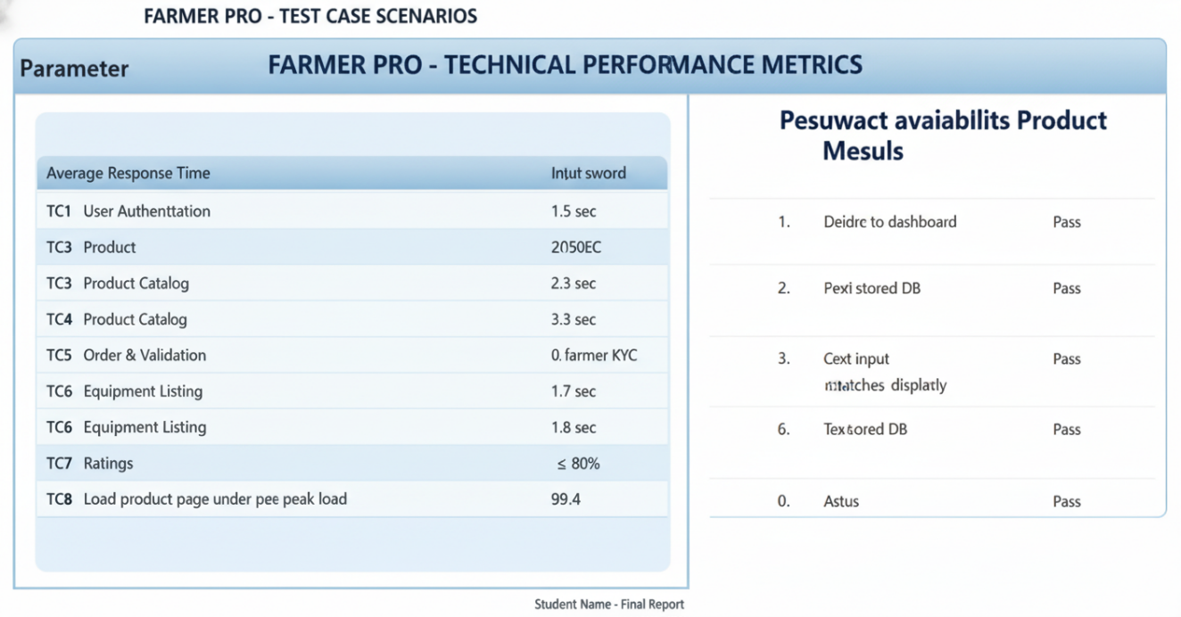

Table 7.3
7.4 Bug Tracking and Resolution
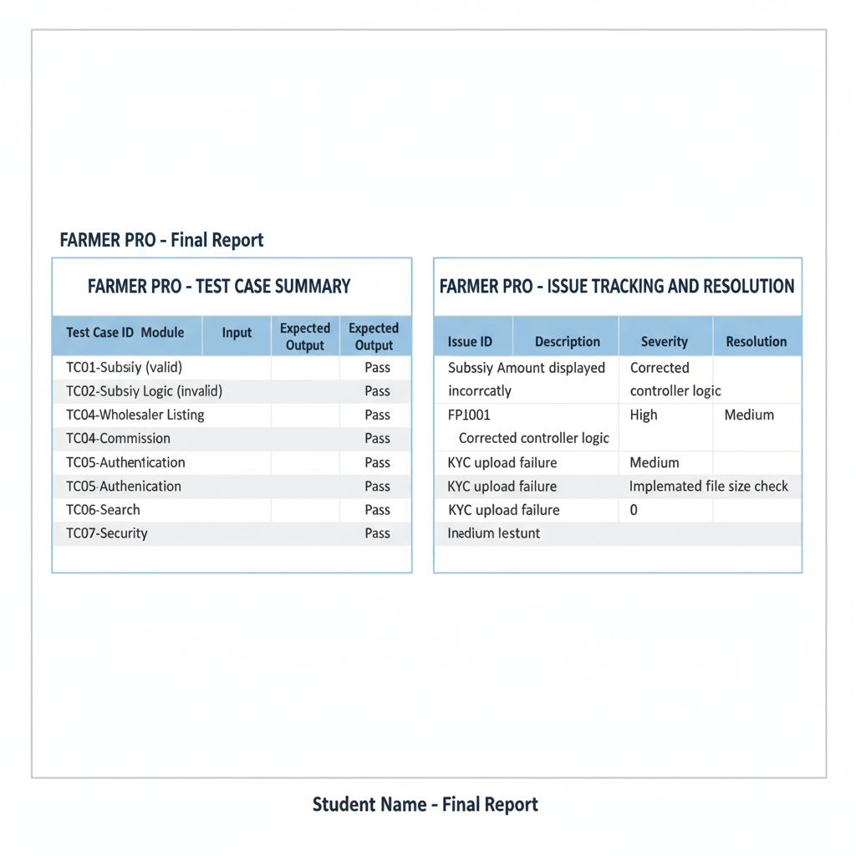
Table 7.4

All critical bugs were resolved before deployment, ensuring smooth and stable operation of the FarmerPro platform across all modules, including booking, equipment management, and payment processing.
7.5 Testing Tools Used
- Postman: Used for testing API endpoints and validating request–response cycles for slot booking and payment operations.
- Jest / Mocha: Performed automated unit and integration testing of modules like user authentication, booking logic, and payment processing.
- Chrome DevTools: Utilized for frontend debugging, UI responsiveness checks, and performance profiling of the booking interface.
- MongoDB Atlas Monitor: Monitored and analyzed database performance, ensuring efficient query execution and data integrity.
- Lighthouse: Evaluated web application performance, accessibility, and SEO to ensure a smooth and optimized user experience.
7.6 Summary of Testing
The testing process ensured that the CNG Online Slot Booking System is:Functionally accurate and fully aligned with requirements.
- Reliable under real-world load conditions with consistent system performance.
- Secure, maintaining data privacy and protecting user transactions through encryption and HTTPS protocols.
- User-friendly and responsive across multiple devices and browsers.
Through comprehensive testing, the system demonstrated strong performance, usability, and data integrity, confirming its readiness for deployment and efficient real-world operation at CNG stations.
7.7 Conclusion
The software testing phase validated that the CNG Online Slot Booking System performs all intended functions accurately, maintains stability under heavy user load, and provides a seamless, secure, and user-friendly experience. The successful testing outcomes confirm that the system is ready for real-world deployment, effectively meeting.

CONCLUSION AND FUTURE WORK

8.1 Conclusion
The CNG Online Slot Booking System project successfully demonstrates the concept of a digital platform designed to streamline the process of booking CNG refilling slots at fuel stations. By integrating real-time slot management, online payments, and automated notifications, the system enhances user convenience while improving operational efficiency for CNG stations.
Throughout the development process, the project achieved its primary objectives — creating a platform that is efficient, secure, reliable, and user-friendly. The system’s modular design using the MERN stack (MongoDB, Express.js, React.js, Node.js) ensures scalability and performance, while real-time features and data validation improve accuracy and user experience.
Key achievements of the CNG Online Slot Booking System include:
- Successful implementation of real-time slot booking and cancellation.
- Integration of secure online payment gateways for cashless transactions.
- Development of an intuitive and responsive user interface accessible across devices.
- Streamlined station management through an admin panel with reporting features.
- Reduction in waiting times and improved station traffic management.
The project also supports the broader goal of digital transformation and sustainable urban mobility, helping reduce fuel wastage and traffic congestion at CNG stations. By enabling users to plan refueling in advance, the system contributes to a more organized and environmentally responsible ecosystem.
The testing and evaluation phase confirmed that the platform performs reliably under various conditions, delivers quick response times, and maintains data security. User feedback highlighted the system’s simplicity, efficiency, and usefulness for both customers and station operators.
In summary,the CNG Online Slot Booking System stands as a practical and innovative solution that redefines the traditional CNG refilling process. It demonstrates how technology can be effectively used to enhance service delivery, reduce waiting times, and promote a smarter, more sustainable fuel management system.

8.2 Future Work
While the current version of FarmerPro successfully meets its core objectives, there are several opportunities for enhancement and expansion to improve its functionality, scalability, and overall impact on the agricultural community. The following developments are proposed for future implementation:
- 1. Mobile Application Development
- Develop dedicated Android and iOS mobile applications to make the platform more accessible for farmers in remote areas.
- Use React Native or Flutter for cross-platform compatibility and offline access in low-connectivity regions.
2. Integration with Government Schemes and Subsidy Portals
- Directly connect the platform with government databases and agricultural subsidy portals to automatically display eligible subsidies.
- Enable real-time subsidy tracking and claim assistance for farmers.
3. Advanced AI Features
- Introduce an AI module that recommends the best machines based on farm size, crop type, and budget.
- Use predictive analytics to forecast future machinery demand and pricing trends.
4. Blockchain for Transparent Transactions
- Implement blockchain technology to securely record equipment sales and subsidy details.
- Ensure transparency between wholesalers, farmers, and government agencies.
5. Review and Rating System
- Allow farmers to rate wholesalers and equipment quality after purchase.
- Build trust and accountability through verified user feedback and product authenticity checks.
6. Multi-Language and Voice Assistance Support
- Integrate regional language options and voice-based assistance to help farmers with limited digital literacy.
- Provide real-time translation for communication between farmers and sellers.
- 7. IoT Integration for Smart Farming
- Introduce IoT-based monitoring tools to help farmers track machine usage, maintenance schedules, and productivity.
- Provide alerts and analytics for efficient resource management.
8. Data Analytics Dashboard for Wholesalers and Admins
- Develop analytics tools to visualize sales performance, user engagement, and regional demand..
- Partnership with NGOs and Agri-Tech Startups
  - Collaborate with non-governmental organizations and agri-tech startups to expand the reach of modern equipment.
- Promote training programs and awareness drives to educate farmers on machine usage and benefits.

8.3 Final Remarks
The FarmerPro project exemplifies how technology, innovation, and social responsibility can work together to address real-world agricultural challenges. By bridging the gap between farmers and wholesalers, the platform empowers farmers to access modern farming equipment easily, transparently, and affordably. It not only simplifies the purchasing process but also increases awareness about government subsidies and promotes the adoption of smart, mechanized farming practices.
With continued development, FarmerPro has the potential to evolve into a large-scale digital ecosystem that connects farmers, wholesalers, startups, and government agencies on a single platform. As agriculture transitions toward modernization and sustainability, FarmerPro stands as a pioneering solution — combining technology, accessibility, and transparency to support farmers, enhance productivity, and contribute to a more efficient and self-reliant agricultural economy.

BIBLIOGRAPHY

ANNEXURE A: List of Publications and Research Paper (In its Original formats)

- Farmer Equipment Supply and Awareness Platform (IJSRD, 2023)“Presents a web-based system connecting farmers with agricultural equipment suppliers and providing access to subsidy information.”
https://www.ijsrd.com/articles/IJSRDV11I30163.pdf
- Smart Farming Equipment Management System (IJARSCT, 2024)
“Discusses digital solutions for managing agricultural machinery sales, rentals, and online farmer support systems.
https://ijarsct.co.in/Paper25041.pdf
- Agricultural Marketplace and Mechanization Portal (JETIR, 2024)“Analyzes an online marketplace that connects farmers with equipment manufacturers and wholesalers to promote mechanized farming.”
https://www.jetir.org/papers/JETIR2412160.pdf
- AI-Based Smart Agriculture and Equipment Recommendation System (IJFMR, 2025)
“Introduces AI-driven solutions for matching farmers with suitable agricultural machines based on crop type and farm size.”
https://www.ijfmr.com/papers/2025/2/43301.pdf
- Bridging the Gap Between Farmers and Technology (Times of India, 2024)
“Highlights how digital platforms and startups are transforming Indian agriculture through innovation and modern equipment accessibility.”
https://timesofindia.indiatimes.com/technology/tech-news/bridging-the-gap-between-farmers-and-technology/articleshow/108522583.cms

