Analysis:

1. Analysis of data available based on region.

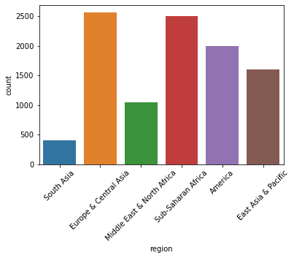

In given dataset, More data is from Middle East & North Africa and Middle East & North Africa as compared to other and data of South Asia is the lowest among all regions.

2. Year wise distribution of data
2.1 Year vs Fartility
2.2 Year vs life
2.3 Year vs population
2.4 Year vs Child_Mortality
2.5 Year vs GDP

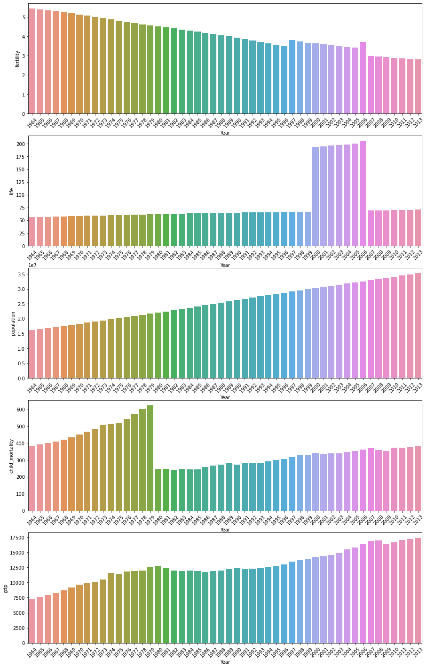

- Fertility is decreased continuously (except 1996 May be due to atmospheric change fertility increase)
- Life is almost constant (slightly increasing) (except 2000-2006 the rate of life is quite high)
- Population is increased steadily there is no exception.
- Rate of Child Mortality quite high between 1964-1979(steadily increase). Highest Child mortality in 1978. In 1980, Child mortality drops suddenly 3 times and then slowly and steadily increased.
- GDP increase steadily from 1964-1980. GDP from 1981-1995 is almost constant. After 1996 GDP is increased steadily.
3. Region wise distribution of data
2.1 Region vs Fartility
2.2 Region vs life
2.3 Region vs population
2.4 Region vs Child_Mortality
2.5 Region vs GDP

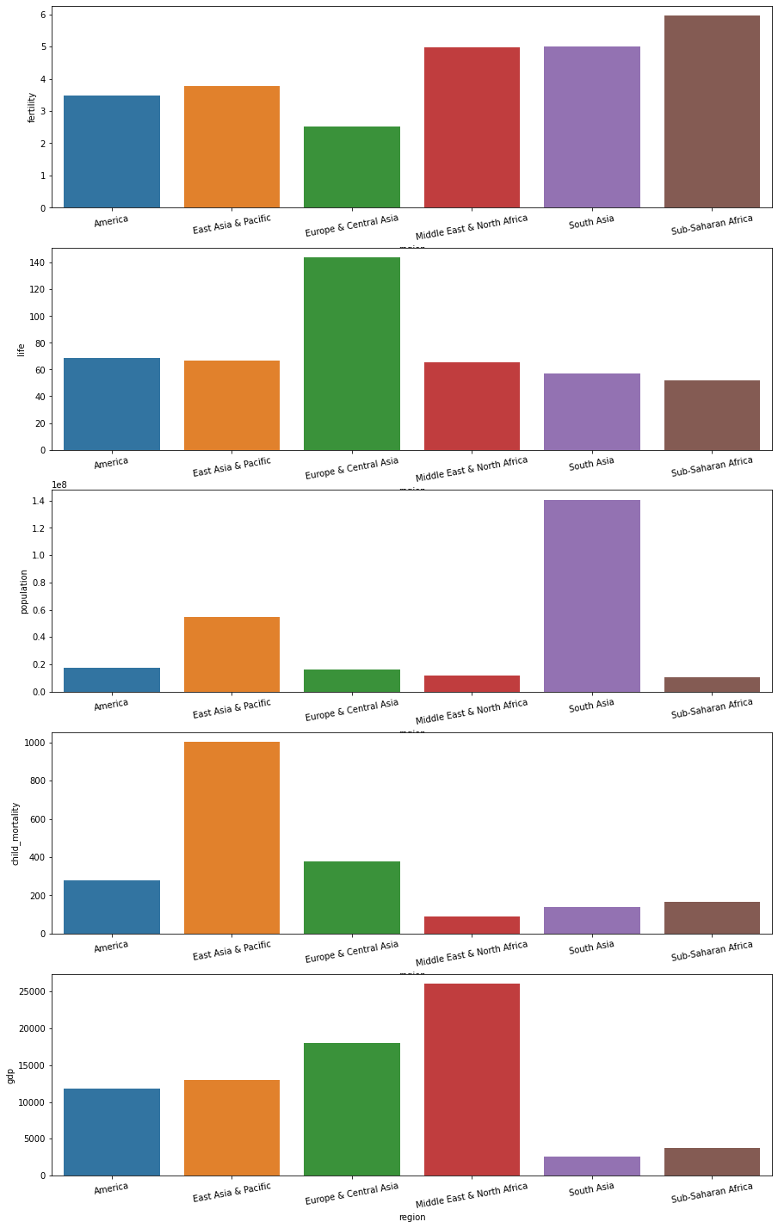

- The Most fertile region is Sub-saharan Africa and the least fertile Europe & Central Asia.
- The Life in Europe & Central Asia is quite high as compare to other region.
- Population of South Asia is quite high as compared to other regions.
- Child Mortality of East Asia & Pacific is quite high as compared to other regions.
- Highest GDP is in the Middle East & North Africa and the lowest is in South Asia.

3. Region wise Distribution of data (Finding Outliers)
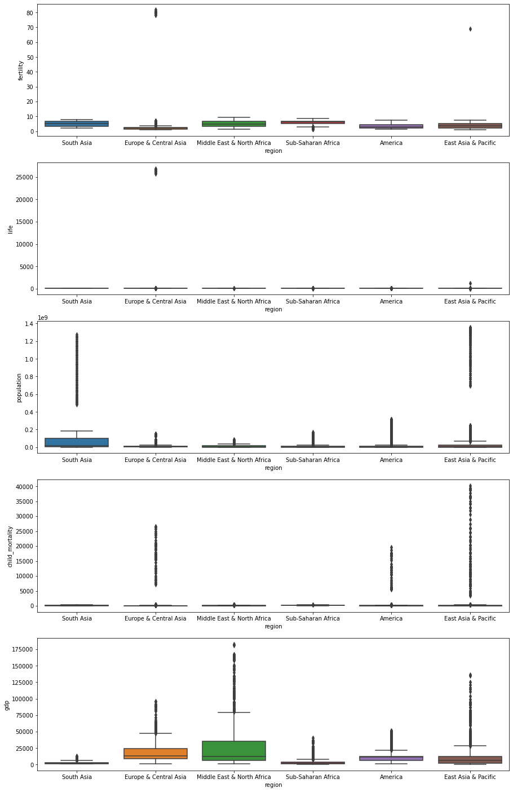

- In case of fertility, Europe & Central Asia, Middle East & North Africa and East Asia & Pacific contents outliers.
- In case of life, Europe & Central Asia and East Asia & Pacific contents outliers.
- There are lots of outliers in each region in case of population.
- In case of Child Mortality, Europe & Central Asia, America and East Asia & Pacific contents outliers.
- There are lots of outliers in each region in case of GDP.

4. Country wise EDA(India)

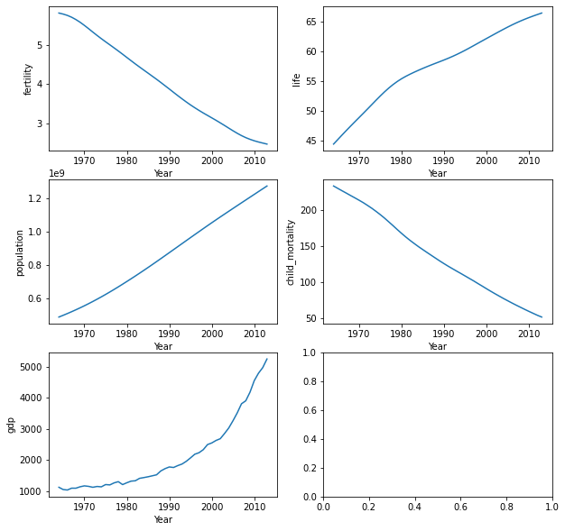

- As we see world fertility, In India, the same trend is going on from 1964-2013.
- The Life in India increases steadily.
- There is a steady increase in population.
- Child mortality is steadily decreased.
- Rate of the increase in GDP, not that much from 1964-1990 but GDP increase continuously after 1990.

