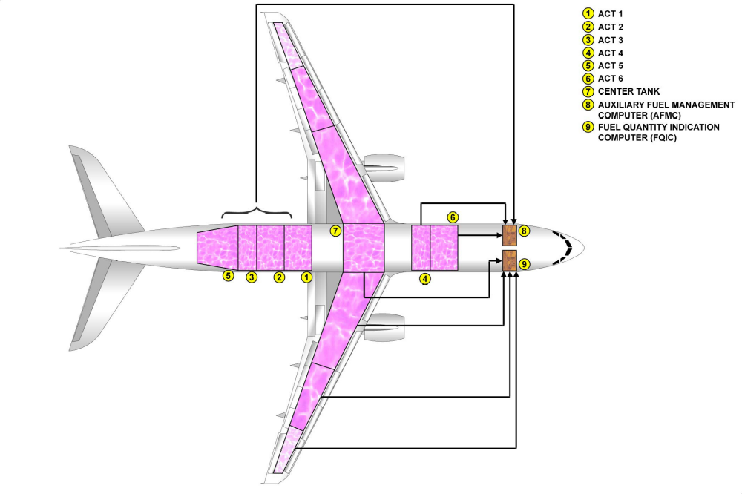
A319 CJ model Additional fuel tank:

