MASK OPERATION
As soon as the emergency oxygen container doors open, the masks fall out. They are hung on lanyards within the reach of users. When the first user pulls the mask towards his face, the release pin starts the chemical generation. Oxygen flows through the flexible supply hose to the mask. The flow indicator shows a green stripe.
CHEMICAL OXYGEN GENERATION
The chemical generator uses the basic principal of thermal decomposition of sodium chlorate. An indicator turning from yellow to black shows the generator is expended. The chlorate core is fitted in a stainless-steel housing. A thermal insulating material is used between the core and the housing. A filter is installed in the outlet end of the housing.
GENERATOR OPERATION
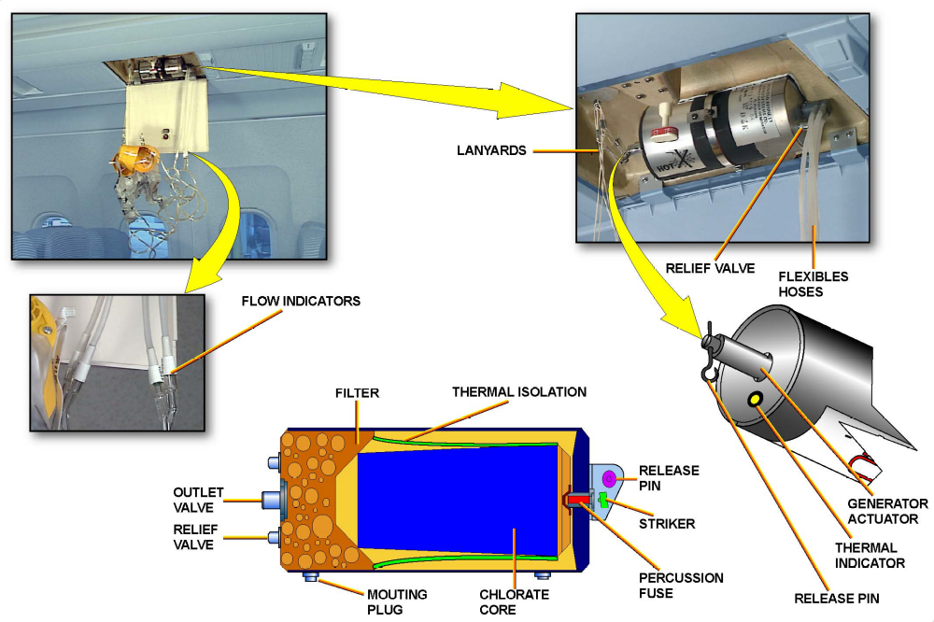
The generator actuator has a spring-loaded striker and a percussion fuse. A relief valve fitted on the generator housing protects the generator against high internal pressure.

