WING ICE PROTECTION
Hot air from the pneumatic system is supplied for the anti-icing of the three outboard leading-edge slats (3, 4 and 5) of each wing. Bleed air from the engines or the APU is supplied to each wing through a pressure regulating and shut off valve called Wing Anti-Ice (WAI) valve. A single P/BSW on the overhead ANTI ICE panel controls WAI supply to both wings. WAI must be manually selected by the crew and is available in flight only.

ENGINE AIR INTAKE ICE PROTECTION

Each engine air intake is protected from ice by an independent air bleed supply from the High Pressure (HP) compressor of that engine. The air is supplied through the engine air intake anti-ice valve. Engine anti-ice is manually selected by the crew and is available in flight or on the ground with the engine running. After circulating around the inlet, the air is ducted overboard.

PROBE ICE PROTECTION

Ice protection of the Angle of Attack (AOA) sensors, pitot probes, static ports, and Total Air Temperature (TAT) probes is achieved by electrical heating. In order to give reliable information to the air data systems, the air data probes are heated automatically when at least one engine is running. The probes are arranged in three channels related to the three air data systems: CAPT, F/O and STBY (Air Data/Inertial Reference Unit (ADIRU) 1, 2, 3). The heating system for each channel is controlled by a Probe Heat Computer (PHC) 1, 2, 3.

WINDSHIELD ANTI ICE PROTECTION

Electrical heating is provided for windshield anti-icing and cockpit side window de-fogging. The front windshields and side windows are heated AUTOMATICALLY when at least one engine is running. The PROBE/WINDOW HEAT pushbutton switch (normally in the AUTO position) may be used to select the window heating ON with the engines shut down.

DRAIN MAST ICE PROTECTION

When the electrical system is powered, the waste water drain masts are also electrically heated. There are two drain masts located on the lower fuselage forward and aft sections. Heating of the FWD and AFT drain masts is controlled by two Control Units located in the cargo compartments.
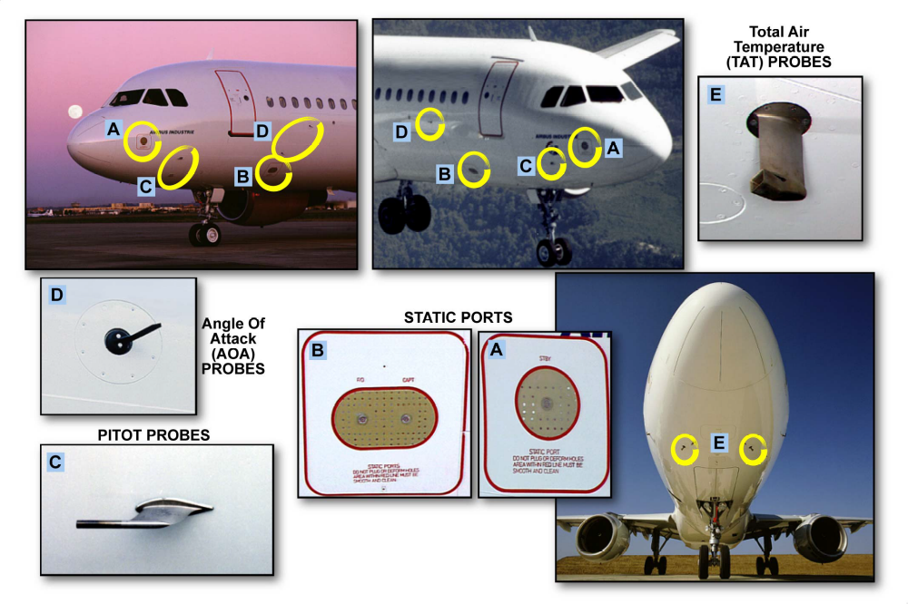
PROBE ICE PROTECTION

