RAIN REPELLENT SYSTEM PRESENTATION [A320]

FUNCTION
In heavy rain conditions, a rain repellent liquid, stored in a pressurized bottle, may be sprayed on the windshield to improve visibility. The spray nozzles are permanently purged by air from cabin hot air supply.
CONTROL
When the RAIN Repellent P/B is pressed in, the solenoid valve opens for a short time. This causes a measured quantity of rain repellent liquid to be sprayed on to the related windshield. To repeat the cycle, the P/B must be pressed again. On ground, the rain repellent system is inhibited when both engines are shut down.
GENERAL
The system is designed to improve visibility through the windshield in heavy rain, particularly when the wipers are not sufficient. The system operates independently on the CAPT side and on the F/O side.
RAIN REPELLENT CIRCUIT
The rain repellent fluid used is of type 3 and is packaged in a nitrogen-pressurized can. The can is directly attached to the rain repellent fluid gage. A purge P/B is used when the can is replaced. A nozzle sprays the rain repellent fluid onto the related windshield through four orifices.
PURGE CIRCUIT
The spray nozzle lines are permanently purged by air from cabin hot air supply. The blow-out reservoir works as a pressure accumulator, a decanting reservoir and has a test connection.
OPERATION
Upon actuation of the P/B, the time-controlled solenoid valve of the associated side releases out fluid to the spray nozzle for a preset period of time. To initiate a new cycle, it is necessary to release, then to press the P/B again. Between each cycle, the lines are automatically and permanently purged by hot air. The pressure indication shows the nitrogen pressure in the bottle. When the needle is in the yellow range, or the can is completely empty, the bottle should be replaced.
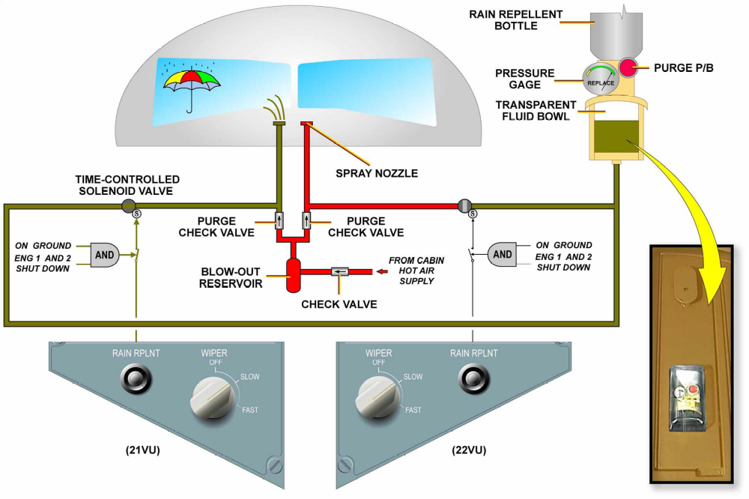
OPERATION

