FLY BY WIRE PRINCIPLE

The pilots use the side sticks to fly the aircraft in pitch and roll (and in yaw indirectly through turn coordination). Computers interpret the pilot's inputs and move the flight control surfaces to follow their orders. However, regardless of the pilot's inputs, the computer prevents:
- excessive maneuvers,
- flight outside the safe flight envelope.
Autopilot commands are given directly to the computers.
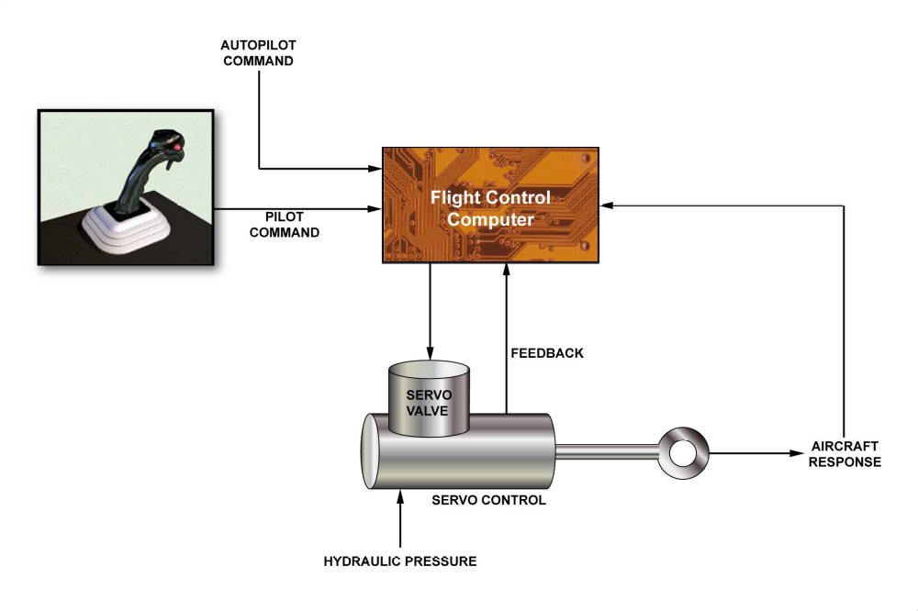
FLY BY WIRE PRINCIPLE

