A320F FLIGHT CONTROLS ARCHITECTURE

A computer arrangement permanently controls and monitors the flight control surfaces, it also records and stores faults.
This arrangement includes:
- 2 Elevator Aileron Computers (ELAC) for pitch and roll control,
- 3 Spoiler Elevator Computers (SEC) for pitch and roll control,
- 2 Flight Augmentation Computers (FAC) for yaw control,
- 2 Flight Control Data Concentrators (FCDC) for indication and maintenance tests,
- 2 Flight Management Guidance Computer (FMGC) for autopilot commands,
- 2 Slat Flap Control Computers (SFCC) for slat and flap control.
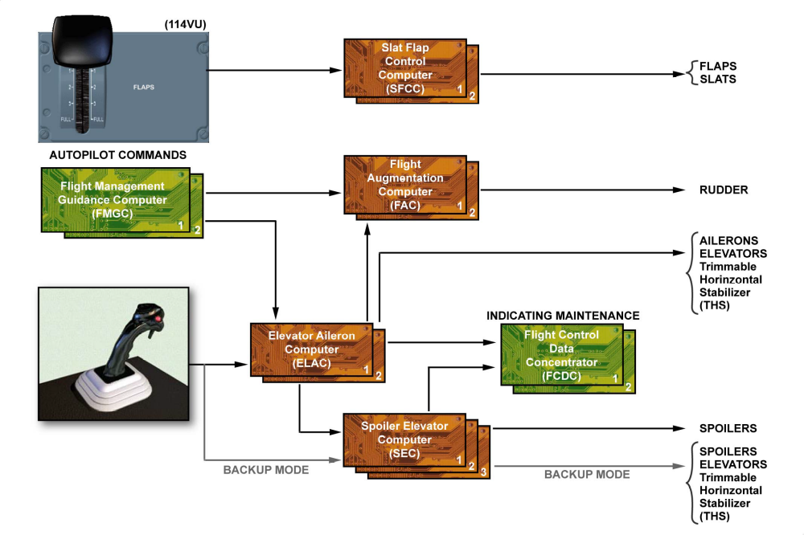
FLIGHT CONTROLS ARCHITECTURE

