FIRE PROTECTION SYSTEMS PRESENTATION [A320 family]

GENERAL
The A320 family fire protection systems have:
- fire detection and extinguishing systems for the engines and APU,
- smoke detection for the avionics equipment and compartment,
- smoke detection and fire extinguishing for the cargo compartments and lavatories,
- portable fire extinguishers for the flight compartment and the cabin
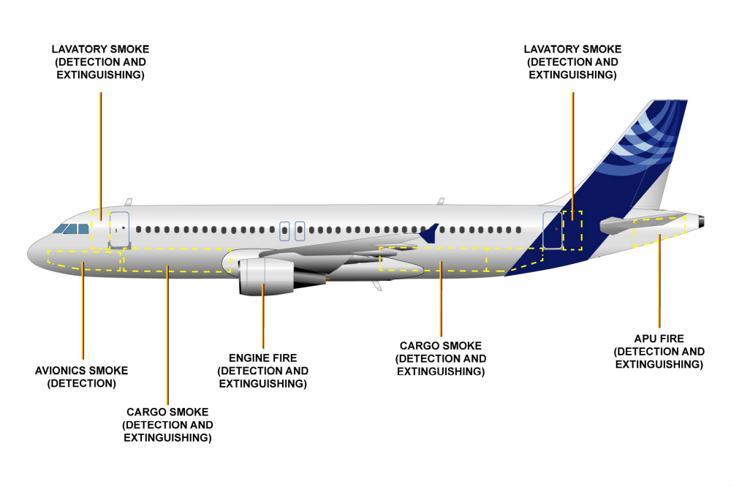

ENGINE FIRE PROTECTION
The engine fire protection is fulfilled by two sub-systems: the FIRE detection system and the FIRE extinguishing system. It has 2 fire extinguisher bottles in each.
APU FIRE PROTECTION
The APU fire protection is fulfilled by two sub-systems: the FIRE detection system and the FIRE extinguishing system. It has 1 Fire extinguisher bottle.
AVIONICS COMPARTMENT SMOKE DETECTION
The aircraft has a cooling system for the avionics equipment. The cooling system is controlled and monitored by the Avionics Equipment Ventilation Controller (AEVC). The air is circulated through the system by a blower fan (cool air supply) working together with an extraction fan (warm air removal). There is no fire extinguisher in that area.
CARGO COMPARTMENT SMOKE PROTECTION
The cargo compartments are protected by both smoke detection and fire extinguishing systems. It has normally 1 extinguisher bottle, 2 is optional.
LAVATORY SMOKE PROTECTION
Each lavatory has one smoke detector. The lavatories and galleys on the aircraft are ventilated by an air extraction system. Air continuously circulates through the lavatories and is extracted out through the ceiling and across the smoke detectors. It has 1 fire extinguisher bottle.
CABIN FIRE PROTECTION
There are portable fire extinguishers in the cockpit and the cabin. The quantity, type and location of the portable extinguishers depends on each customer's interior configuration.

