ENGINE FIRE DETECTION LOGIC

GENERAL
The engine Fire Detection Unit (FDU) has two channels capable of detecting any case of engine fire and loop failure. Each channel does the same detection logic depending on the loop A and loop B status.
FIRE WARNING
In case of a fire detected on both loops or on one loop with the other faulty, the channels provide a fire warning to the ENGINE FIRE panel, ENGINE START control panel and ECAM displays. The FDU generates a fire warning signal if any of the following conditions are met:
- fire on loop A and fire on loop B
- fire on loop A and fault on loop B
- fault on loop A and fire on loop B
- fault on loop A and fault on loop B within 5 seconds (both loops broken due to a torching flame).
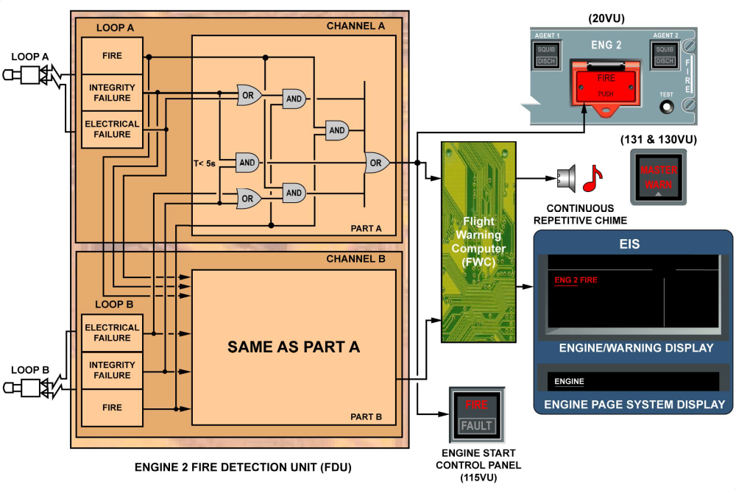
Fire warning

