PNEUMATIC SYSTEM PRESENTATION

SYSTEM INTRODUCTION
The Airbus single aisle family pneumatic system supplies High Pressure (HP) air for:
- air conditioning,
- wing ice protection,
- water pressurization,
- hydraulic reservoir pressurization,
- engine starting.
High Pressure air can be supplied from three sources:
- the engine bleed system,
- the APU,
- a HP ground power unit.
The pneumatic system operates pneumatically and is monitored by 2 Bleed Monitoring Computers (BMC 1 & 2). There is one BMC for each engine bleed system. Both BMCs exchange data. If one BMC fails, the other BMC takes over most of its monitoring functions.
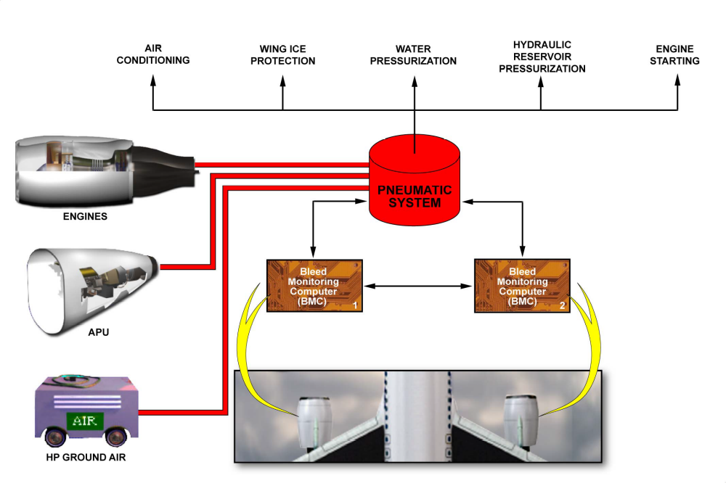
SYSTEM INTRODUCTION

