BMC INTERFACES

INPUTS
Each Bleed Monitoring Computer (BMC) has three types of inputs:
- DIGITAL INPUTS via ARINC 429 buses, from the opposite BMC, corresponding Engine Interface Unit (EIU) and Centralized Fault Display Interface Unit (CFDIU),
- ANALOG INPUTS from the bleed sensors,
- DISCRETE INPUTS from valve position switches, BMC and overhead panel. 28V DC power is supplied for energization of the bleed Pressure Regulating Valve (PRV) control solenoid.

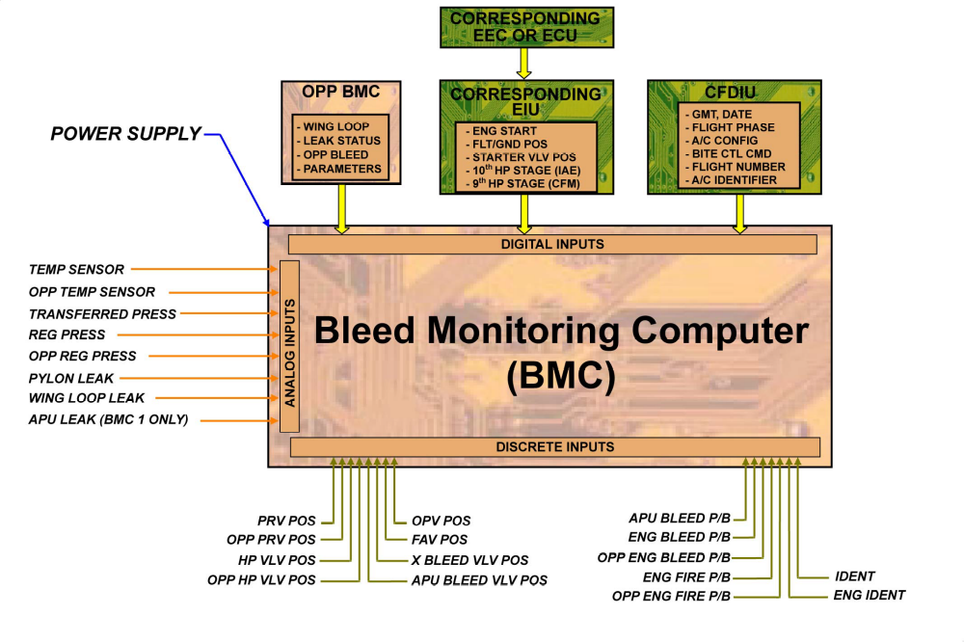

INPUTS

