SYSTEM OVERVIEW

General
The CFM56-5B engine is a dual-rotor, variable stator, high bypass ratio turbo fan power plant. The CFM56-5B powers the complete single aisle family of aircraft. CFM56-5B engines are available in several thrust ratings. All the engines are basically the same. A programming plug on the Electronic Control Unit (ECU) changes the available thrust. The power plant installation includes the engine, the engine inlet, the exhaust, the fan cowls and the reverser assemblies. The pylon connects the engine to the wing structure. The engine is attached to the pylon by forward and aft mounts.
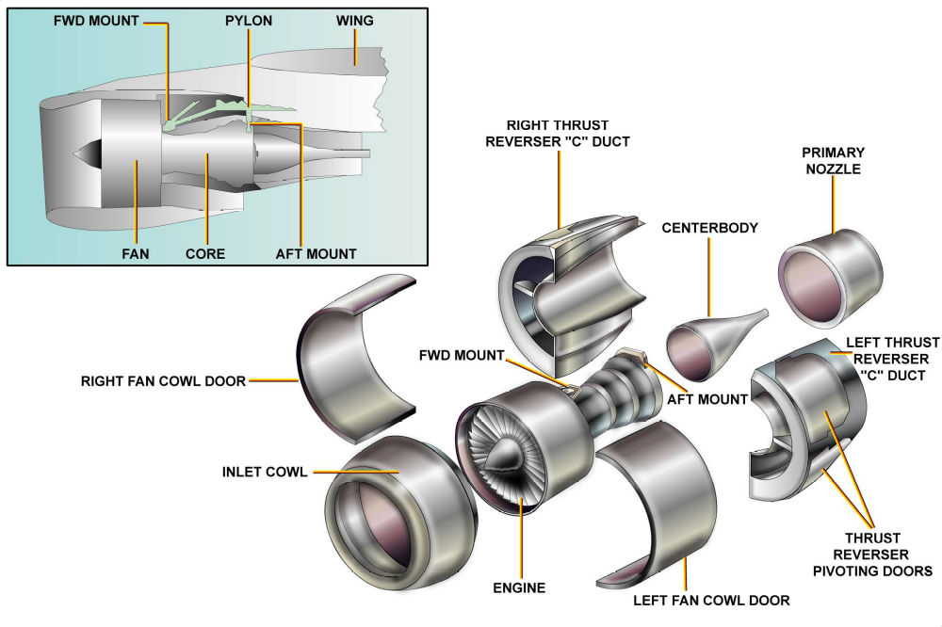
System Overview
ENGINE CHARACTERISTICS
The Airbus A320 family is powered by two CFM International CFM56-5B turbofan engines. These engines can produce a thrust from 21600 lb. (9800 kg) to 33000 lb. (14970 kg) depending on the aircraft version set by the engine data programming plug.
PYLON
The engines are attached to the lower surface of the wings by pylons. The pylons provide an interface between the engine and the aircraft for electrics and fluids.
NACELLE
The engine is enclosed in a nacelle, which provides aerodynamic airflow around the engine and ensures protection for the accessories.
ENGINE CONTROL
The engine includes a Full Authority Digital Engine Control (FADEC), which provides engine control, engine monitoring and help for maintenance and trouble shooting.
ENGINE GENERAL PARAMETERS
There is a different kind of thrust depending on the engine installed on the aircraft. 21600 lb. (9800 kg) can be achieved during takeoff with the CFM56-5B8 on A318, or 27000 lb. (12250 kg) with CFM56-5B4 on A320.

