APU BASIC DESCRIPTION

GENERAL
The Auxiliary Power Unit (APU) is of a modular design. The three APU modules are:
- the power section,
- the load compressor,
- the accessory drive gearbox.
ENGINE COMPRESSOR
The compressor is of a single stage centrifugal compressor design. The main components of the compressor are:
- a single stage centrifugal impeller,
- single stage diffuser vanes,
- axial de-swirl vanes.
COMBUSTION CHAMBER
The combustion chamber is of a reverse flow annular design and is installed inside the turbine plenum. The main parts of the combustion chamber are:
- the inner combustion chamber shell,
- the outer combustion chamber shell.
The following components are installed on the combustion chamber:
- an igniter plug,
- 10 dual orifice fuel nozzles.
TURBINE
The turbine assembly drives the engine compressor, the load compressor and the gear train of the Accessory Gearbox (AGB). The two-stage axial flow turbine includes:
- a cooled first stage nozzle,
- inserted first stage rotor blades,
- an un cooled second stage stator,
- a dual alloy second stage rotor,
- an annular exhaust diffuser.
LOAD COMPRESSOR
The load compressor is of a single stage centrifugal design. It supplies bleed air to the pneumatic system. The main components of the load compressor are:
- the inlet guide vane assembly,
- the load compressor impeller,
- the load compressor diffuser,
- the load compressor scroll.
INLET GUIDE VANES
The Inlet Guide Vanes (IGVs) control the amount of bleed air flow and pressure from the APU load compressor. The 16 IGVs are moved simultaneously by a gear train operated by an actuator. The IGV actuator is operated by high-pressure fuel supplied from the Fuel Control Unit (FCU). The IGV opening angle depends on the bleed air demand for:
- Main Engine Start (MES) system,
- Environmental Control System (ECS).
ACCESSORY GEARBOX
The gearbox transmits the shaft power to the APU accessories and to the APU generator, which are installed on the gearbox pads. The gearbox is also the oil reservoir for the APU lubrication system. The components mounted on the accessory gearbox are:
- the starter motor assembly,
- the cooling air fan assembly,
- the lubrication unit with the oil pump assembly which drives the FCU,
- the AC generator.

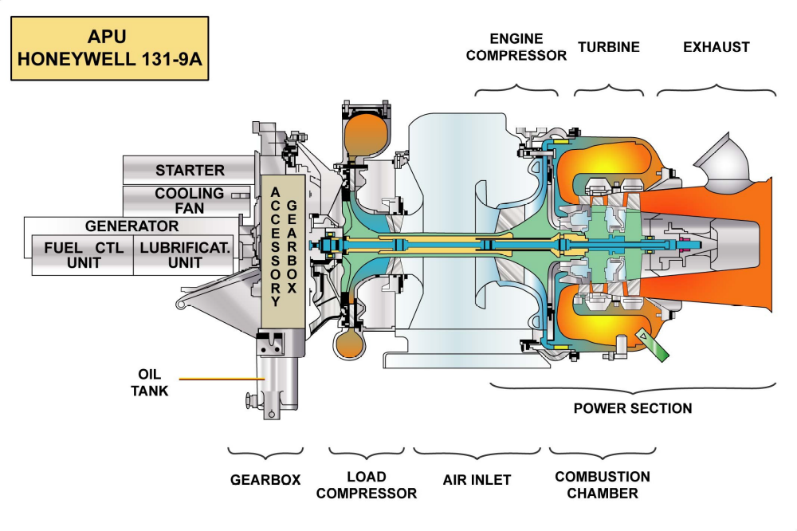
Figure: APU

