ECB INTERFACES

POWER SUPPLY
One of the A/C batteries at the minimum and the A/C DC network, electrically supply the Electronic Control Box (ECB), through the MAIN control relay of the Auxiliary Power Unit (APU).
MASTER SWITCH P/B
The APU MASTER SWITCH sends a discrete supply or stop signal to the ECB. The ECB sends a discrete signal to the FAULT light, when an automatic shutdown occurs or if there is an emergency shutdown.
AIR INTAKE FLAP
The ECB receives an air intake flap open or closed position signal and sends a power output to open or close the air intake flap.
START P/B
A discrete input signal from the START P/B starts the starting sequences. The ECB sends a discrete signal to the ON light during the APU start sequence. A discrete output signal to the A/C energizes the AVAIL light in the START P/B when the APU speed is above 95%.
BACK-UP AND MAIN START CONTACTORS
The ECB receives a discrete input from the main start contactor and sends discrete outputs to the back-up and main start contactors.
EMERGENCY STOP
A discrete input signal from the A/C starts the APU emergency shutdown logic after the ECB receives this signal.
LGCIU 1
The ECB receives the aircraft on ground discrete input signal from Landing Gear Control and Interface Unit (LGCIU) 1.
APU FUEL FEED SYSTEM
The ECB receives a discrete signal from the APU low fuel pressure switch. It sends a discrete signal to the APU fuel LP shut-off valve.
EIU
During engine starts, the ECB receives a Main Engine Start (MES) signal from Engine Interface Unit (EIU) 1 or 2. This signal causes the ECB to set the Inlet Guide Vanes (IGVs) to the fully open position if APU bleed has been selected to ON.
BMC
When the APU BLEED P/B is set to ON, Bleed Monitoring Computer (BMC) 1 or 2 sends a discrete input to the ECB. This controls the APU load control valve to open. The BMCs receive a closed-position signal from the APU load control valve to monitor the pneumatic system and to show ECAM indications.
TSO/JAR
The ECB receives a discrete input from the TSO/JAR configuration-programming pin. This open or ground signal finds if the ECB obeys the Technical Standard Order (TSO) or the Joint Aviation Requirements (JAR). Concerning the JAR, all System Display (S/D) circuits are available in flight. This configuration is the standard configuration. For TSO, only emergency, overspeed and loss of speed shutdowns, are available in flight.
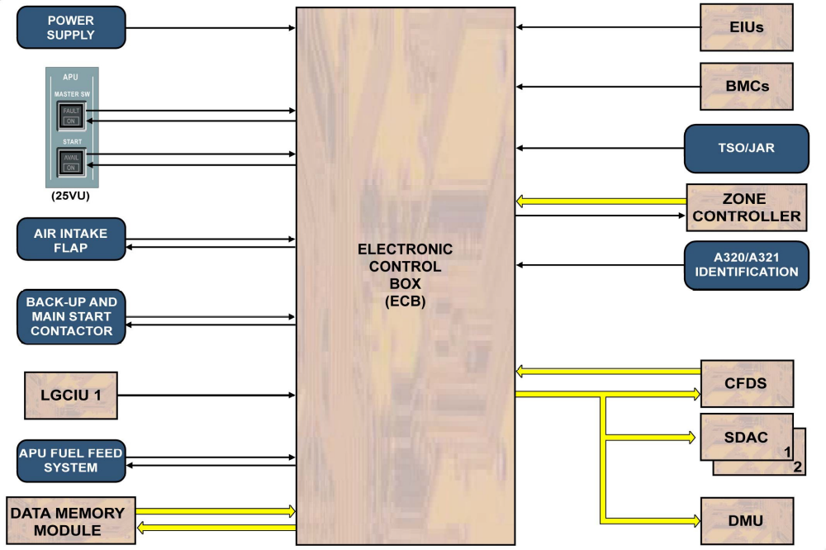
Figure: ECB interface

