Construction of Stabilizers.

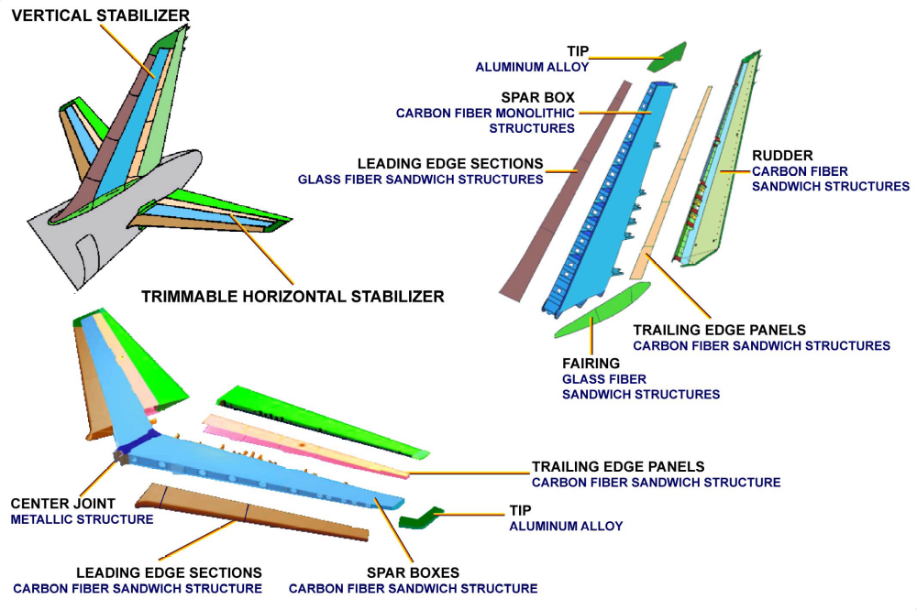
STABILIZERS - HORIZONTAL STABILIZER & ELEVATORS

