A/C SERVICING ARRANGEMENT
On the A318, note that special care must be taken during manual cargo loading and unloading of the forward cargo compartment, because of the close proximity of the engine air intake to the cargo loading vehicles (conveyor belt).
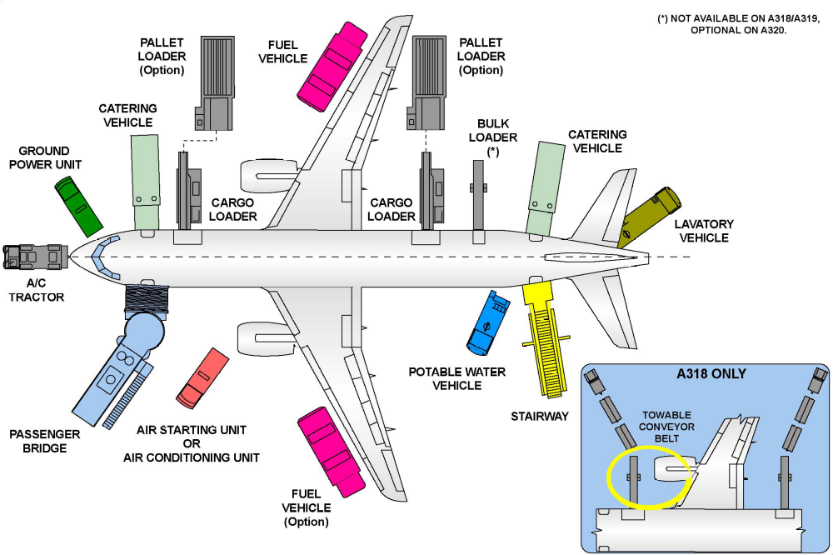
NOTE: Note: The use of a self-propelled conveyor belt is not recommended by Airbus Industry. The main difference between the A318/A319 and the A320/A321 servicing arrangement is that the A320 and A321 can have a bulk loader on the bulk cargo door.

