# Bernoulli’s Equation

This type of pressure, which exerts a force on all bodies, is called **Static pressure (P)** and acts equally in all directions.

When air is in motion, however, it possesses an additional energy (kinetic energy) due to the fact that it is moving, and the faster it moves the more kinetic energy it has. If moving air is now brought to rest against some object, the kinetic energy is turned into pressure energy.

This pressure on the surface of the body which causes the moving air to stop is called **Dynamic pressure.** The value of dynamic pressure depends on the density of the air and its speed and may be expressed as:

**Dynamic pressure = ½** ρ**V2**

Bernoulli’s equation highlights the relationship between speed and pressure and can be expressed as:

|  |  |  |  |  |
| --- | --- | --- | --- | --- |
| **P** | **+** | **½ ρ V²** | **=** | **constant** |
| Static  pressure |  | Dynamic  pressure |  | Total  pressure |

By applying the conservation of energy, the above equation can be expressed as:

**P1 + ½ ρ V²1 = P2 + ½ ρV²2**

This implies that if V2 is greater than V1, then P2 must be less than P1 (i.e. there will be a subsequent drop in pressure P).

This principle can be applied to aerodynamics, as the flow through a venturi has similar characteristics to the flow over an airfoil.

**The Venturi Tube**

An application of Bernoulli’s equation is seen during experiments using a Venturi tube. This simple instrument is a tube which gradually narrows to a throat, then expanding at the exit. It can be used to demonstrate an approximate relationship between pressure and velocity for low flow speeds.

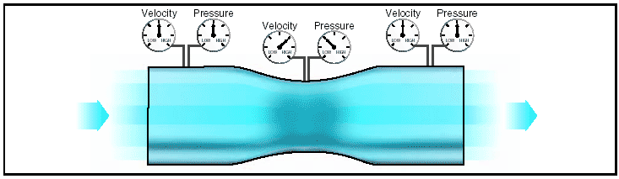

As air flows (dynamic pressure) into a constriction, that is between the surface of the airfoil below and the weight of the static air above, due to the continuity equation, the air is squeezed and the streamlines move closer together and therefore must speed up in order that the mass of air can flow through the constricted area in a set period of time.

As discovered by Bernoulli, this speeding up of the air will reduce the static pressure in the converging throat part of the venturi.

Figure 15 shows in a wind tunnel experiment, how the air flowing over the top of the airfoil shape is travelling faster than below. This accelerated air is producing the relative lower pressure on the upper surface.

The end result of this effect is a greater lowering of pressure on the upper surface compared to that of the lower. This imbalance of pressure between the upper and lower surfaces of the airfoil creates a net force in the upward direction.

As discussed in the last paragraph, the overall effect of this pressure difference is an upward force felt by the airfoil leading to the fundamental cause of Lift