# Gravity-Feed System

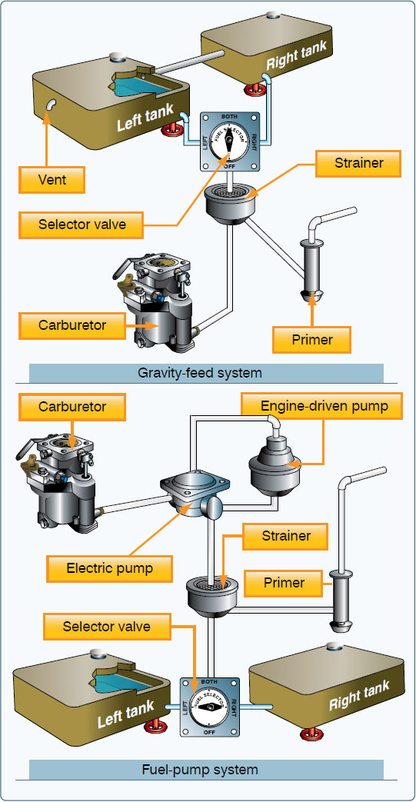Gravity Feed Systems: High-wing aircraft with a fuel tank in each wing are common. With the tanks above the engine, gravity is used to deliver the fuel. A simple gravity feed fuel system is shown in Figure 1. The space above the liquid fuel is vented to maintain atmospheric pressure on the fuel as the tank empties. The two tanks are also vented to each other to ensure equal pressure when both tanks feed the engine. A single screened outlet on each tank feeds lines that connect to either a fuel shutoff valve or multi location selector valve. The shutoff valve has two positions: fuel ON and fuel OFF. If installed, the selector valve provides four options: fuel shutoff to the engine; fuel feed from the right-wing tank only; fuel feed from the left fuel tank only; fuel feed to the engine from both tanks simultaneously. Downstream of the shutoff valve or selector valve, the fuel passes through a main system strainer. This often has a drain function to remove sediment and water. From there, it flows to the carburetor or to the primer pump for engine starting. Having no fuel pump, the gravity feed system is the simplest aircraft fuel system.

Figure: 1