# AUTO FLIGHT SYSTEM PRESENTATION

**GENERAL**

The Automatic Flight System (AFS) gives the pilots the functions reducing their workload and improving the safety and the regularity of the flight. The AFS is designed around:

- 2 Flight Management and Guidance Computers (FMGCs),

- 2 Flight Augmentation Computers (FACs),

- 2 Multipurpose Control and Display Units (MCDUs),

- 1 Flight Control Unit (FCU).

**CONTROLS**

The FCU and the MCDUs let the pilots control the functions of the FMGCs. The FAC engagement P/BSWs and the Rudder TRIM control panel are connected to the FACs. The MCDUs are used for long-term control of the aircraft and do the interface between the crew and the FMGC allowing the management of the flight. The FCU is used for short-term control of the aircraft and does the interface required for transmission of engine data from the FMGC to the Full Authority Digital Engine Control (FADEC).

**FMGC**

There are two interchangeable FMGCs. Each FMGC is made of two parts: The Flight Management (FM) part and the Flight Guidance (FG) part. The FM part gives the functions related to flight plan definition, revision and monitoring and the FG part gives the functions related to the aircraft control.

**FAC**

There are two interchangeable FACs. The basic functions of the FACs are the rudder control and the flight envelope protection. NOTE: The FAC includes an interface between the AFS and the Centralized Fault Display System (CFDS) called Fault Isolation and Detection System (FIDS). This function is activated only with FAC1 P/BSW in position 1.

**OTHER SYSTEMS**

The AFS is connected to the majority of the aircraft systems. Examples of AFS data exchanges:

- reception of the aircraft altitude and attitude from the Air Data/Inertial Reference System (ADIRS),

- transmission of autopilot orders to the Elevator and Aileron Computers (ELACs).

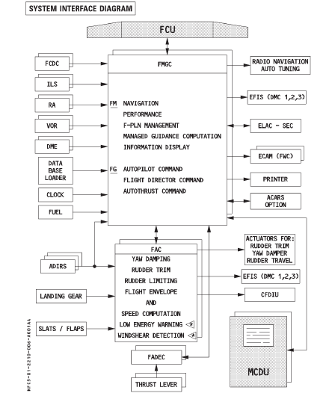

Figure: Auto Flight System Interface