# ATA 100 - Manufacturers Technical Data

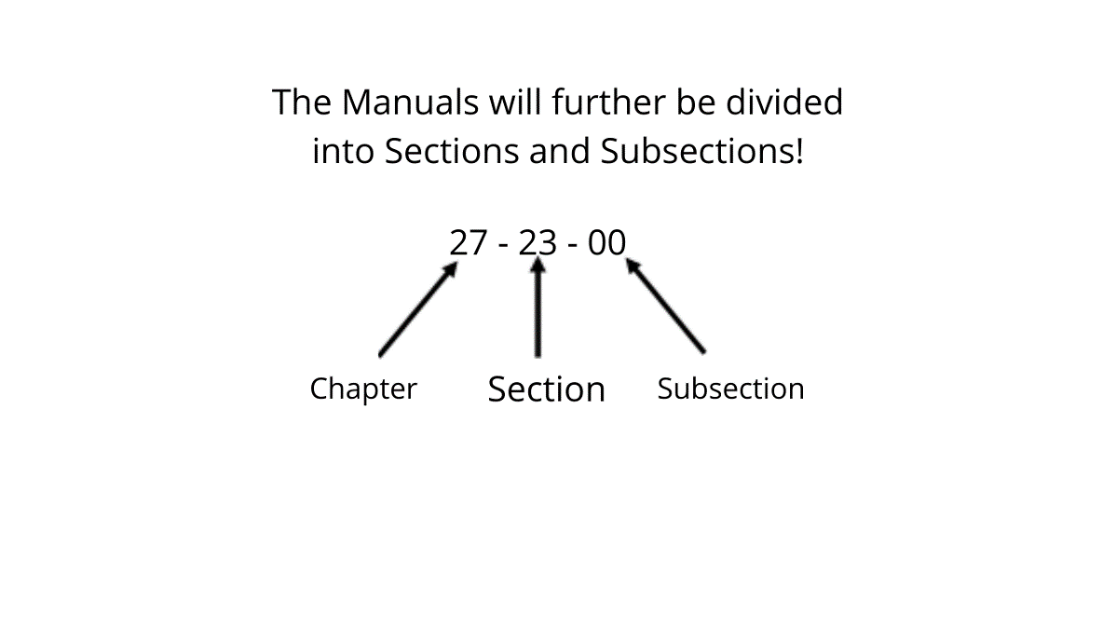This specification is the industry`s recommended format and contents standards for technical manuals written by aviation manufacturers and used by airlines and others in the aviation industry. The Maintenance Documentations for aircraft and aircraft components, are divided into the so called “ATA - Chapters”, in accordance to the ATA specification 100.

* **ATA Page block definition**

**Topics Page Block**

Description and Operation 001 to 099

Trouble Shooting 101 to 199

Maintenance Practices 201 to 299

Servicing 301 to 399

Removal/Installation 401 to 499

Adjustment/Test 501 to 599

Inspection/Check 601 to 699

Cleaning/Painting 701 to 799

Approved Repairs 801 to 899

Dispatch Deviation Guide (Maint. Practices) 901 to 999

