# NPN Diode Operation as Transistor.

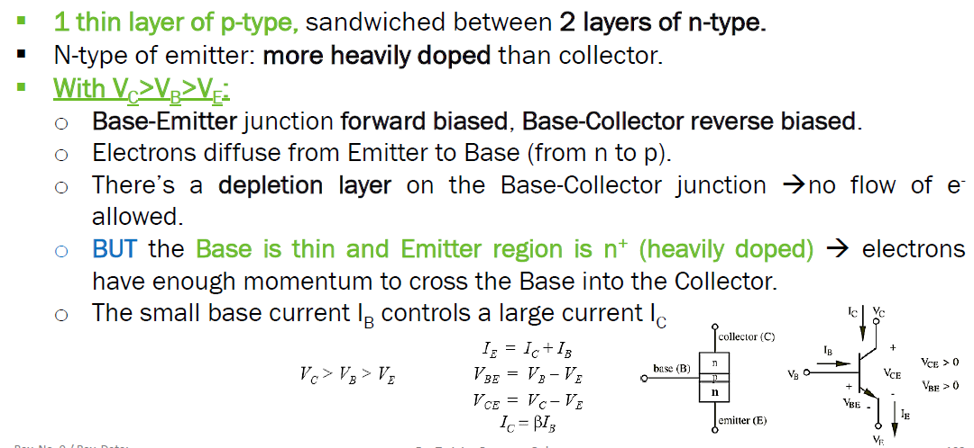 **BJT npn TRANSISTOR:**

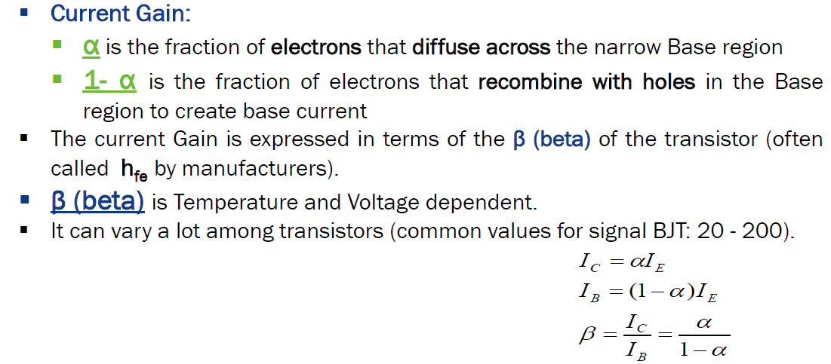**BJT CHARACTERISTIC:**