# Aircraft Waste System:

**A Typical Liquid Flush Toilet 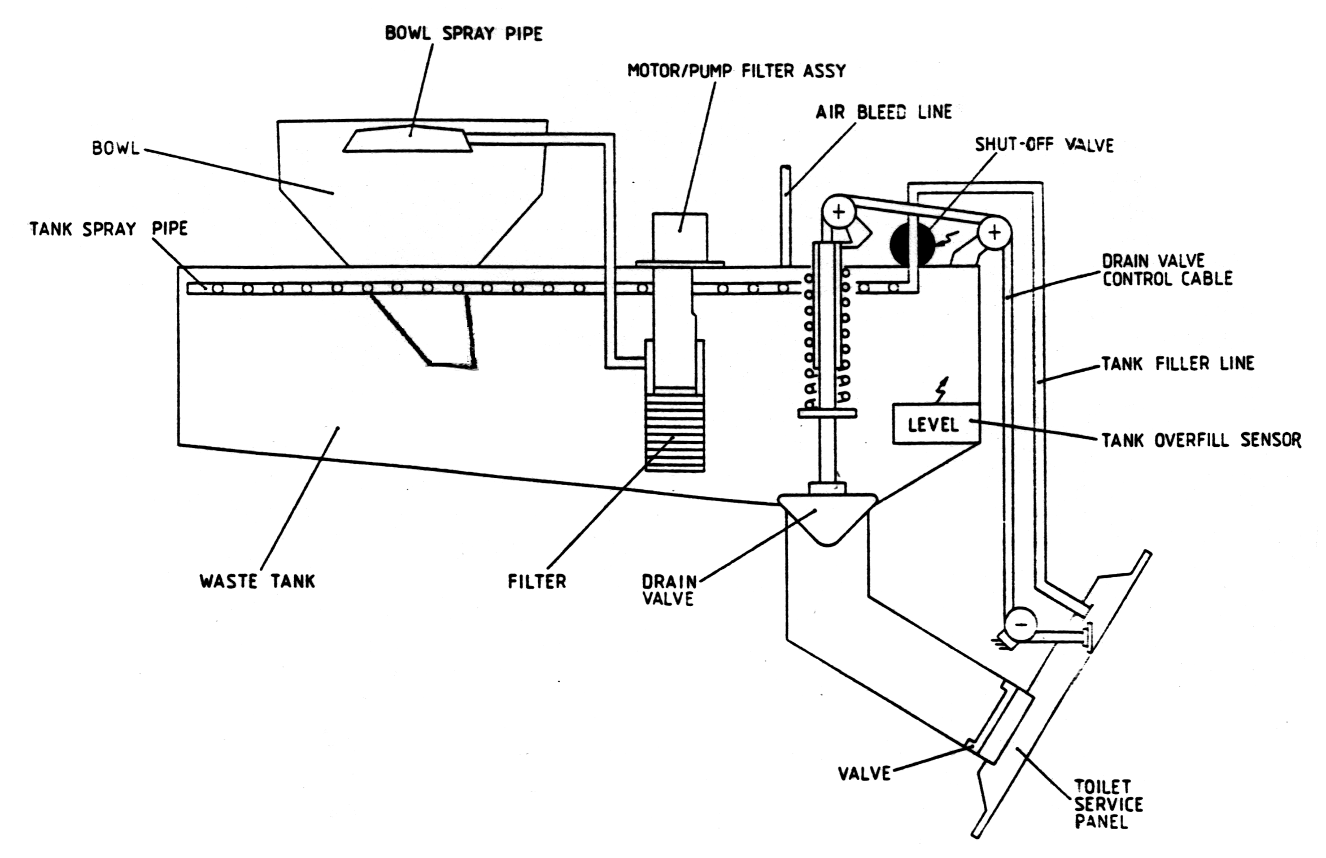in aircraft:** These are the most common type of toilet found in small to medium sized passenger aircraft, each toilet being a completely self contained quick release unit, having its waste collection tank mounted directly beneath the toilet bowl. The tank is normally made out of composites or plastics. Directly below the waste tank is a service panel. An illustration of a typical liquid flush toilet assembly is shown: