# Aircraft Air-condition System:

**AIR SUPPLY**

The source of fresh air supply and arrangement of essential components will vary between aircraft type and each air conditioning system, but in general one of the following methods described in the following paragraphs will be adopted:

**Engine Bleed Air (compression)**

This method is the most common and is installed on the majority of modern aircraft types. Very hot air is tapped from the main engine compressor stages and supplied to the cabin, flight deck and other areas. Before the air enters the cabin, it is passed through a temperature control system, which reduces its temperature and pressure. Additionally, a means of flow control is utilized and, in some aircraft,, humidity control forms part of the system.

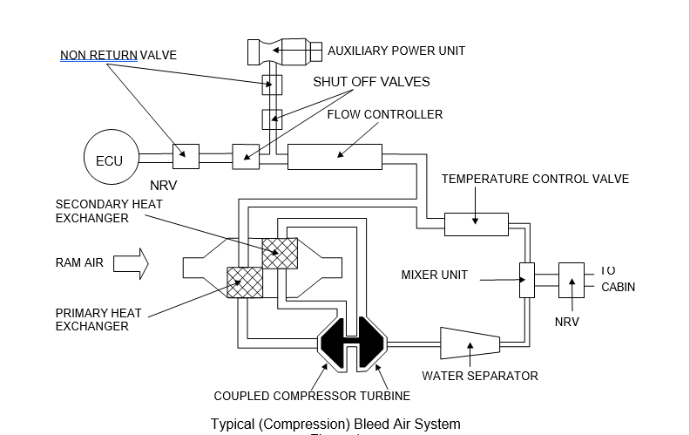In pressurized aircraft, the discharge of the conditioned air is regulated to maintain the cabin pressure at the selected pressure altitude.