# Air-condition Basic operation:

Many airplanes, especially larger ones now use an air conditioning system commonly known as Trim Air. The theory behind this system is that, for air conditioning purposes, these larger aircraft may have 3 or 4 zones where the temperature can be individually controlled. Zone 1 would be the flight deck with the passenger cabin segregated into 2 or 3 more zones, such as first, business and economy.

Each zone temperature is dependent on such things as the zone location and occupant numbers. As most airplanes utilize only 2 air conditioning packs that feed into a common manifold, which is then distributed to all the zones. It would not be practical or efficient to continually modulate the output temperature from the packs; somebody would always be too hot or too cold. So, the packs produce conditioned air at a few degrees below the temperature desired by the coldest zone. Now this means the air to the other zones would be too cold, so each of the other zones uses trim air to warm their specific air supply bringing it to the desired temperature before ducting into that particular zone.

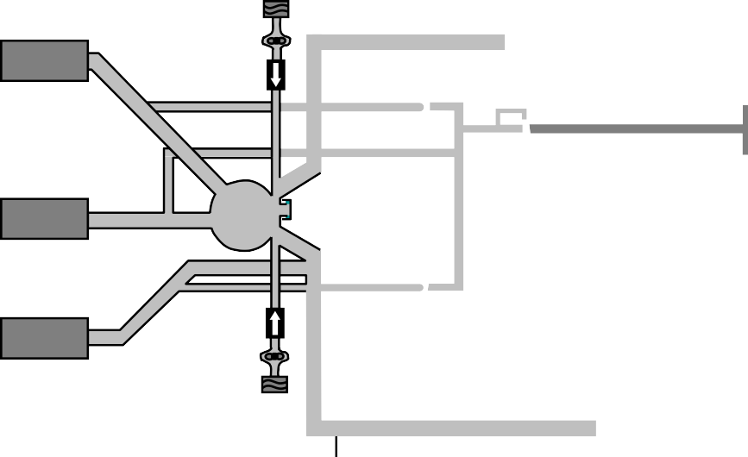

**ENGINE AIR**

**AFT PASS**

**TRIM VALVES**

**MASS FLOW CONTROLLER**

**FWD PASS**

**MIX MANIFOL**

**FLT DECK**

**TRIM VALVE**

**RECIRCULATION FAN AND FILTER**

**PRESSURE BULKHEAD**

**MASS FLOW CONTROLLER**

**COOLING PACK**

**E**

**RIGHT COOLING PACK**

**LEFT**

Aircraft 3 zone trim air system