SETTING UP Multilevel NUMBERING IN WORD (2010)

If you want automatically numbered Chapters and Sections, you can set up numbering in Word – this example shows 1.1.1 (Chapter, Section, Subsection) format.

**NOTE:** This example links the numbering to Styles; use the “Microsoft Word 2010 Styles” document to set up preferred Styles before setting up the numbering.

Start (at the top of your Word document) by setting up the Number Format: on the Home tab, click on the down arrow next to the Numbering icon and select Define New Number Format.

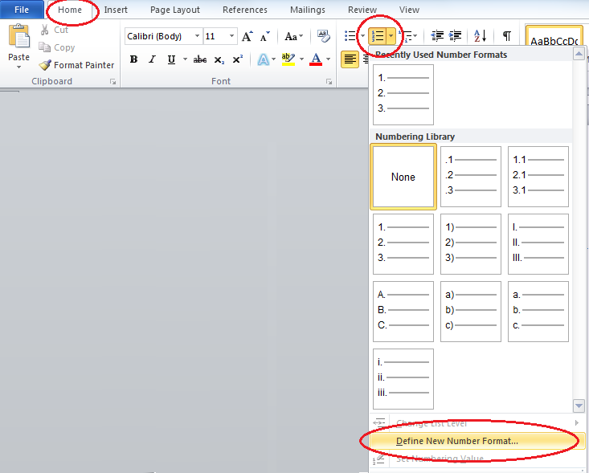

Then make sure the “Number style” shows as 1, 2, 3, … and delete the period from the Number format box.

# 

It is not necessary to set up the font features – those will be automatically applied when the numbers are linked to the Styles.

Next, create your list of numbers. From the Home tab, click on the “Multilevel list” icon down arrow and select “Define New Multilevel List.”

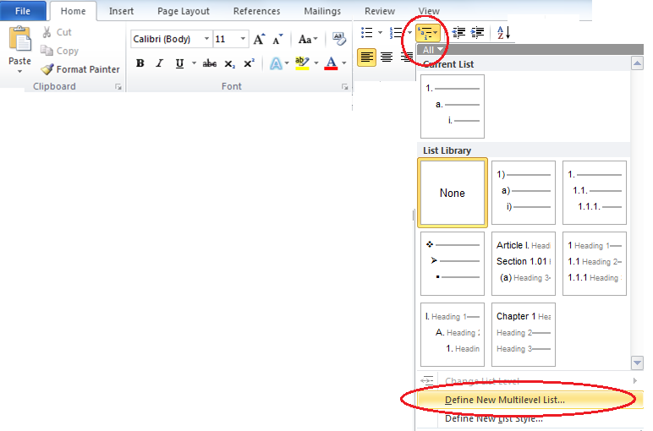

Note – you will not have to click OK until you’ve set up all three levels of numbering. If for some reason you need to exit before finishing all three, you’ll have to select “Define new multilevel list” again to edit your created list.

**Chapter Headings – Level 1**

Click on 1, then duplicate the Position settings as shown, and then click on the “More” button.

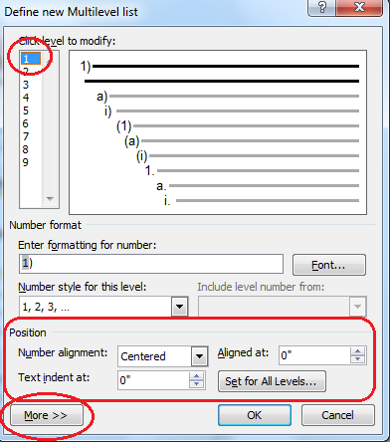

Select “Heading 1” (or whatever you named your Chapter/main heading) from the “Link level to style” dropdown list, and then select “nothing” from the “Follow number with” list.

# 

Change the default number format “1)” by placing your cursor in the text box after the “)” and deleting it. Replace it with “: (spacebar)”. Then click before the number in the text box and type in CHAPTER (spacebar).

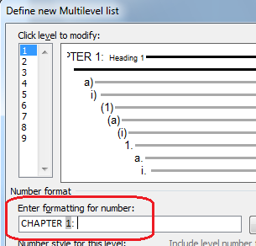

**Section Headings – Level 2**

Click on 2 to modify the next level. Make sure “Number style for this level” is set to 1, 2, 3, …. Select Level 1 number to include.

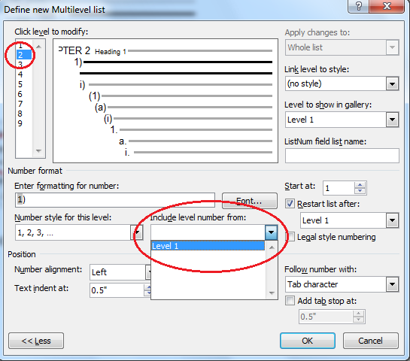

Select “Heading 2” style to link to, and set “follow number with” to either space OR nothing.

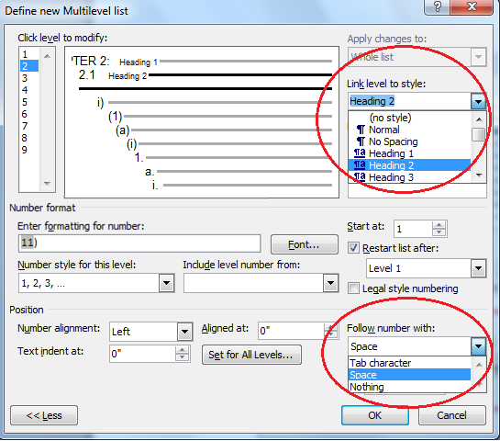

Change the formatting to match the sample below – delete the “)” and place a period between the two numbers. If you set “Follow number with” to *nothing*, add a couple of spaces after the number. If you set “Follow number with” to *space*, add one space after the number.

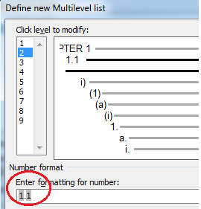

**Subsection Headings – Level 3**

Click on 3 to modify the next level. Make sure “Number style for this level” is set to 1, 2, 3, …. Click on the “Include level number from” dropdown button, select Level 1 number to include, then repeat and select Level 2 number to include as well.

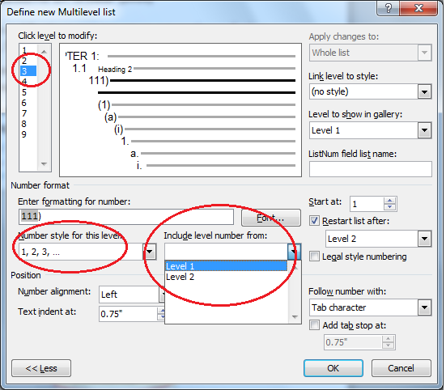

Next, set “Link level to style:” to Heading 3 (or whatever you called your Subsection style). Set “Follow number with:” to space OR nothing.

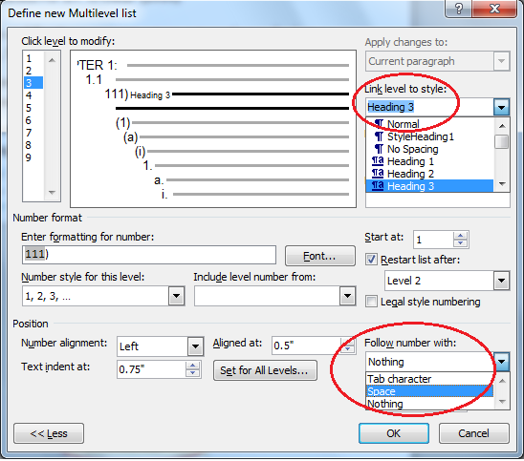

Set the Position settings to match below – Left alignment, Aligned at 0”, Text indent at 0”.

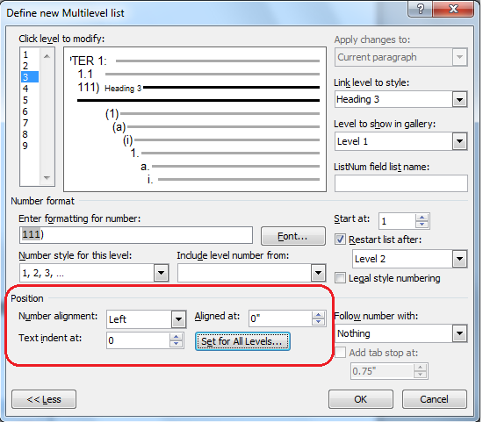

Finally, change the formatting – delete the “)” and insert periods between the numbers. If you set “Follow number with” to *nothing*, add a couple of spaces after the number. If you set “Follow number with” to *space*, add one space after the last digit.

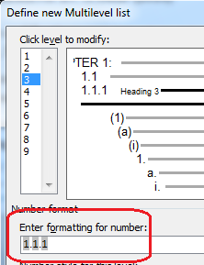

Finally, you can click OK to accept all the settings for the three levels.

The numbering will be applied automatically every time you apply the appropriate style. You should not have to go back into the Number Format or Multilevel list setup again unless you want to edit any of the settings (e.g., how many spaces following number, alignment, etc.).

These settings will generate Chapter / Section / Subsection headings that look like the following:

# EXAMPLE OF HEADING 1 style and numbering

## Example 1st Section Heading Style and Numbering

### Example Section 1, 1st Subsection Heading Style and Numbering

### Example Section 1, 2nd Subsection Heading Style and Numbering

## Example 2nd Section Heading Style and Numbering

### Example Section 2, 1st Subsection Heading Style and Numbering

### Example Section 2, 2nd Subsection Heading Style and Numbering